2.- In the rest of the columns of the registers will be:

* Registers with white background indicate that the PPAP has been requested by the customer, the request has not been sent to the vendor, and 30 days have not passed without the documentation being sent to the customer.

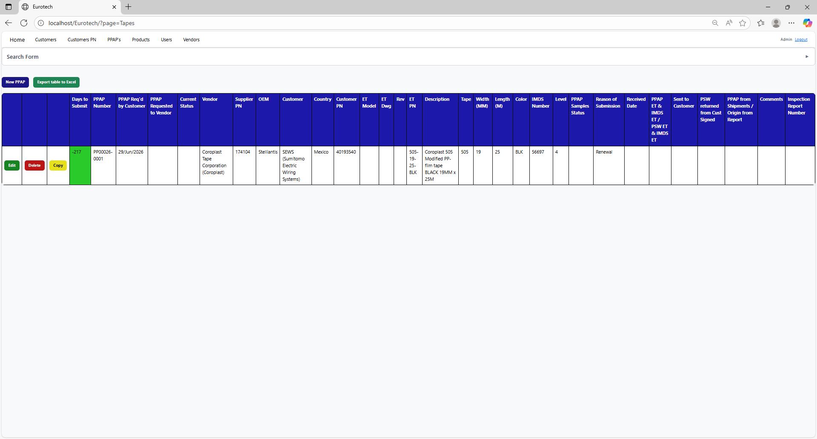

* Registers with blue background indicate that the PPAP has been requested by the customer, the request has been sent to the vendor, and 30 days have not passed without the documentation being sent to the customer.

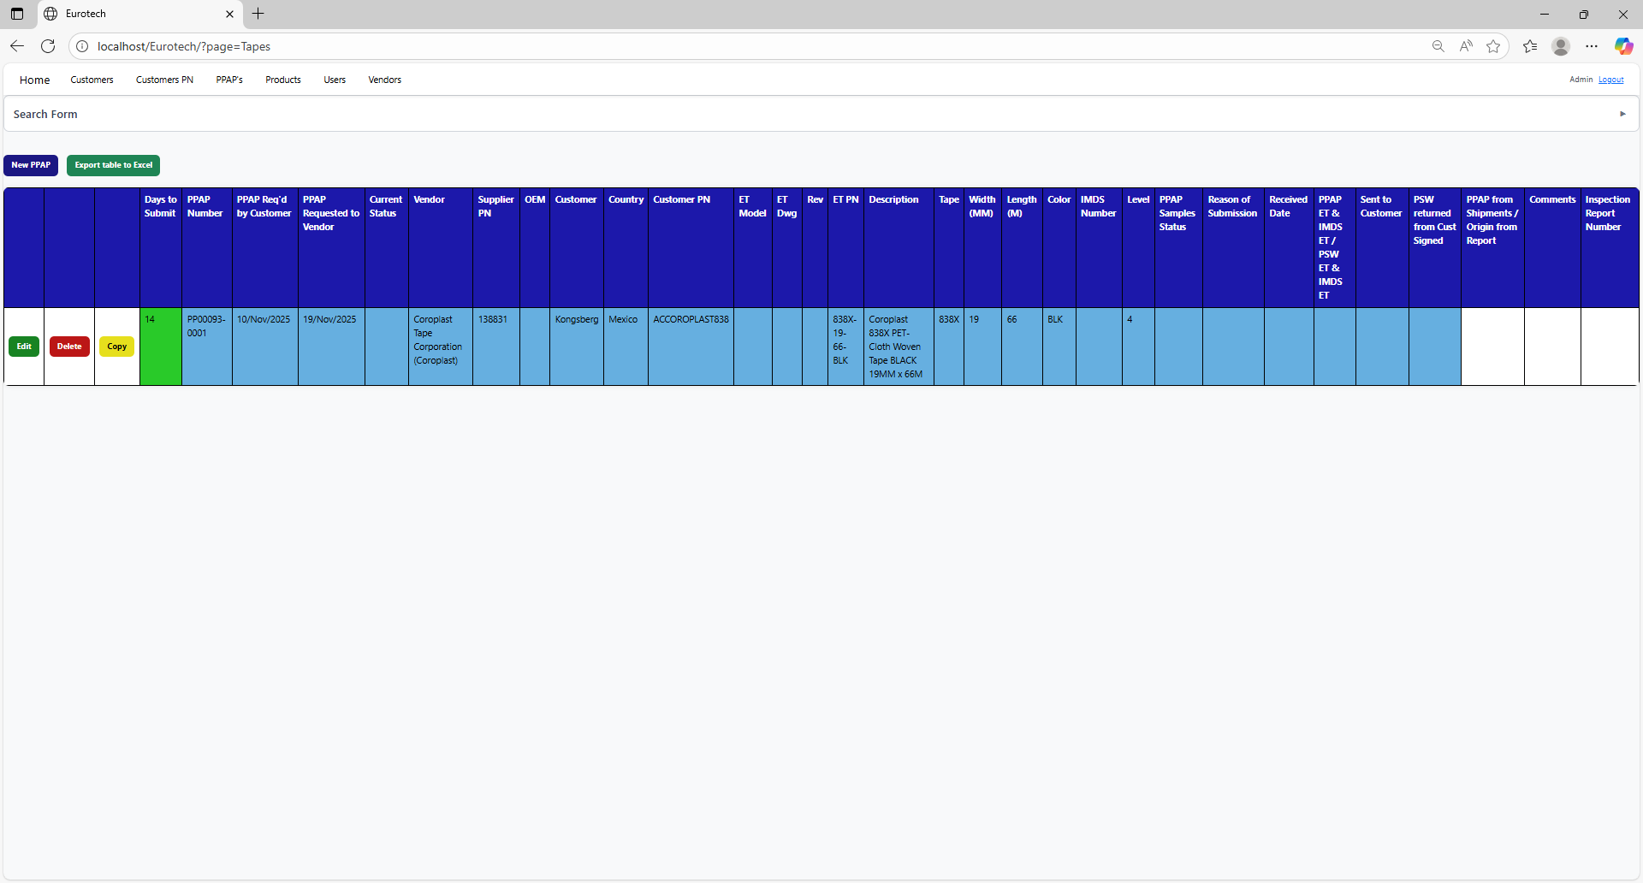

* Registers with red background indicate that the PPAP has been requested by the customer, and the 30-day limit has passed without the documentation being sent to the customer.

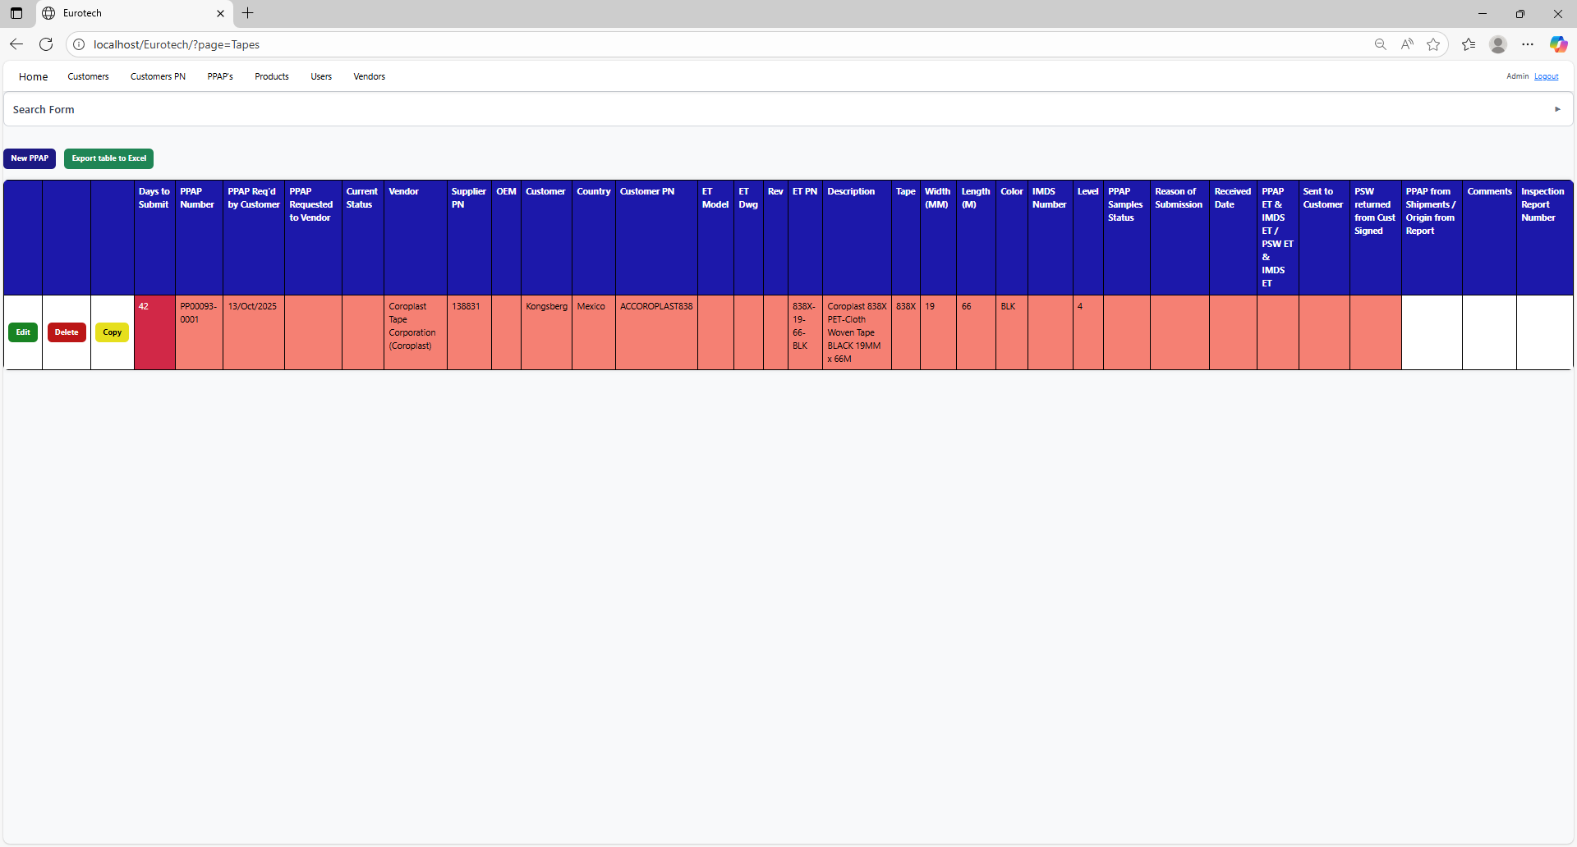

* Registers with yellow background indicate that the PPAP has been sent to the customer, and the PSW has not been returned signed by the customer.

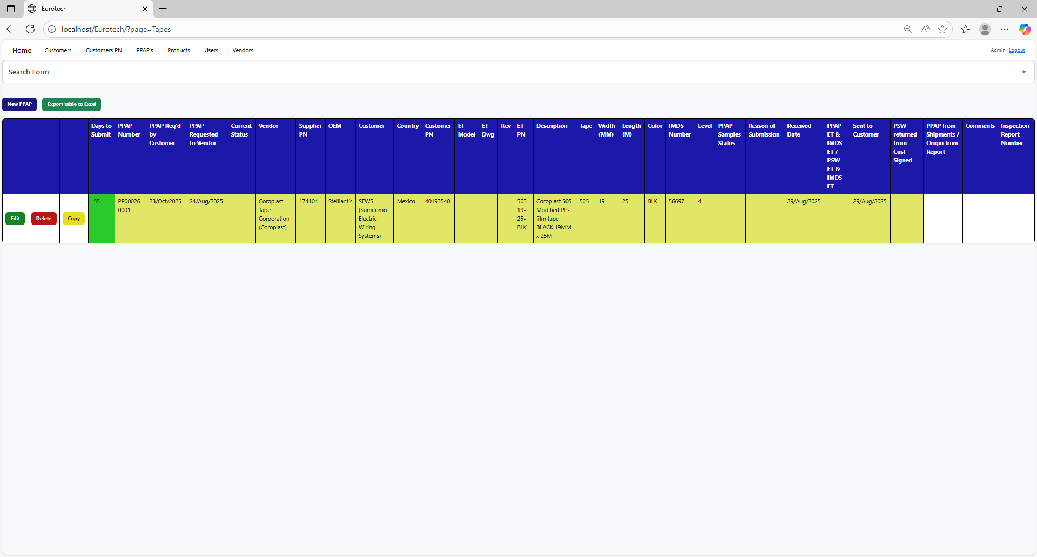

* Registers with green background indicate that the PSW has been returned signed by the customer.

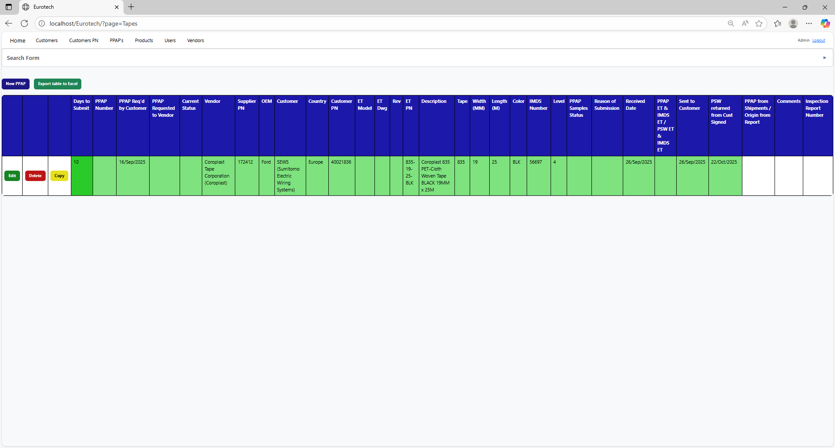

### *3.6.4 How to Add a New PPAP.*

If you want to add a new PPAP, you must click the “New PPAP” button that is below the “Search Form”.

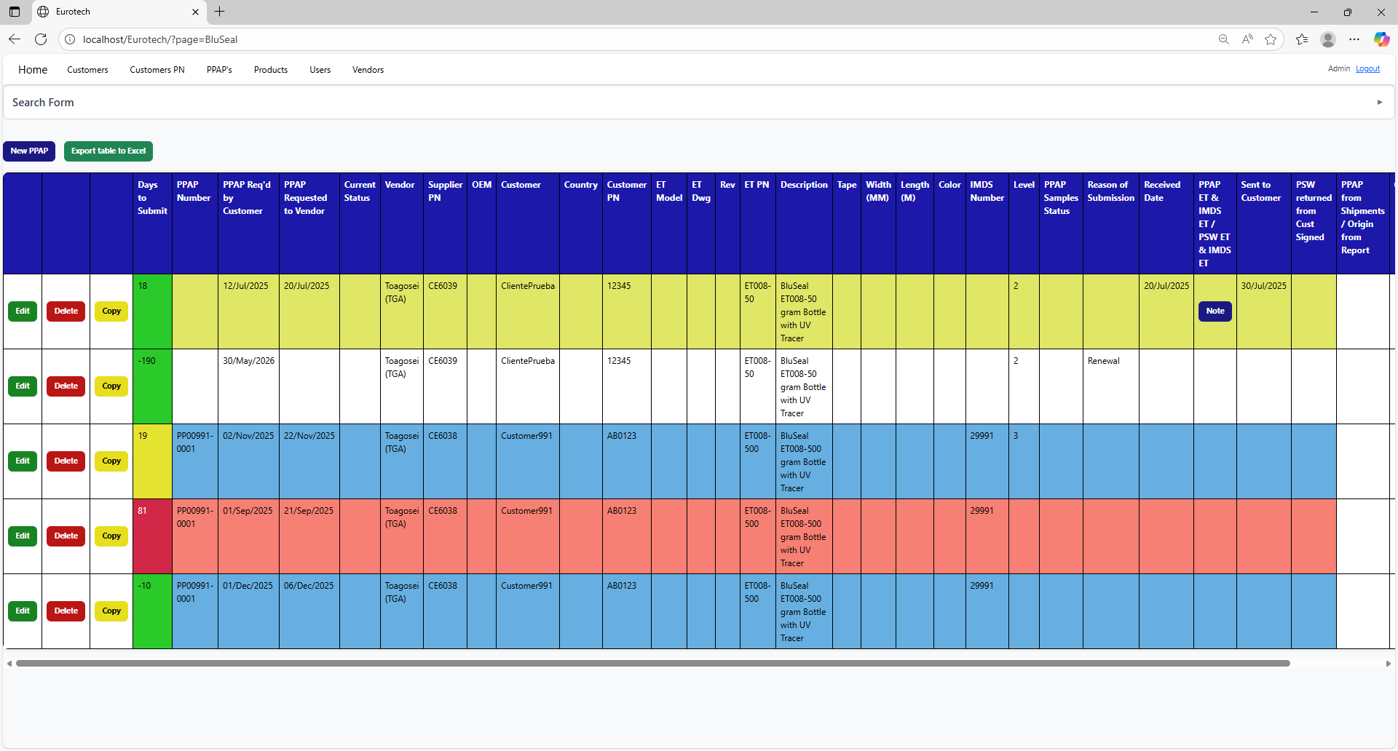

Once you click the “New PPAP” button, it will display a register form to create a new PPAP.

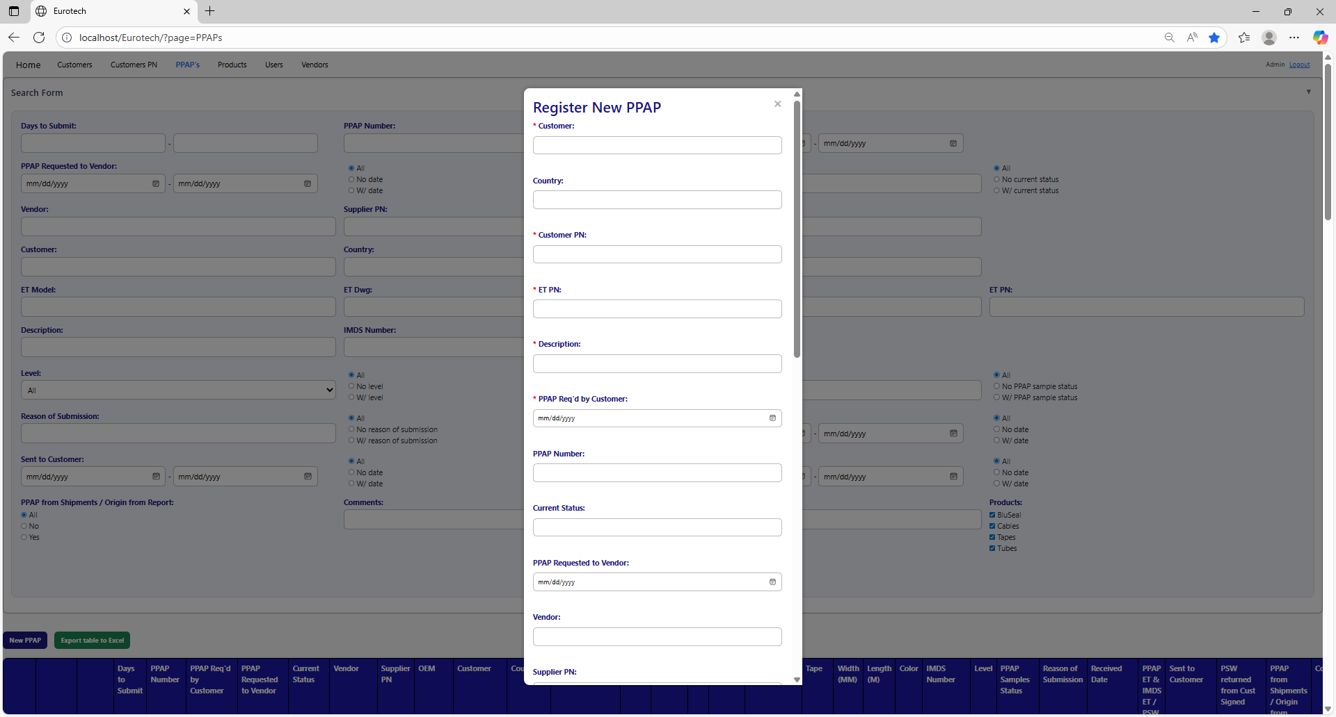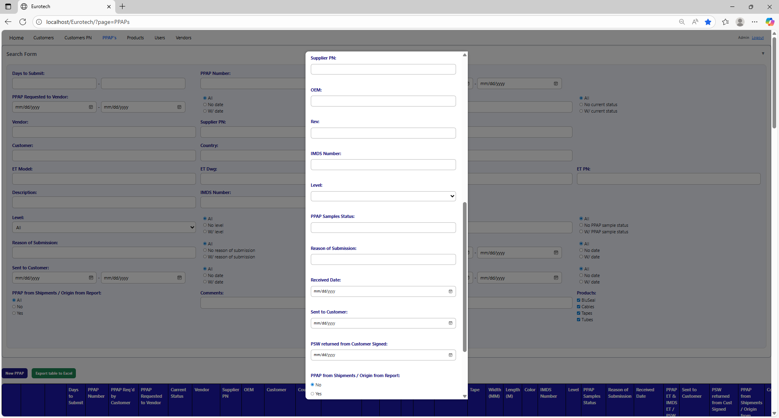

Non-mandatory field

Mandatory fields

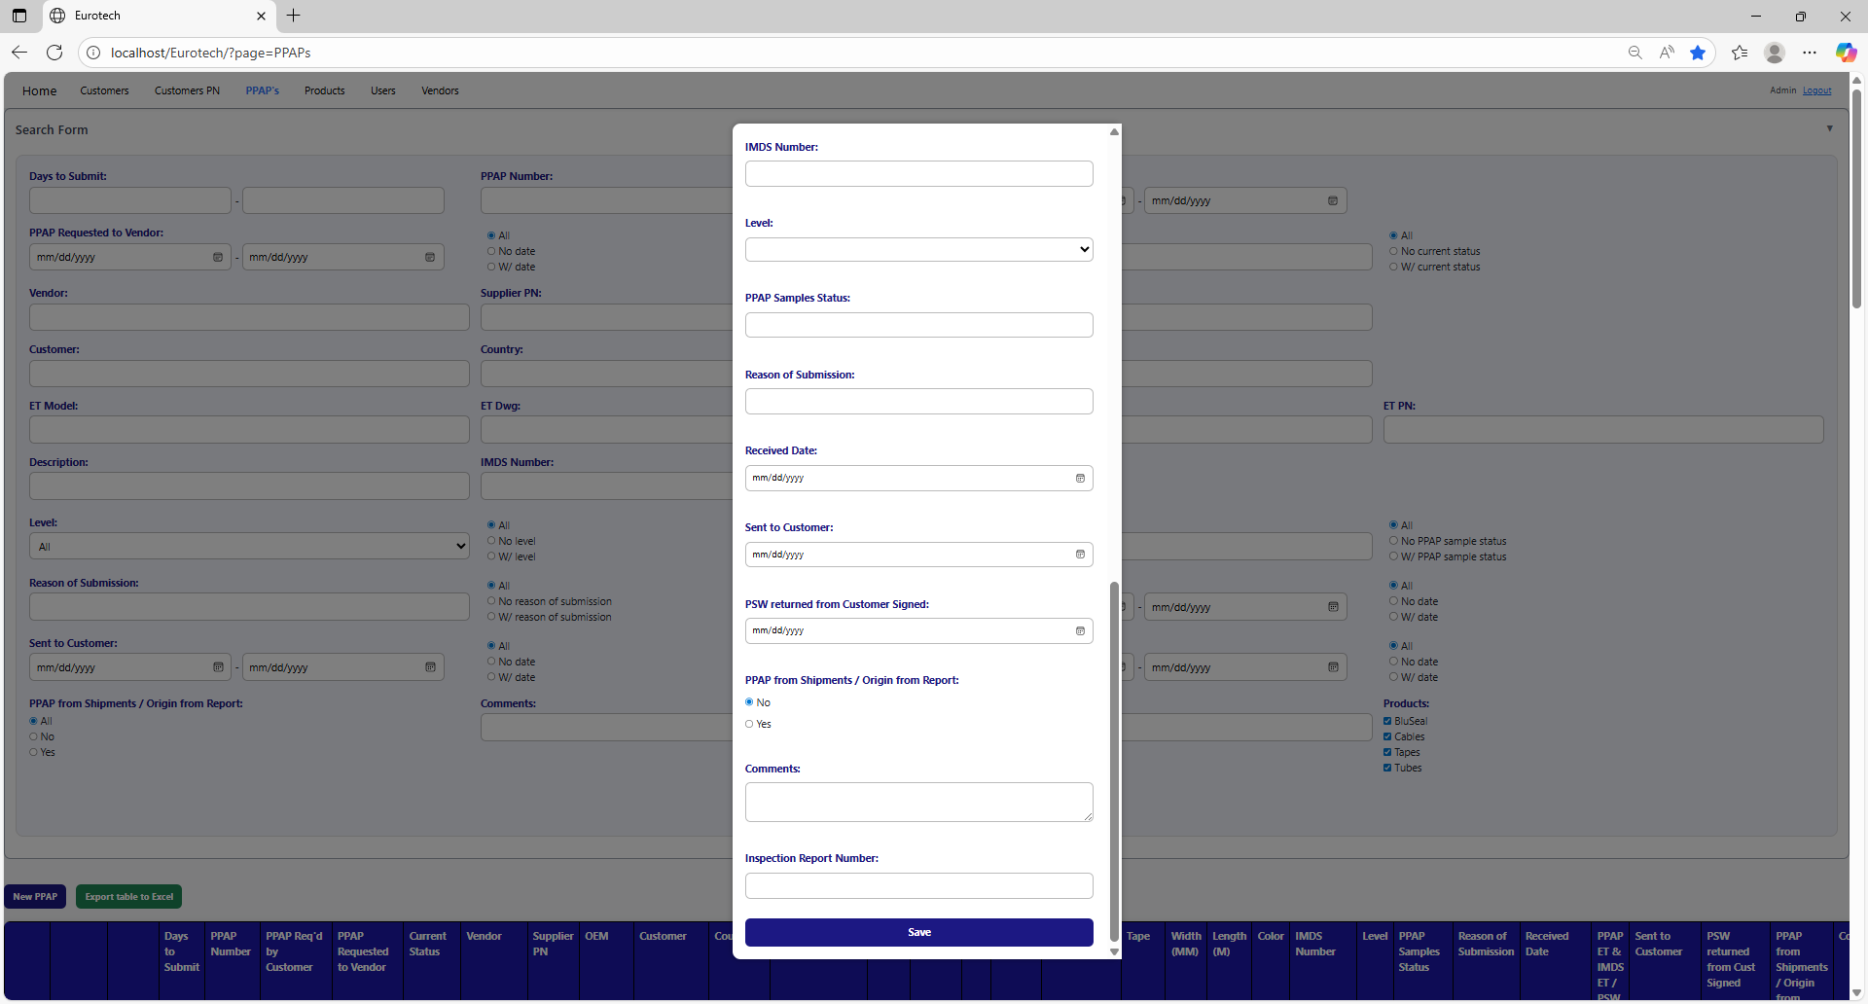

Non-mandatory field

If you want to save the register of a new PPAP, you must click the “Save” button.

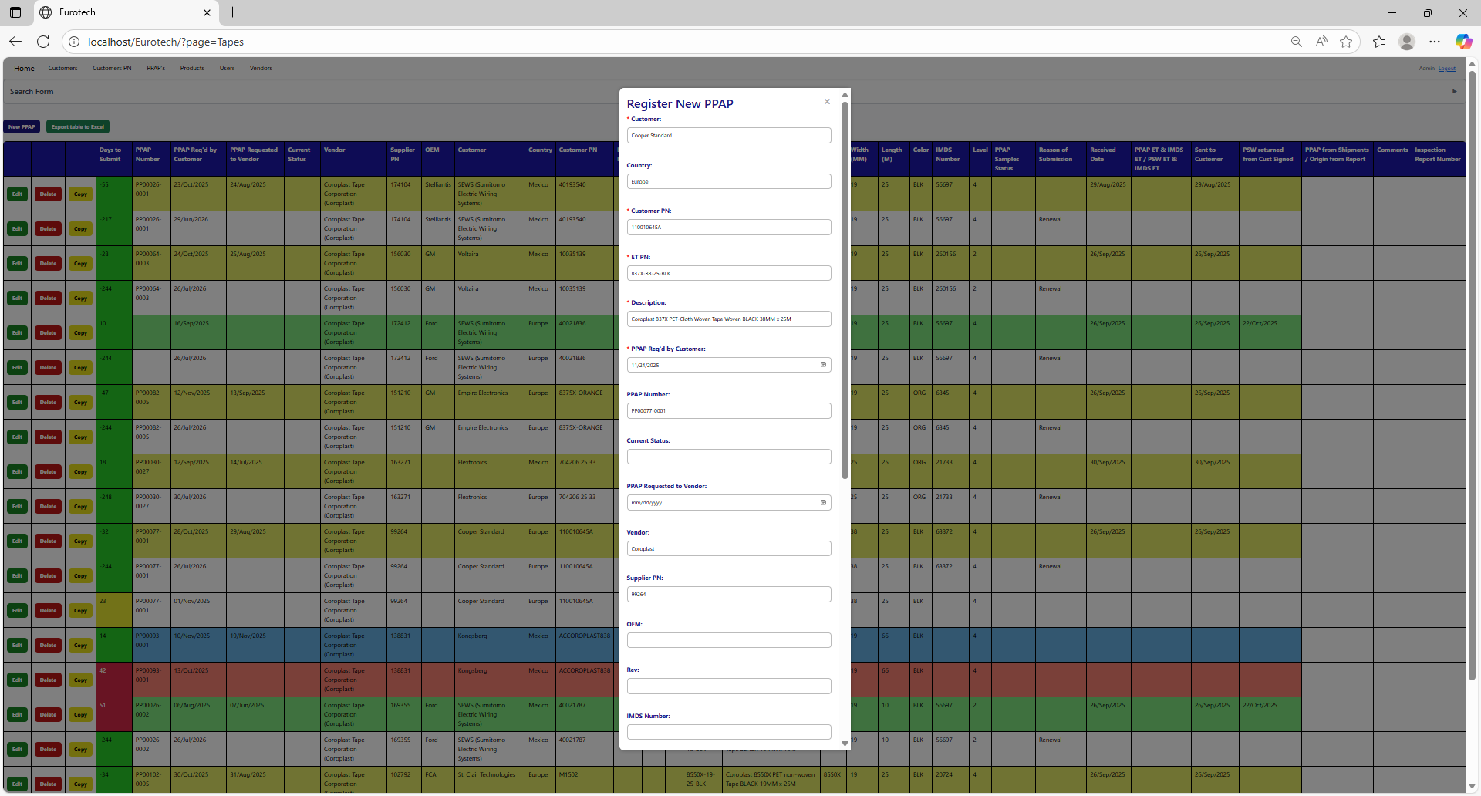

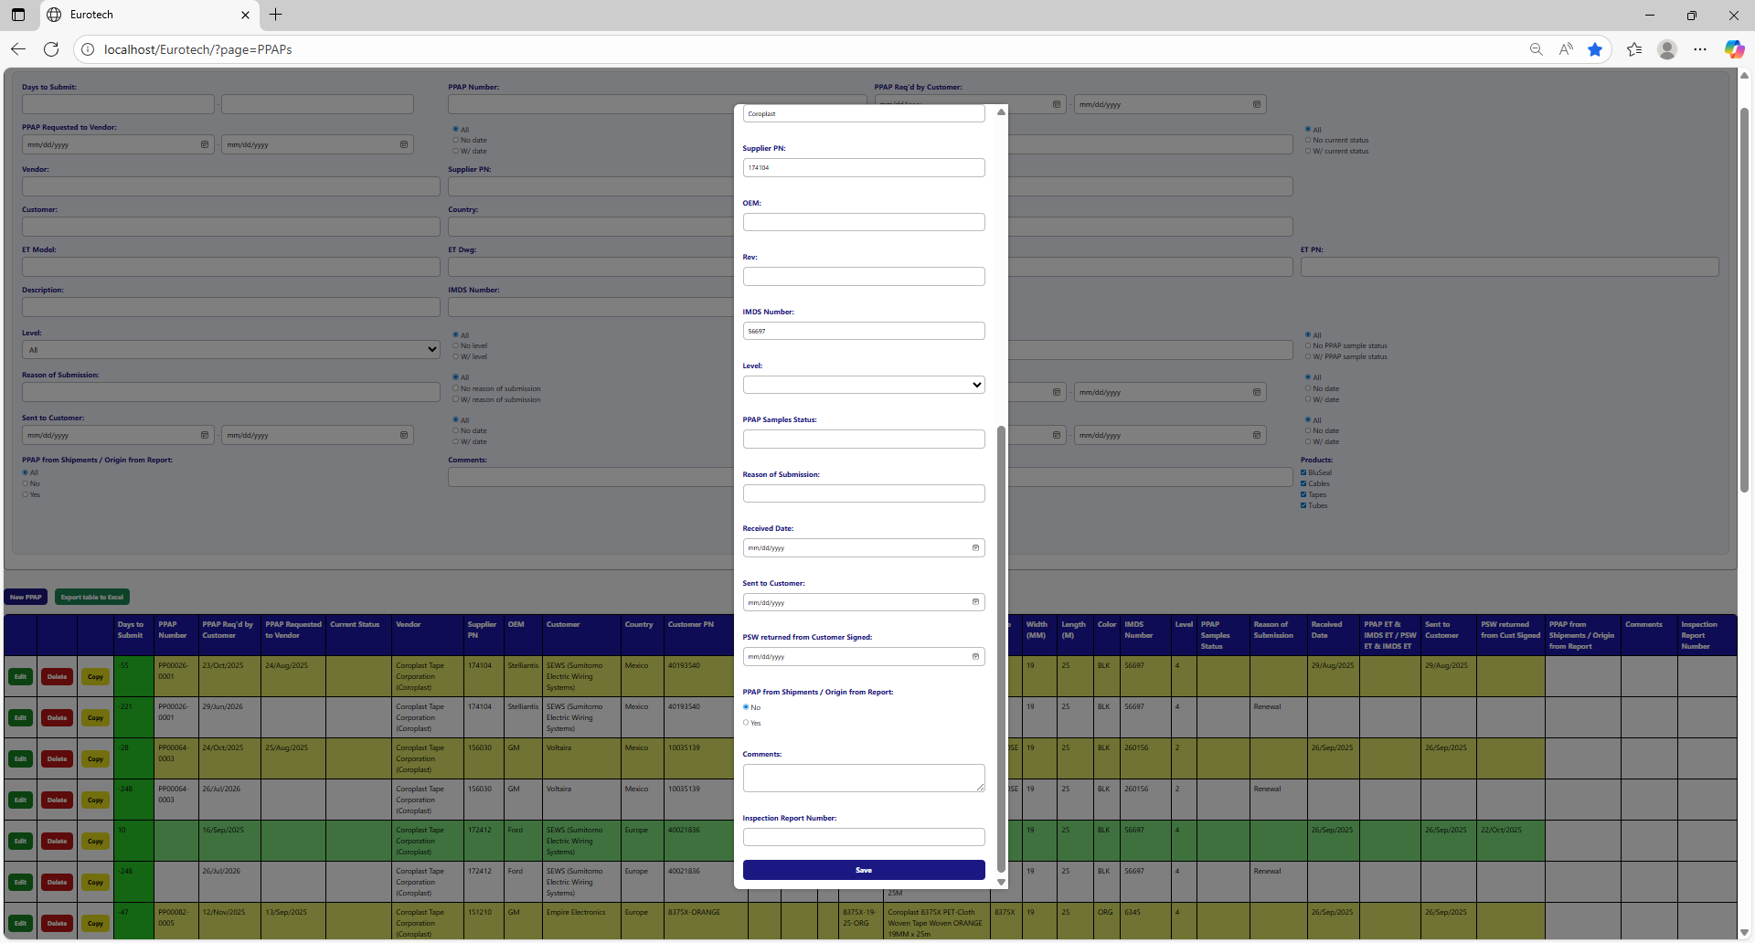

If no errors are found, the register will be added successfully.

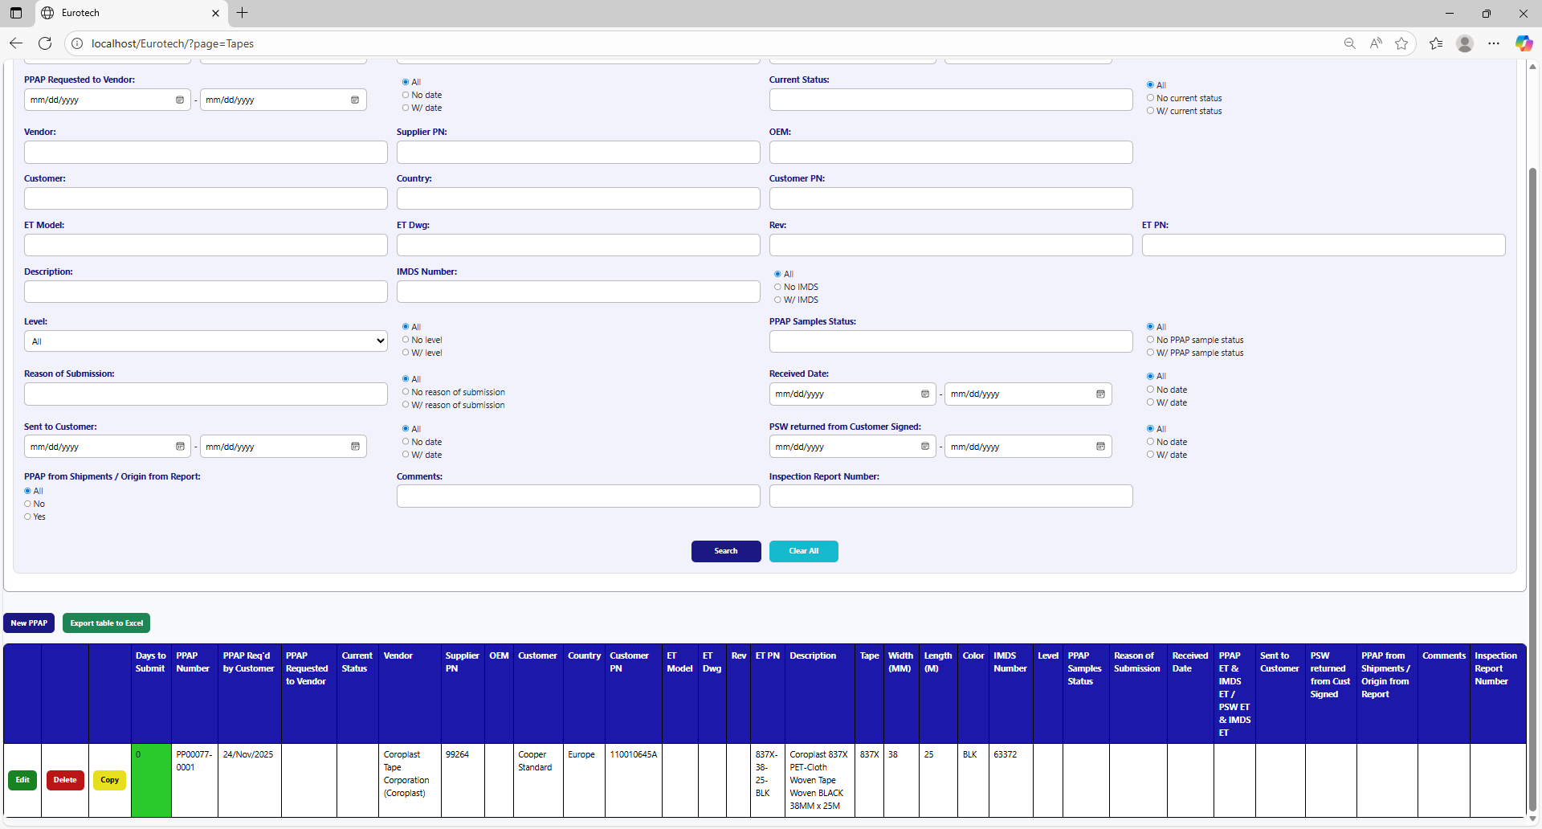

If an error is found, you can check in the Index the instruction *3.11.3.1 Register Form Errors.*

### *3.6.5 How to Edit Information of a PPAP.*

In each register from the table, it will be an “Edit” button. If this button is clicked, it will display an update form to edit the information of the selected PPAP.



Once you click the “Edit” button, it will display an update form to edit the information of the selected PPAP.

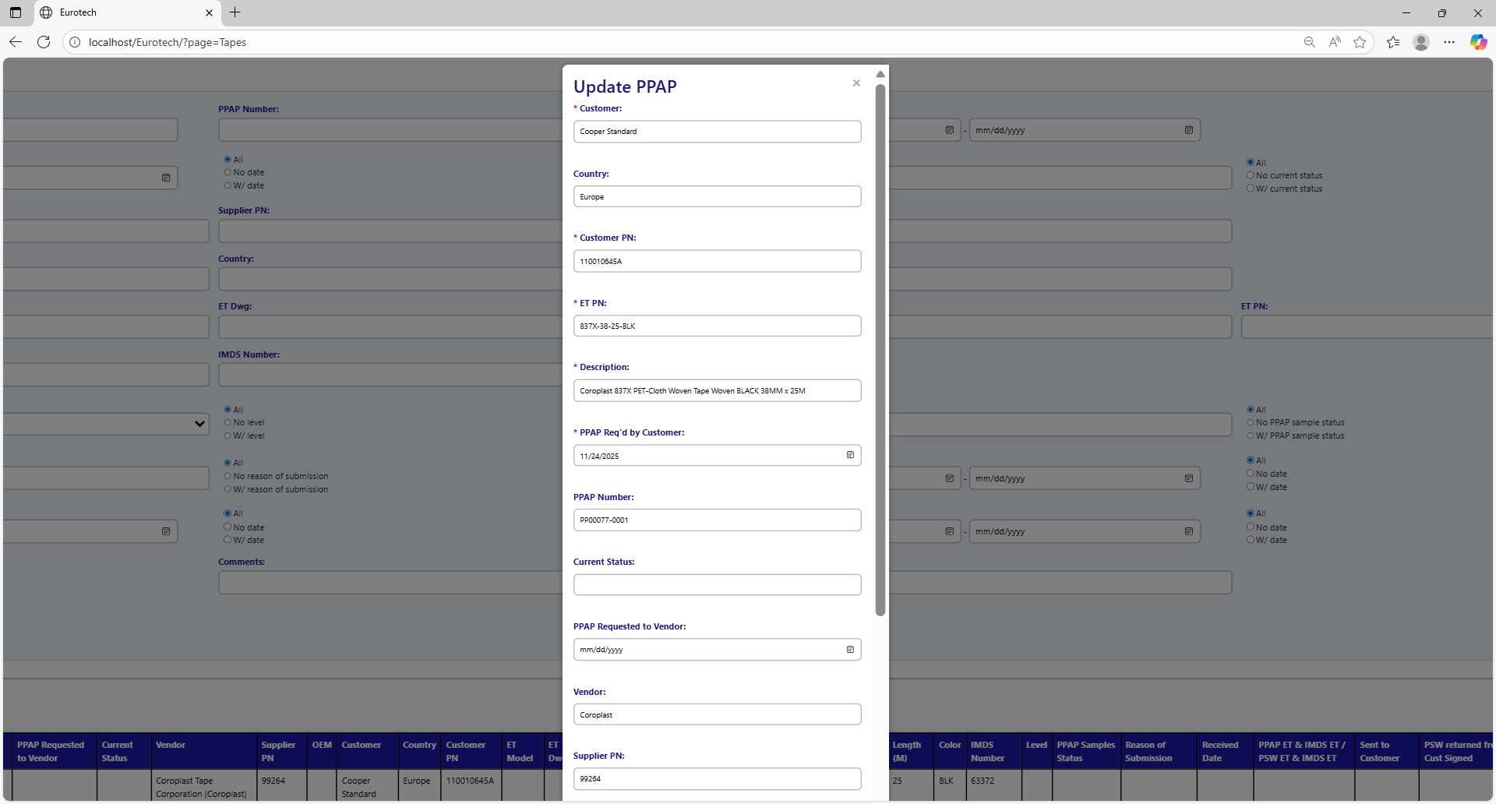

Example of a modification:

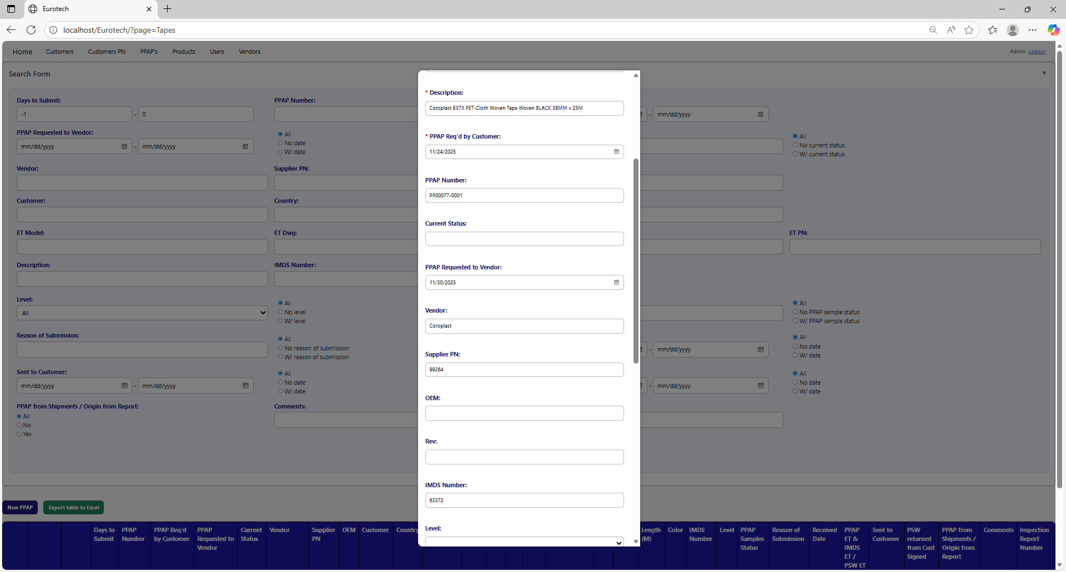

To save the changes, you must click the “Save” button.

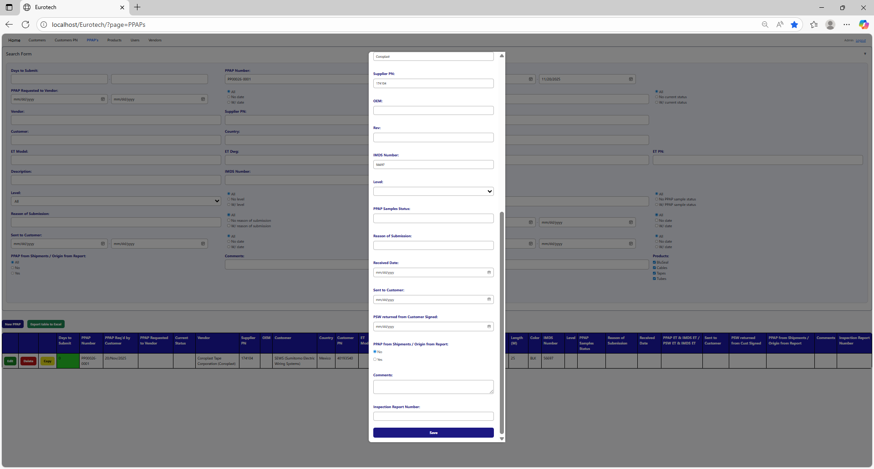

If no errors are found, the register will be updated successfully.

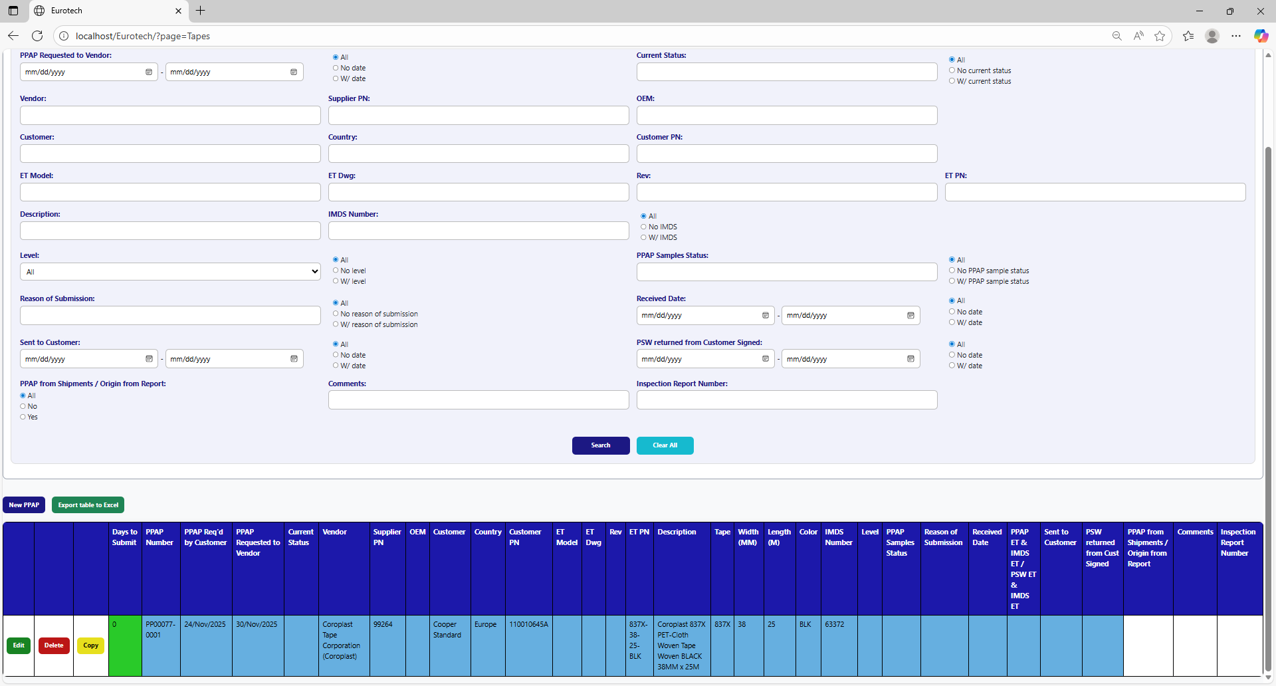

If an error is found, you can check in the Index the instruction *3.11.3.2 Edit Form Errors.*

### *3.6.6 How to Copy the Information of a PPAP.*

In each register from the table, it will be a “Copy” button. You must click the “Copy” button of the register you want to copy its information.



Once you click the “Copy” button, it will display the register form, but with the information of the PPAP selected.

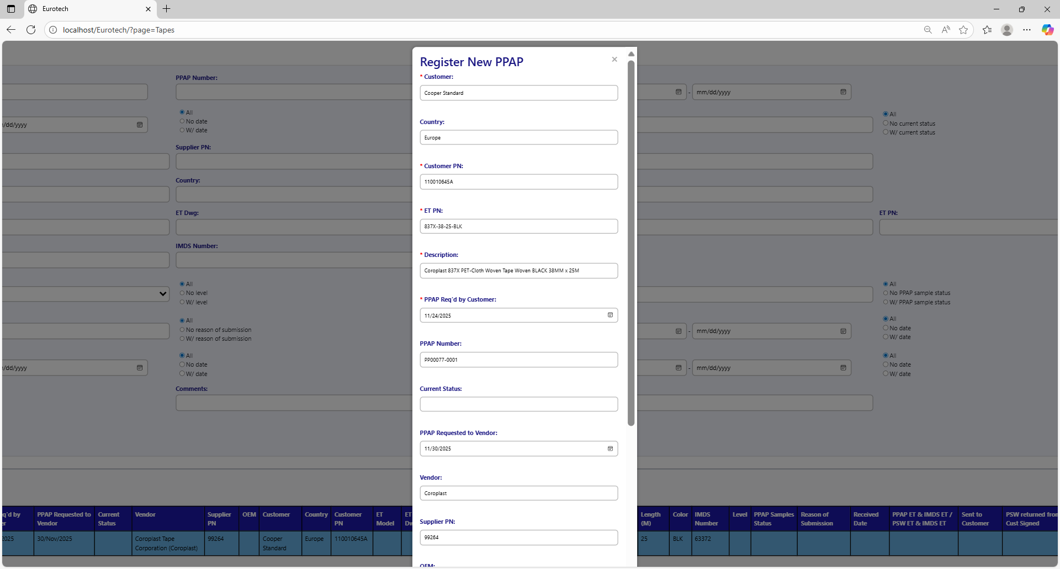

You can do the modifications you need to the information and use the “Save” button to save the new register.

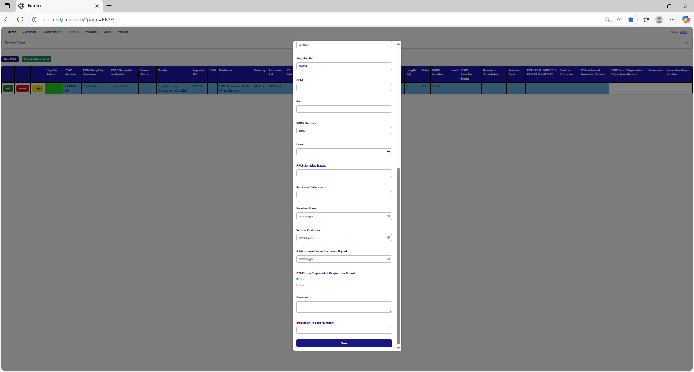

### *3.6.7 How to Delete a PPAP.*

In each register from the table, it will be a “Delete” button. You must click the “Delete” button of the register you want to delete.



Once you click the “Delete” button, it will display the information of the selected PPAP with a message to confirm the delete action. To confirm the delete of the PPAP, you must click the “Confirm” button.

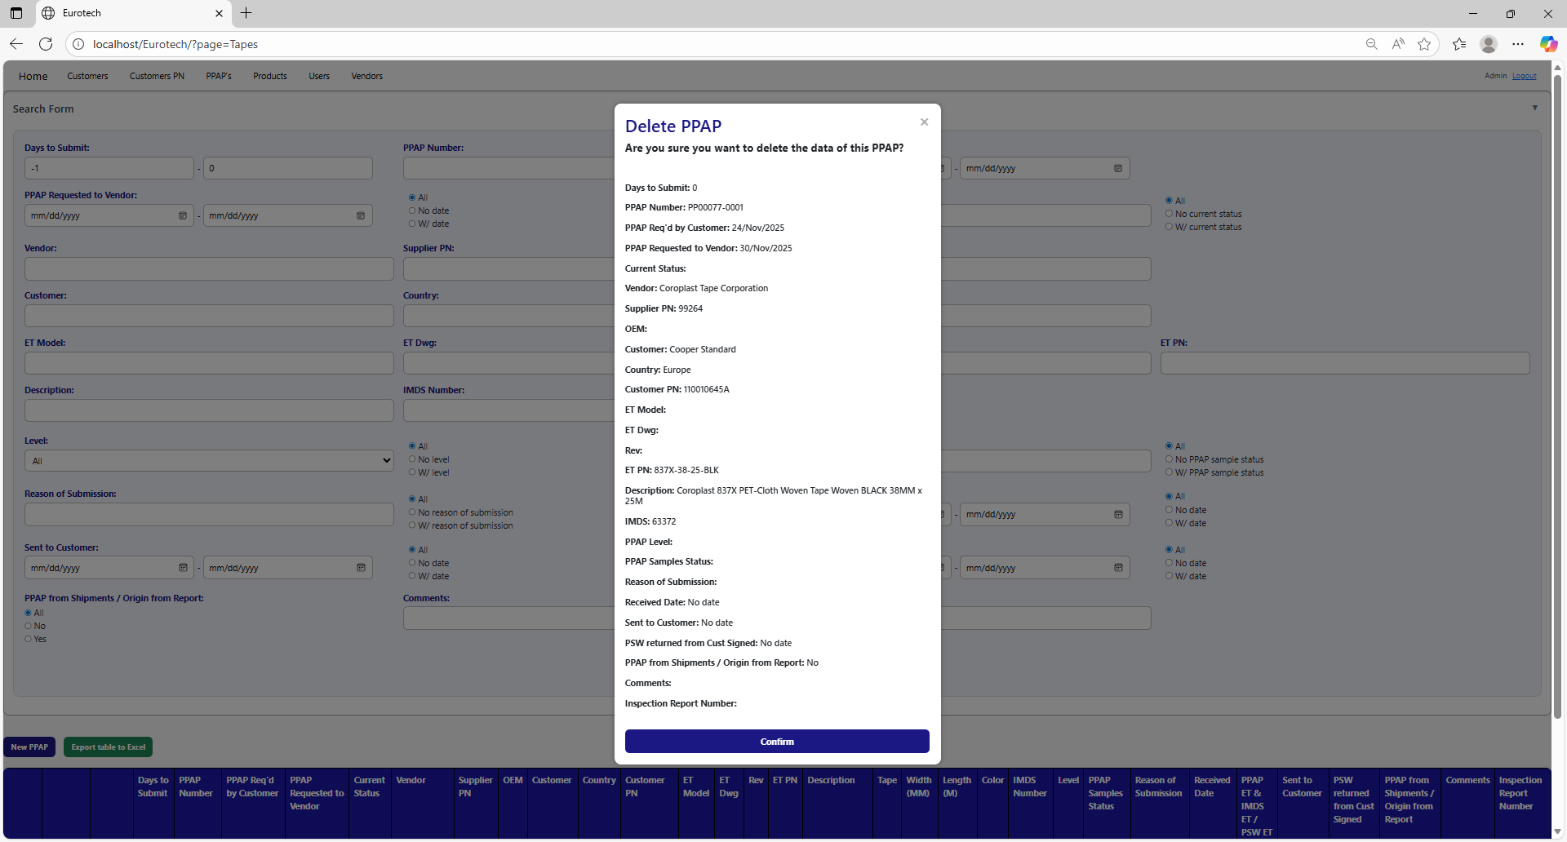

### *3.6.8 How to Automatically Create a Renewal for a PPAP.*

When a PPAP is registered or updated, and the "Sent to Customer" field is filled in, it also creates the register for the following year's renewal, putting the date of "Sent to Customer" in the "PPAP Req'd by Customer" field, adding 10 more months.

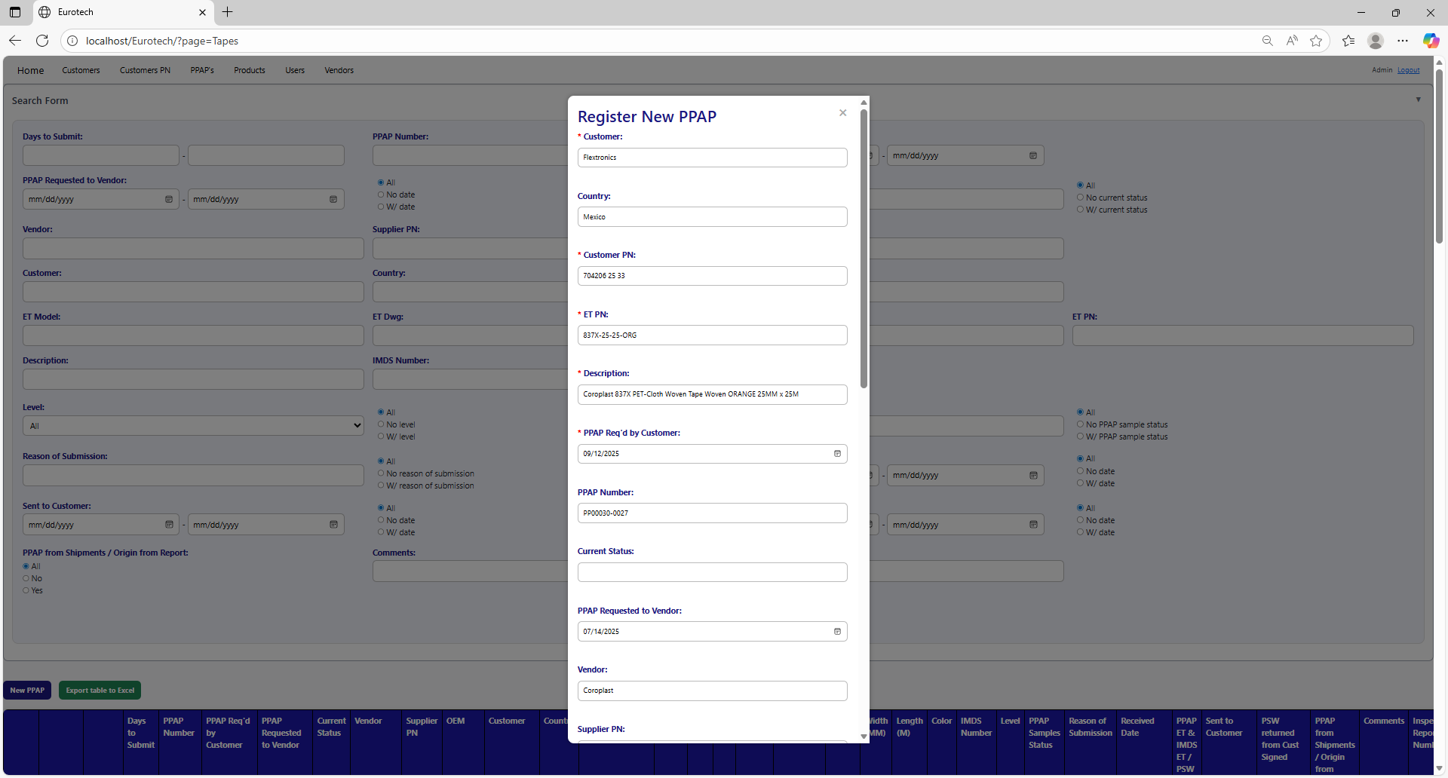

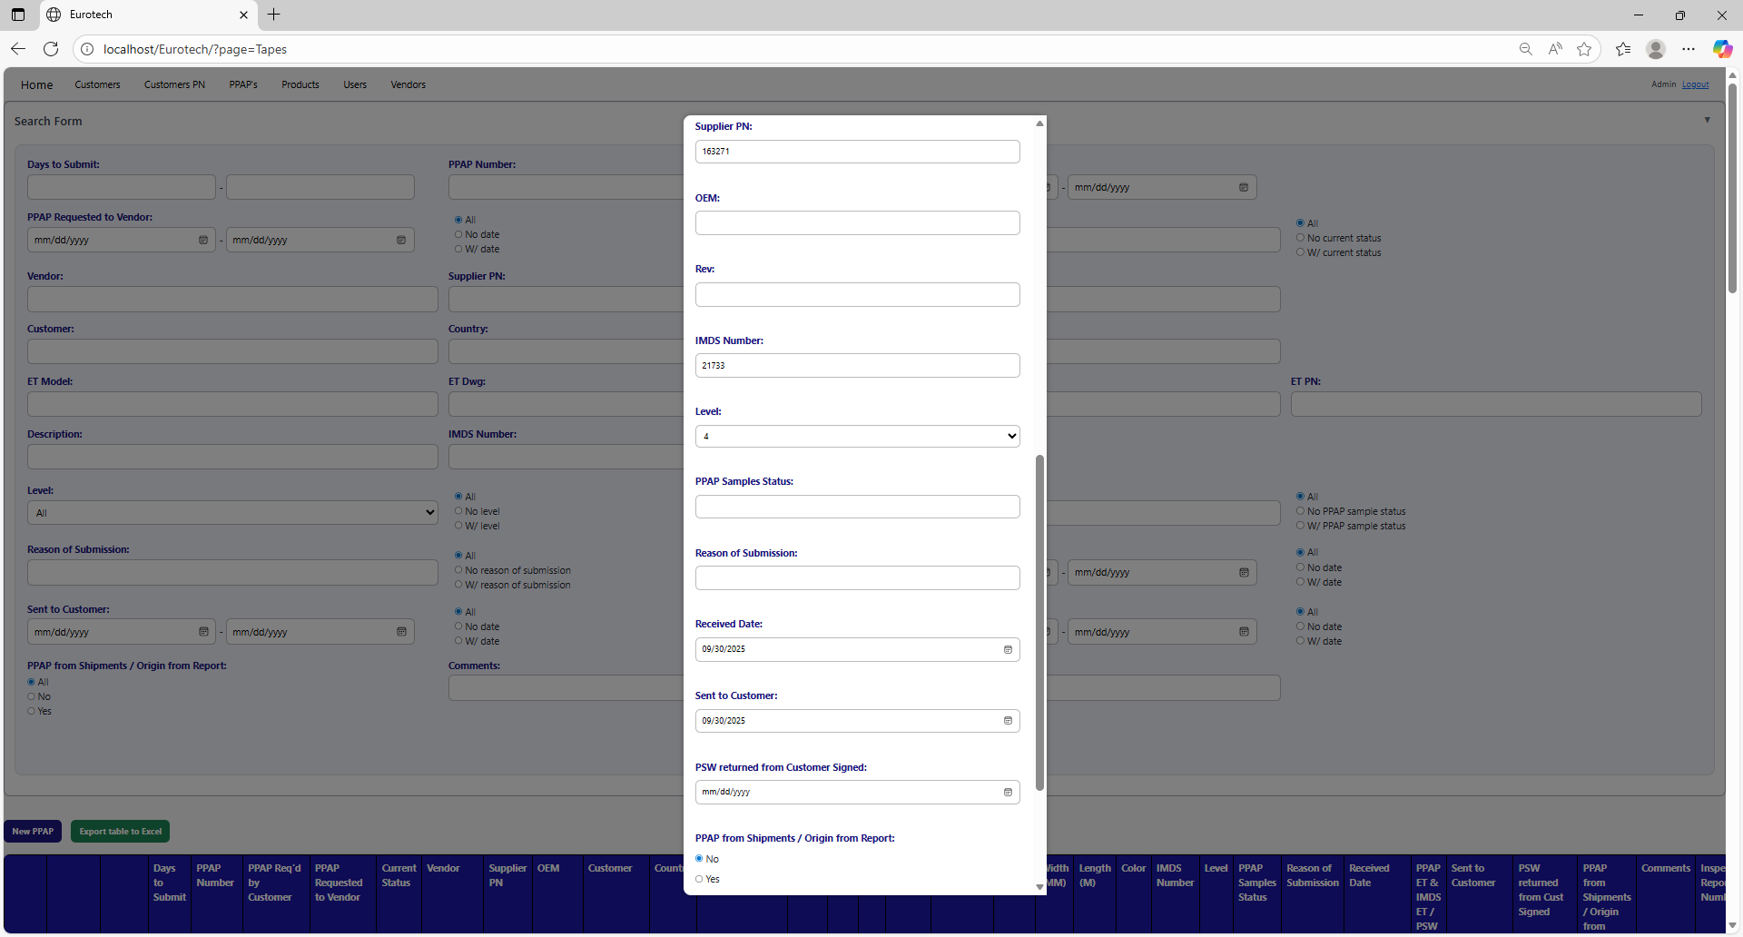

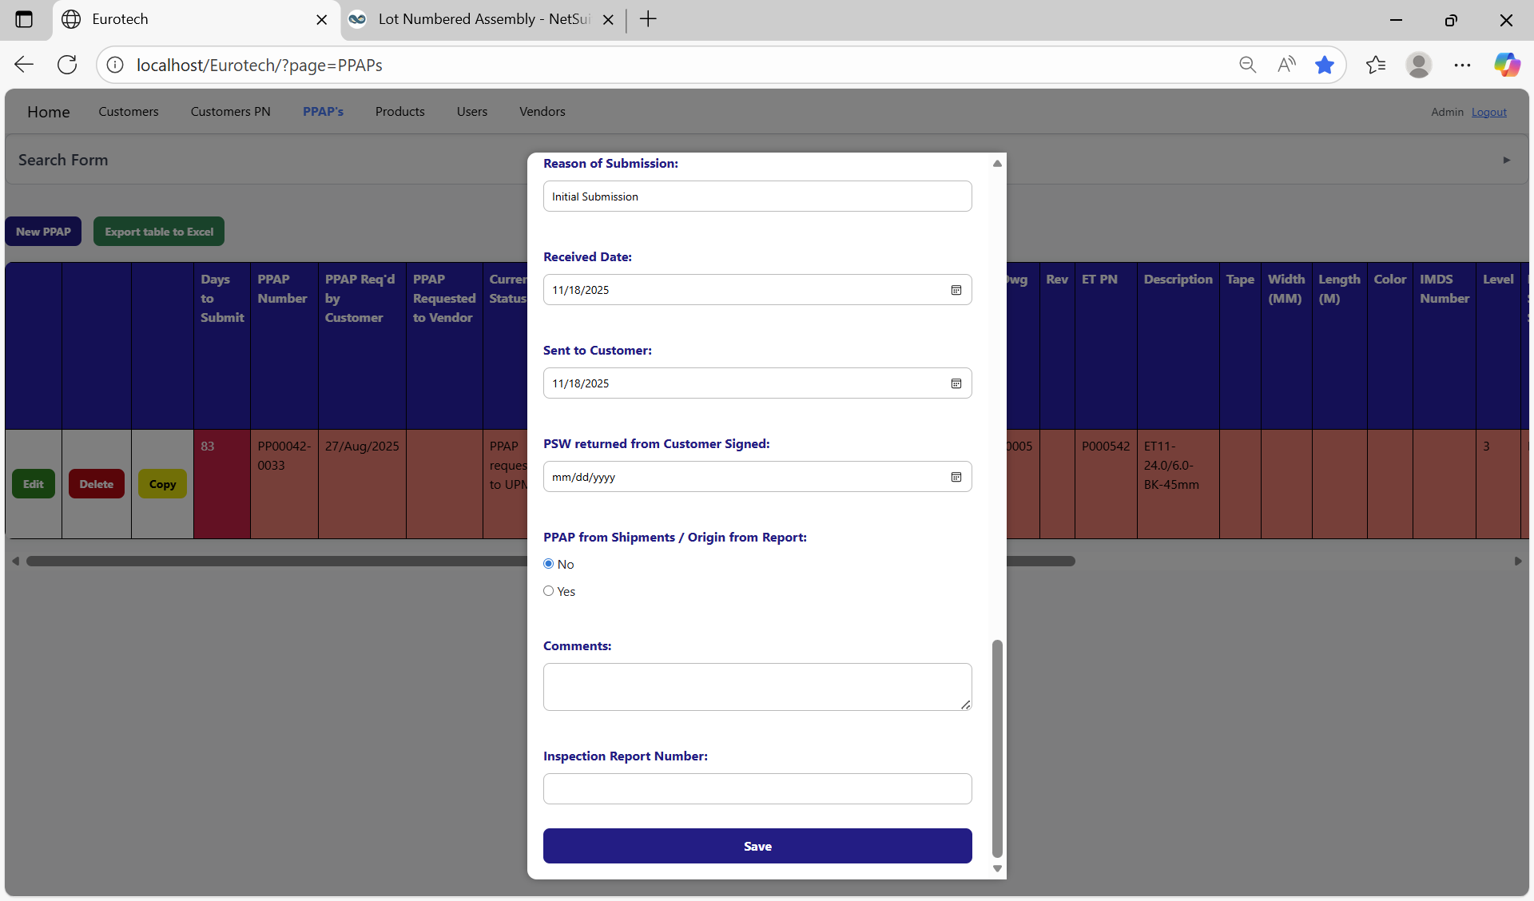

Once you click the “Save” button, the register for the following year's renewal will be created.

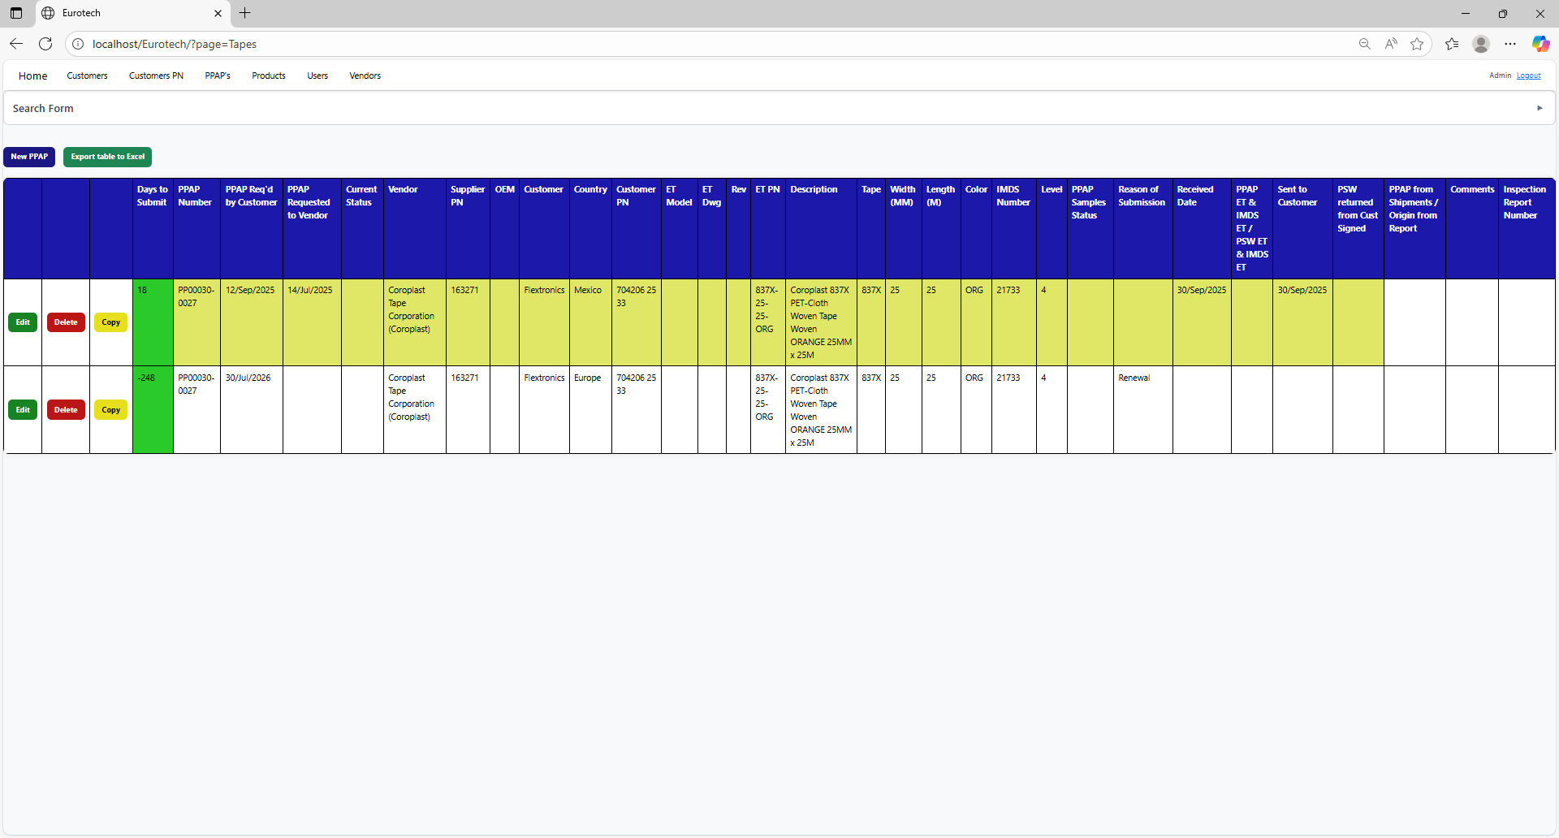

### *3.6.9 Duplicating Register Alert.*

If you were trying to register a new PPAP and it shows you a message with the title “Duplicating Register”, is not an error. The page is trying to prevent duplicate registers by verifying if there is another register in which the fields “Customer”, “Country”, “Customer PN” and “ET PN” match with the data of the new PPAP and its dates are between 10 months before the “PPAP Req'd by Customer” date of the new PPAP and that same date, or if there is a future renewal register that already exists, it will show its renewal date, and it will ask you if you are sure to register the PPAP.

This is an example of the “Duplicating Register” alert:

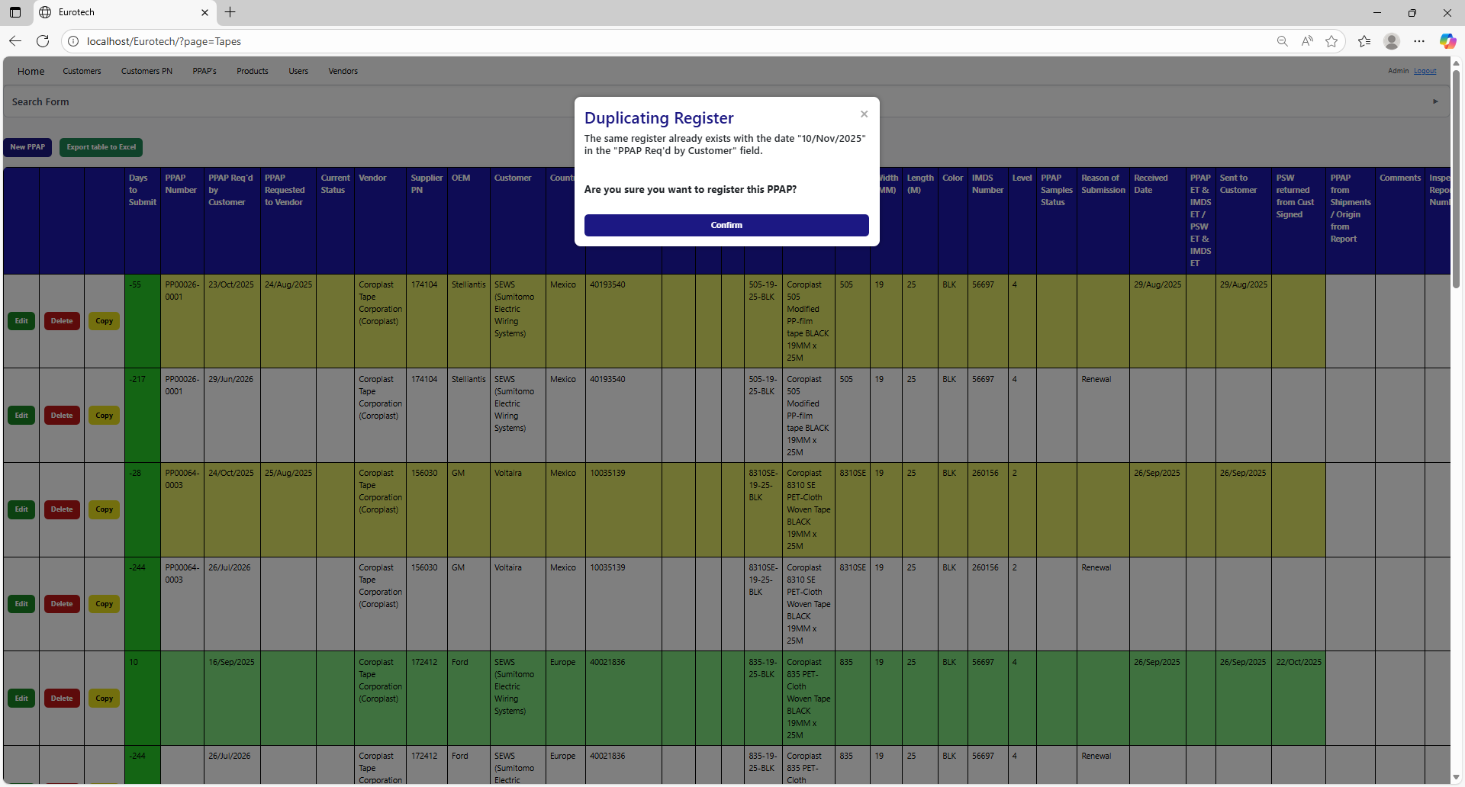

Once you are sure to register the PPAP, you must click the “Confirm” button.



### *3.6.10 How to Export the Information of the Table to an Excel Document.*

To export the table to an Excel document, you must click the “Export table to Excel” button.



Once you click the “Export table to Excel” button, it will start to download the Excel document with the name “PPAPs_Tapes_Report.xls”.

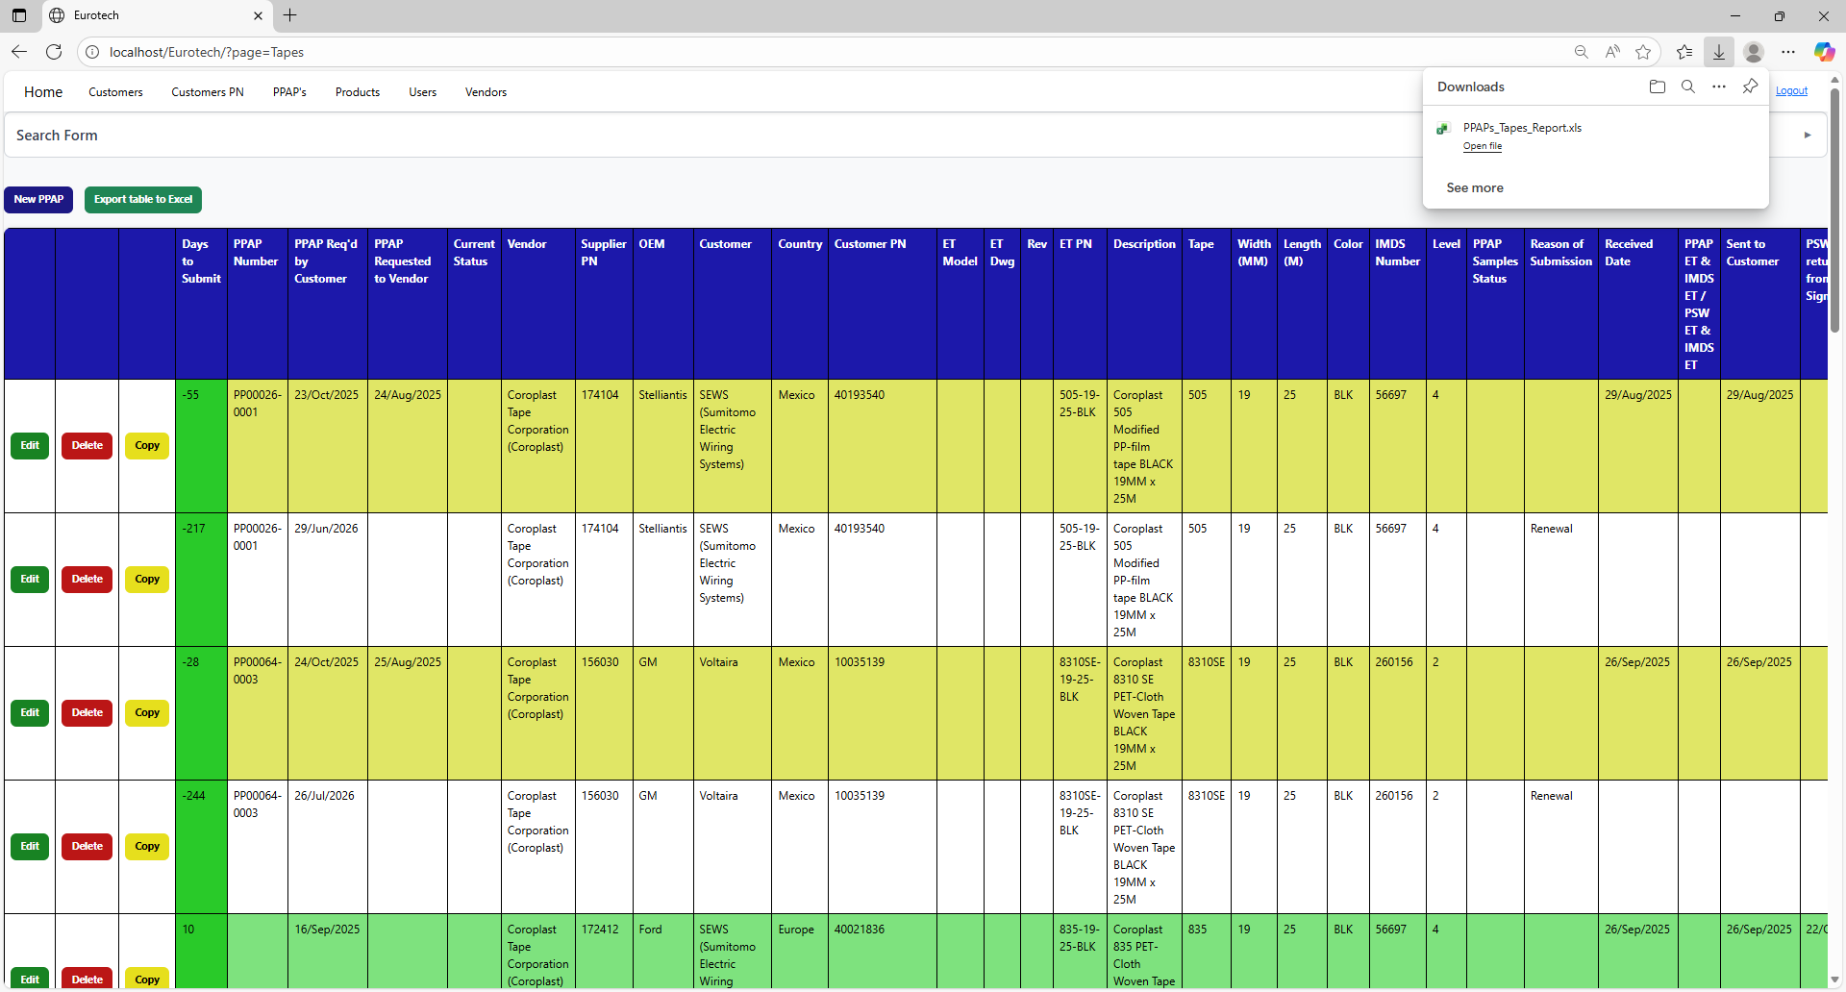

Once the download is finished, you can go to the folder it was downloaded and open the Excel document.

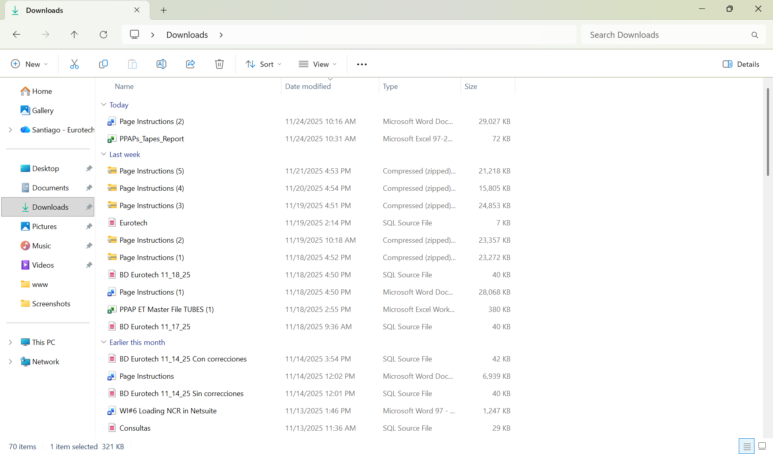

This is an example of how the document would look like:

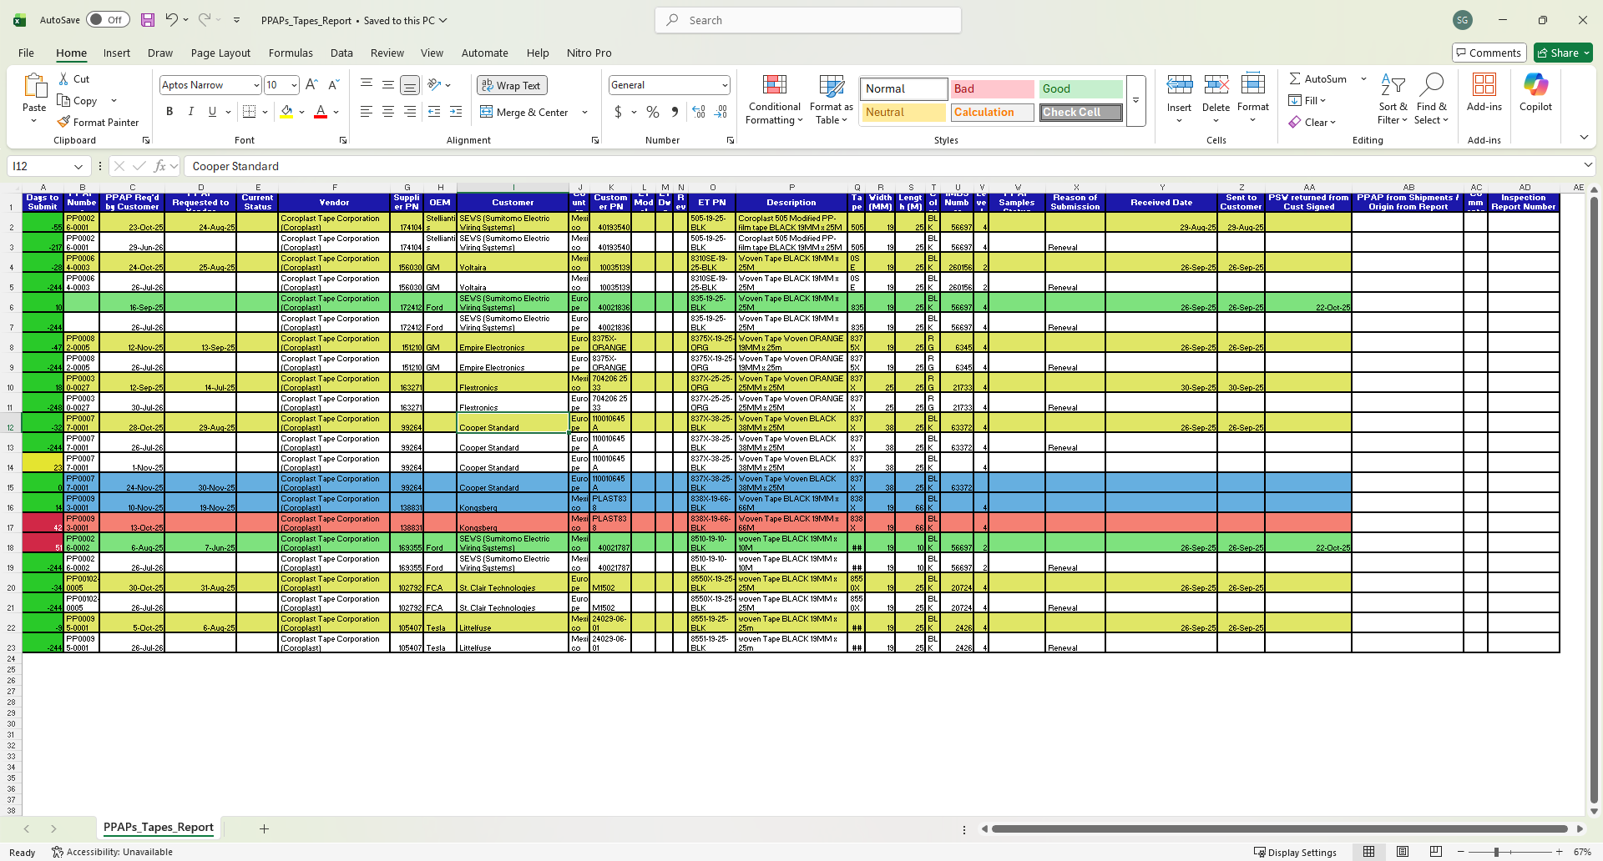

## ***3.7 Tubes Page.***

### *3.7.1 How to Navigate to “Tubes” Page.*

On the navigation bar, you can navigate to the “Tubes” page.

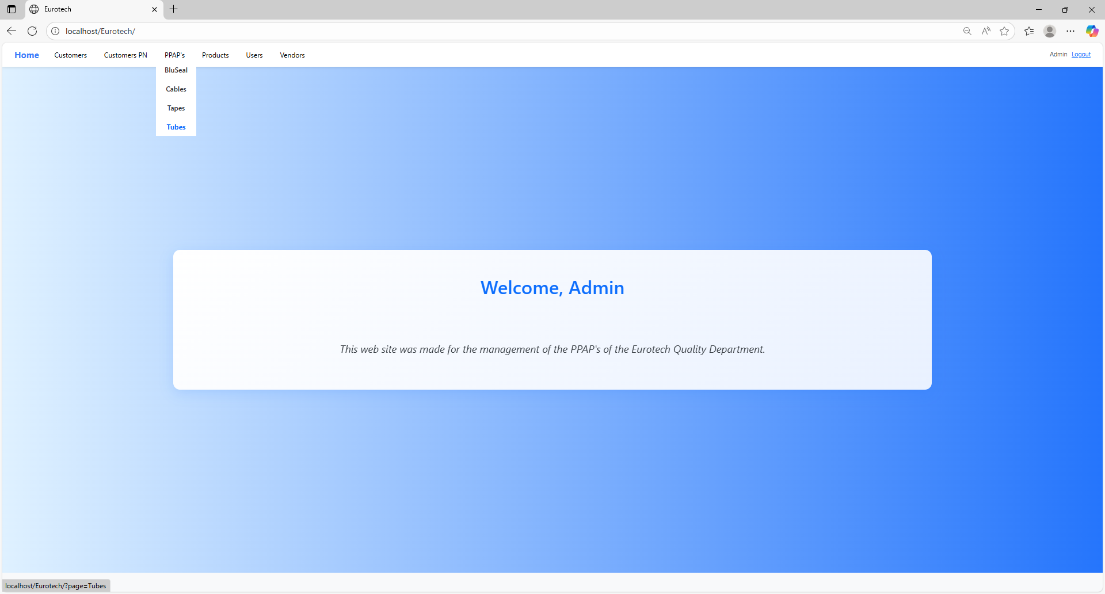

In this page you can manage the registers of all the PPAPs of Tubes.

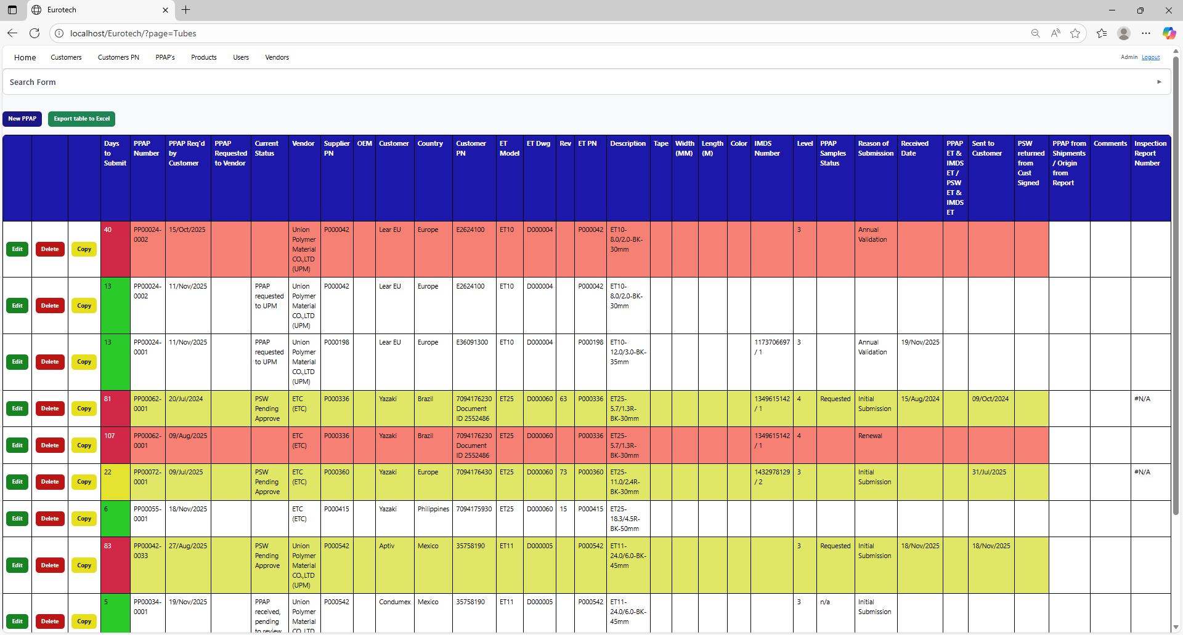

### *3.7.2 How to Search a PPAP.*

At the top of the page, it will be a dropdown “Search Form” that has all the fields of the table for querying registers.

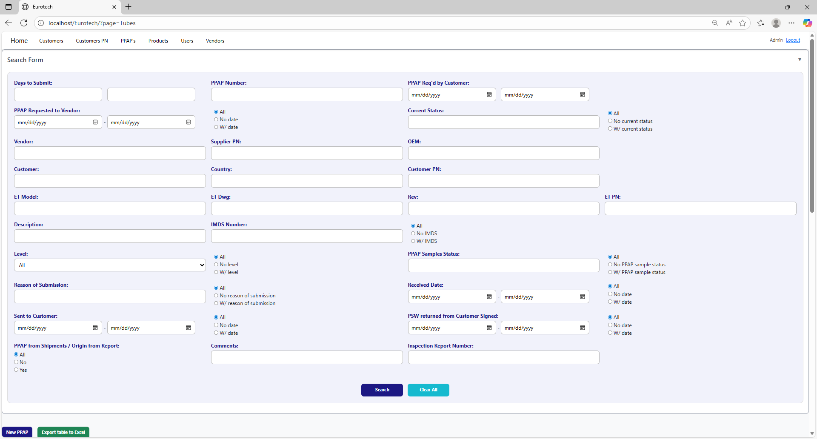

The search form allows you to perform searches by:

* Level
* PPAP Samples Status
* Reason of Submission
* Received Date
* Sent to Customer
* PSW returned from Customer Signed
* PPAP from Shipments / Origin from Report
* Comments
* Inspection Report Number
* Days to Submit
* PPAP Number
* PPAP Req’d by Customer
* PPAP Requested to Vendor
* Current Status
* Vendor
* Supplier PN
* OEM
* Customer
* Country
* Customer PN
* ET Model
* ET Dwg
* Rev
* Eurotech PN
* Description
* IMDS Number

You can search by “Days to Submit”, writing the range of days.

You can search by “PPAP Number”.

You can search by “PPAP Req’d by Customer”, writing the range of dates.

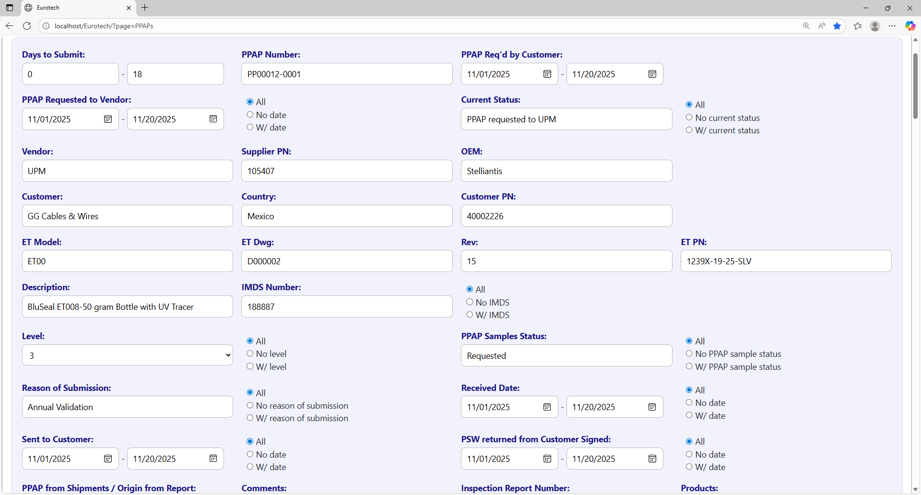

You can search registers that either have or don’t have the “Current Status” field filled in, or all the registers.

You can search by “Current Status”.

You can search registers that either have or don’t have a date on “PPAP Requested to Vendor”, or all the registers.

You can search by “PPAP Requested to Vendor”, writing the range of dates.

You can search by “OEM”.

You can search by “Vendor”.

You can search by “Supplier PN”.



You can search by “Customer PN”.

You can search by “Customer”.

You can search by “Country”.

You can search by “ET PN”.

You can search by “Rev”.

You can search by “ET Dwg”.

You can search by “ET Model”.



You can search registers that either have or don’t have the “IMDS Number” field filled in, or all the registers.

You can search by “IMDS Number”.

You can search by “Description”.

You can search by “PPAP Samples Status”.

You can search by “Level”.

You can search registers that either have or don’t have the “PPAP Samples Status” field filled in, or all the registers.

You can search registers that either have or don’t have the “Level” field filled in, or all the registers.



You can search registers that either have or don’t have a date on “Received Date”, or all the registers.

You can search by “Received Date”, writing the range of dates.

You can search registers that either have or don’t have the “Reason of Submission” field filled in, or all the registers.

You can search by “Reason of Submission”.

You can search registers that either have or don’t have a date on “PSW returned from Customer Signed”, or all the registers.

You can search registers that either have or don’t have a date on “Sent to Customer”, or all the registers.

You can search by “PSW returned from Customer Signed”, writing the range of dates.

You can search by “Sent to Customer”, writing the range of dates.

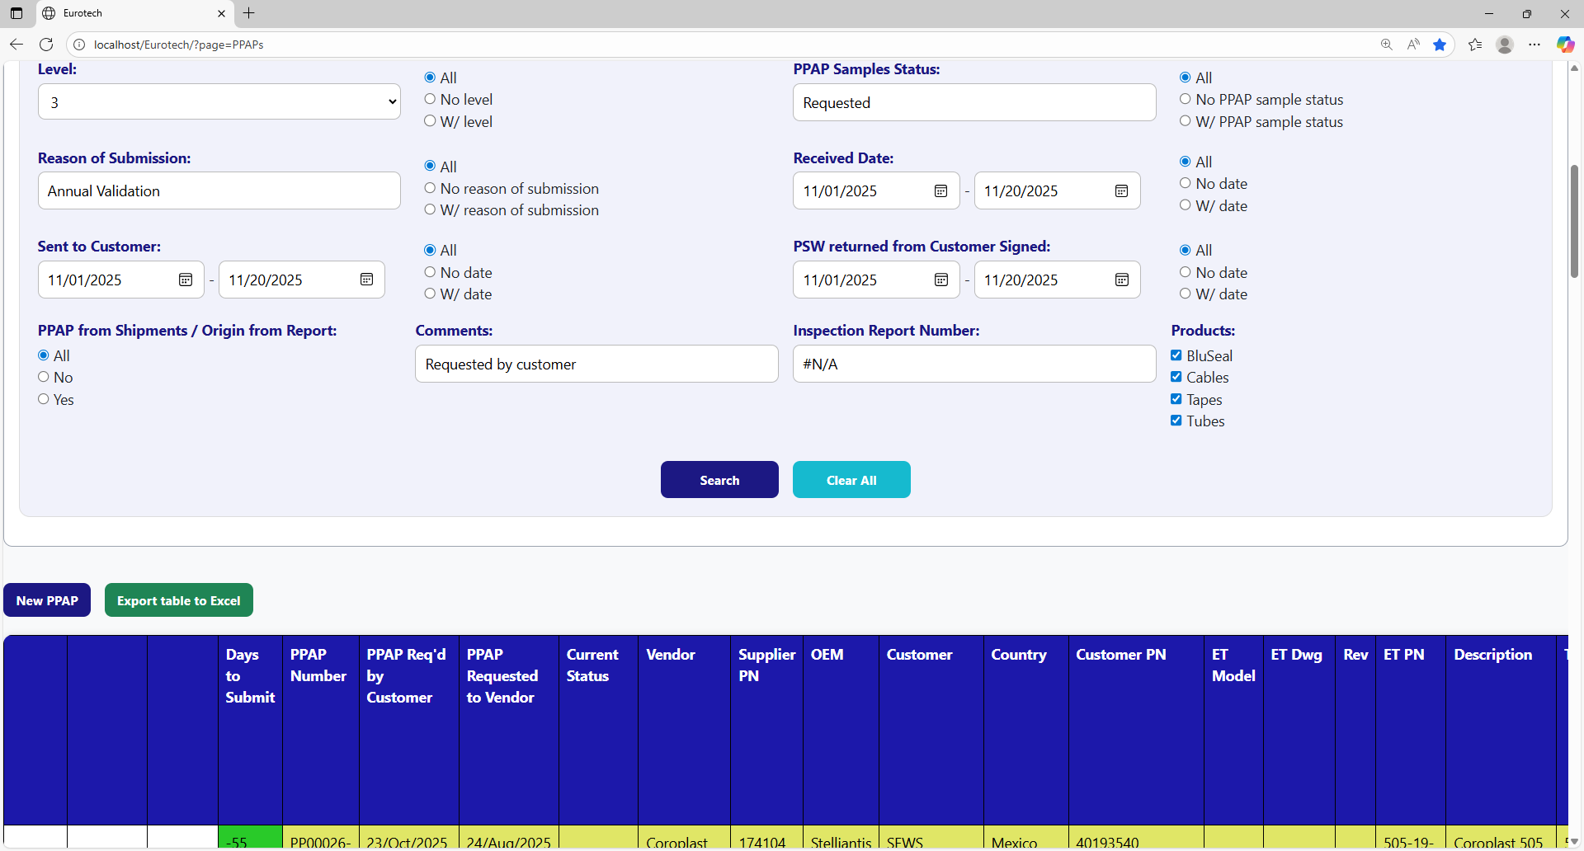

You can search by “Inspection Report Number”.

You can search by “Comments”.

You can search by “PPAP from Shipments / Origin from Report”.

You must click the “Search” button after you fill any of the fields of the “Search Form” to make the search.

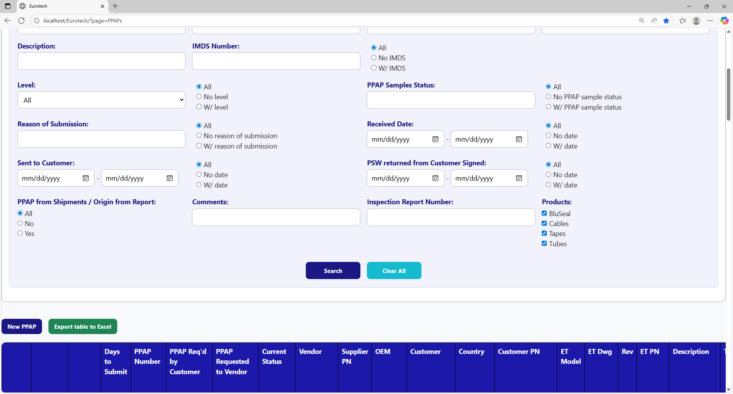

This is an example of how the table would look like after a search (the meaning of the colors of the registers will be explained later).



And with the “Clear All” button, you can clean the querying and see all the registers of the PPAPs.



Once you click the “Clear All” button, the fields of the “Search Form” will be empty, and in the table will be shown all the PPAPs.

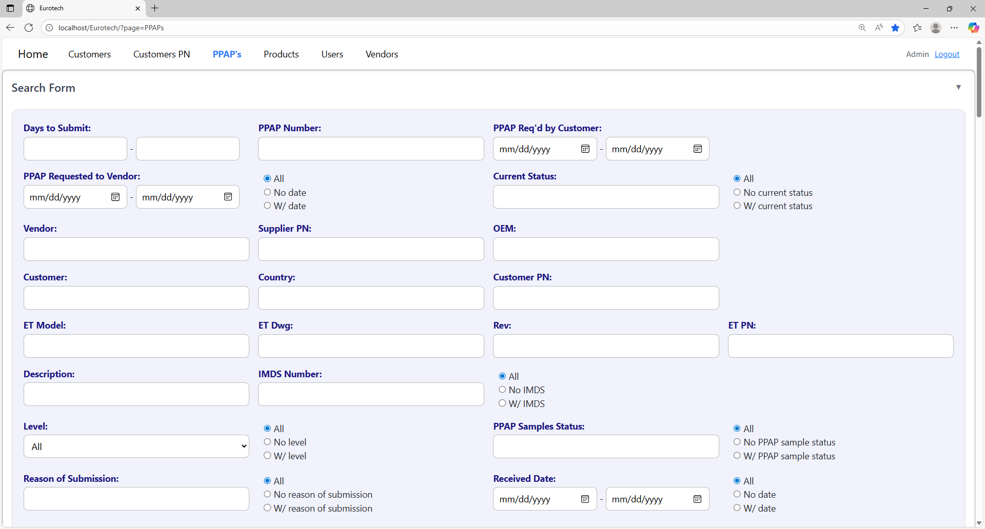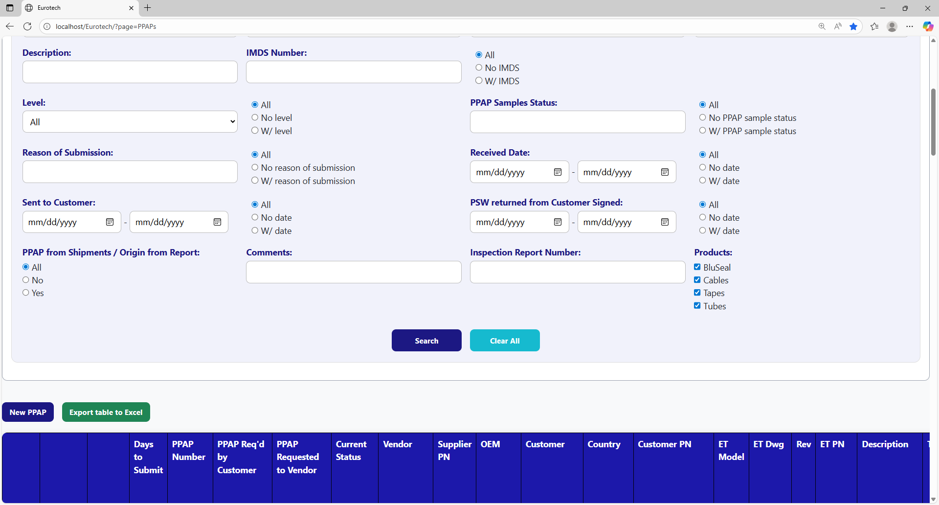



### *3.7.3 Meaning of the Colors of the Registers.*

1.- In the “Days to Submit” column there will be:

* Registers with green field indicate that the difference between the “PPAP Req’d by Customer” date and the “Sent to Customer” date is less than 19 days (if there is no “Sent to Customer” date yet, it is compared with the current date).

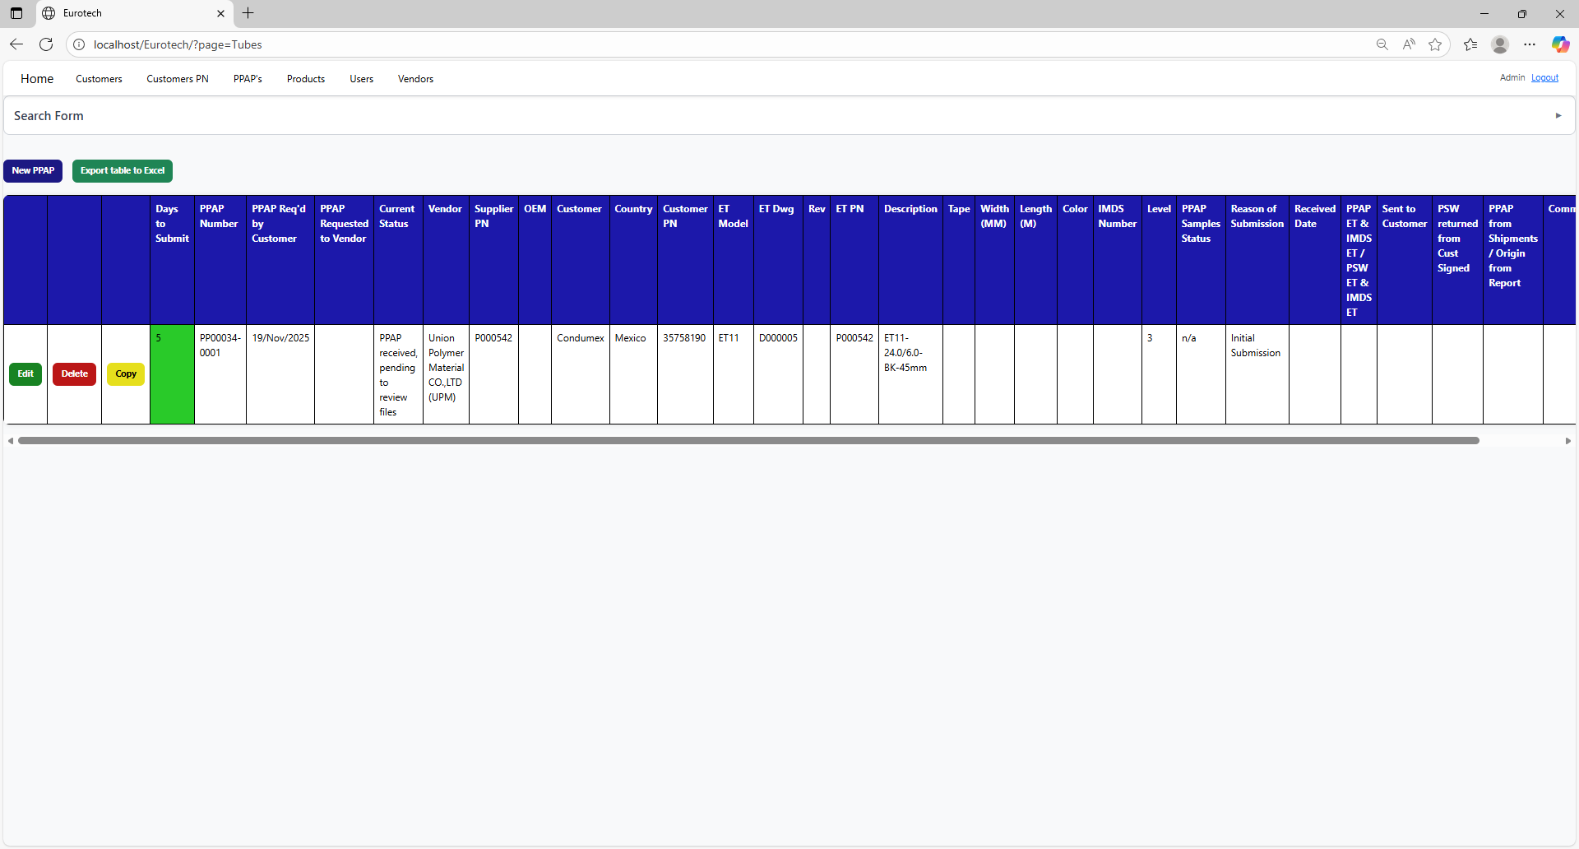

* Registers with yellow field indicate that the difference between the “PPAP Req’d by Customer” date and the “Sent to Customer” date is between 19 and 29 days (if there is no “Sent to Customer” date yet, it is compared with the current date).

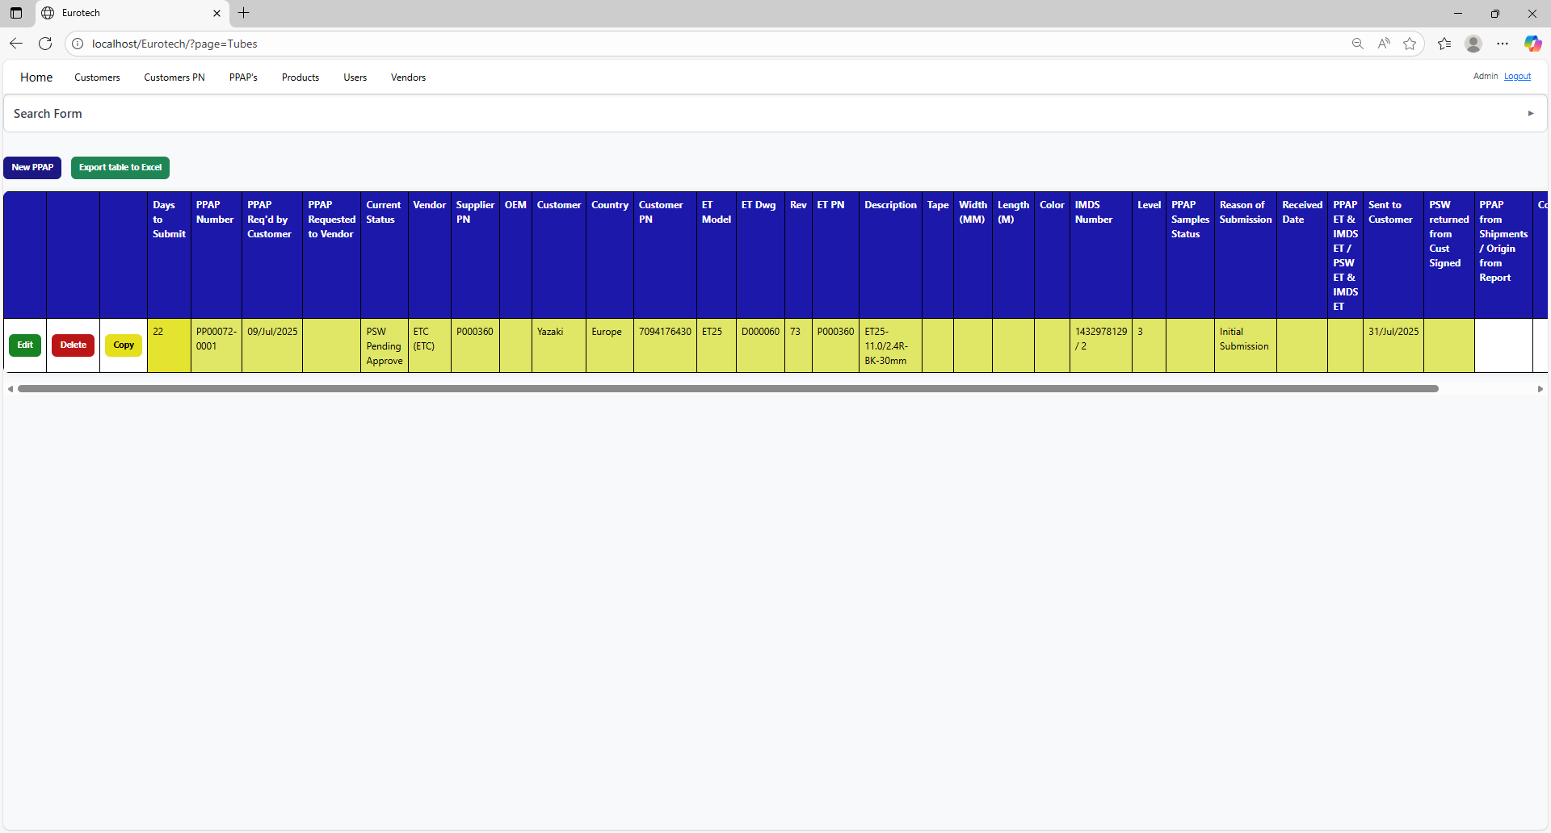

* Registers with red field indicate that the difference between the “PPAP Req’d by Customer” date and the “Sent to Customer” date is greater than 29 days (if there is no “Sent to Customer” date yet, it is compared with the current date).

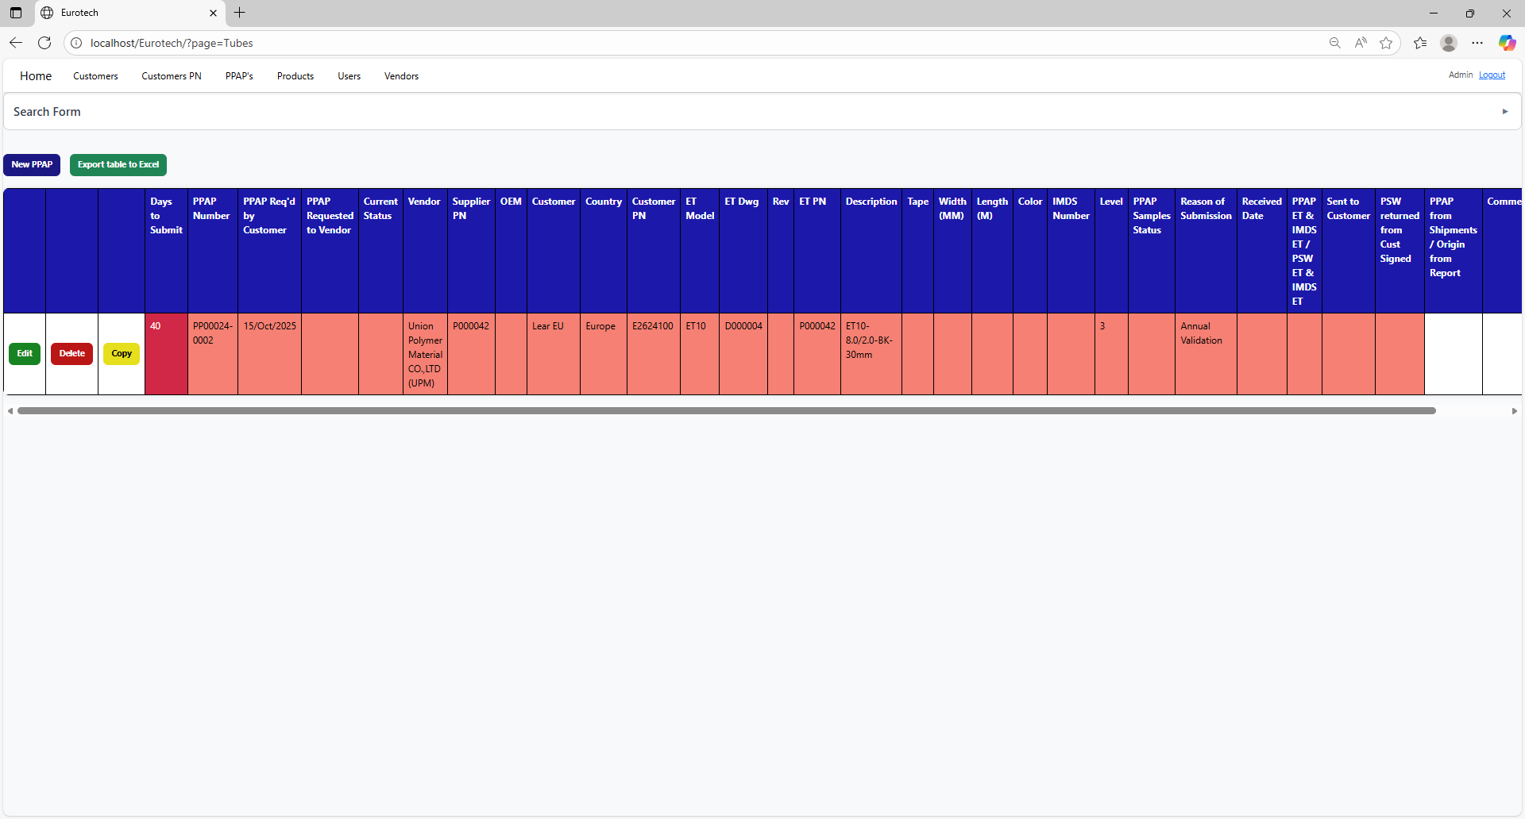

2.- In the rest of the columns of the registers will be:

* Registers with white background indicate that the PPAP has been requested by the customer, the request has not been sent to the vendor, and 30 days have not passed without the documentation being sent to the customer.



* Registers with blue background indicate that the PPAP has been requested by the customer, the request has been sent to the vendor, and 30 days have not passed without the documentation being sent to the customer.

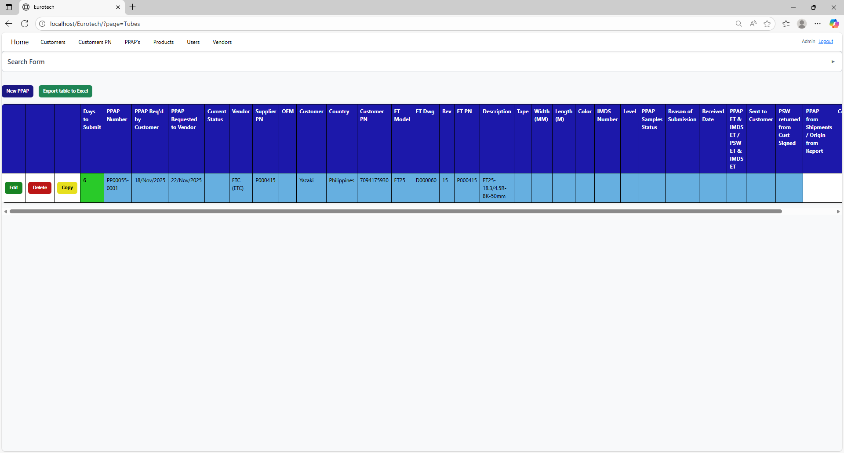

* Registers with red background indicate that the PPAP has been requested by the customer, and the 30-day limit has passed without the documentation being sent to the customer.



* Registers with yellow background indicate that the PPAP has been sent to the customer, and the PSW has not been returned signed by the customer.

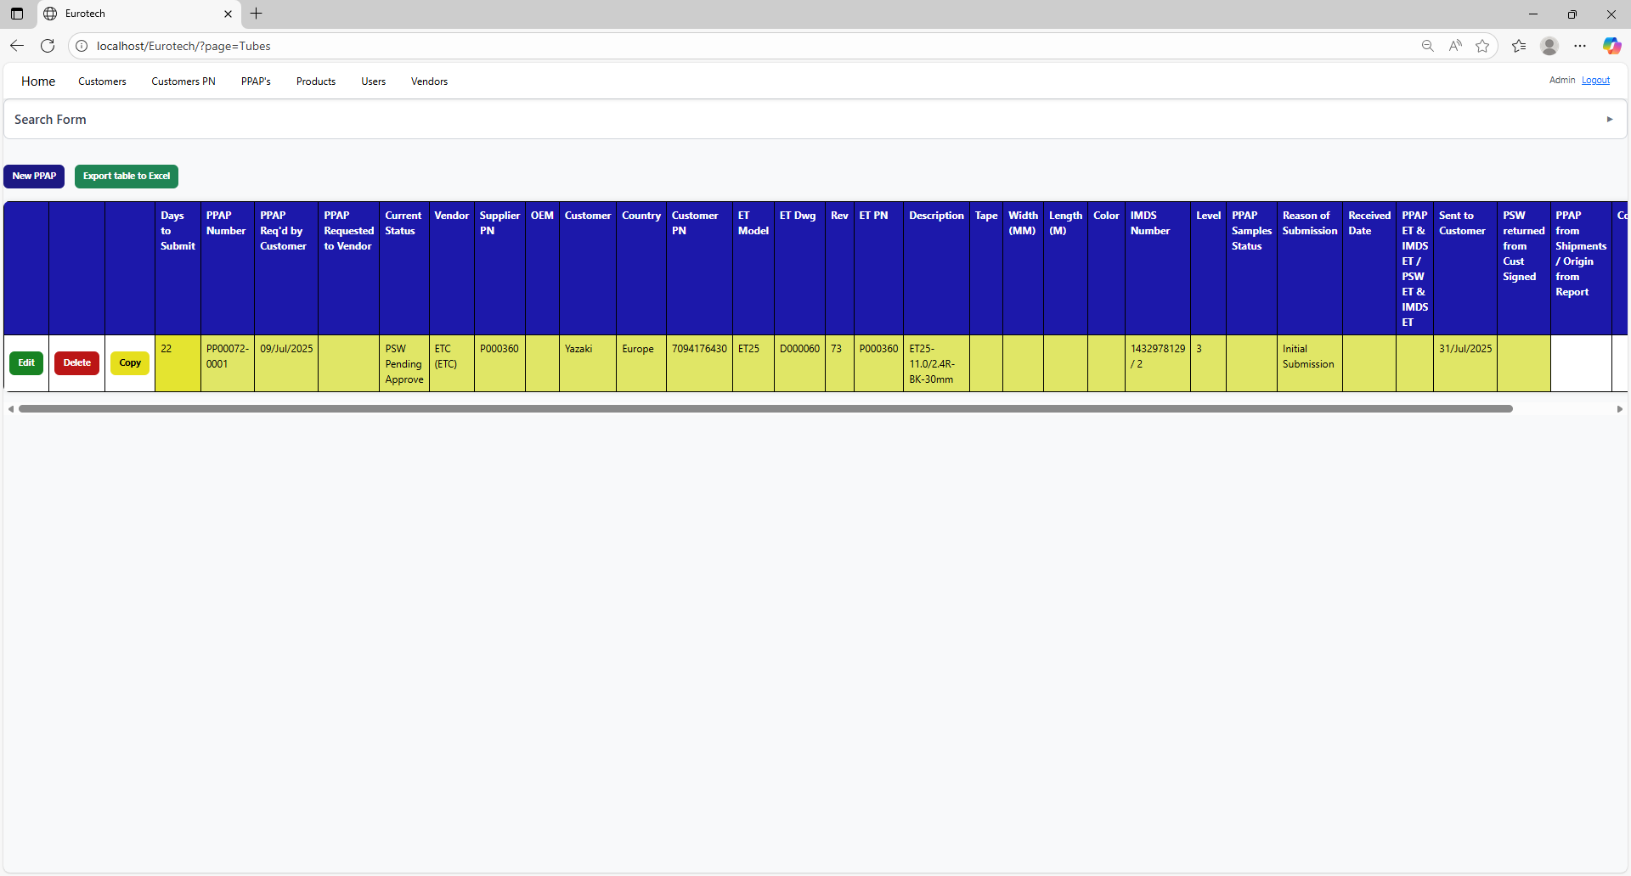

* Registers with green background indicate that the PSW has been returned signed by the customer.

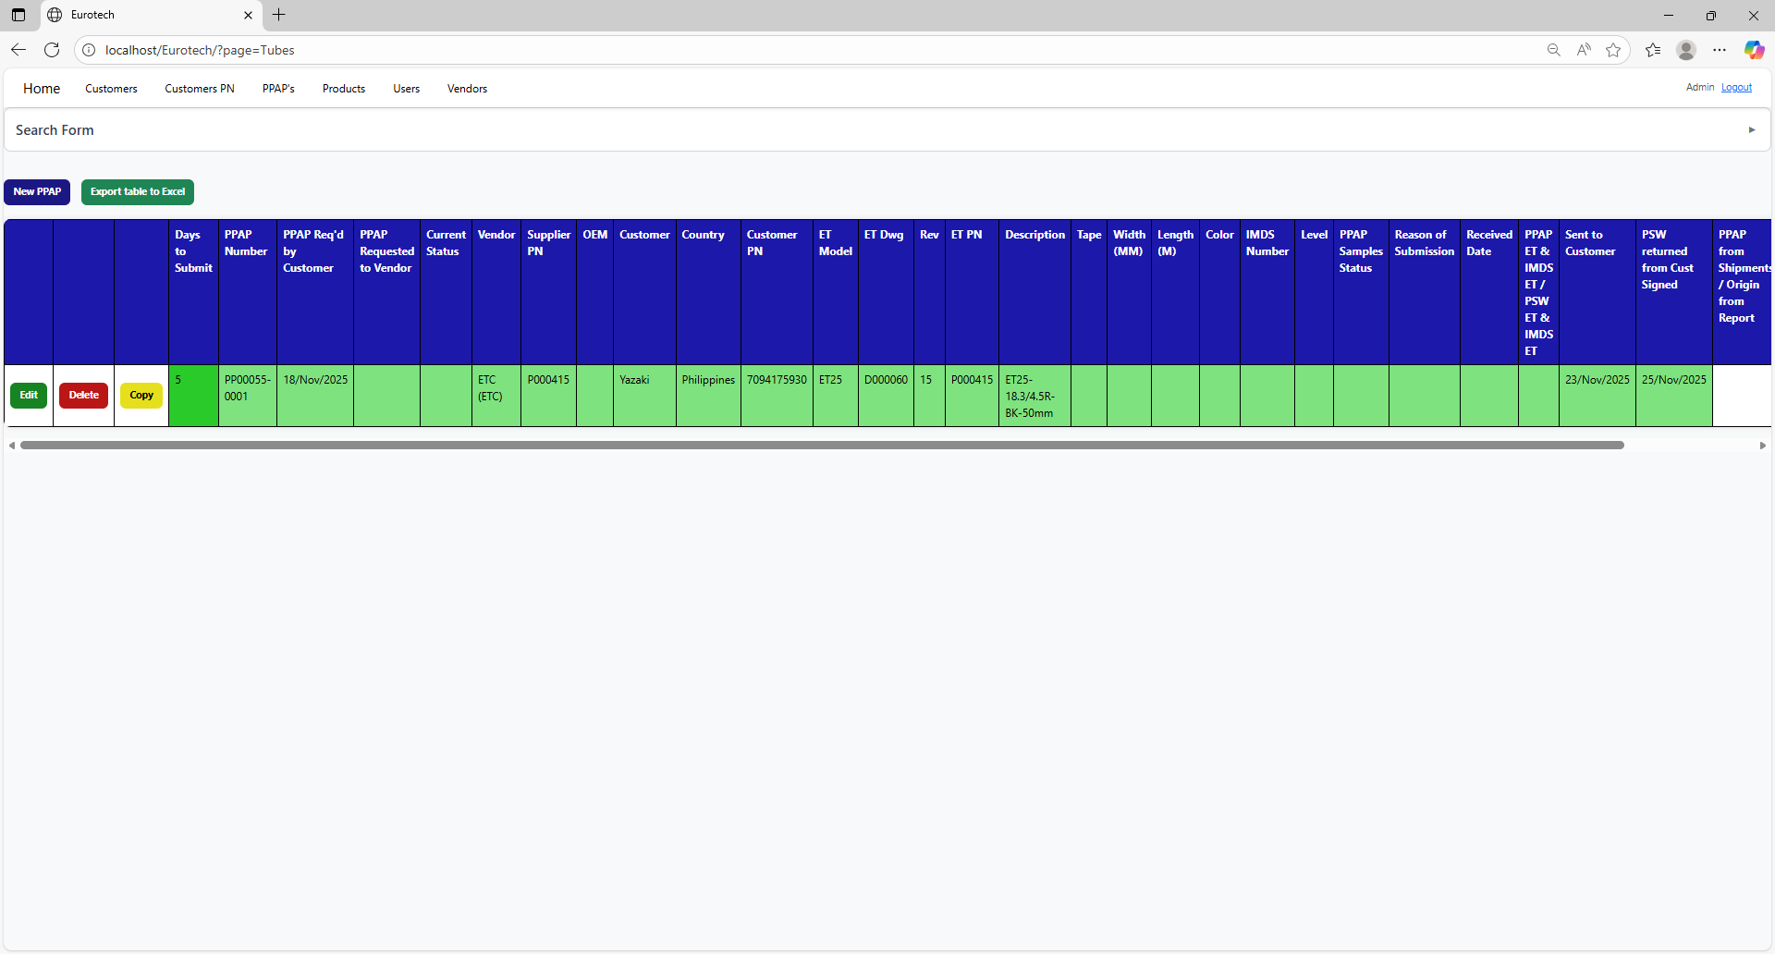

### *3.7.4 How to Add a New PPAP.*

If you want to add a new PPAP, you must click the “New PPAP” button that is below the “Search Form”.



Once you click the “New PPAP” button, it will display a register form to create a new PPAP.



Non-mandatory field

Mandatory fields



Non-mandatory field

If you want to save the register of a new PPAP, you must click the “Save” button.

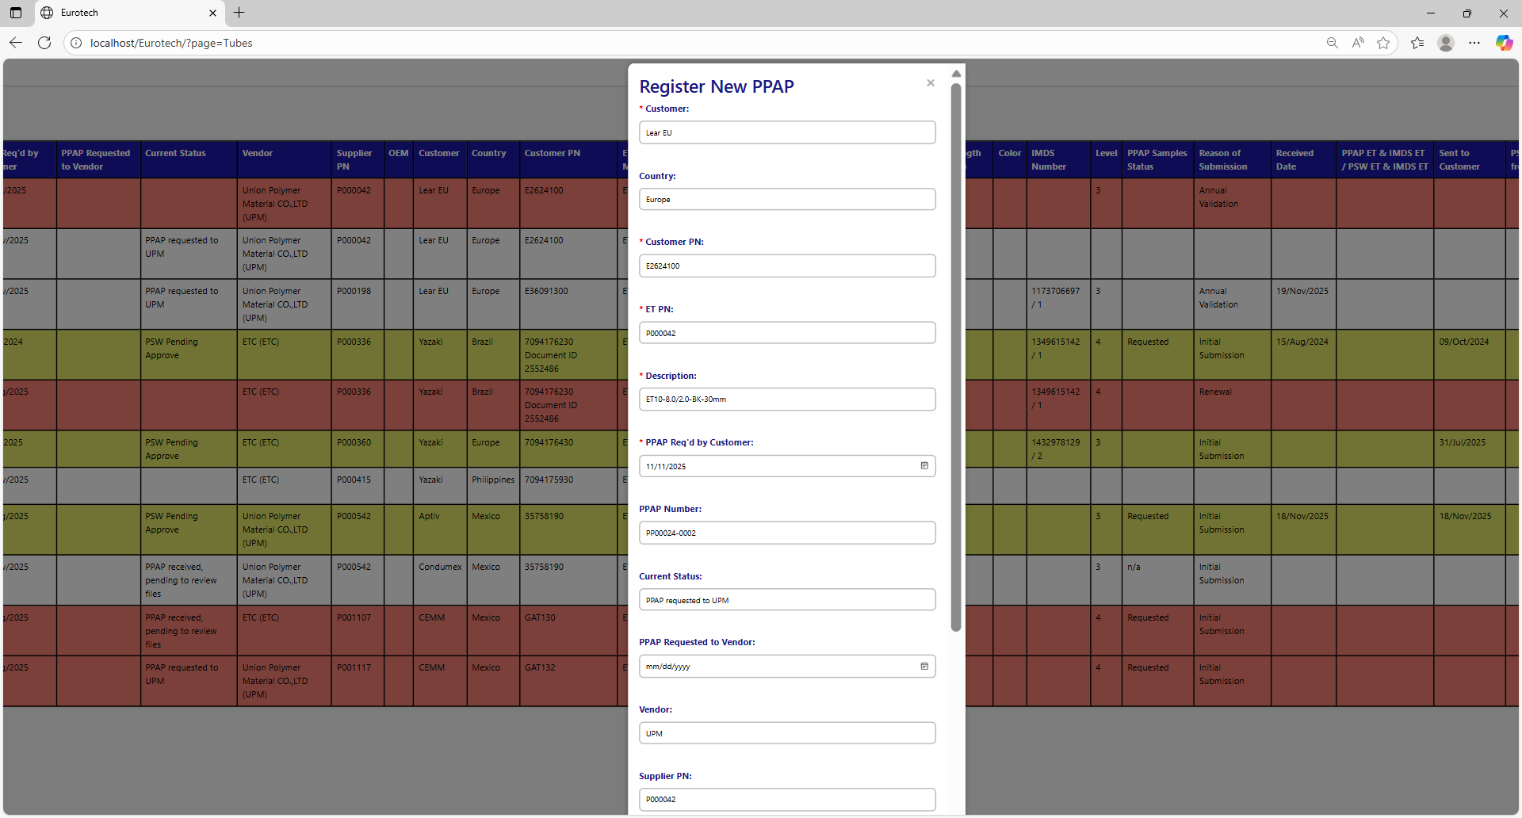



If no errors are found, the register will be added successfully.

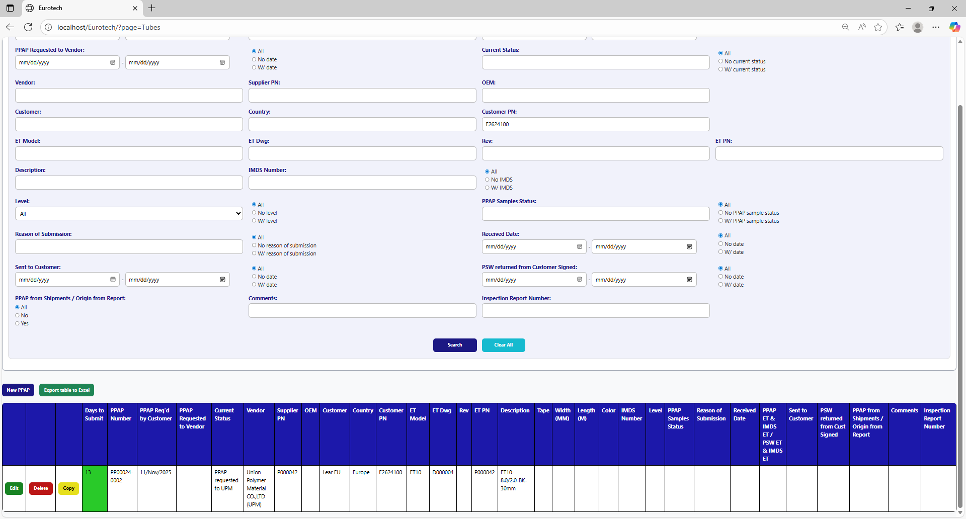

If an error is found, you can check in the Index the instruction *3.11.3.1 Register Form Errors.*

### *3.7.5 How to Edit Information of a PPAP.*

In each register from the table, it will be an “Edit” button. If this button is clicked, it will display an update form to edit the information of the selected PPAP.



Once you click the “Edit” button, it will display an update form to edit the information of the selected PPAP.

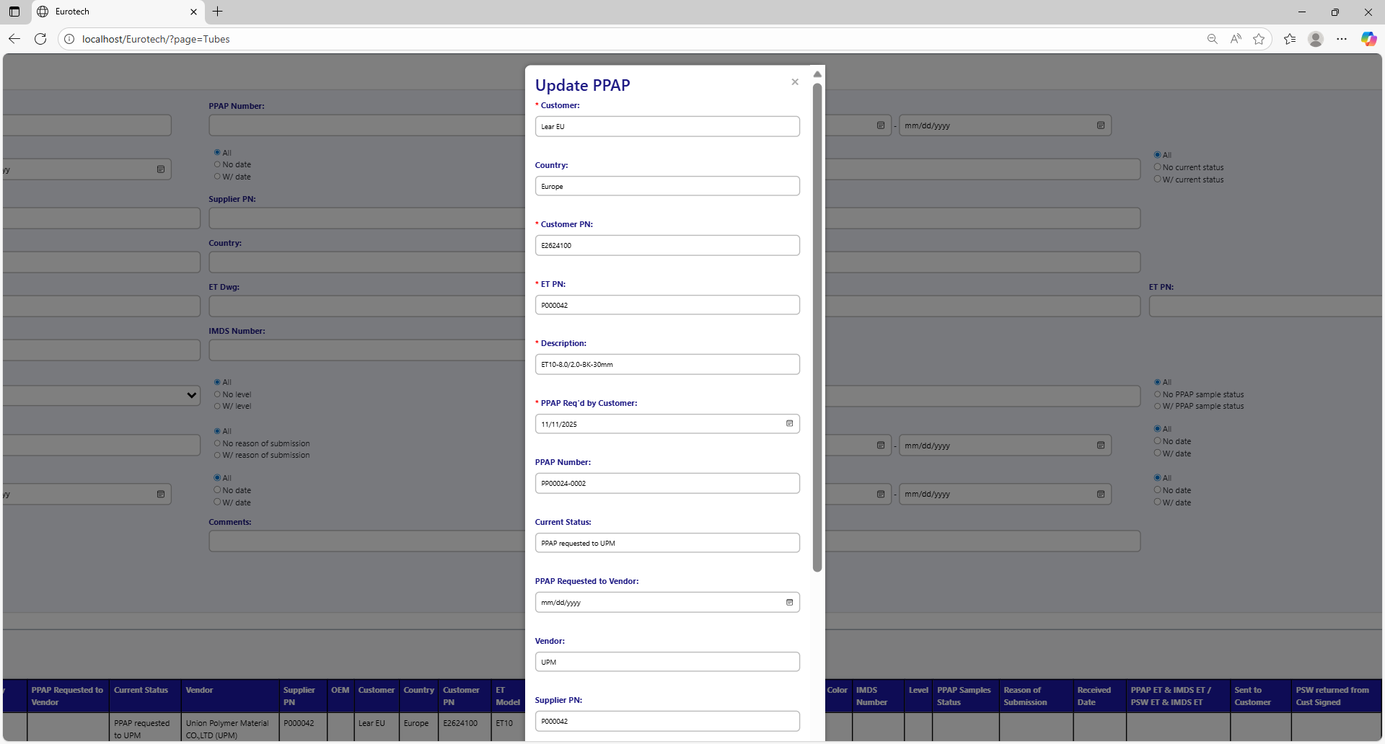

Example of a modification:

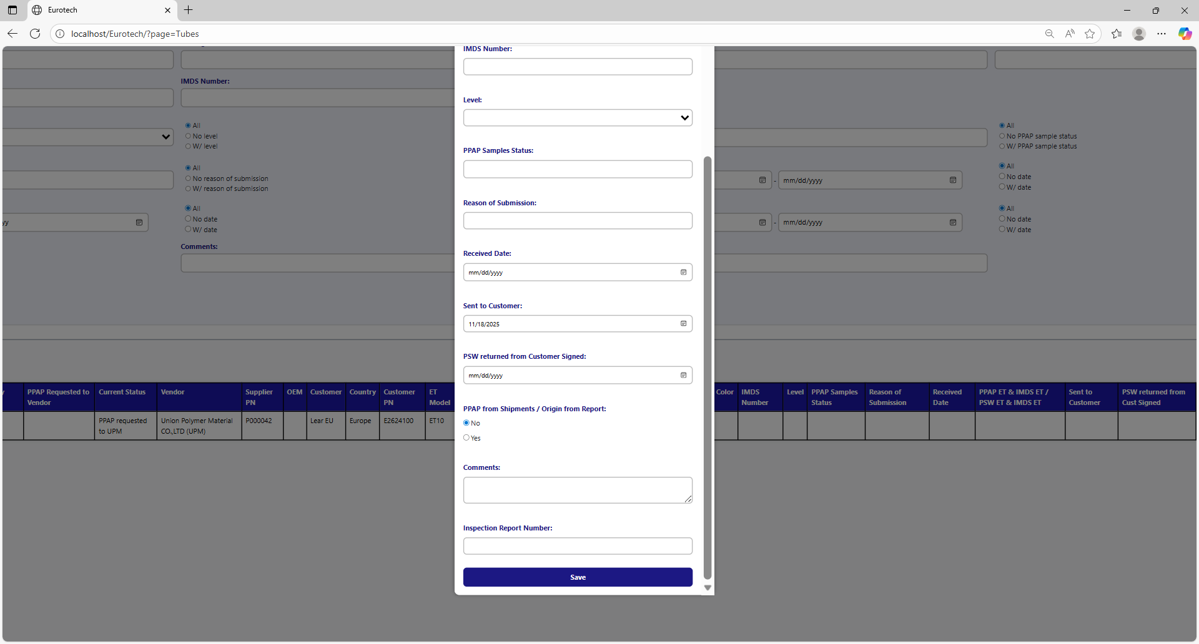

To save the changes, you must click the “Save” button.



If no errors are found, the register will be updated successfully.

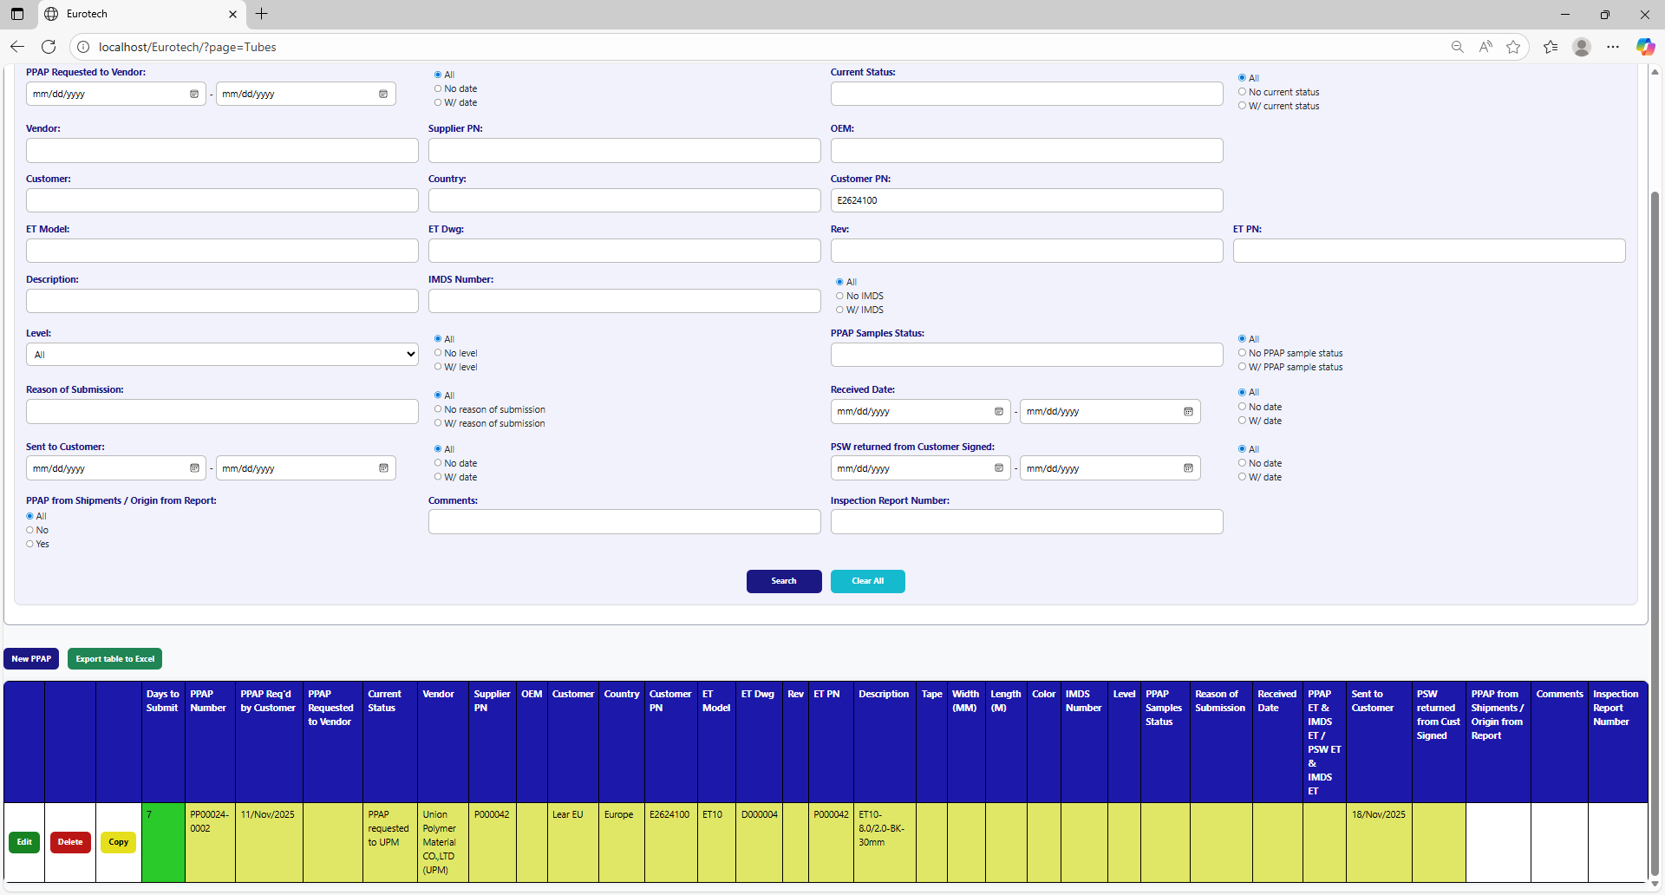

If an error is found, you can check in the Index the instruction *3.11.3.2 Edit Form Errors.*

### *3.7.6 How to Copy the Information of a PPAP.*

In each register from the table, it will be a “Copy” button. You must click the “Copy” button of the register you want to copy its information.



Once you click the “Copy” button, it will display the register form, but with the information of the PPAP selected.

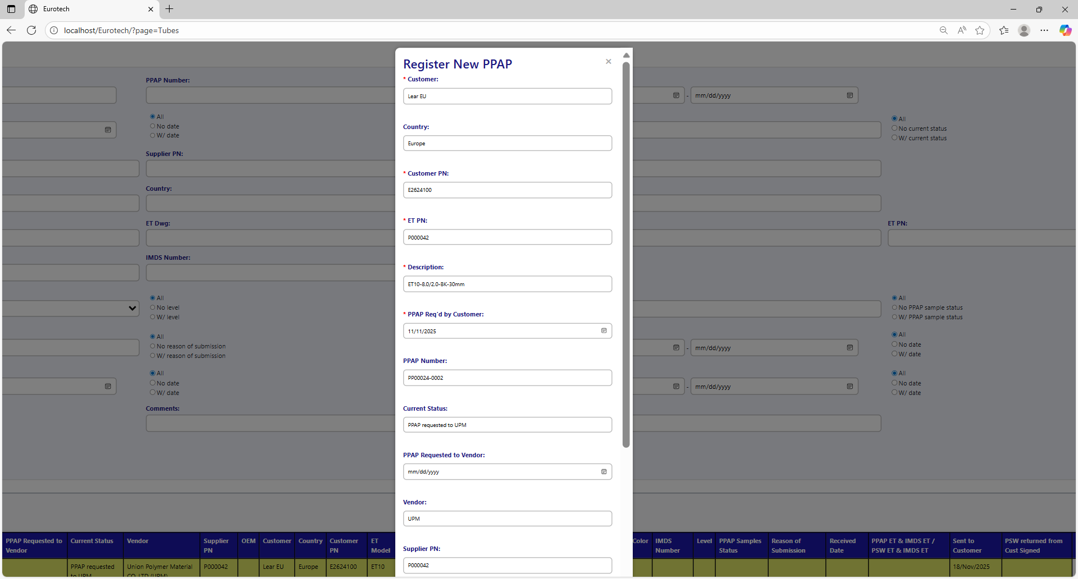

You can do the modifications you need to the information and use the “Save” button to save the new register.



### *3.7.7 How to Delete a PPAP.*

In each register from the table, it will be a “Delete” button. You must click the “Delete” button of the register you want to delete.



Once you click the “Delete” button, it will display the information of the selected PPAP with a message to confirm the delete action. To confirm the delete of the PPAP, you must click the “Confirm” button.

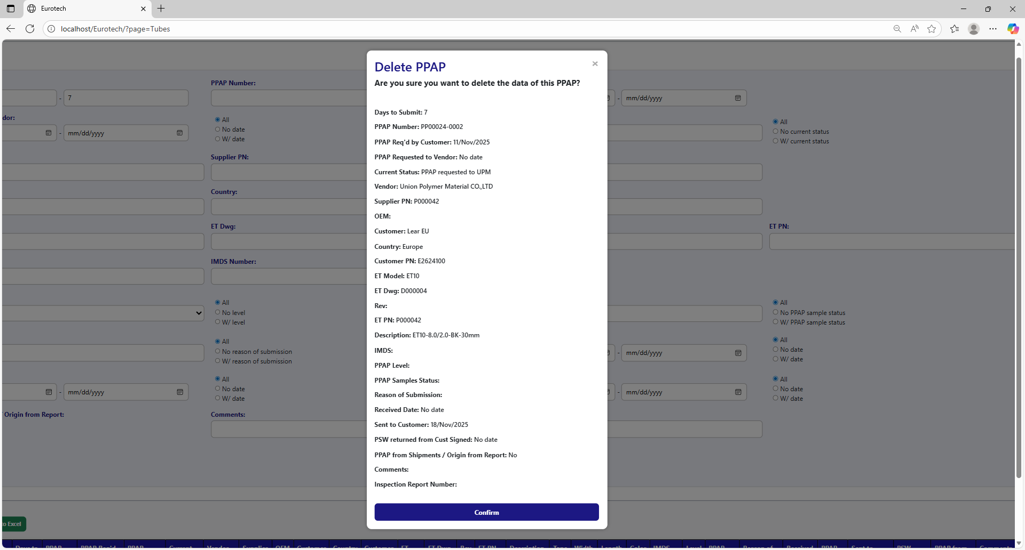

### *3.7.8 How to Automatically Create a Renewal for a PPAP.*

When a PPAP is registered or updated, and the "Sent to Customer" field is filled in, it also creates the register for the following year's renewal, putting the date of "Sent to Customer" in the "PPAP Req'd by Customer" field, adding 10 more months.

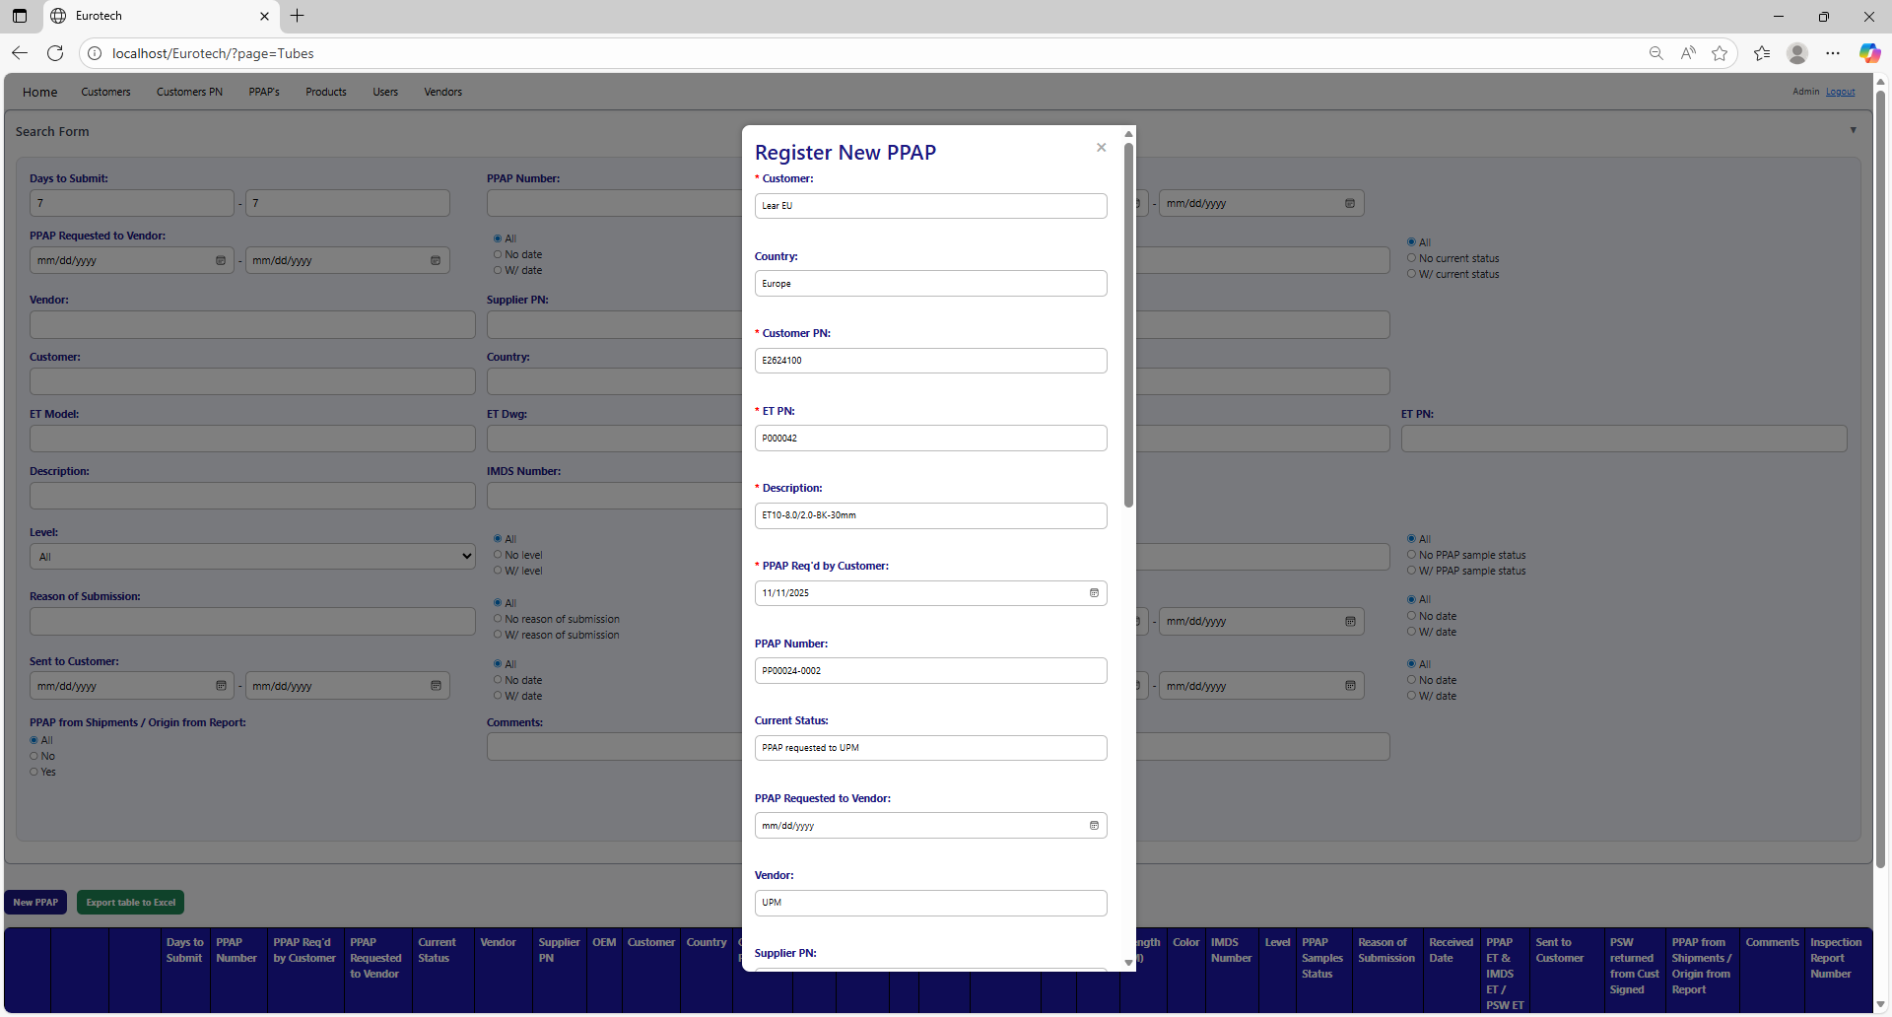

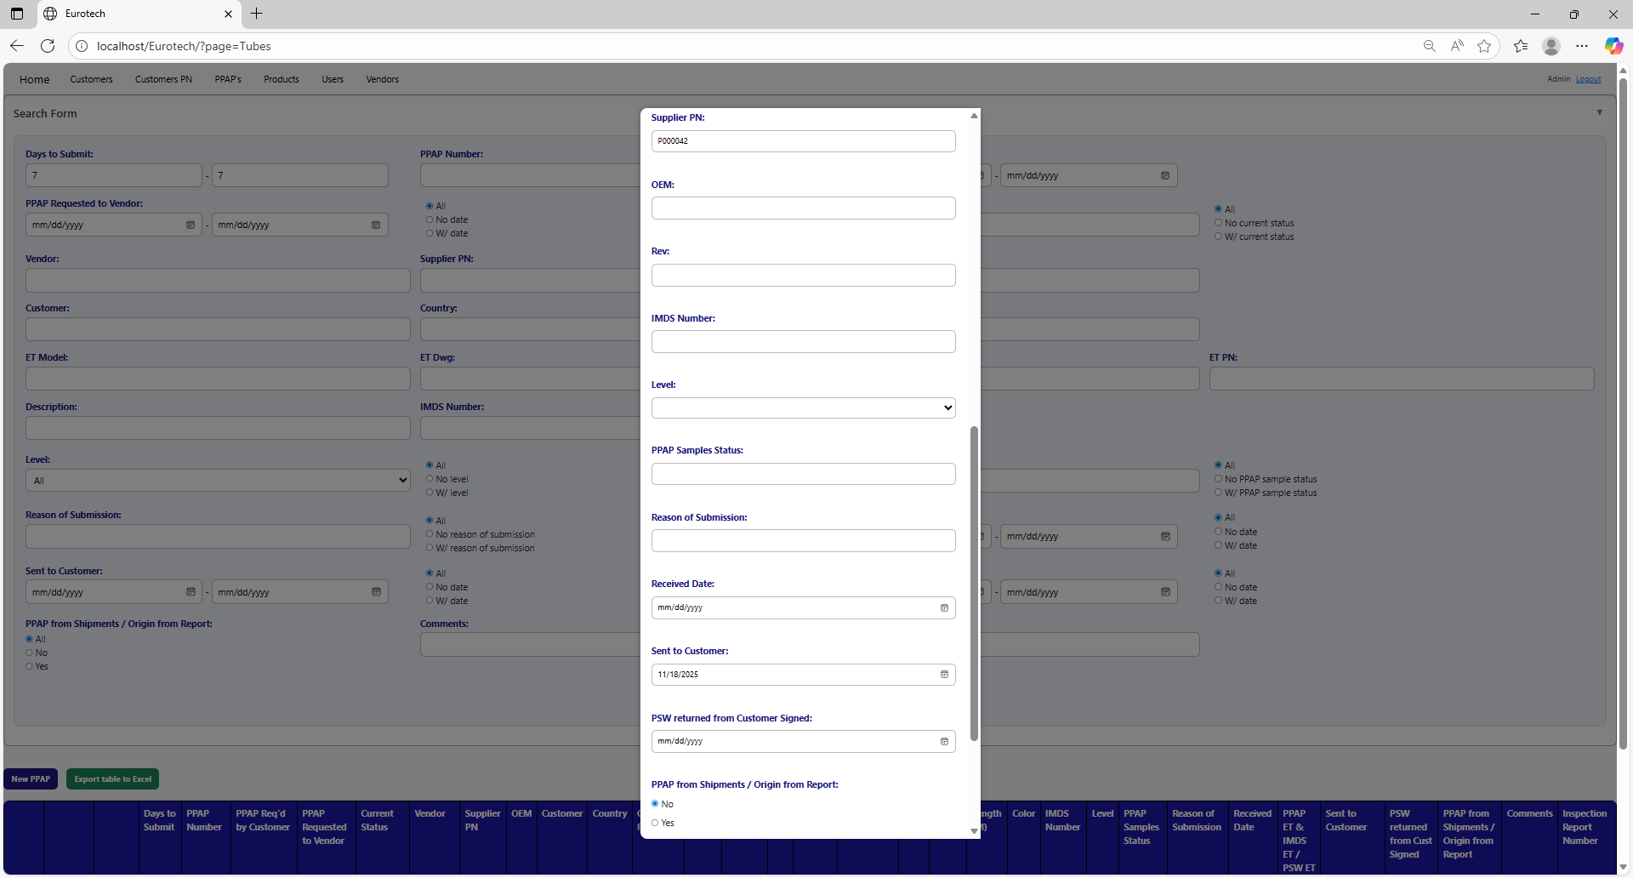



Once you click the “Save” button, the register for the following year's renewal will be created.

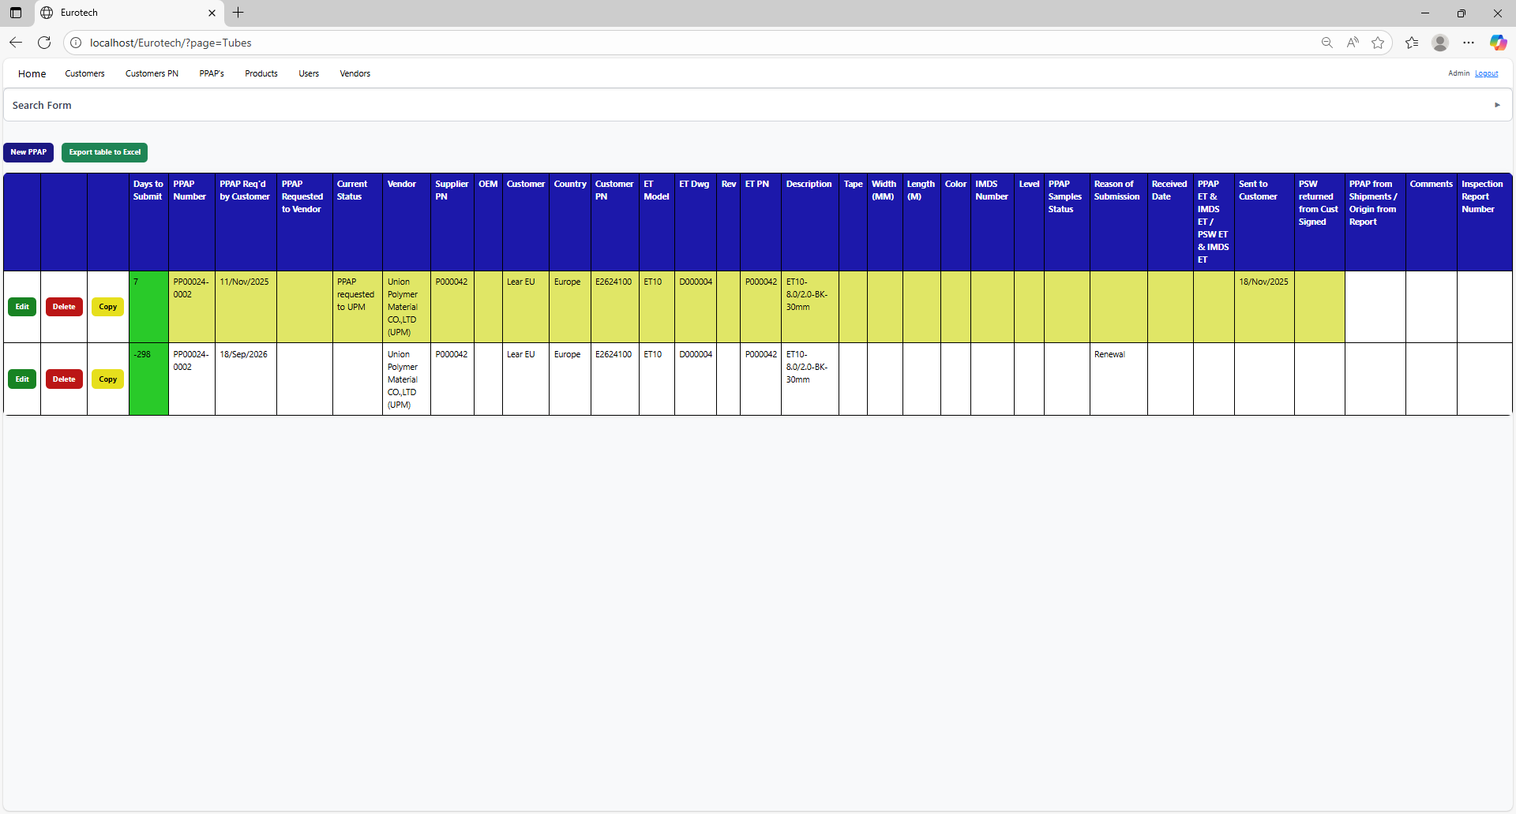

### *3.7.9 Duplicating Register Alert.*

If you were trying to register a new PPAP and it shows you a message with the title “Duplicating Register”, is not an error. The page is trying to prevent duplicate registers by verifying if there is another register in which the fields “Customer”, “Country”, “Customer PN” and “ET PN” match with the data of the new PPAP and its dates are between 10 months before the “PPAP Req'd by Customer” date of the new PPAP and that same date, or if there is a future renewal register that already exists, it will show its renewal date, and it will ask you if you are sure to register the PPAP.

This is an example of the “Duplicating Register” alert:

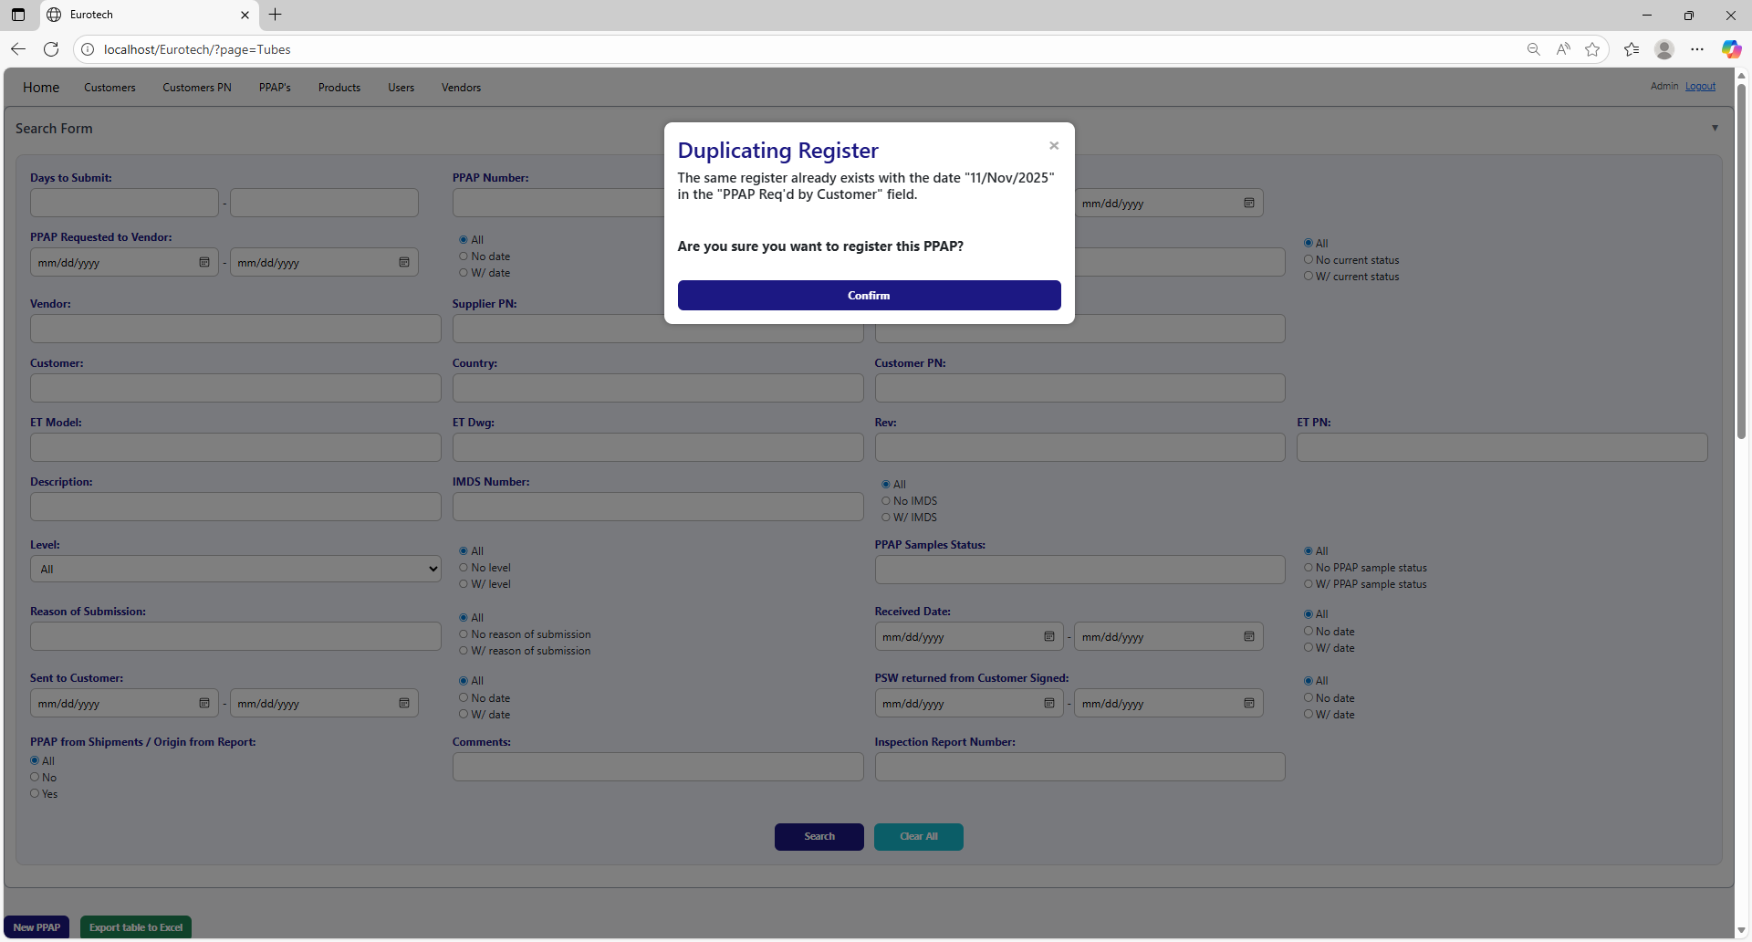

Once you are sure to register the PPAP, you must click the “Confirm” button.



### *3.7.10 How to Export the Information of the Table to an Excel Document.*

To export the table to an Excel document, you must click the “Export table to Excel” button.



Once you click the “Export table to Excel” button, it will start to download the Excel document with the name “PPAPs_Tubes_Report.xls”.

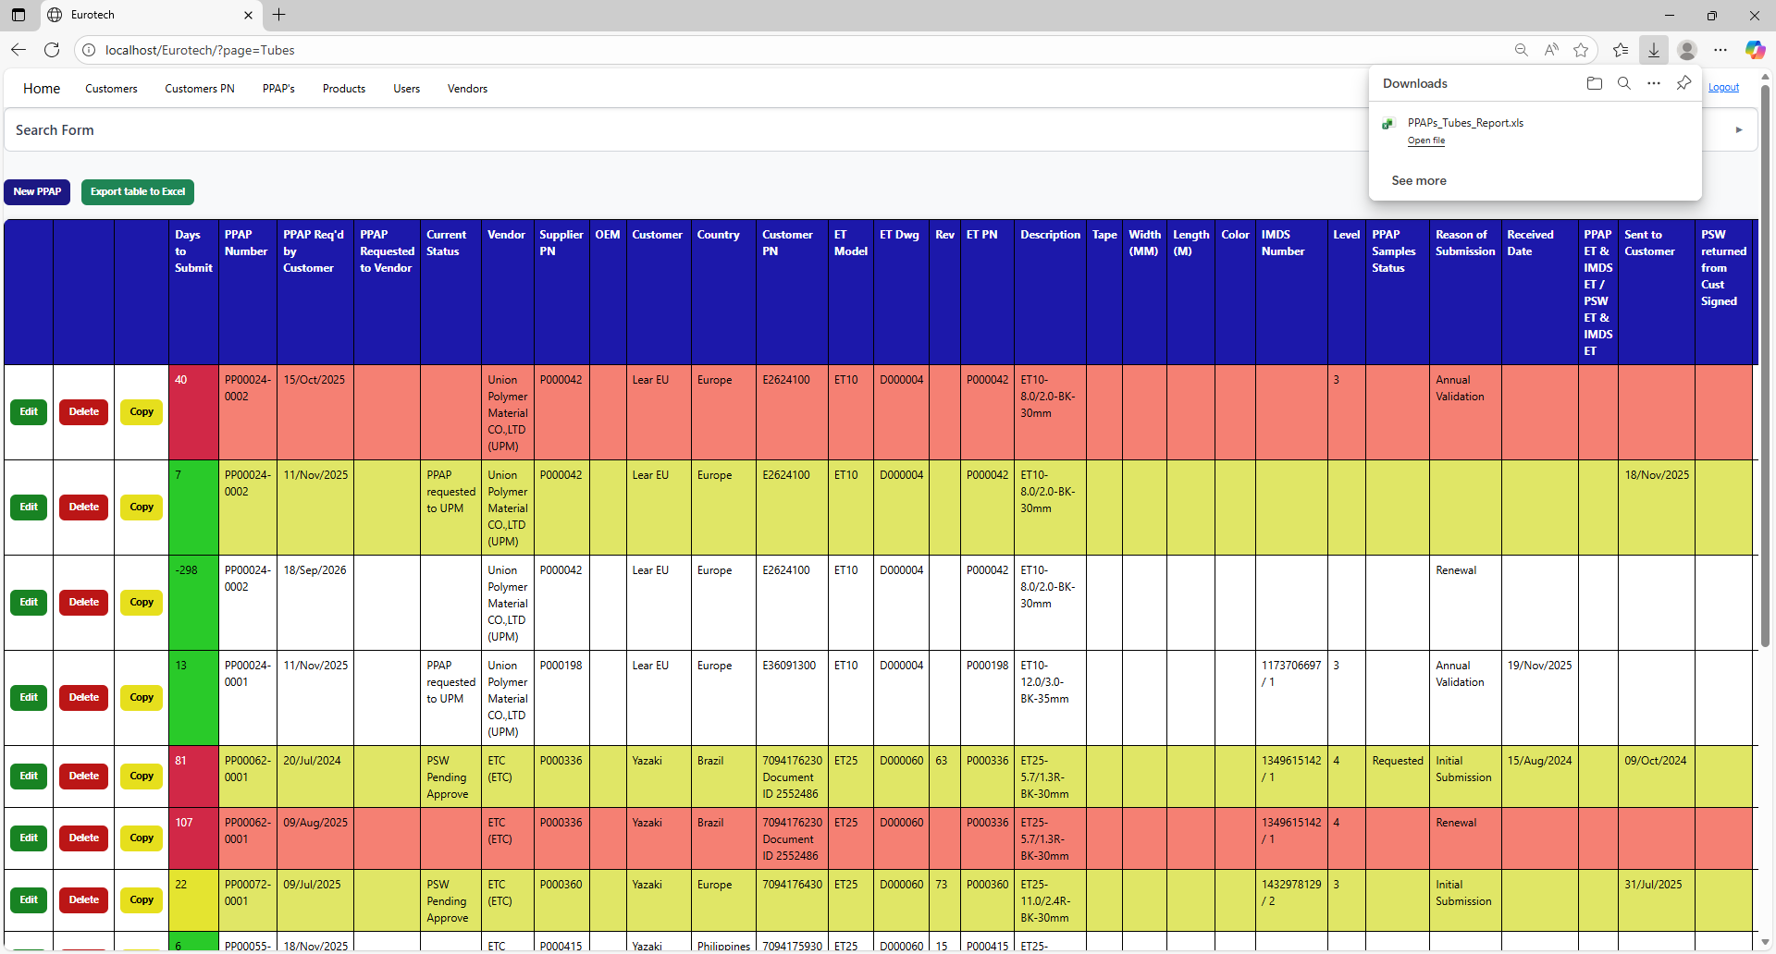

Once the download is finished, you can go to the folder it was downloaded and open the Excel document.

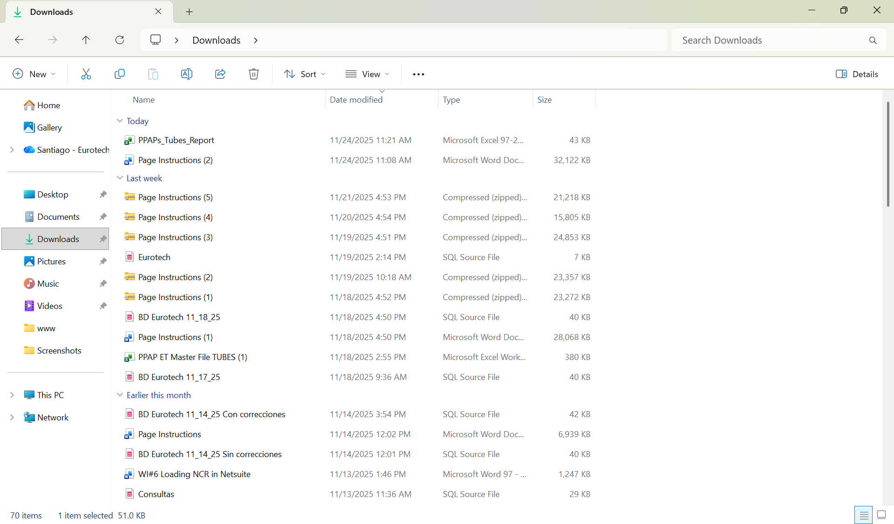

This is an example of how the document would look like:

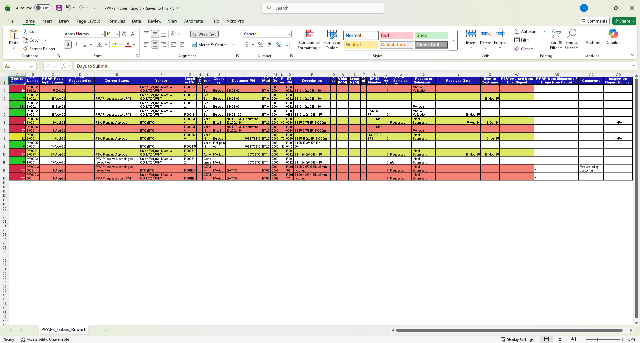

## ***3.8 Products Page.***

### *3.8.1 How to Navigate to “Products” Page.*

On the navigation bar, you can navigate to the “Products” page.

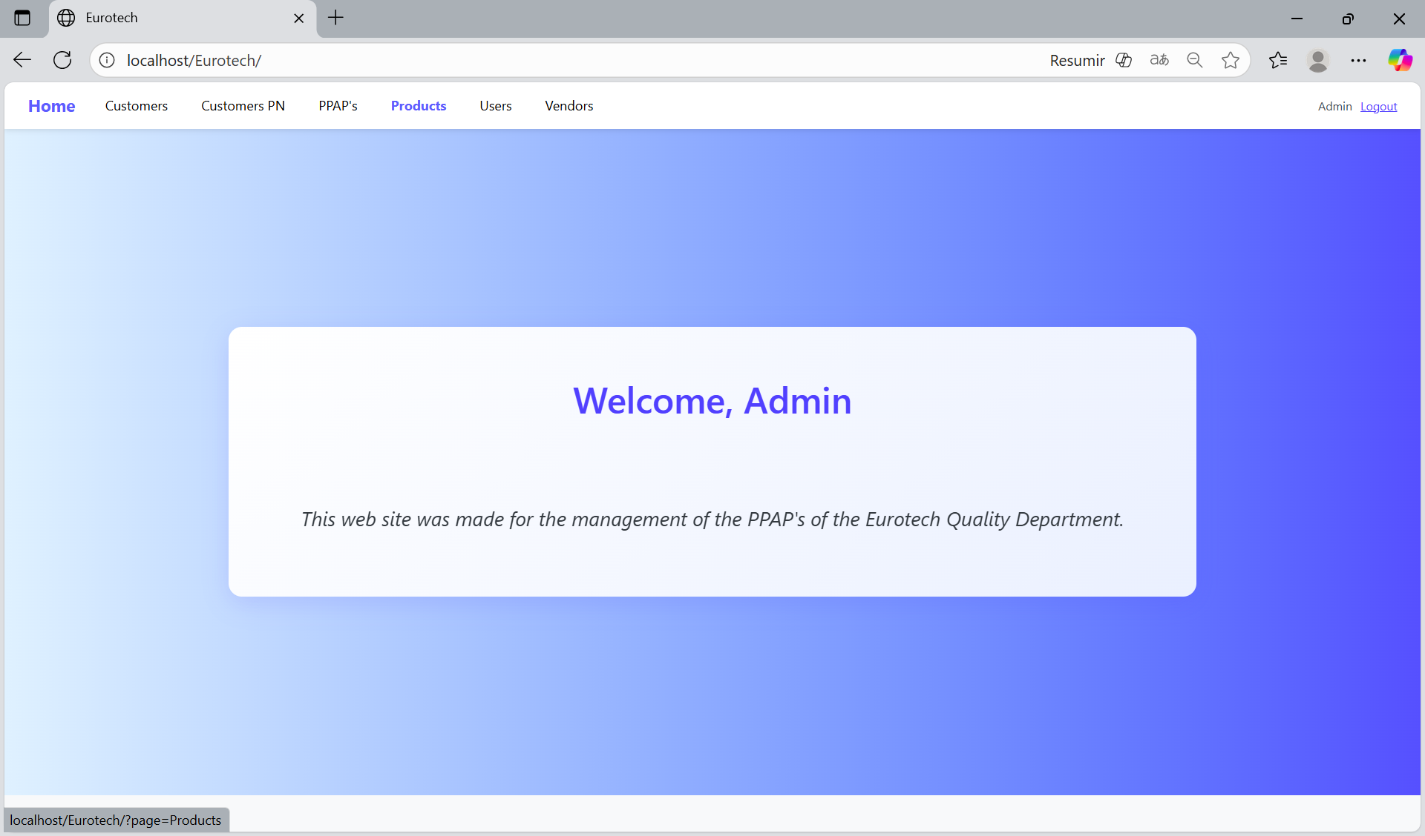

In this page you can manage the registers of all the products.

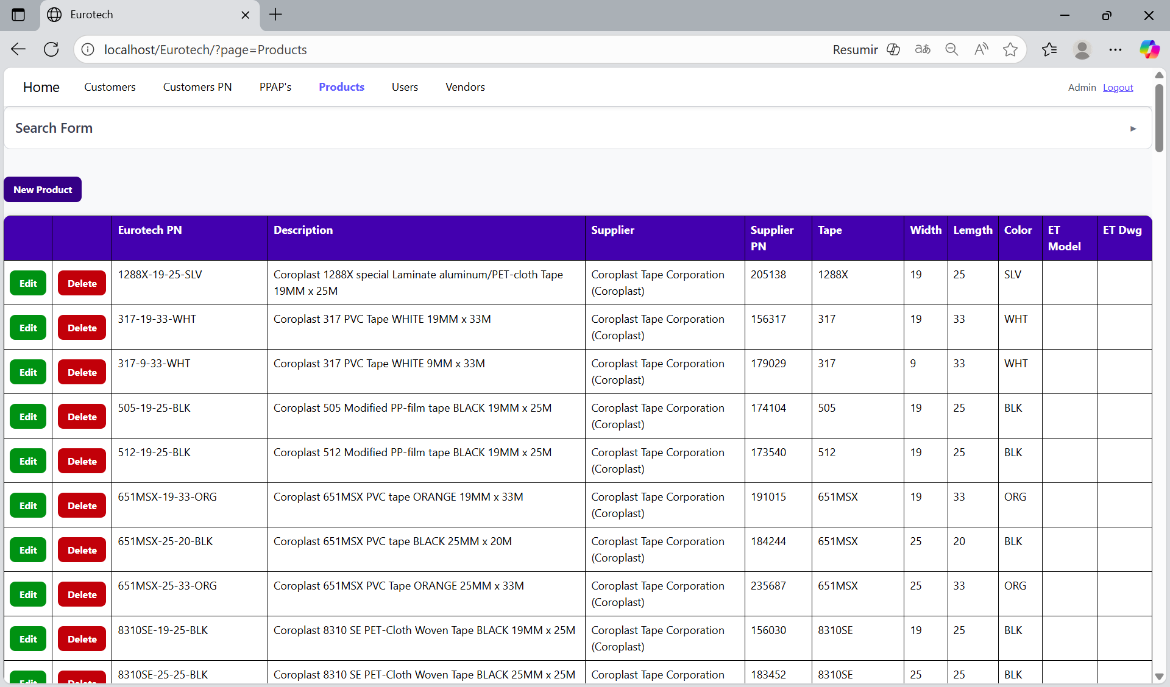

### *3.8.2 How to Search a Product.*

At the top of the page, it will be a dropdown “Search Form” that has all the fields of the table for querying registers.

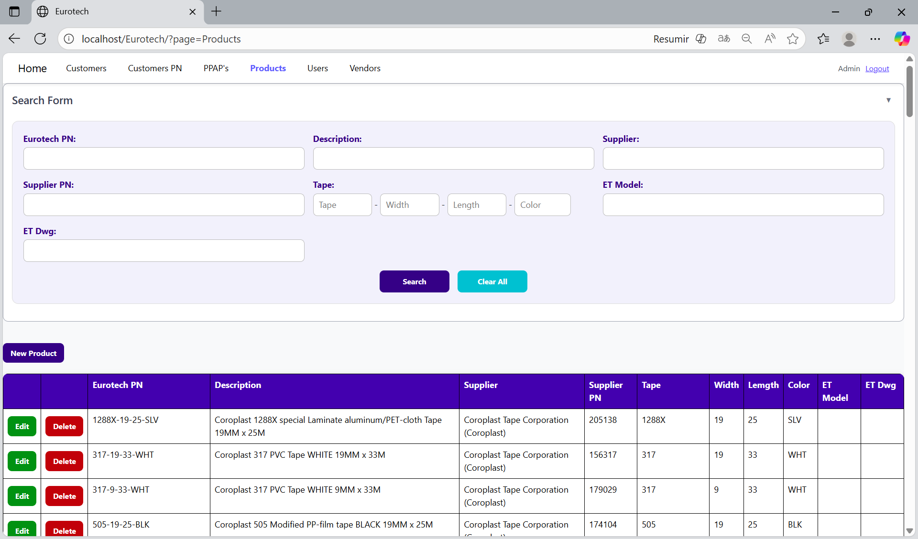

The search form allows you to perform searches by “Eurotech PN”, “Description”, “Supplier”, “Supplier PN”, “Tape”, “Width”, “Length”, “Color”, “ET Model” and “ET Dwg”.

You can search by “Eurotech PN”, using the “Eurotech PN” field and clicking the “Search” button.

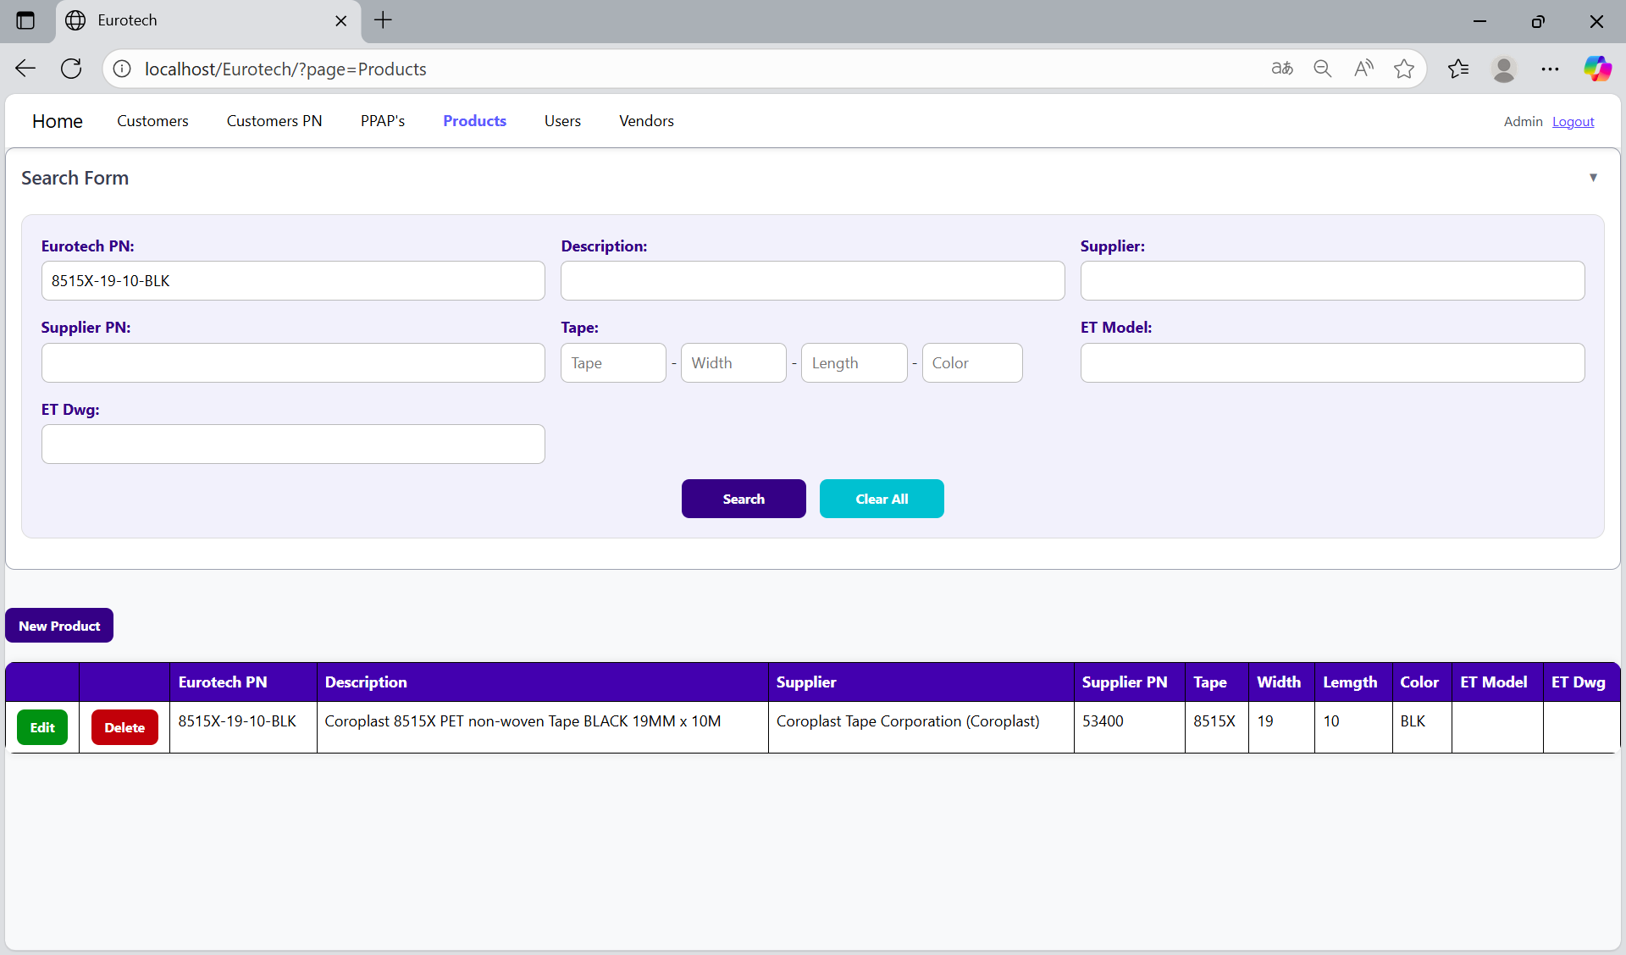

You can search by “Description”, using the “Description” field and clicking the “Search” button.

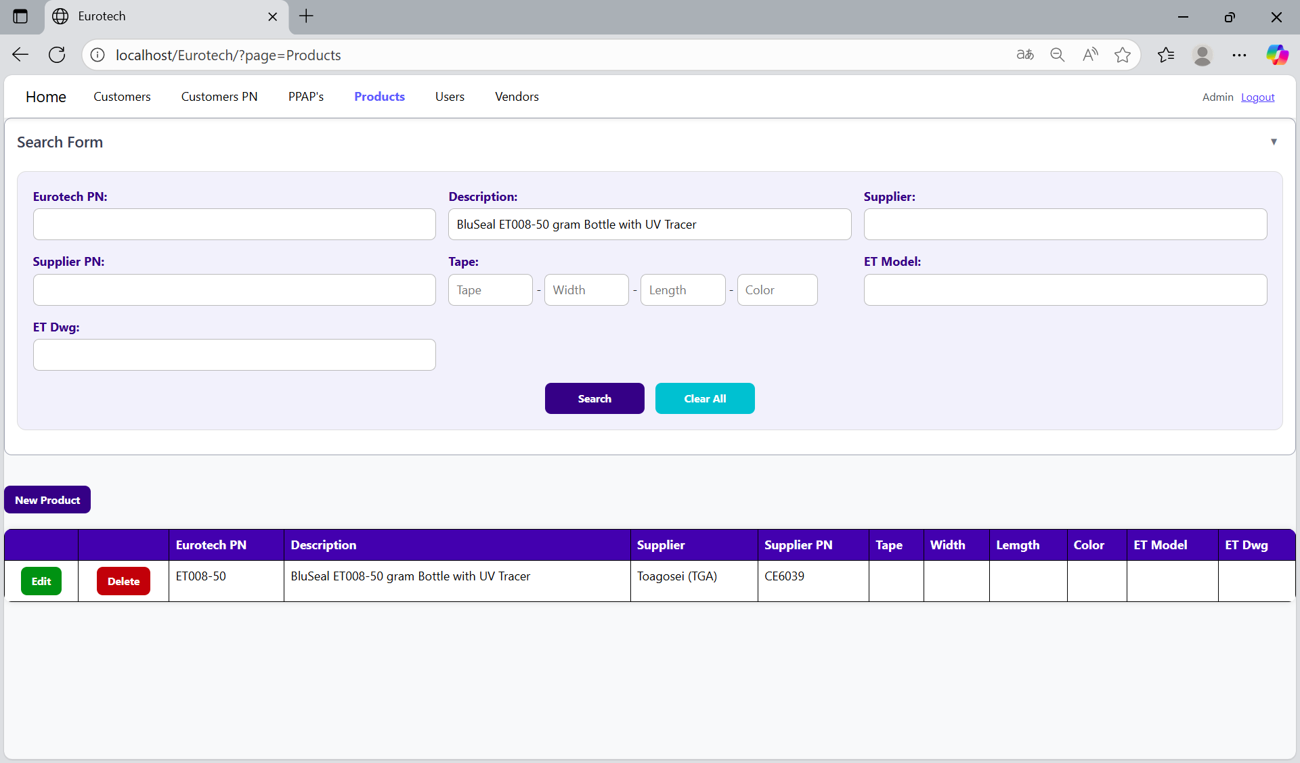

You can search by “Supplier”, using the “Supplier” field and clicking the “Search” button.

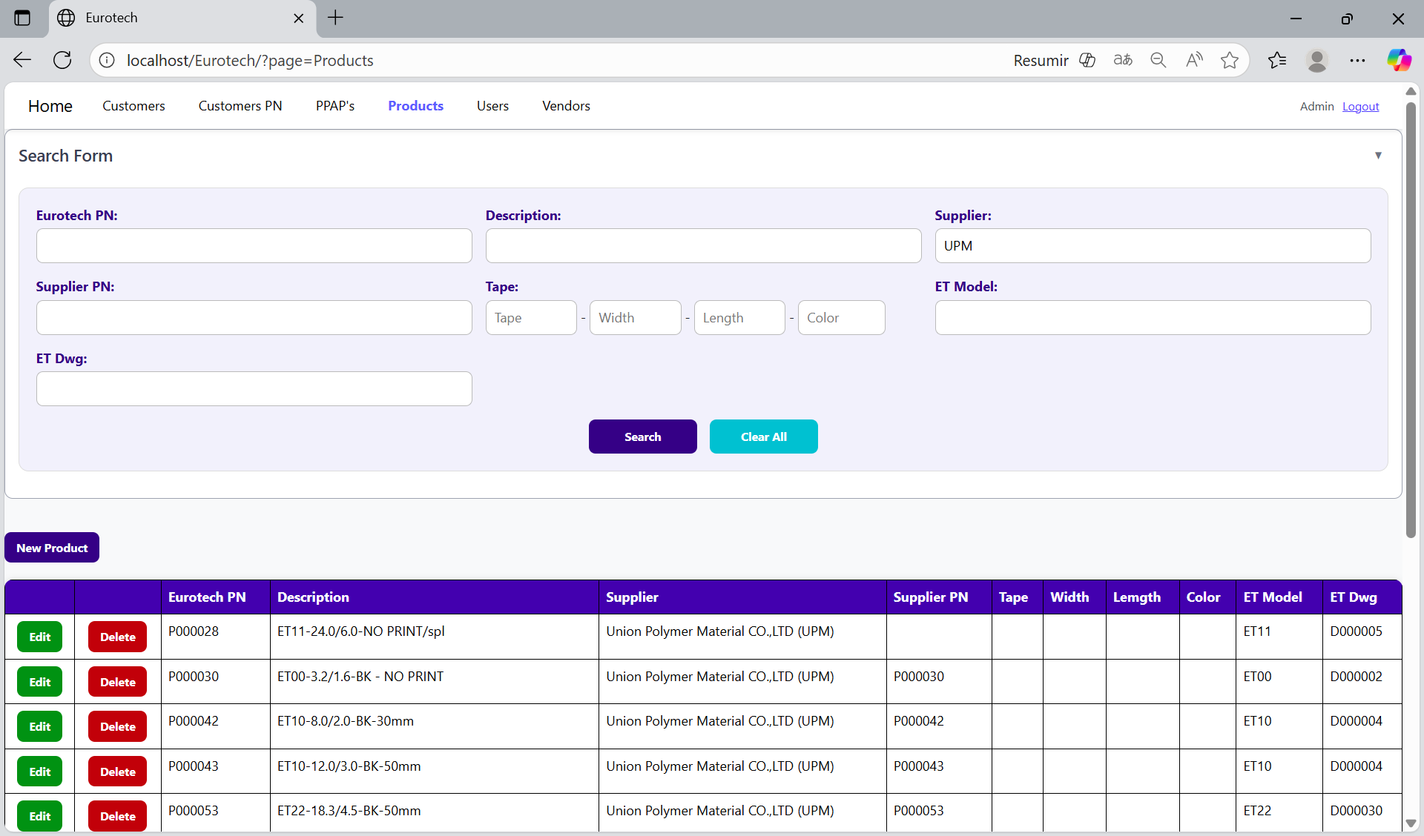

You can search by “Supplier PN”, using the “Supplier PN” field and clicking the “Search” button.

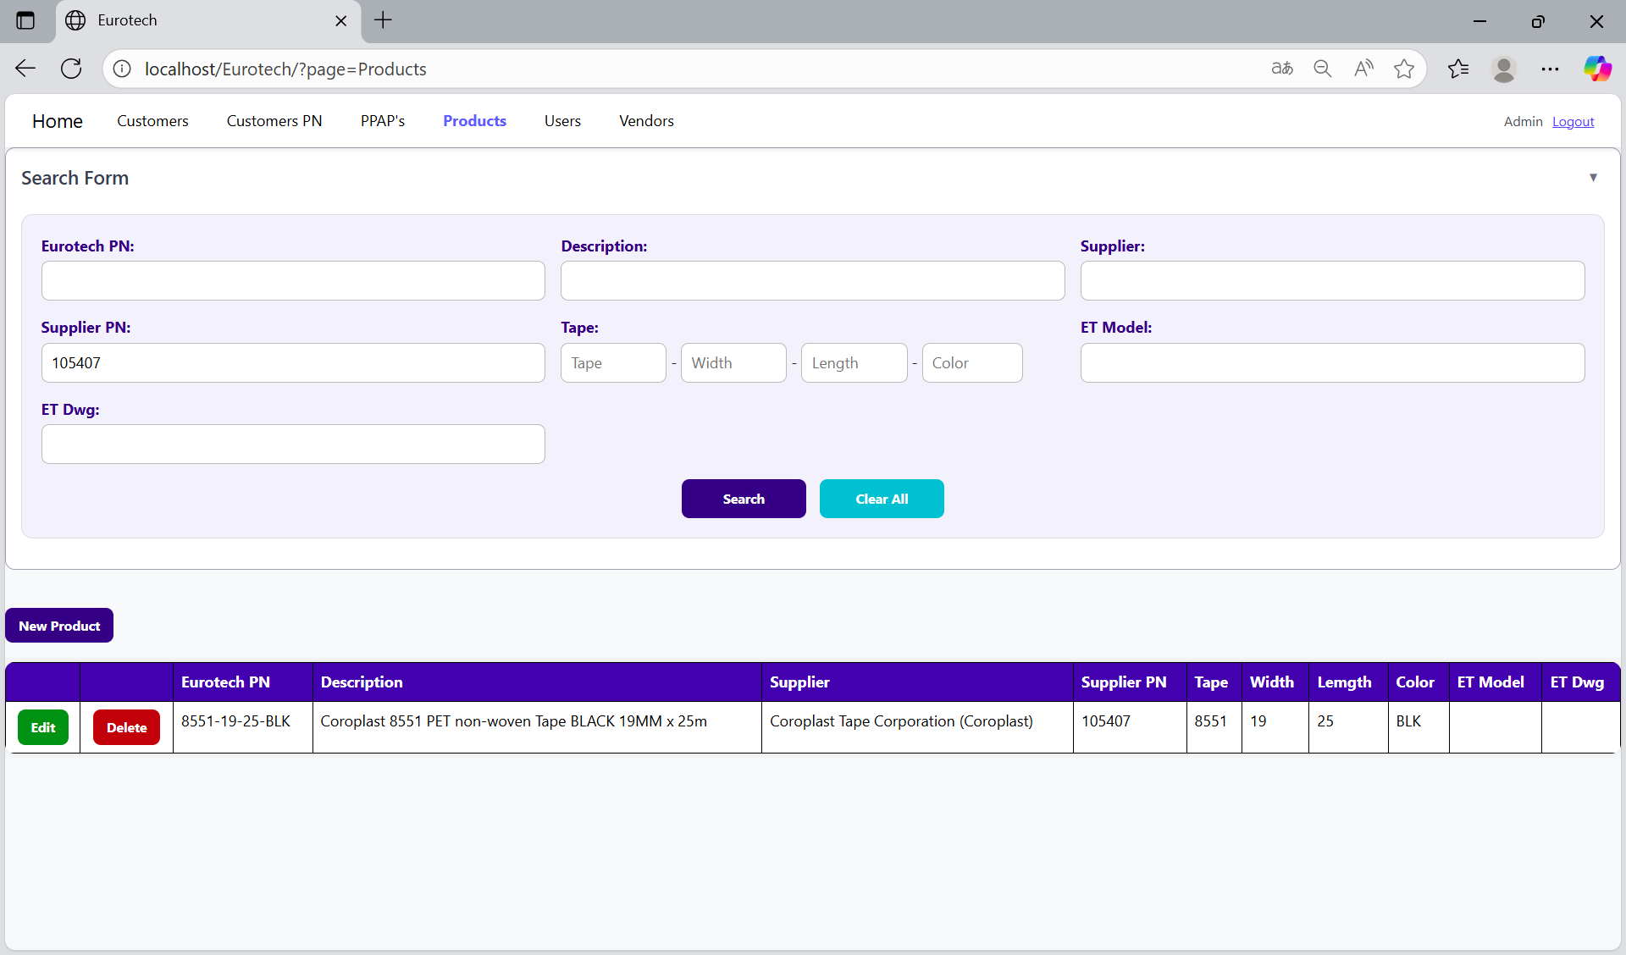

You can search by “Tape”, using the “Tape” field and clicking the “Search” button.

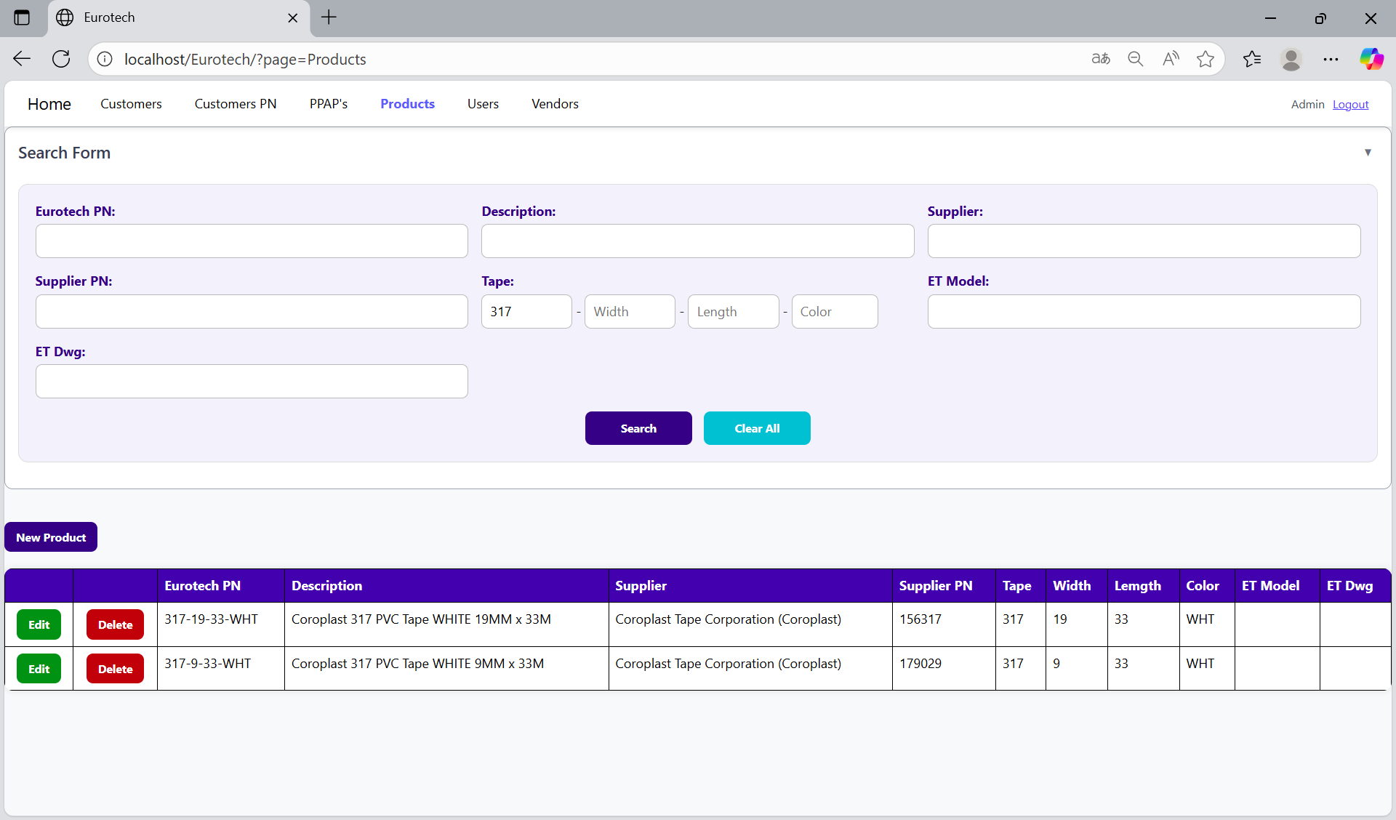

You can search by “Width”, using the “Width” field and clicking the “Search” button.

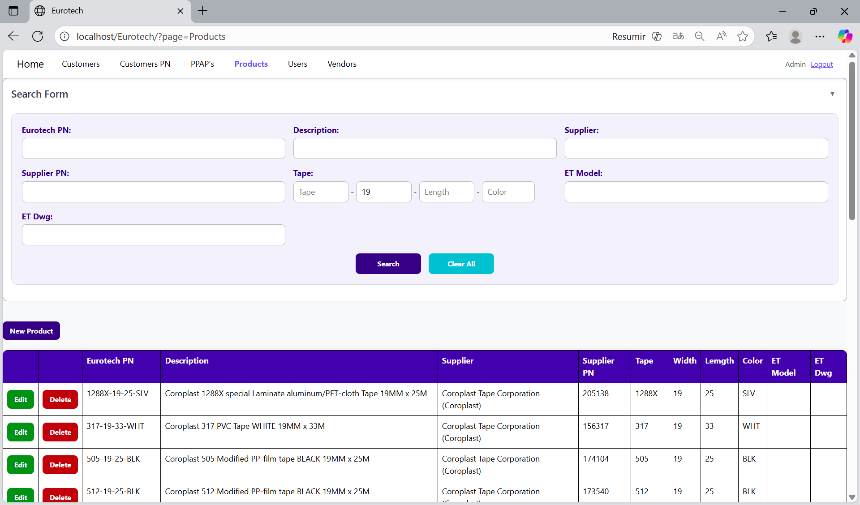

You can search by “Length”, using the “Length” field and clicking the “Search” button.

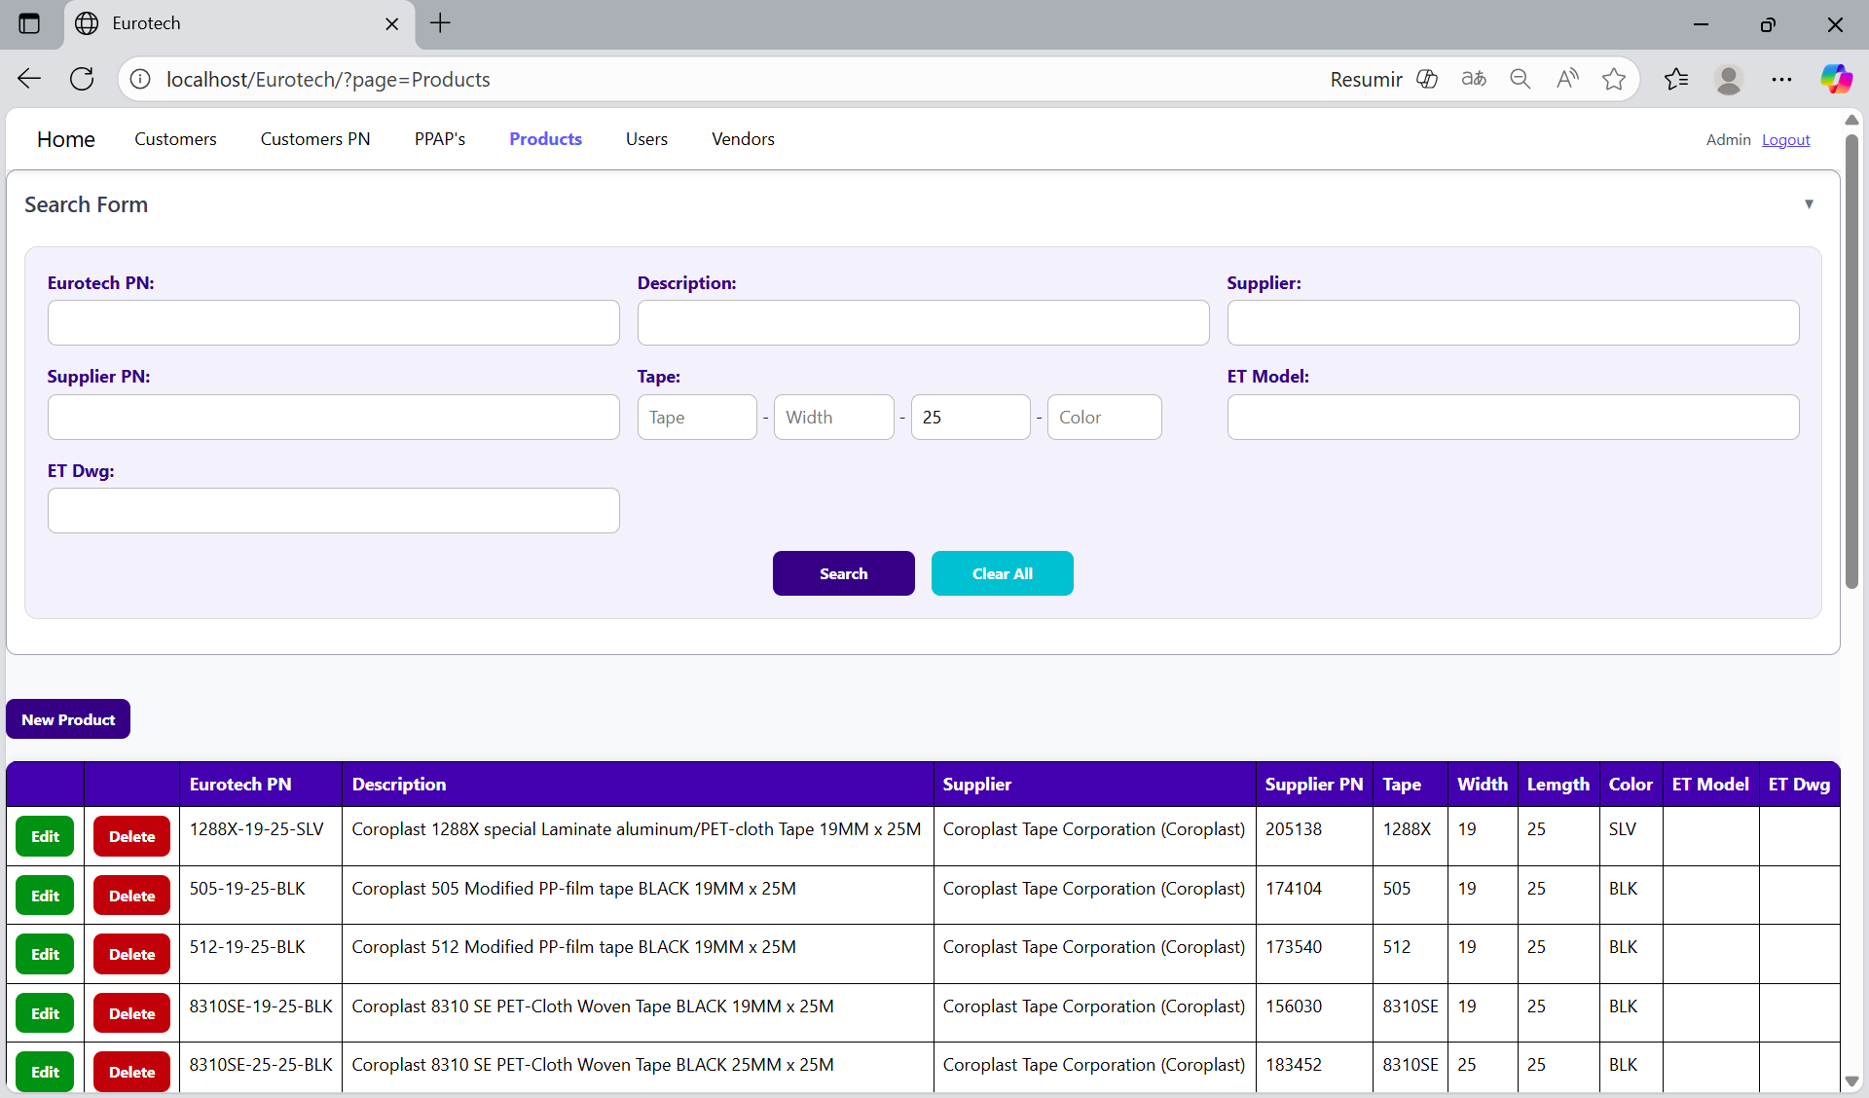

You can search by “Color”, using the “Color” field and clicking the “Search” button.

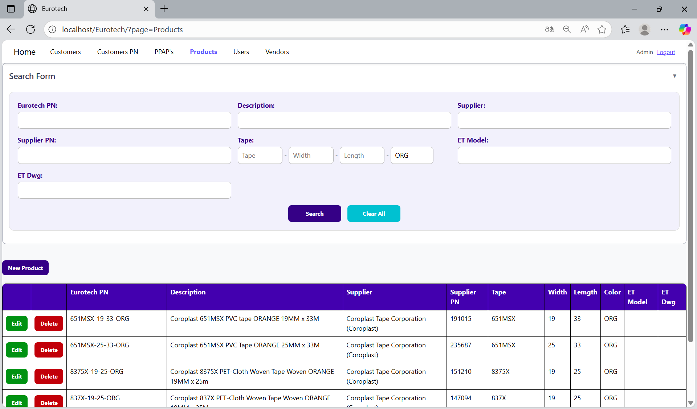

You can search by “ET Model”, using the “ET Model” field and clicking the “Search” button.

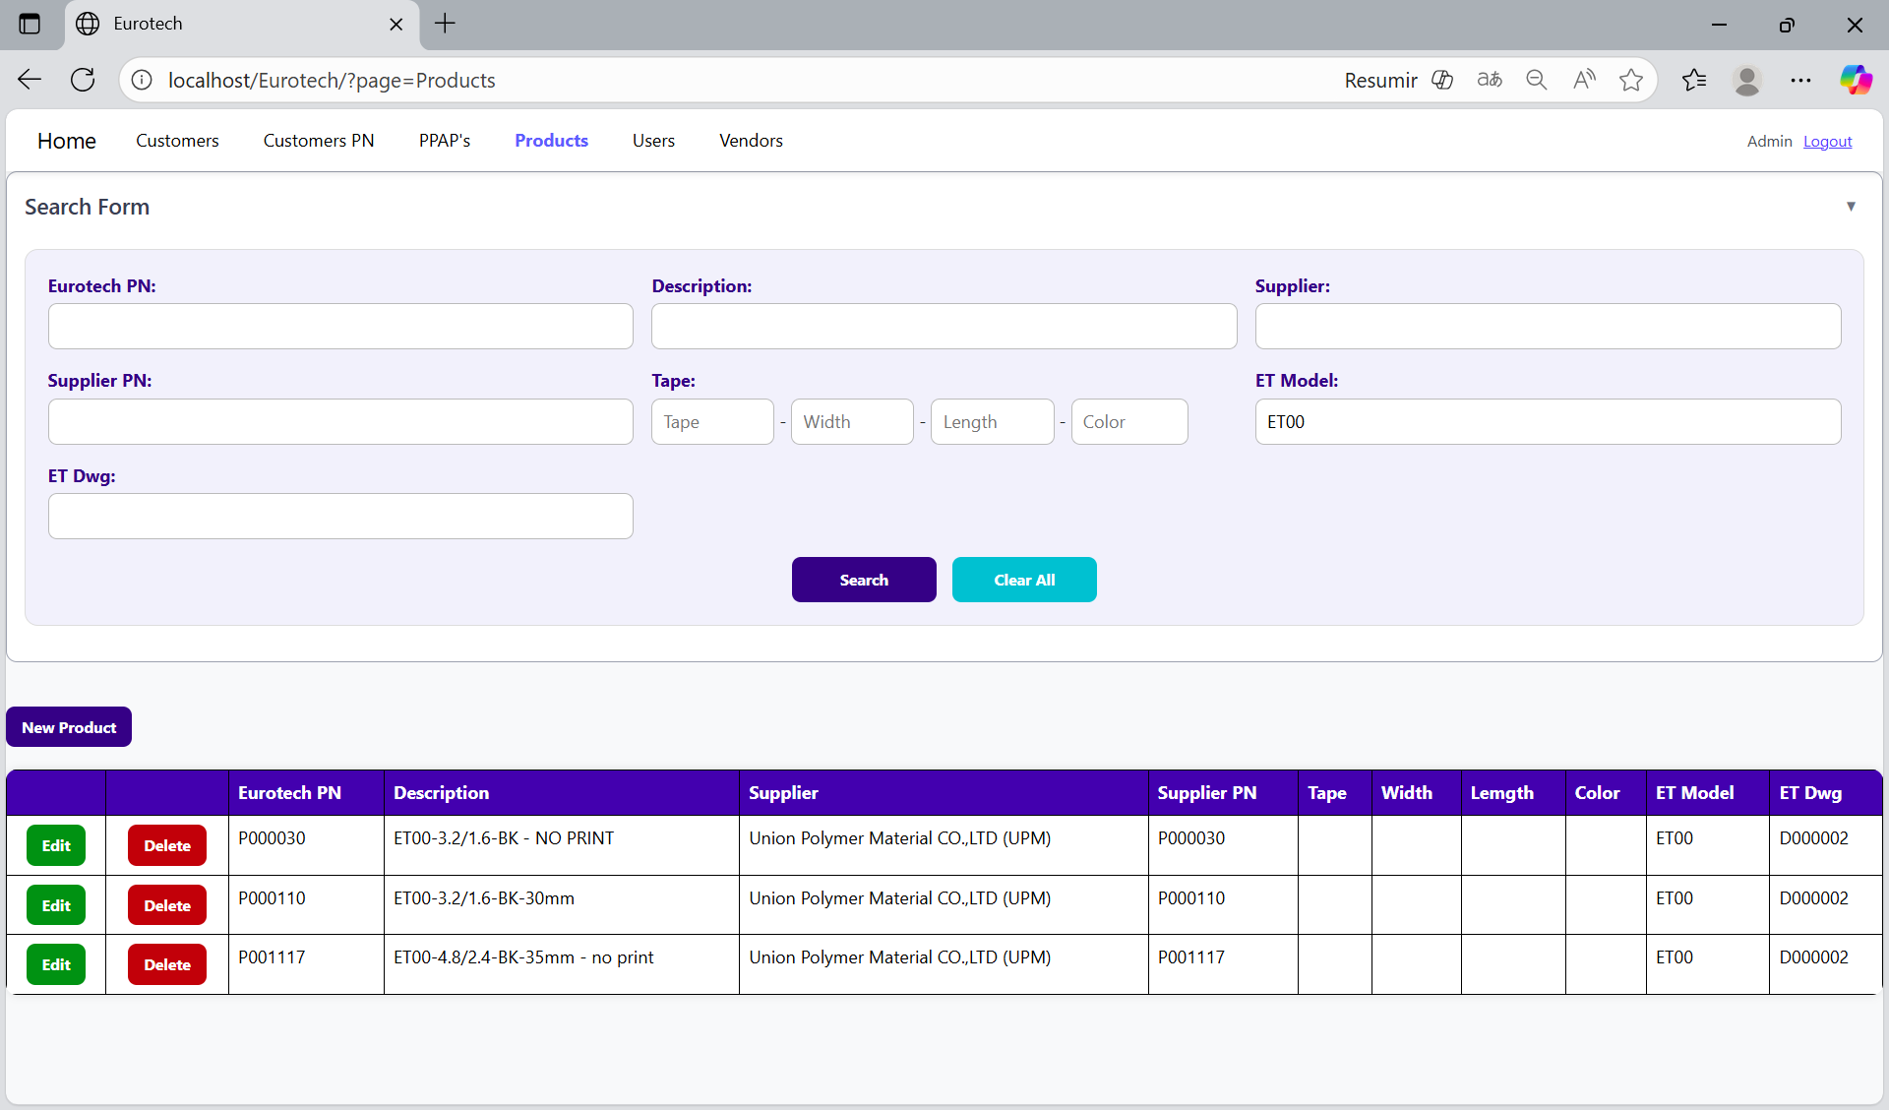

You can search by “ET Dwg”, using the “ET Dwg” field and clicking the “Search” button.

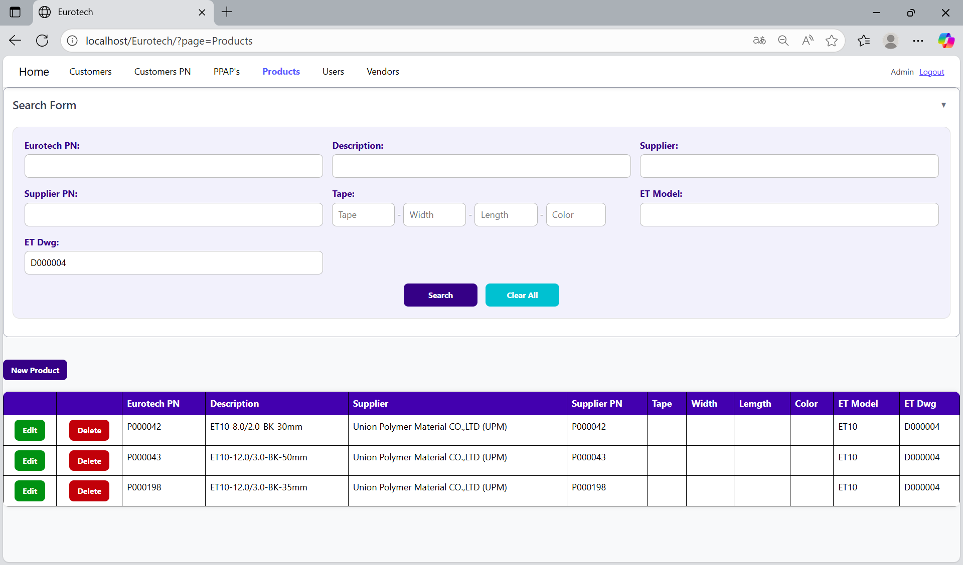

And with the “Clear All” button, you can clean the querying and see all the registers of the products.

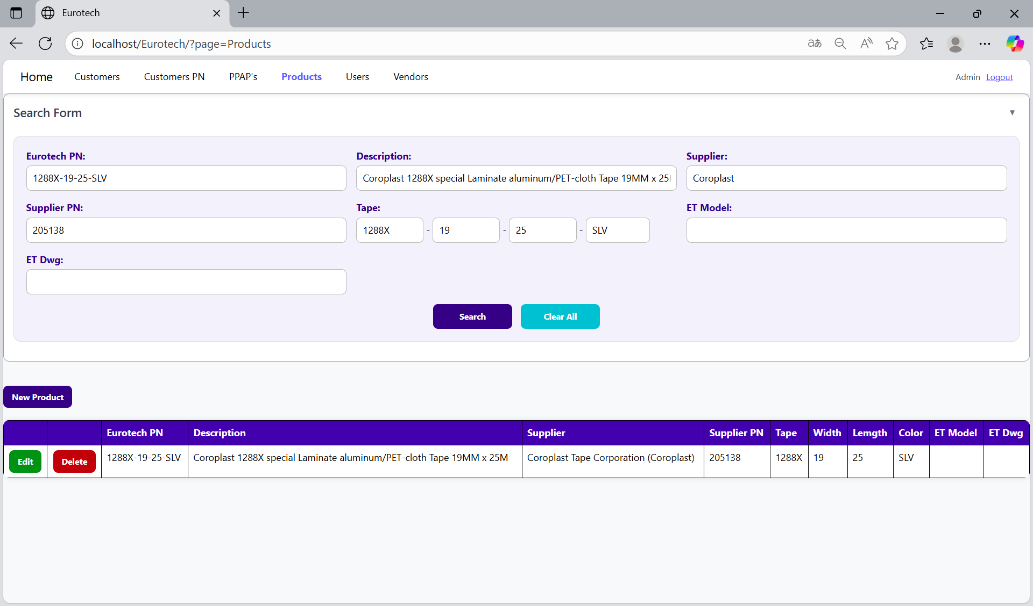

Once you click the “Clear All” button, the fields of the “Search Form” will be empty, and in the table will be shown all the products.

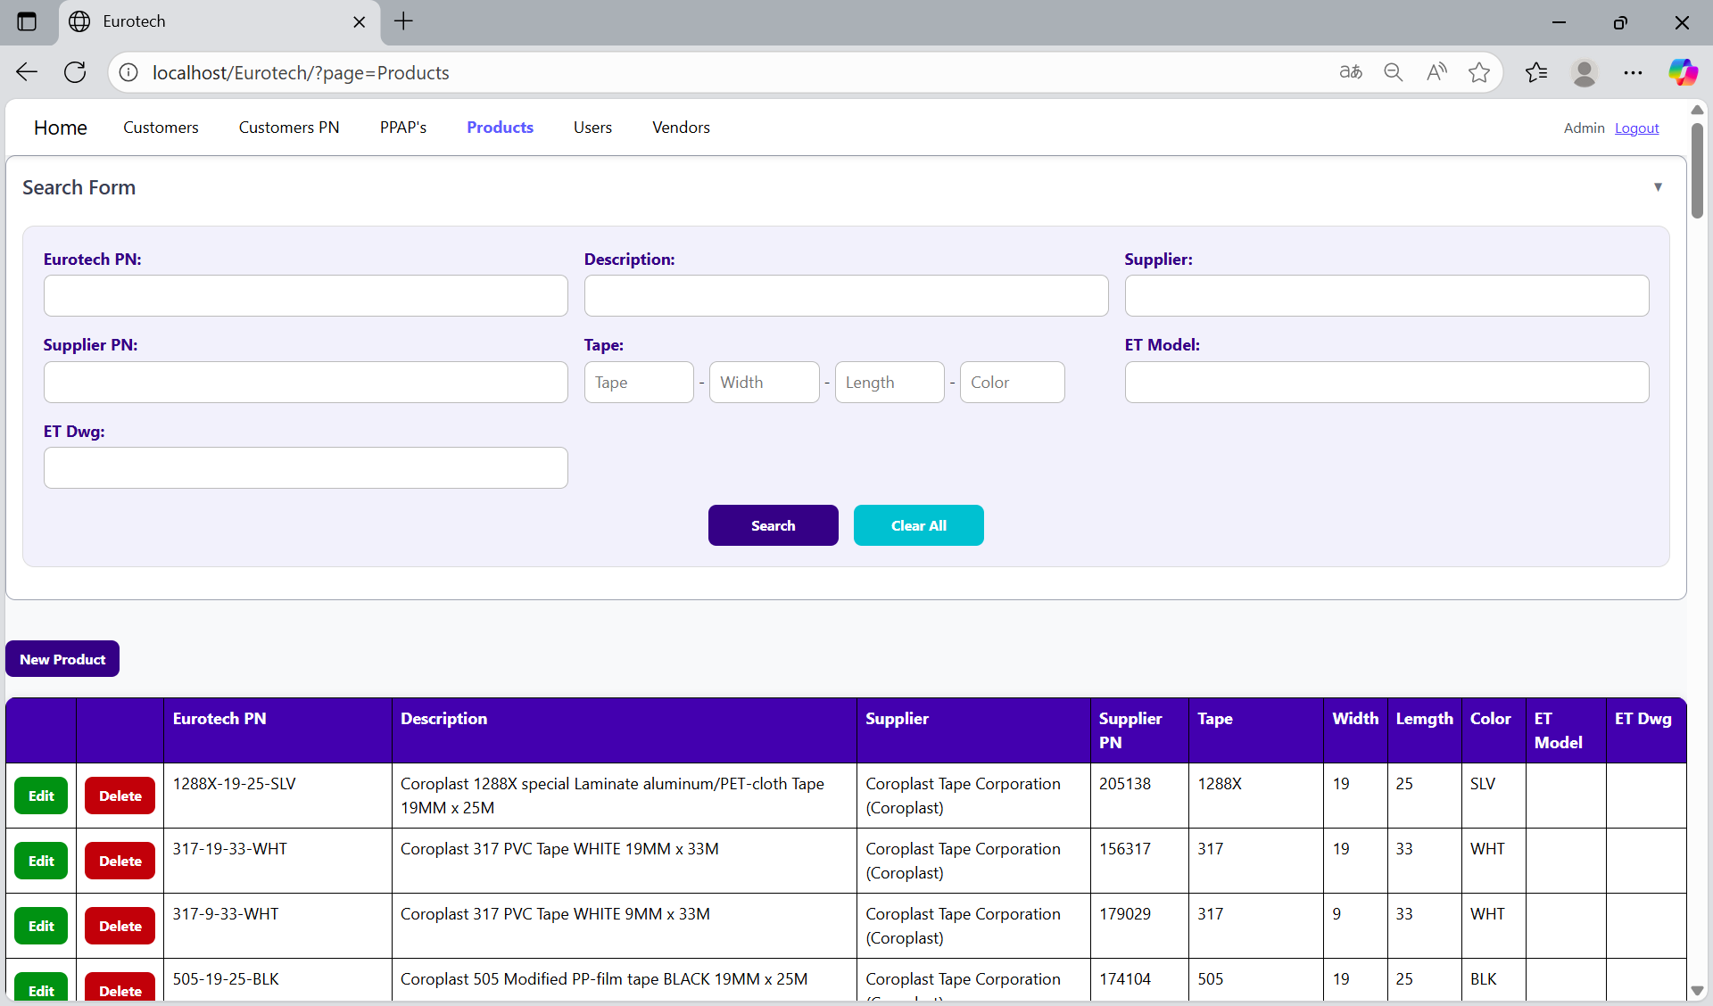

### *3.8.3 How to Add a New Product.*

If you want to add a new product, you must click the “New Product” button that is below the “Search Form”.



Once you click the “New Product” button, it will display a register form to create a new product.

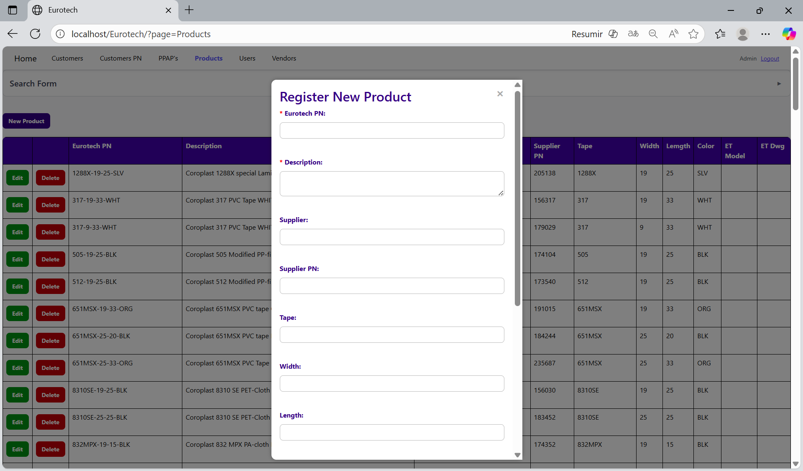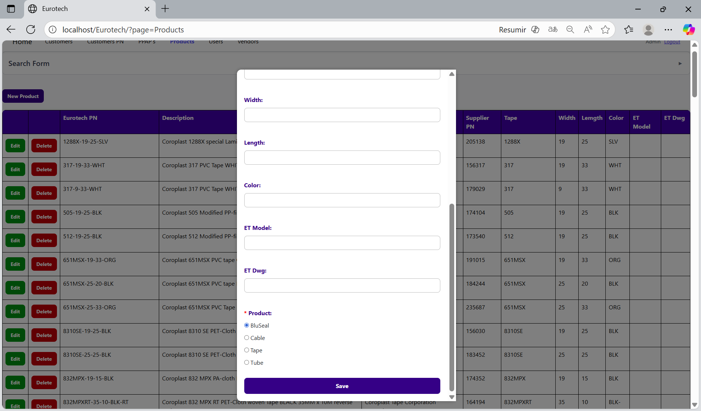

Non-mandatory fields

Mandatory fields

If you want to save the register of a new product, you must click the “Save” button.

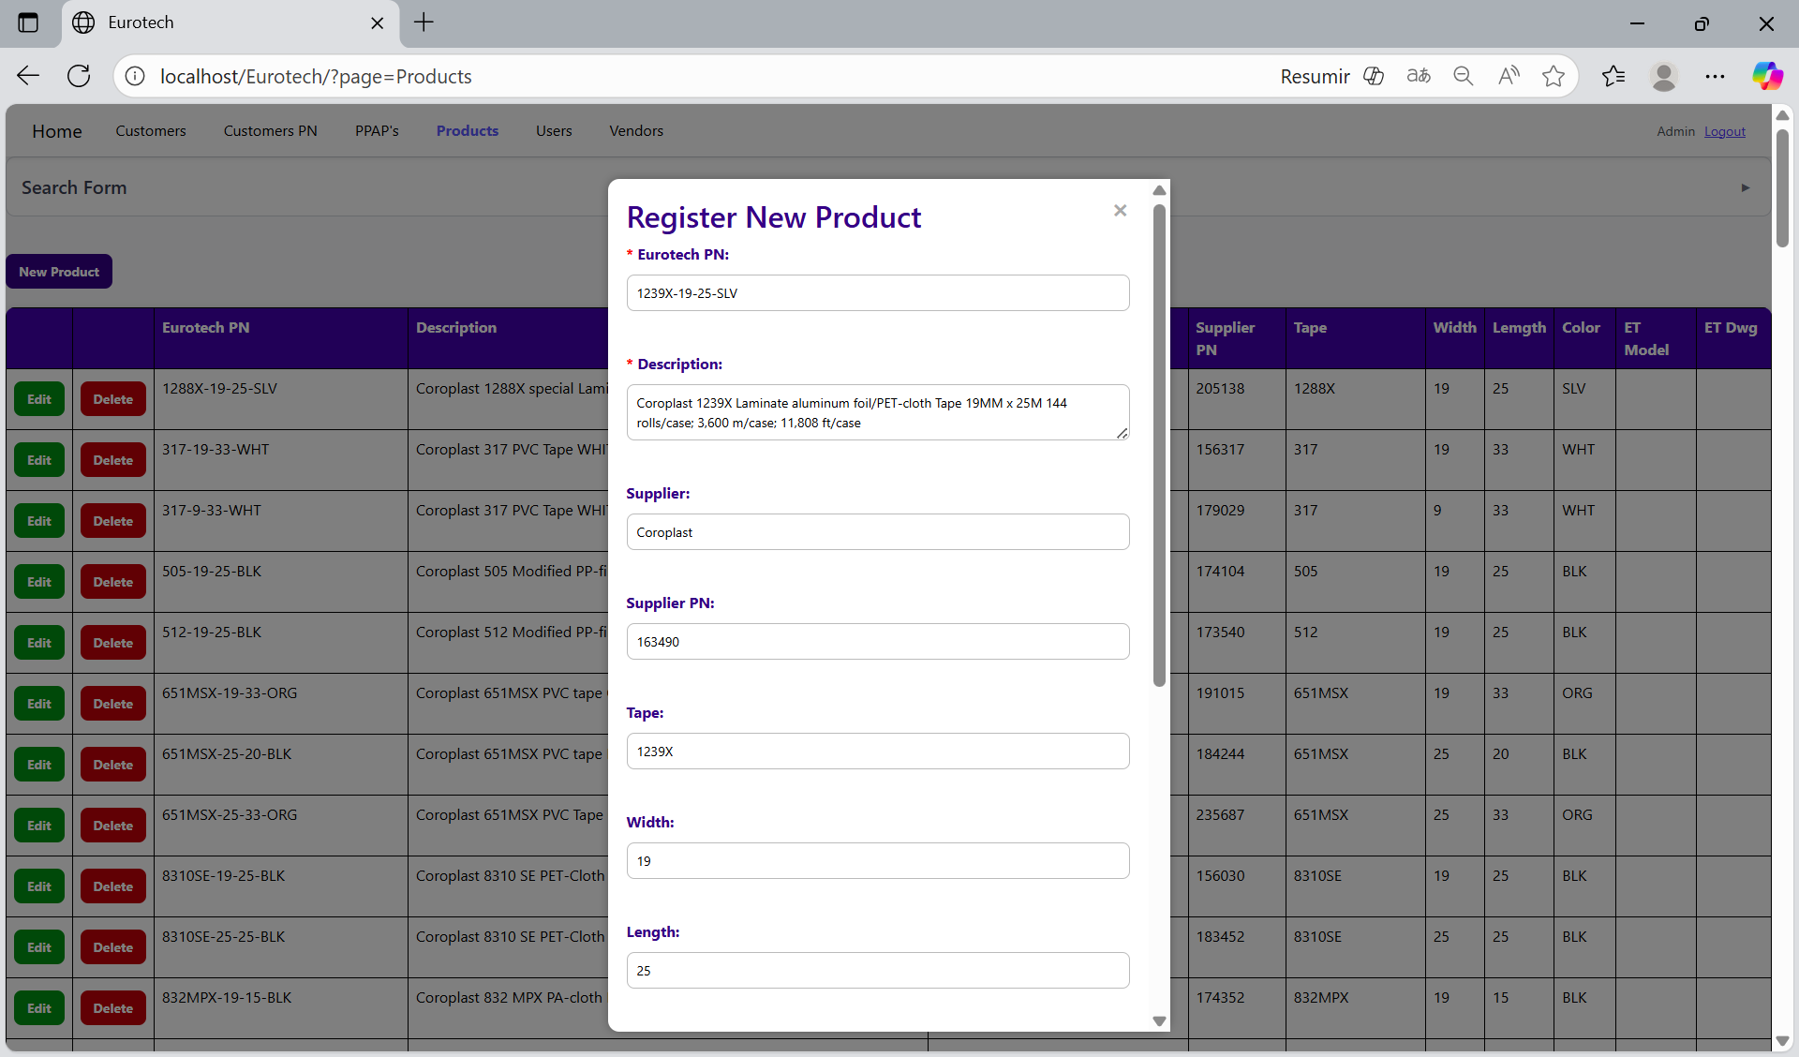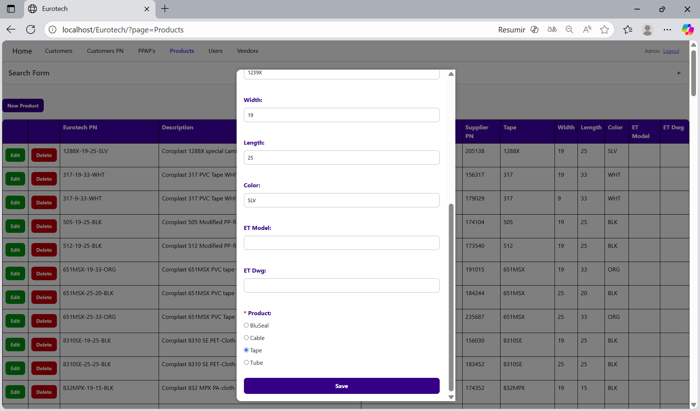

If no errors are found, the register will be added successfully.

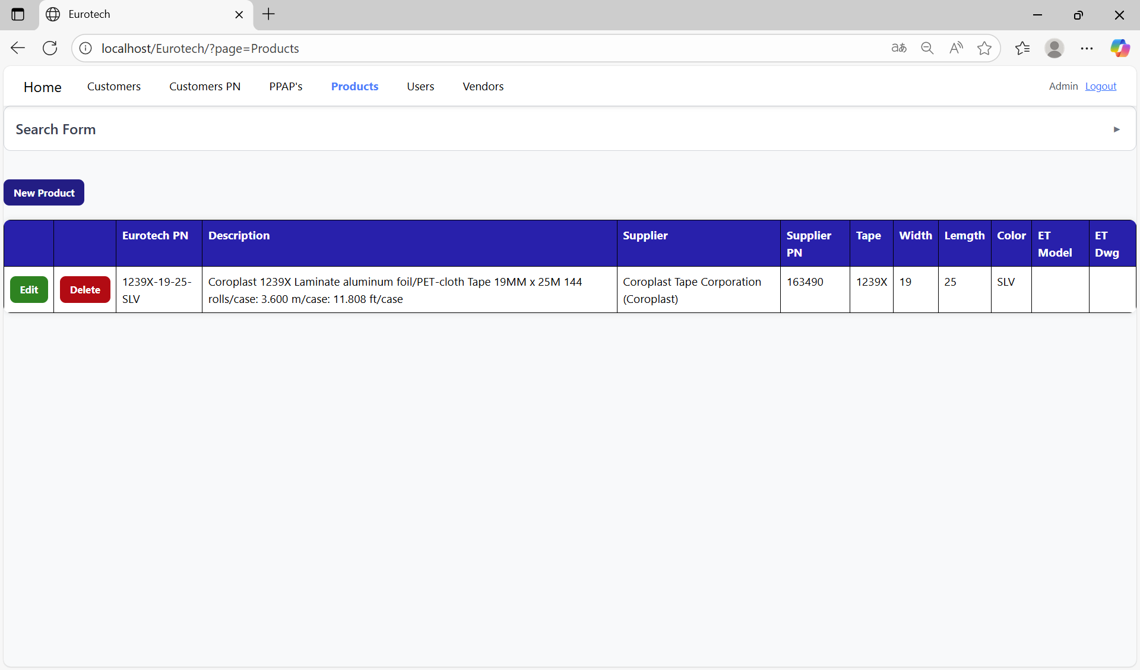

If an error is found, you can check in the Index the instruction *3.11.4.1 Register Form Errors.*

### *3.8.4 How to Edit Information of a Product.*

In each register from the table, it will be an “Edit” button. You must click the “Edit” button of the register you want to update.



Once you click the “Edit” button, it will display an update form to edit the information of the selected product.

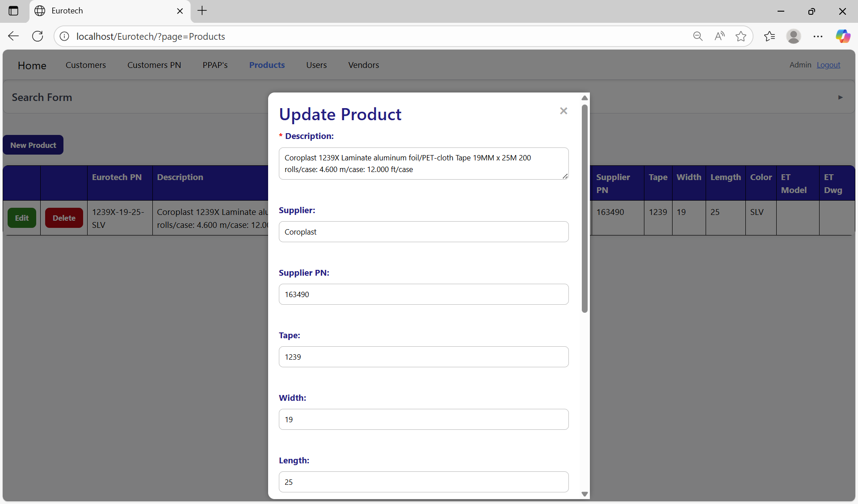

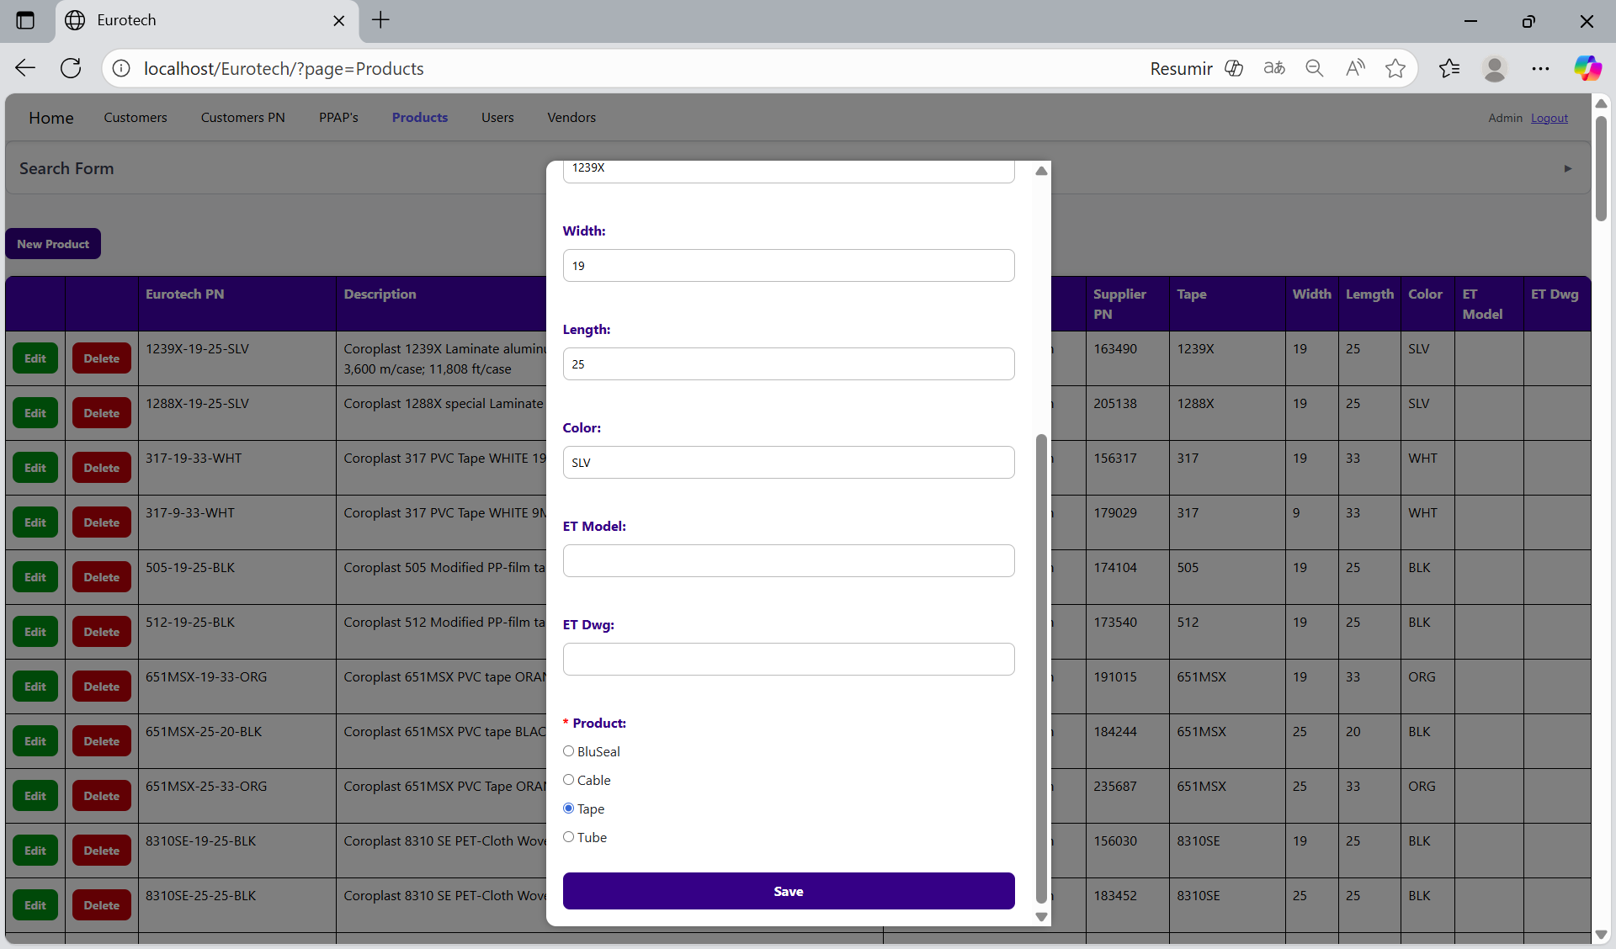

To save the changes, you must click the “Save” button.



If no errors are found, the register will be updated successfully.

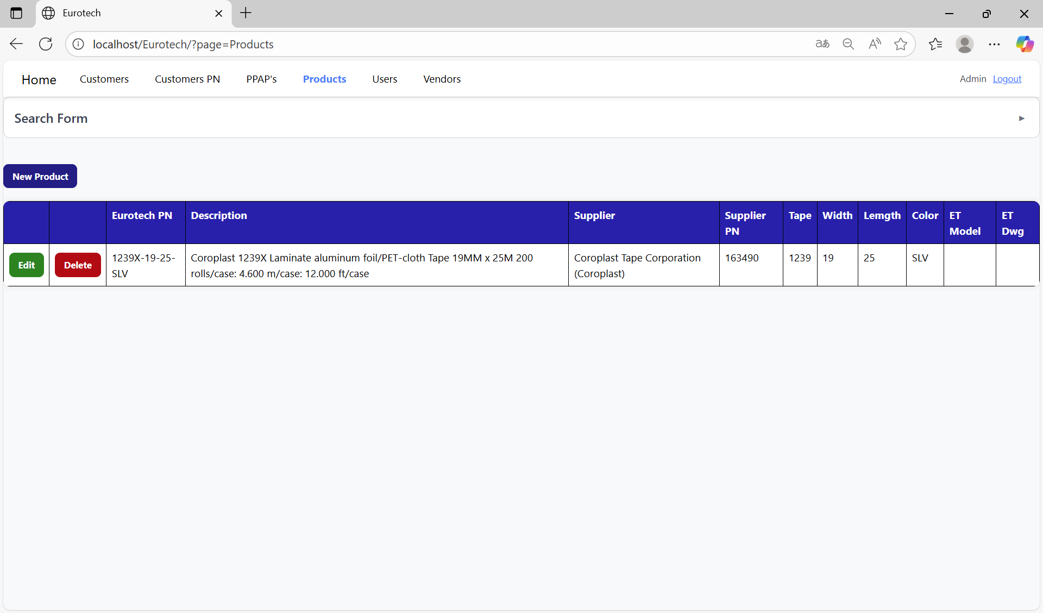

If an error is found, you can check in the Index the instruction *3.11.4.2 Edit Form Errors.*

### *3.8.5 How to Delete a Product.*

In each register from the table, it will be a “Delete” button. You must click the “Delete” button of the register you want to delete.



Once you click the “Delete” button, it will display the information of the selected product with a message to confirm the delete action. To confirm the delete of the product, you must click the “Confirm” button. It only deletes products that don’t have registers in “Customers PN” and “PPAP’s” pages.

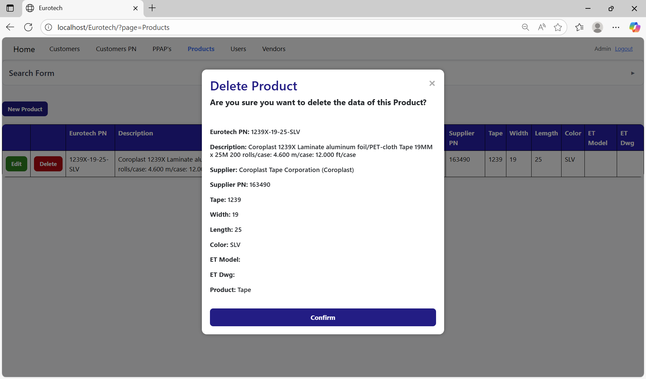

If an error is found, you can check in the Index the instruction *3.11.4.3 Delete Form Errors.*

## ***3.9 Users Page.***

### *3.9.1 How to Navigate to “Users” Page.*

On the navigation bar, you can navigate to the “Users” page.

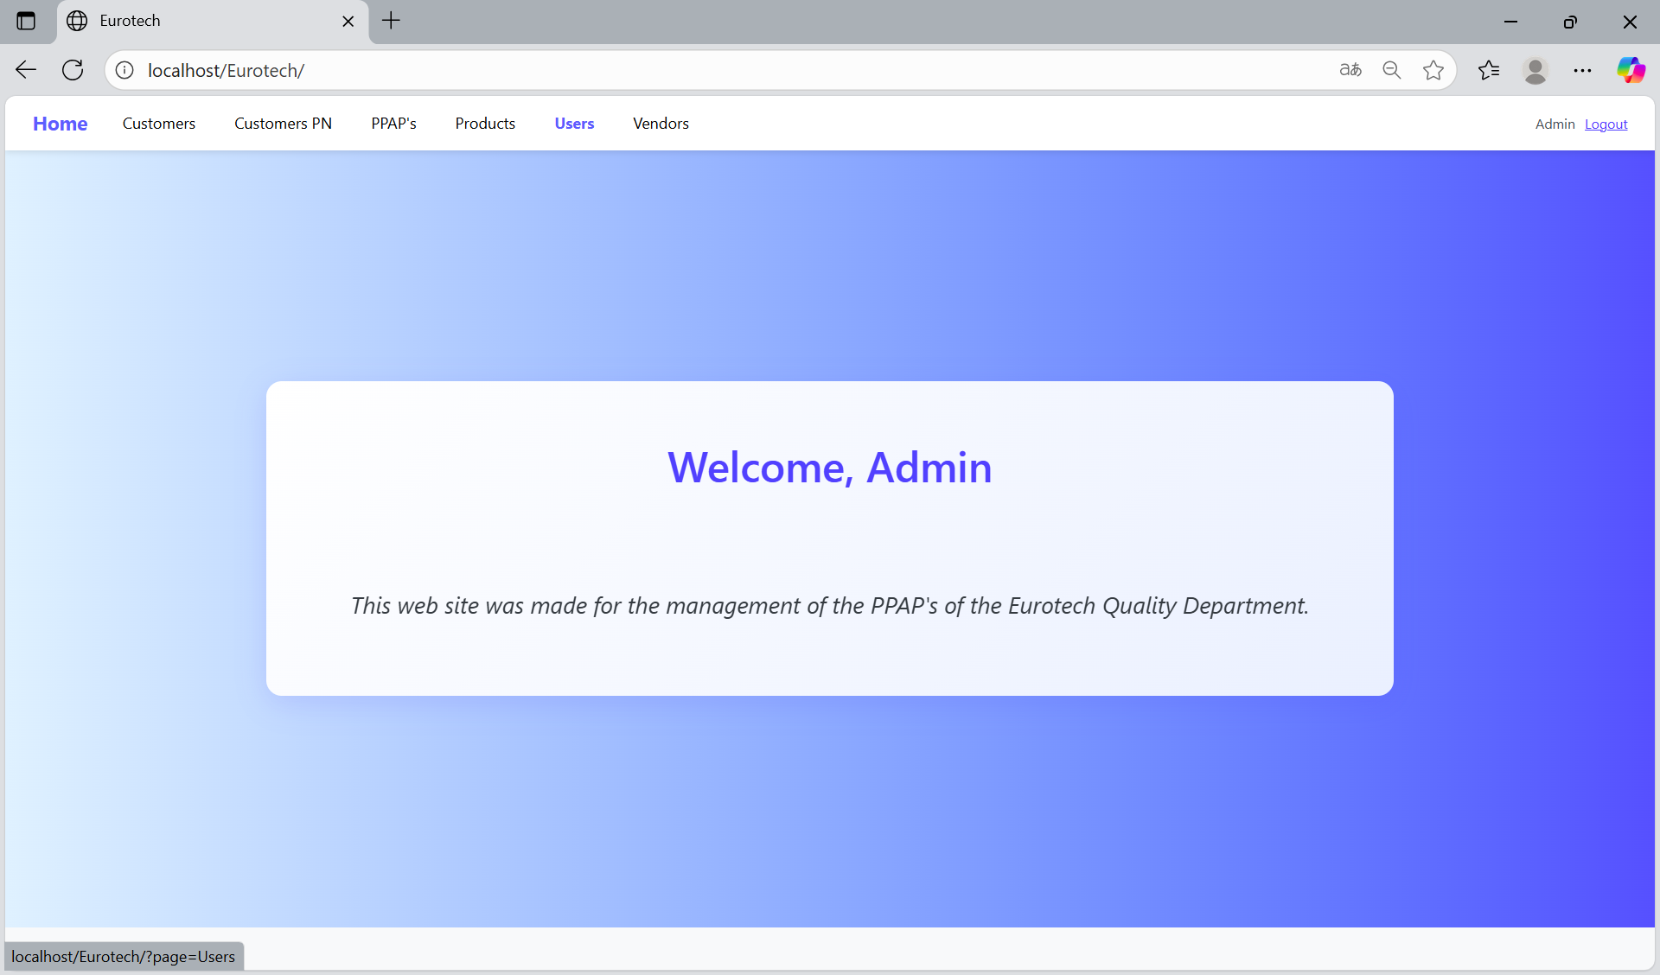

In this page you can manage the registers of all the users.

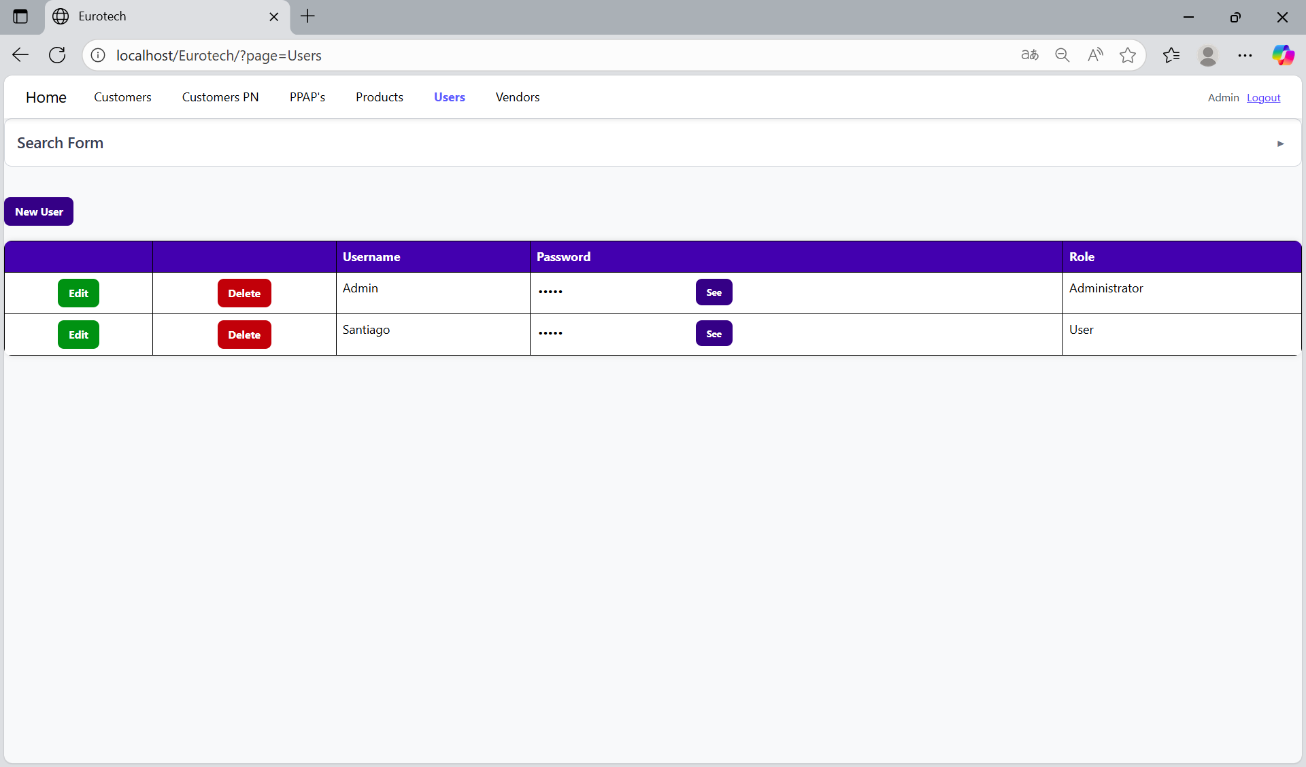

### *3.9.2 How to Search a User.*

At the top of the page, it will be a dropdown “Search Form” that has all the fields of the table for querying registers.

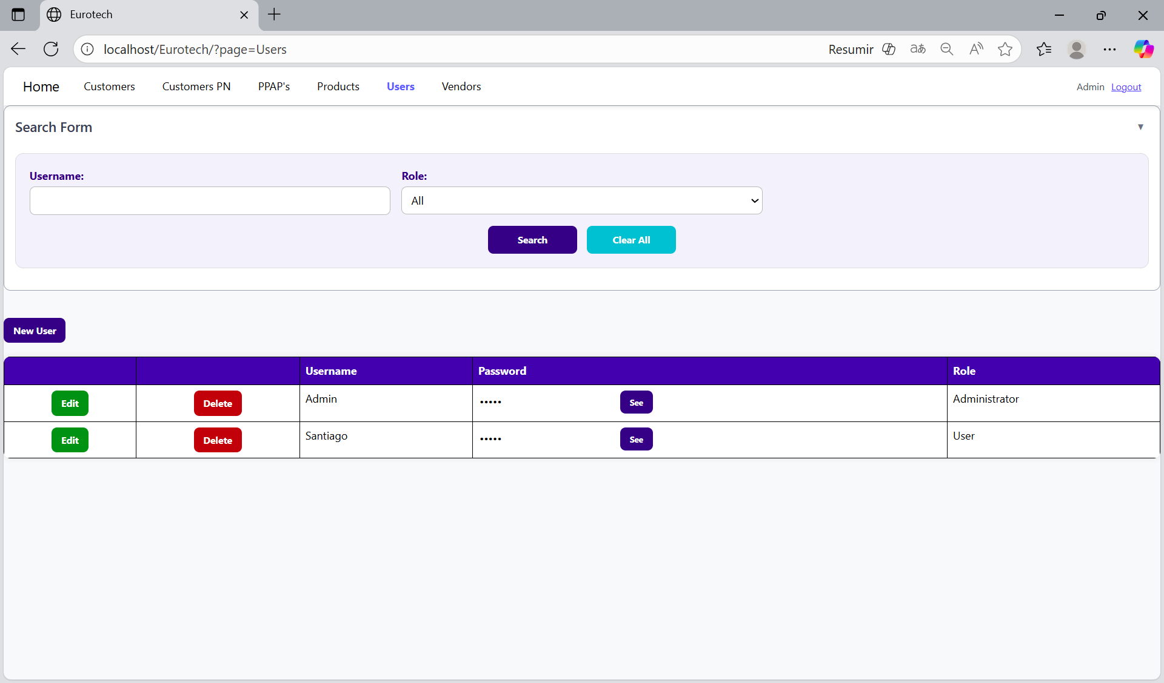

The search form allows you to perform searches by “Username” and “Role”.

You can search by “Username”, using the “Username” field and clicking the “Search” button.

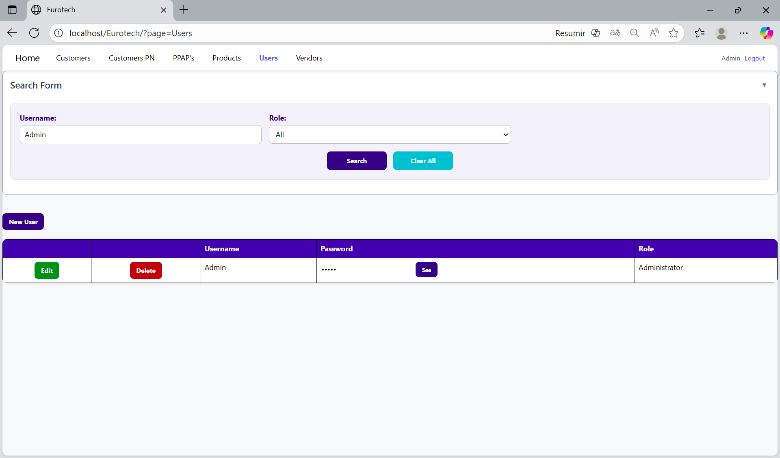

You can search by “Role”, using the “Role” field and clicking the “Search” button.

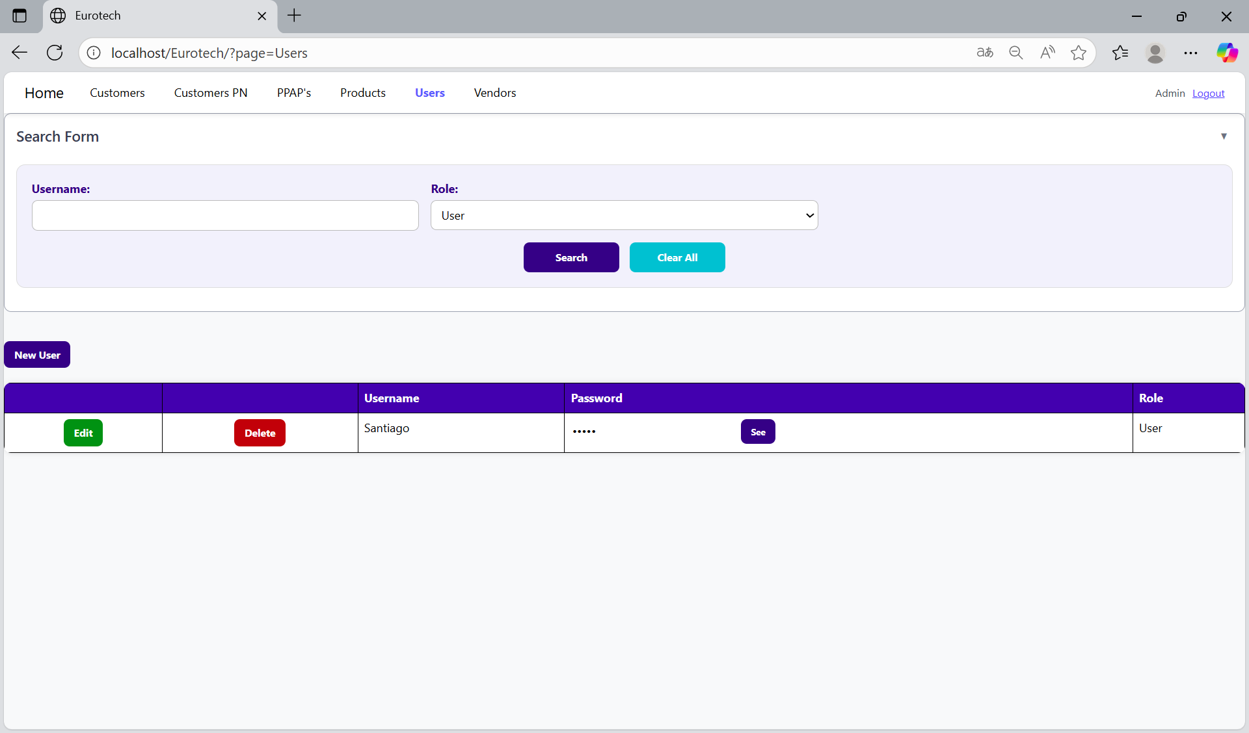

And with the “Clear All” button, you can clean the querying and see all the registers of the users.

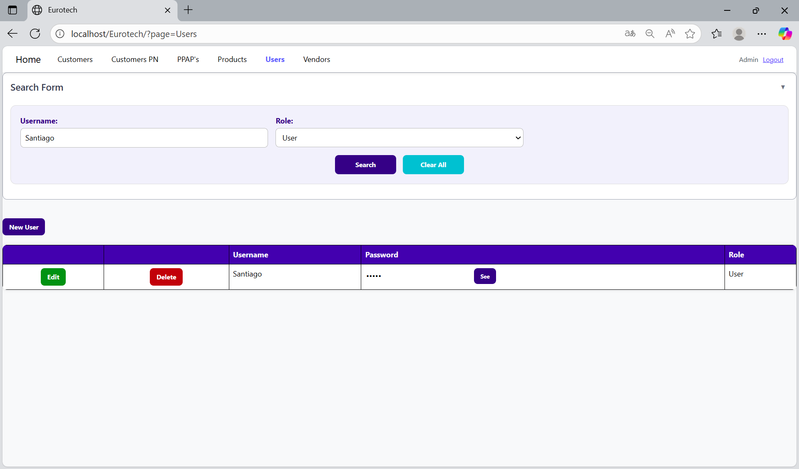

Once you click the “Clear All” button, the fields of the “Search Form” will be empty, and in the table will be shown all the users.

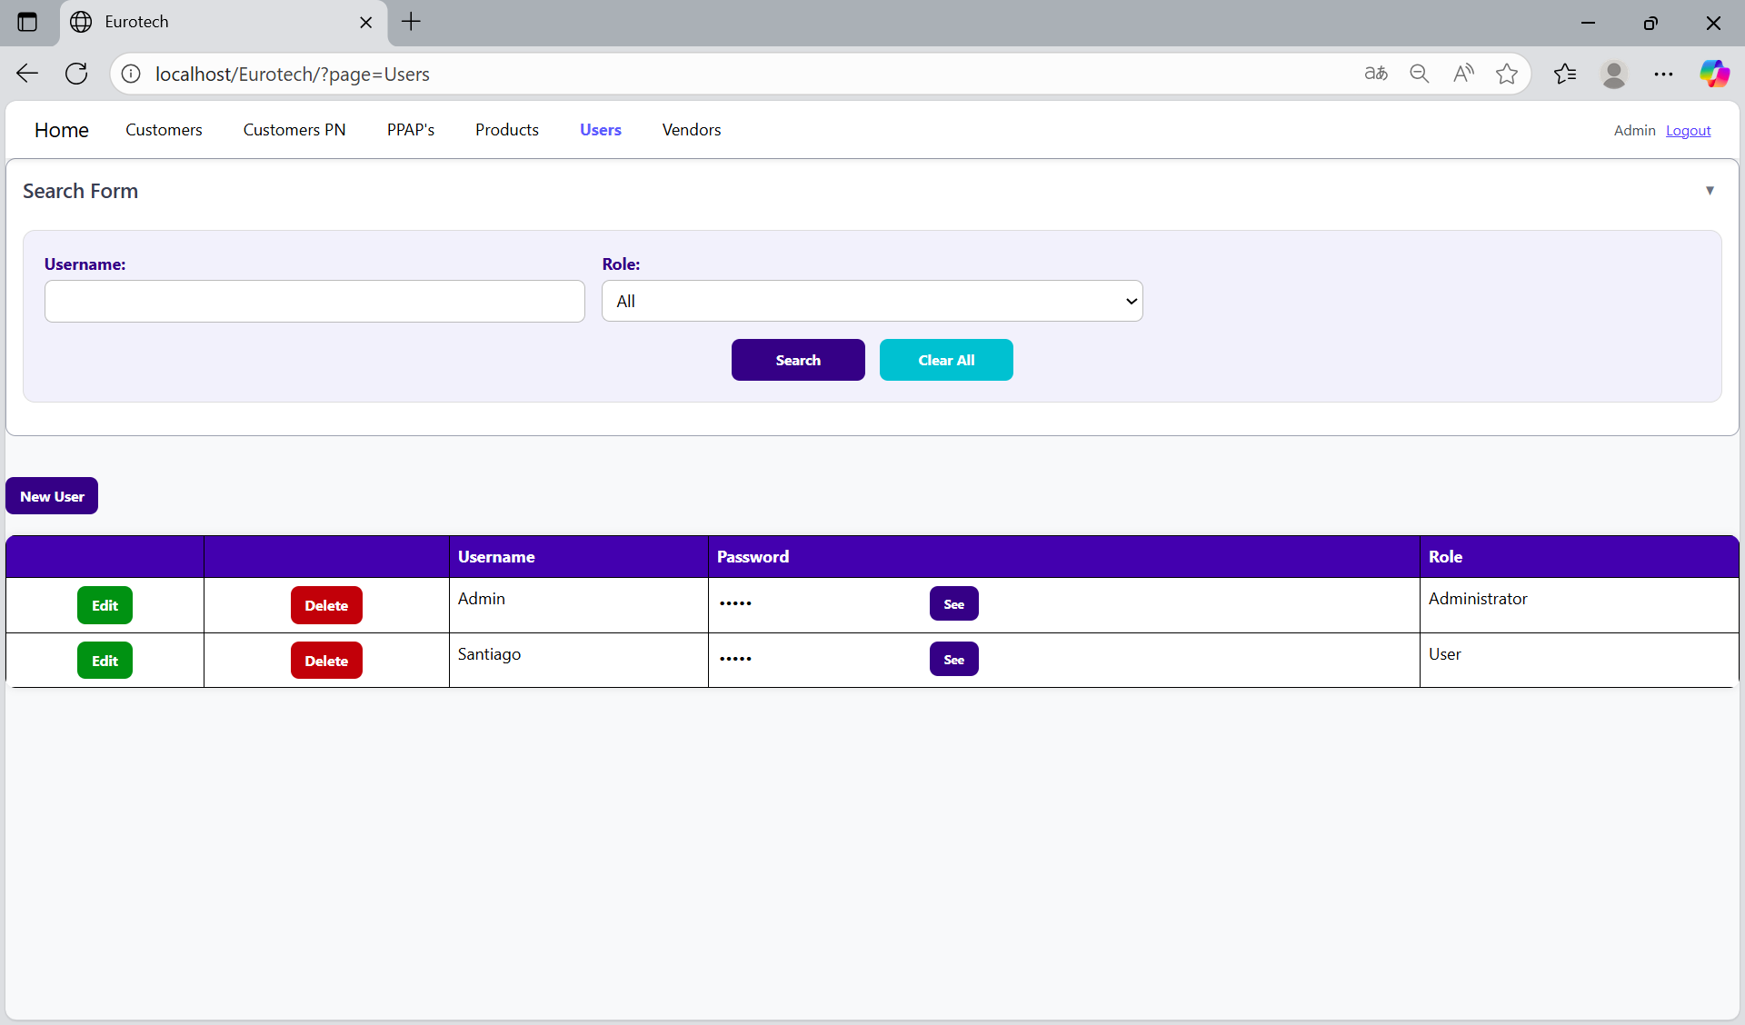

### *3.9.3 How to Add a New User.*

If you want to add a new user, you must click the “New User” button that is below the “Search Form”.

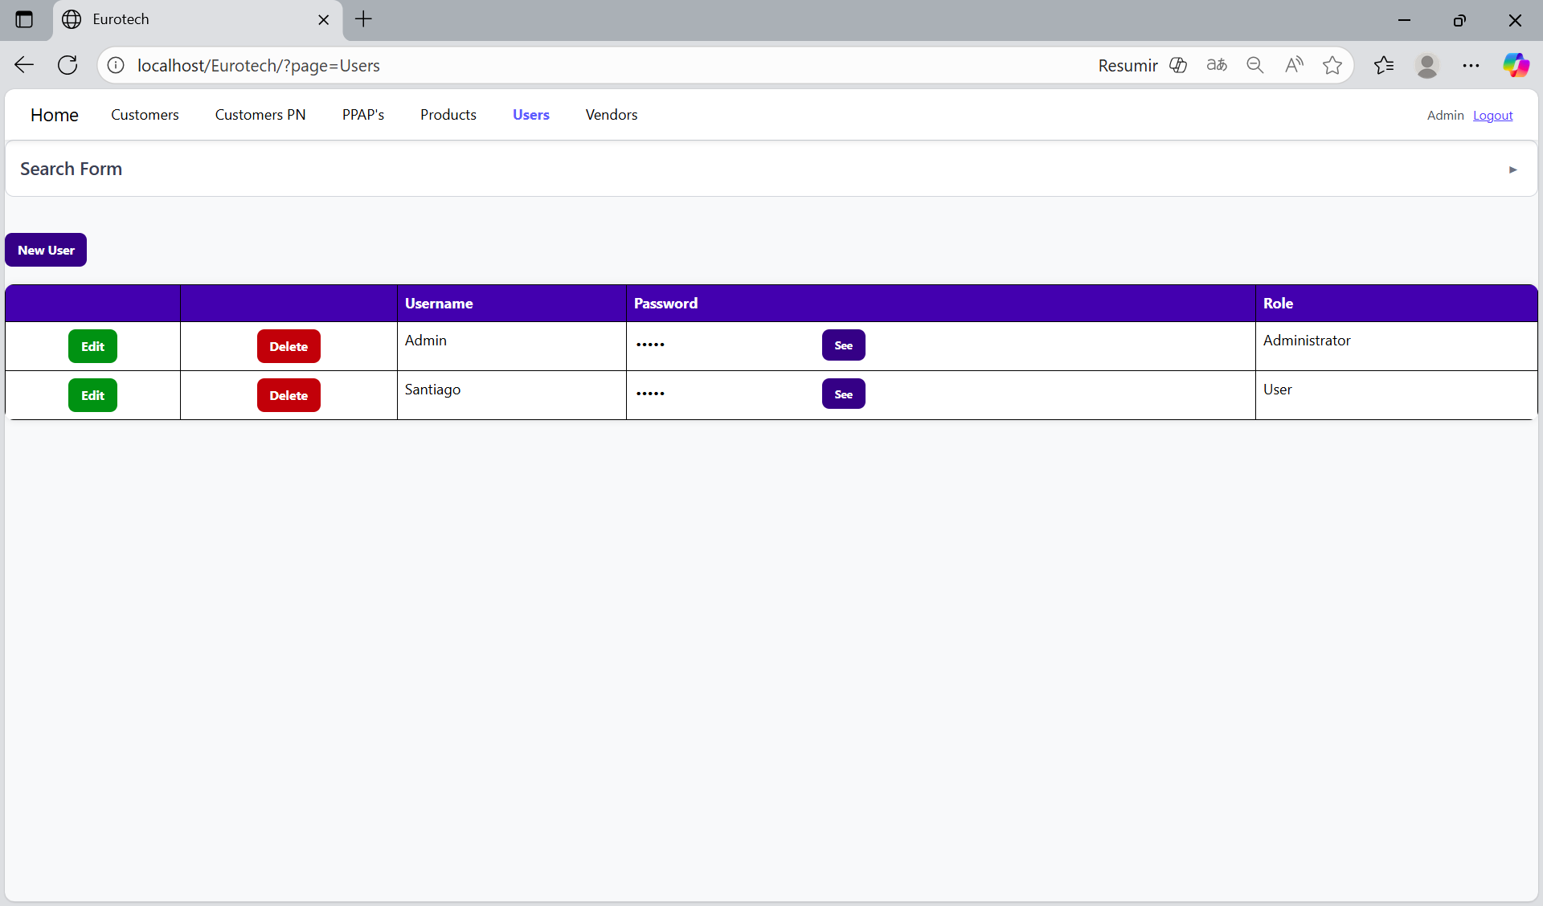

Once you click the “New User” button, it will display a register form to create a new user.

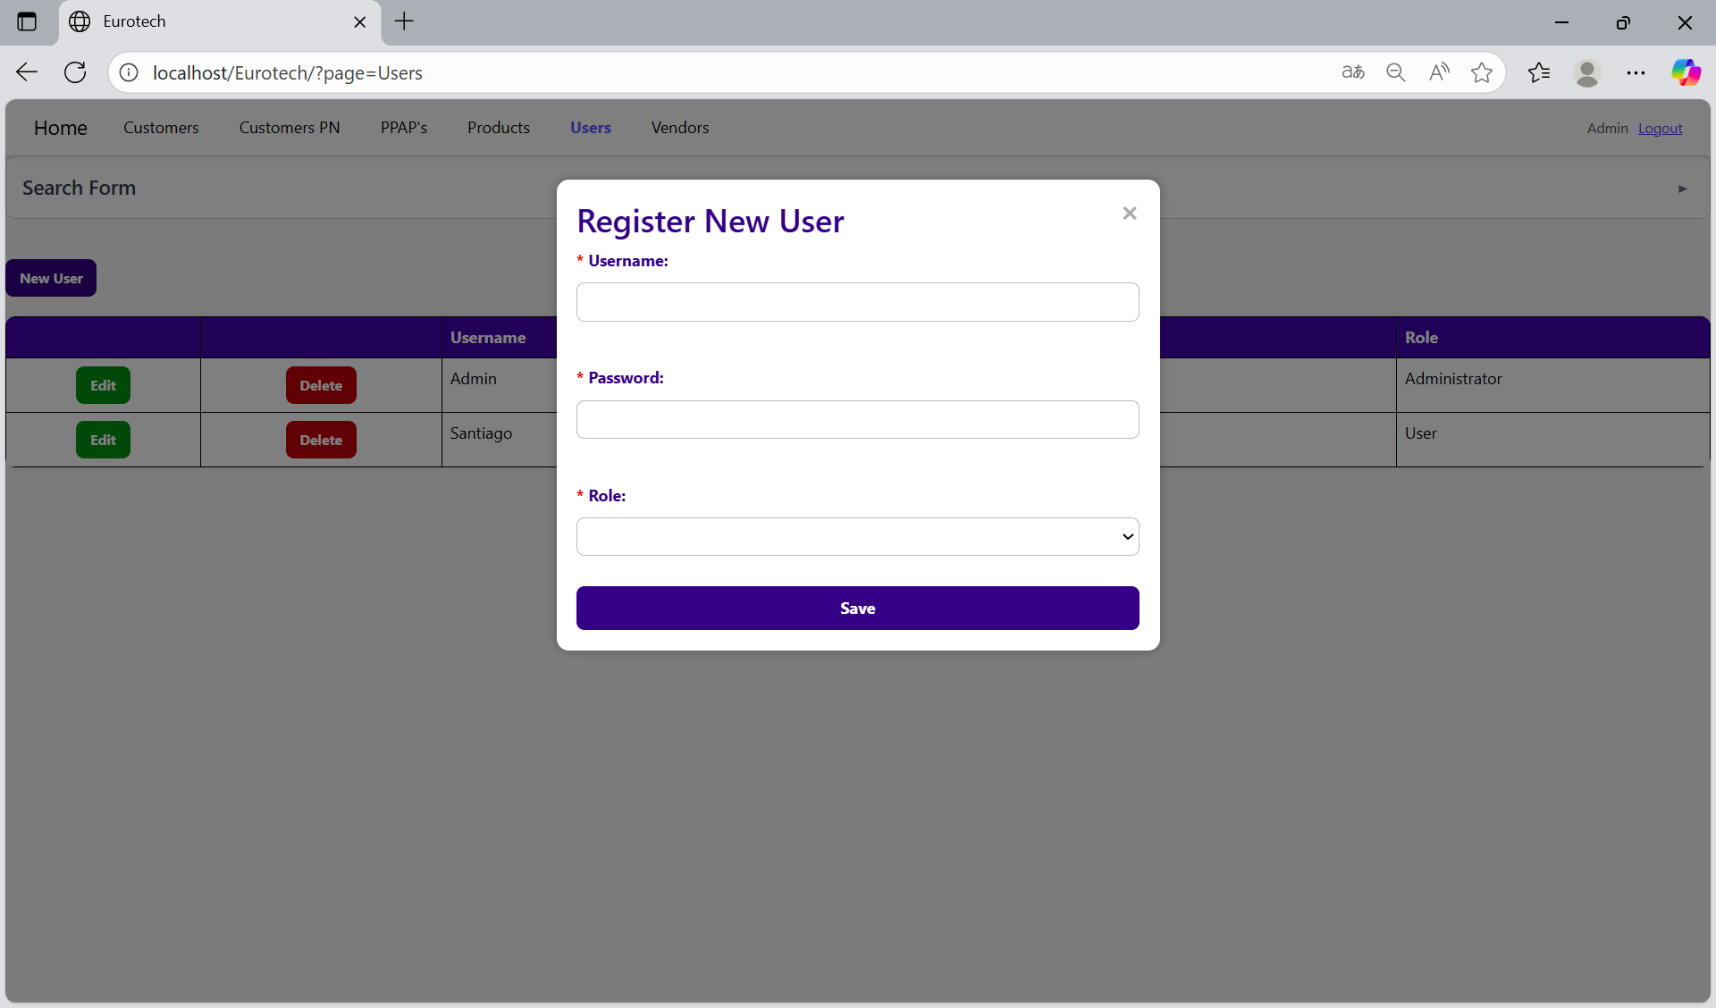

Mandatory fields

If you want to save the register of a new user, you must click the “Save” button.

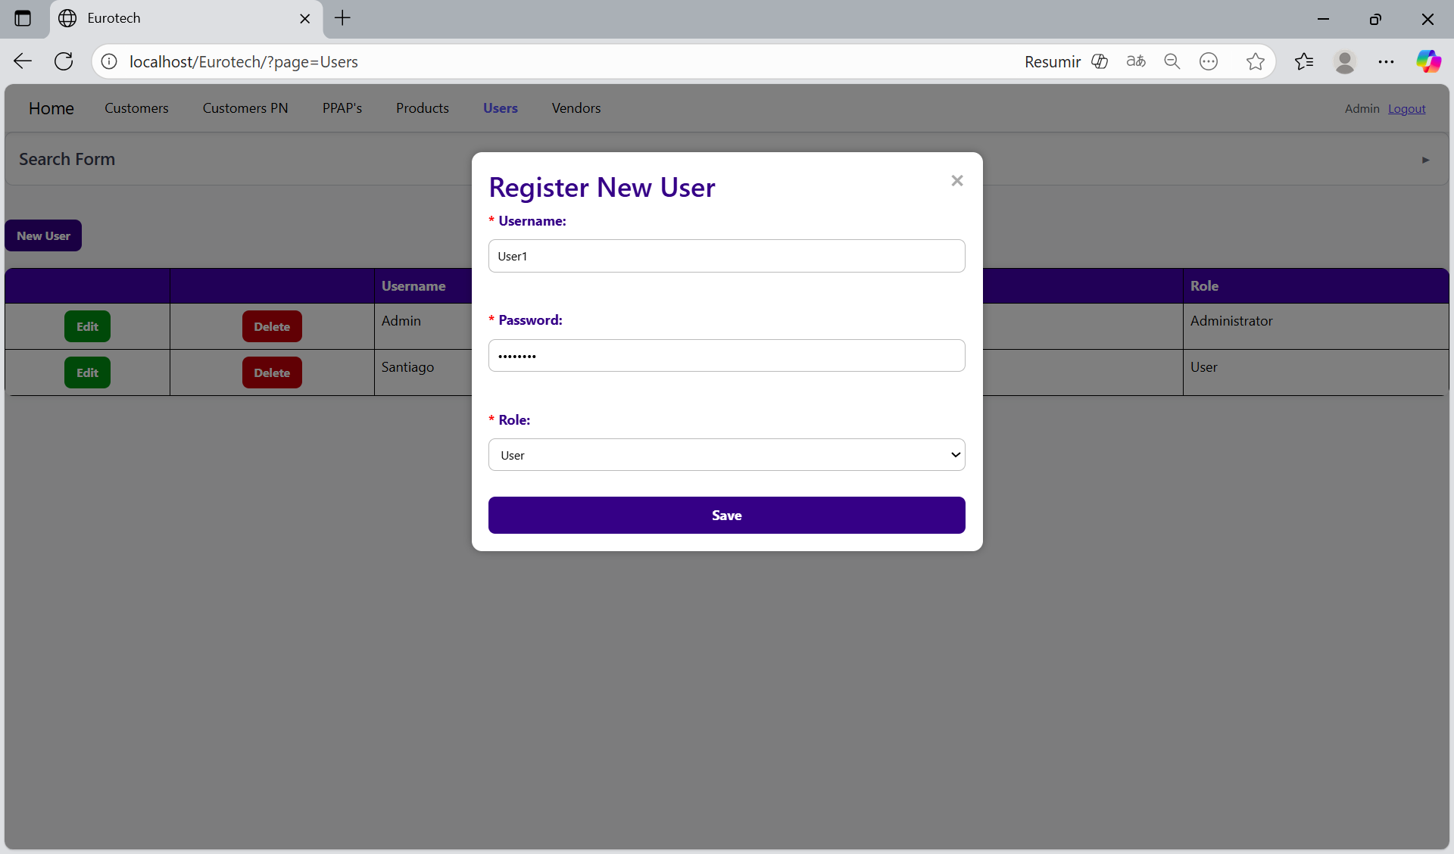

If no errors are found, the register will be added successfully.

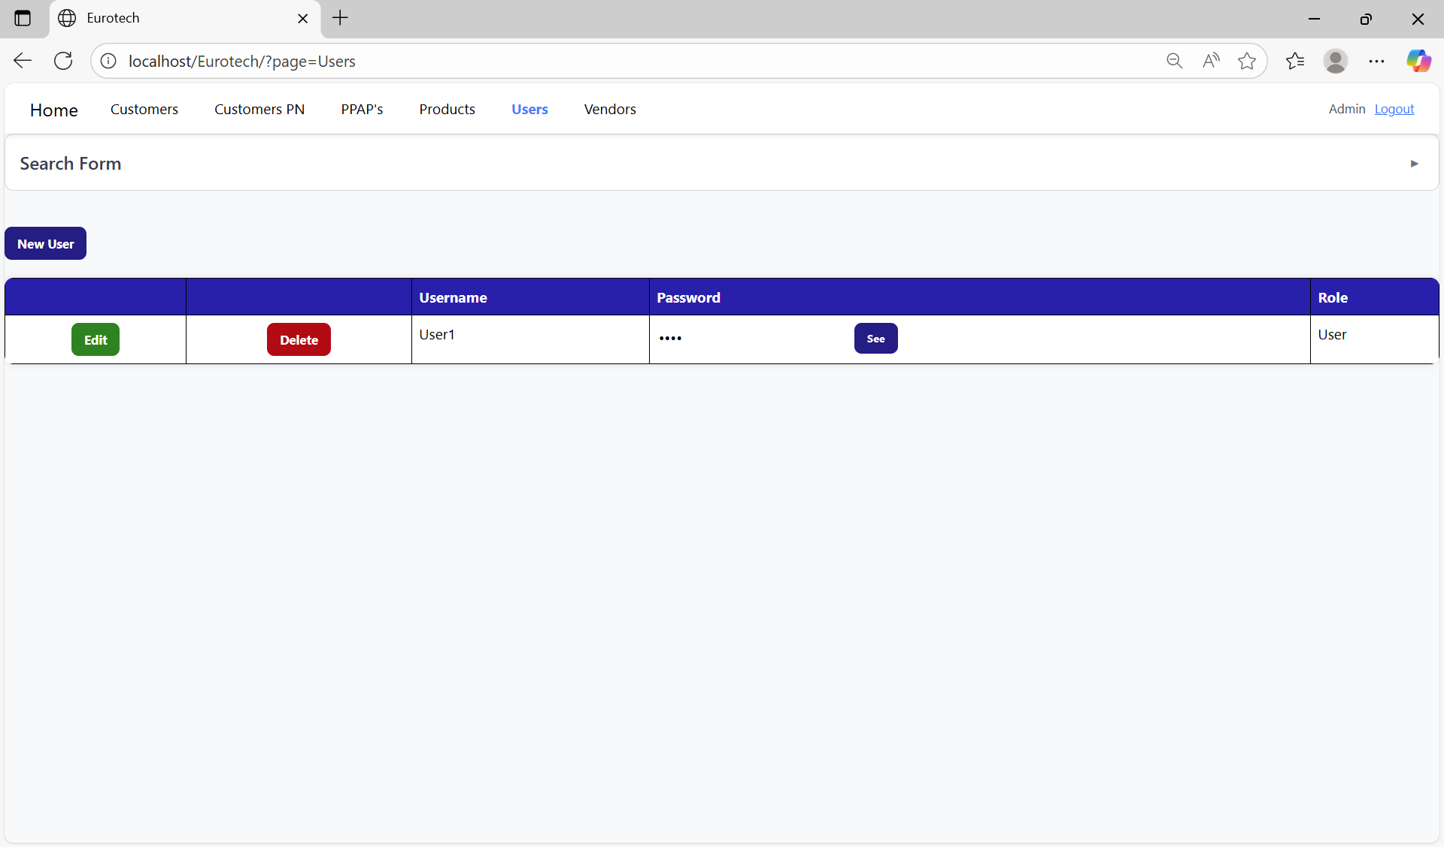

If an error is found, you can check in the Index the instruction *3.11.5.1 Register Form Errors.*

### *3.9.4 How to Edit Information of a User.*

In each register from the table, it will be an “Edit” button. You must click the “Edit” button of the register you want to update.



Once you click the “Edit” button, it will display an update form to edit the information of the selected user.

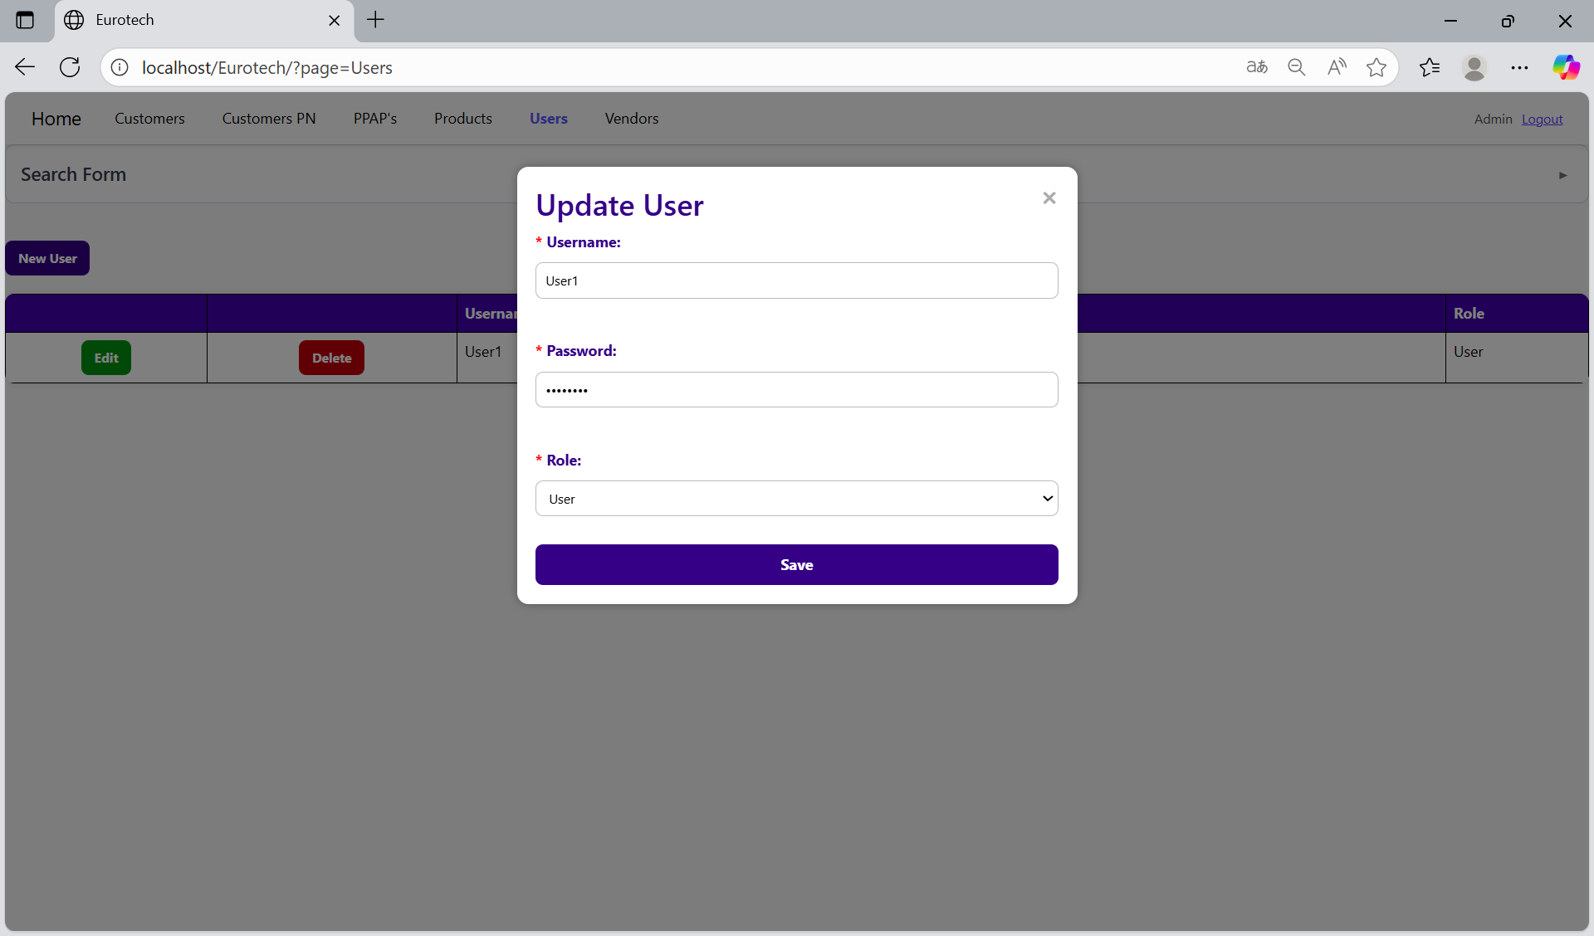

To save the changes, you must click the “Save” button.

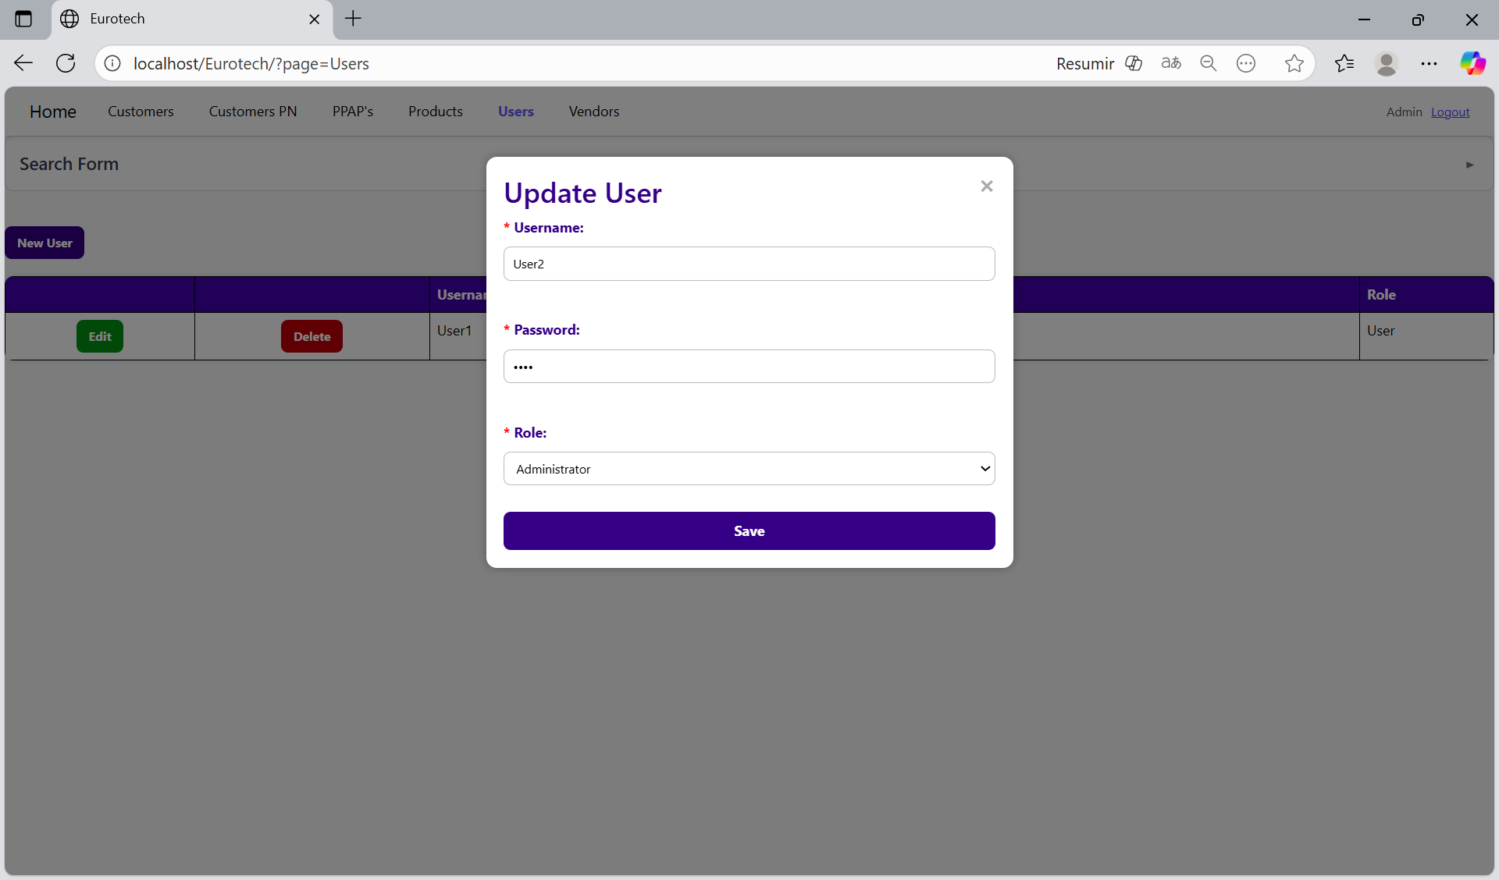

If no errors are found, the register will be updated successfully.

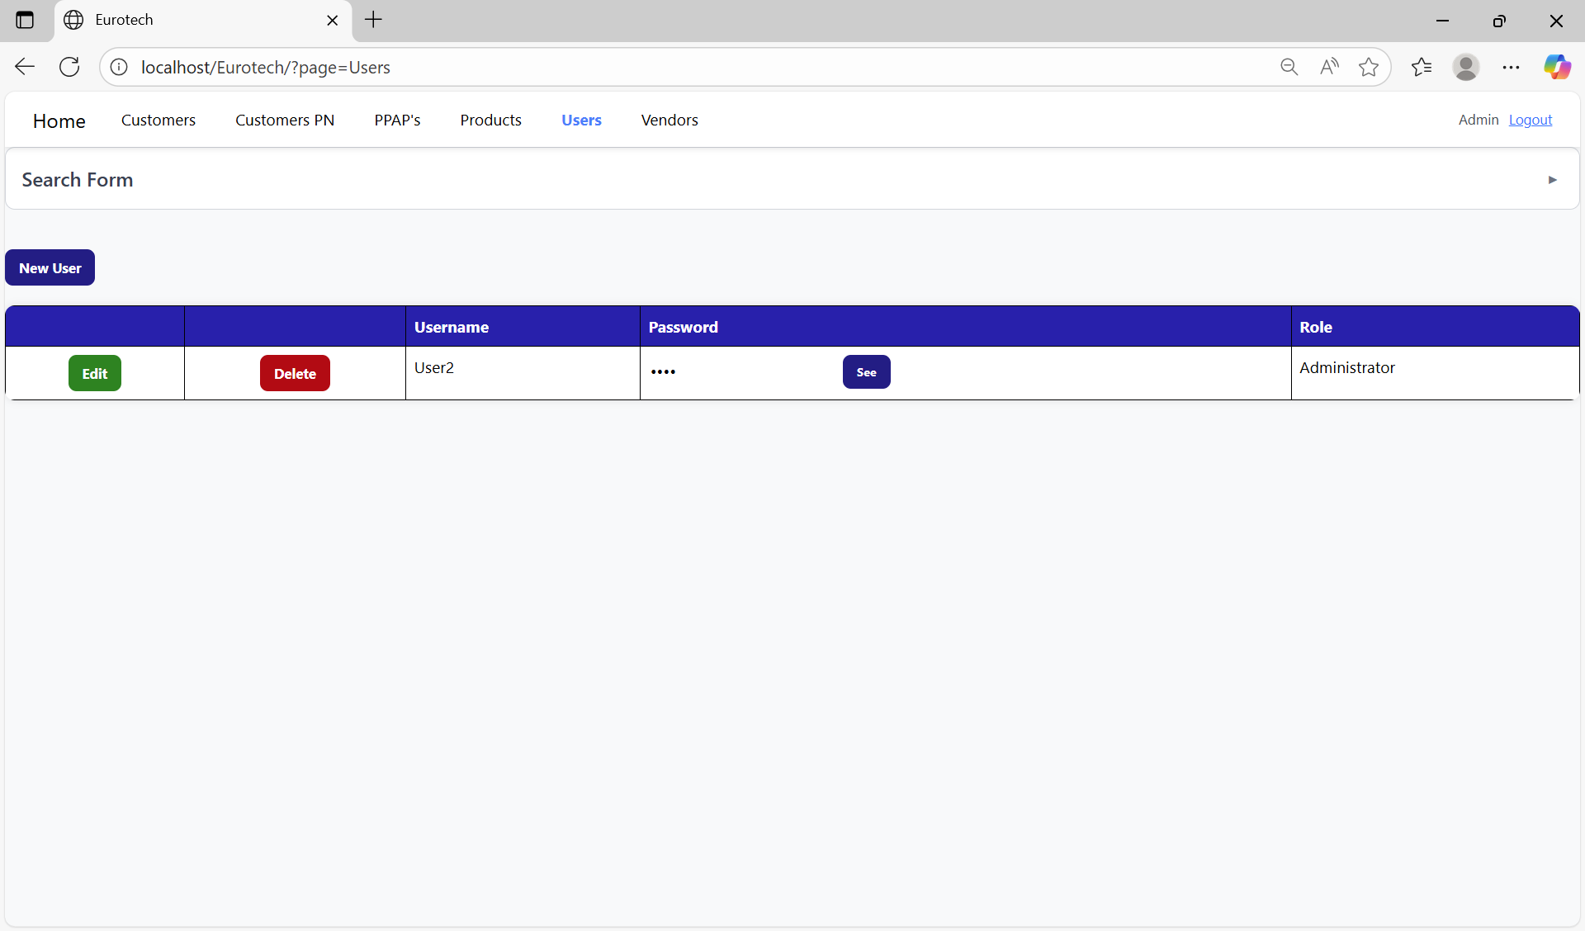

If an error is found, you can check in the Index the instruction *3.11.5.2 Edit Form Errors.*

### *3.9.5 How to Delete a User.*

In each register from the table, it will be a “Delete” button. You must click the “Delete” button of the register you want to delete.



Once you click the “Delete” button, it will display the information of the selected user with a message to confirm the delete action. To confirm the delete of the user, you must click the “Confirm” button.

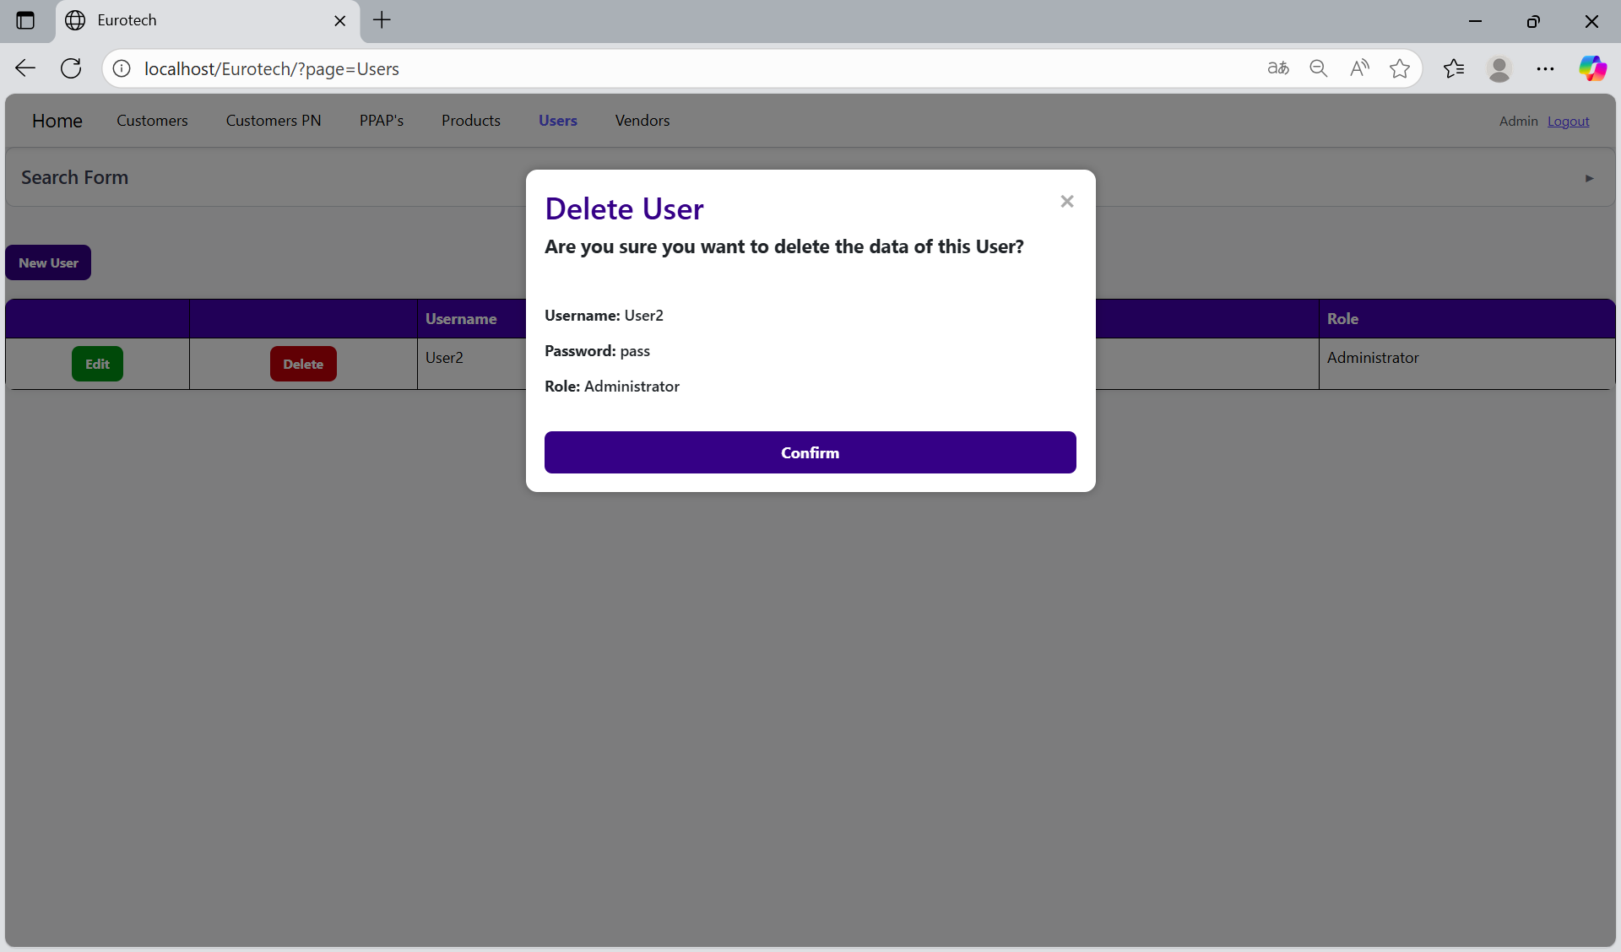

### *3.9.6 How to Check the Password of a User.*

In each register from the table, it will be a “See” button in the “Password” column. You must click the “See” button of the register you want to know the password.

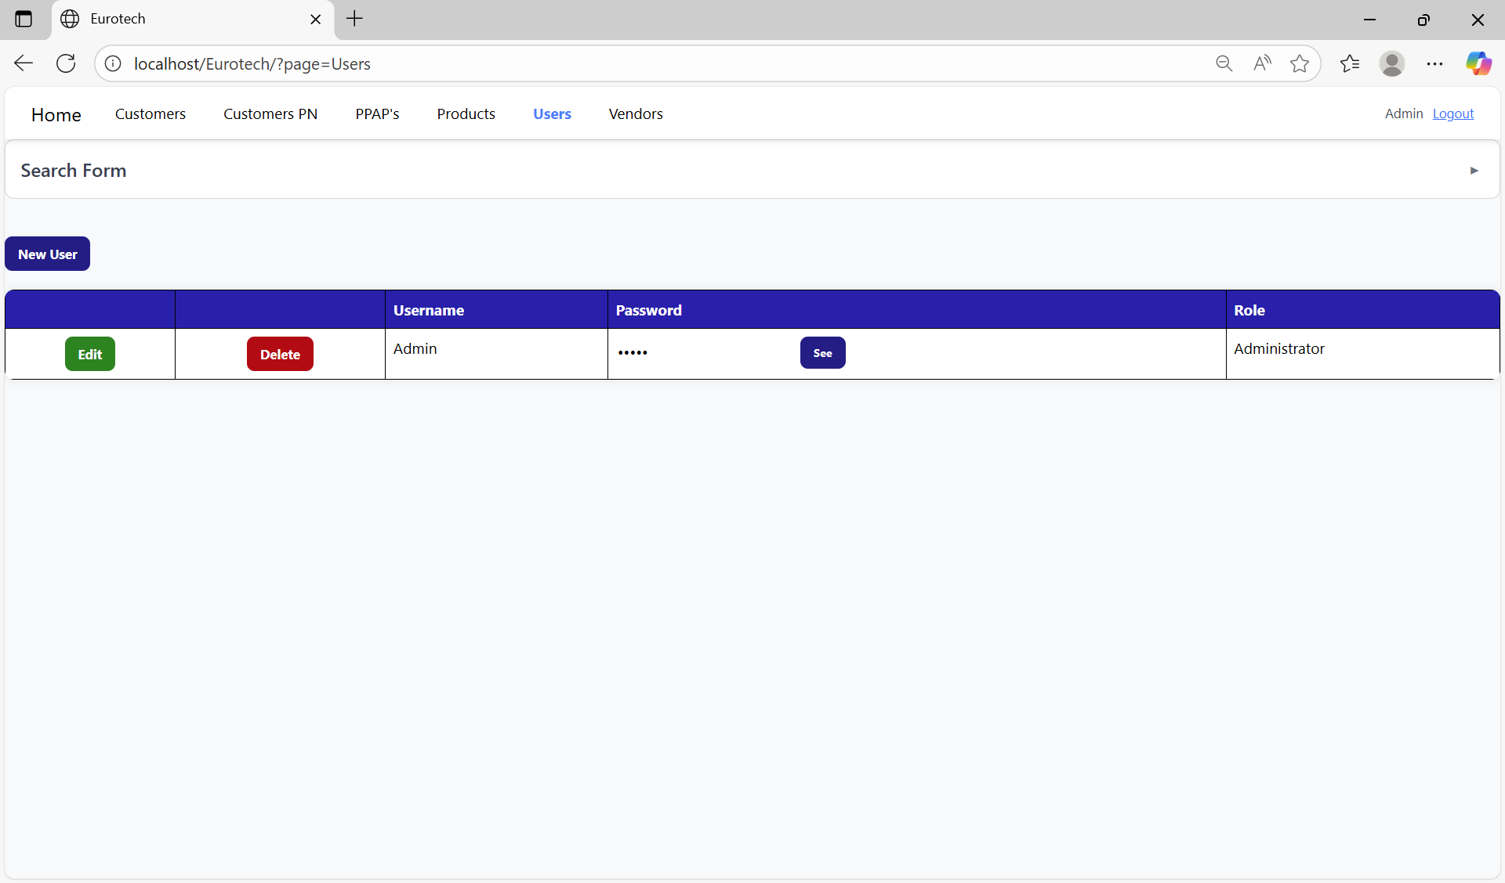

Once you click the “See” button, the password will be visible.

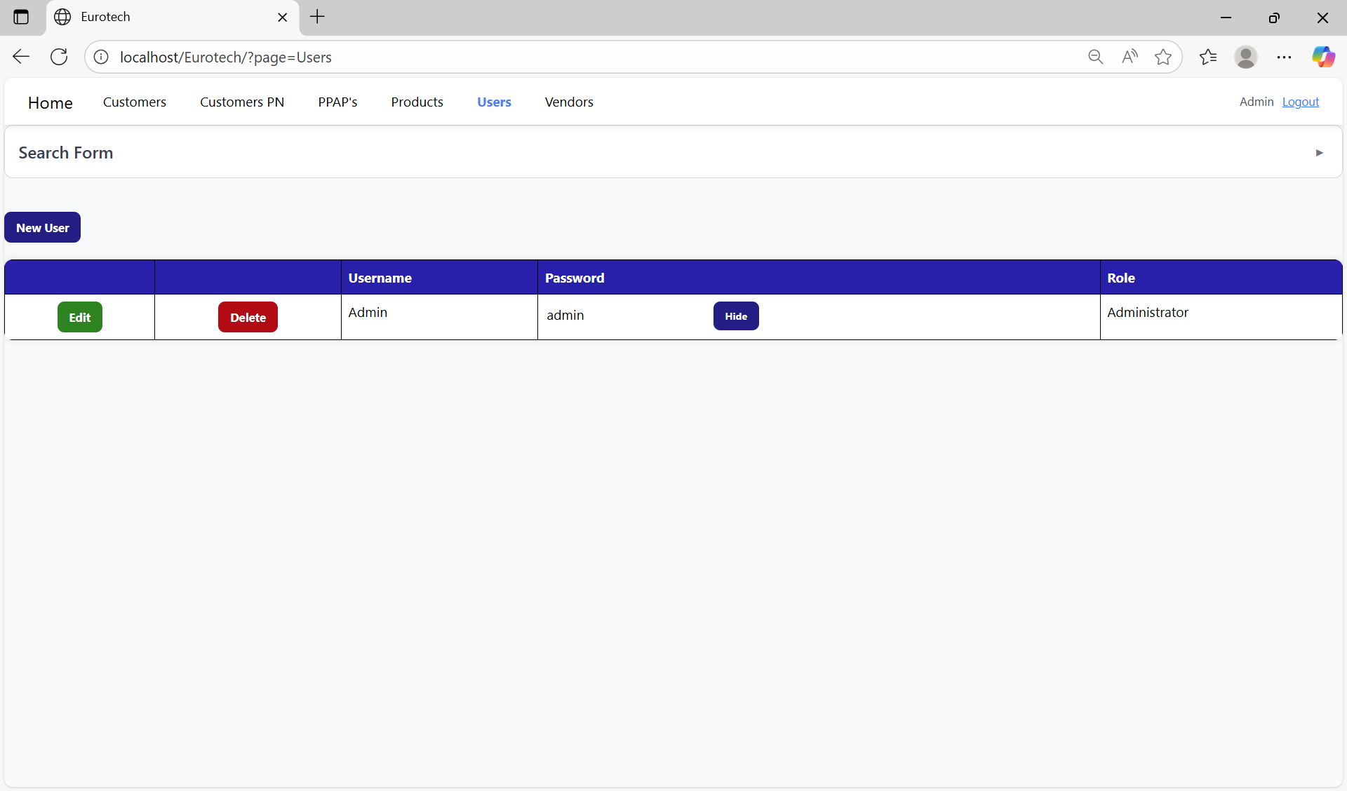

If you want to hide the password, you must click the “Hide” button next to the visible password. 

Now the password will be hidden.



## ***3.10 Vendors Page.***

### *3.10.1 How to Navigate to “Vendors” Page.*

On the navigation bar, you can navigate to the “Vendors” page.

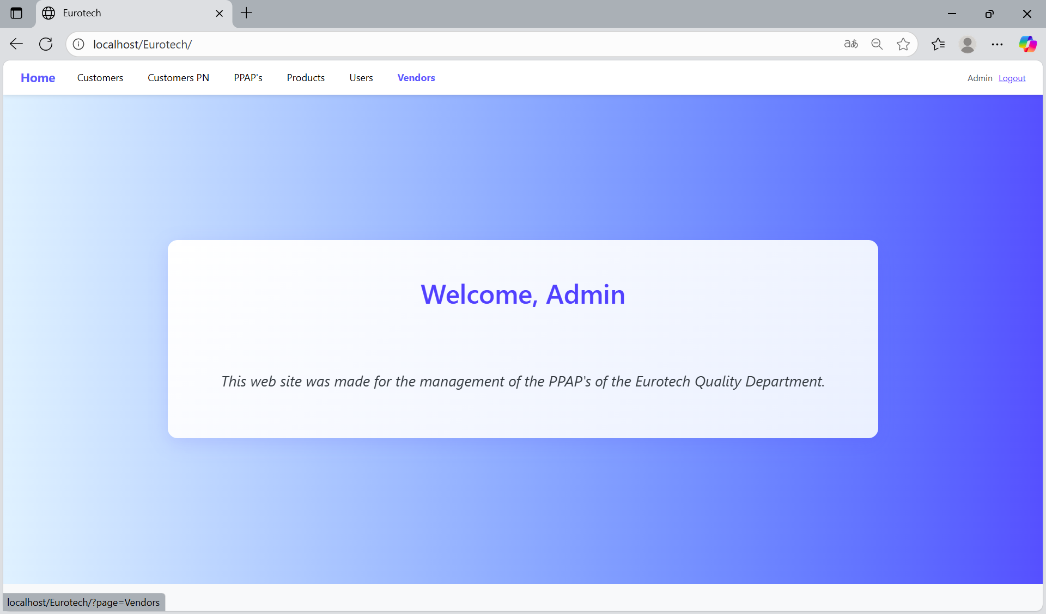

In this page you can manage the registers of all the vendors.

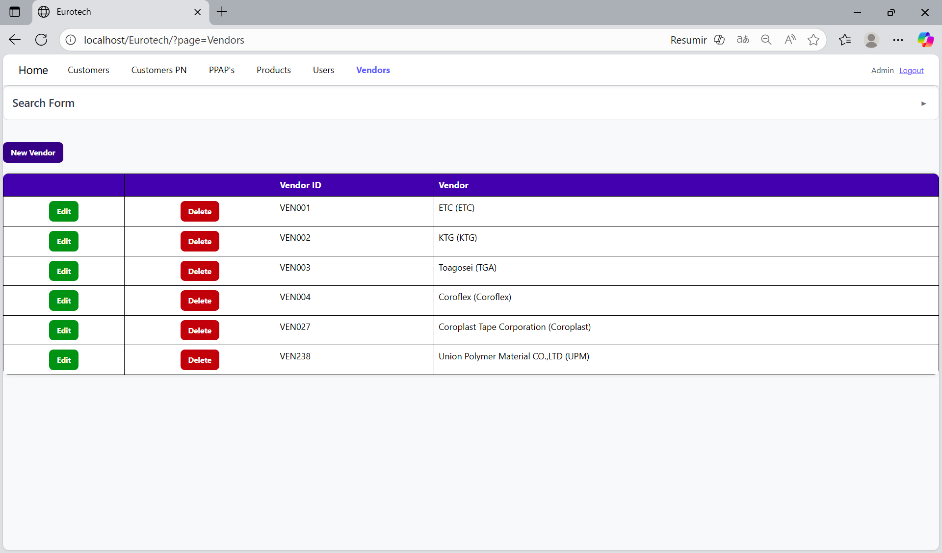

### *3.10.2 How to Search a Vendor.*

At the top of the page, it will be a dropdown “Search Form” that has all the fields of the table for querying registers.

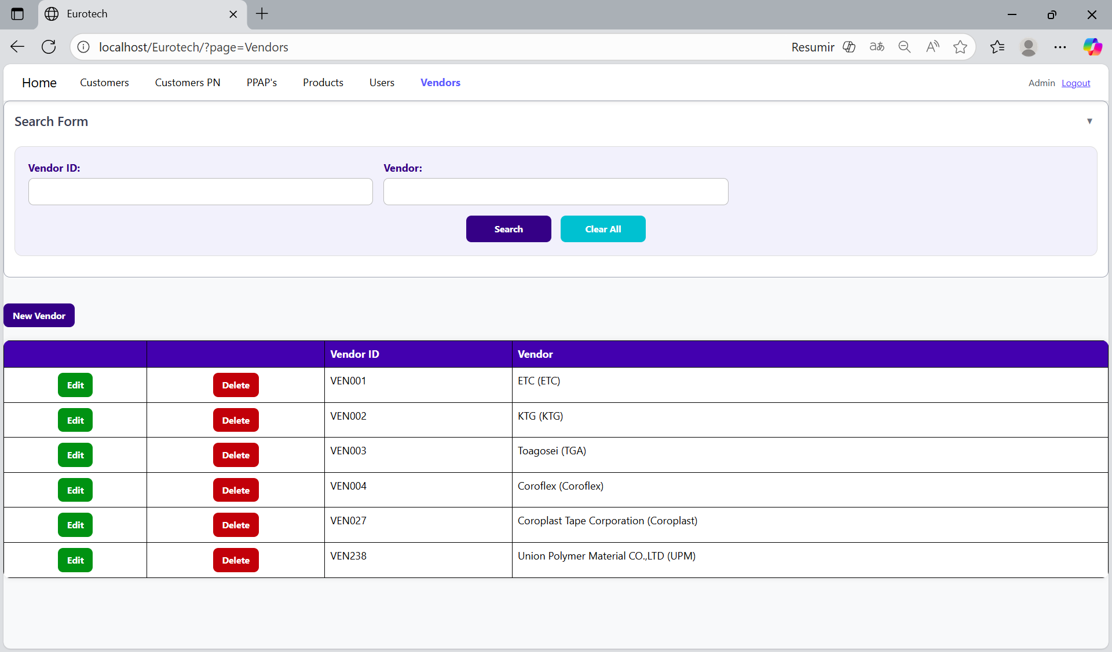

The search form allows you to perform searches by “Vendor ID” and “Vendor”.

You can search by “Vendor ID”, using the “Vendor ID” field and clicking the “Search” button.

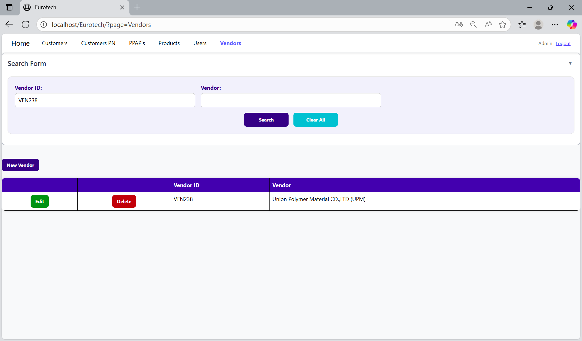

You can search by “Vendor”, using the “Vendor” field and clicking the “Search” button.

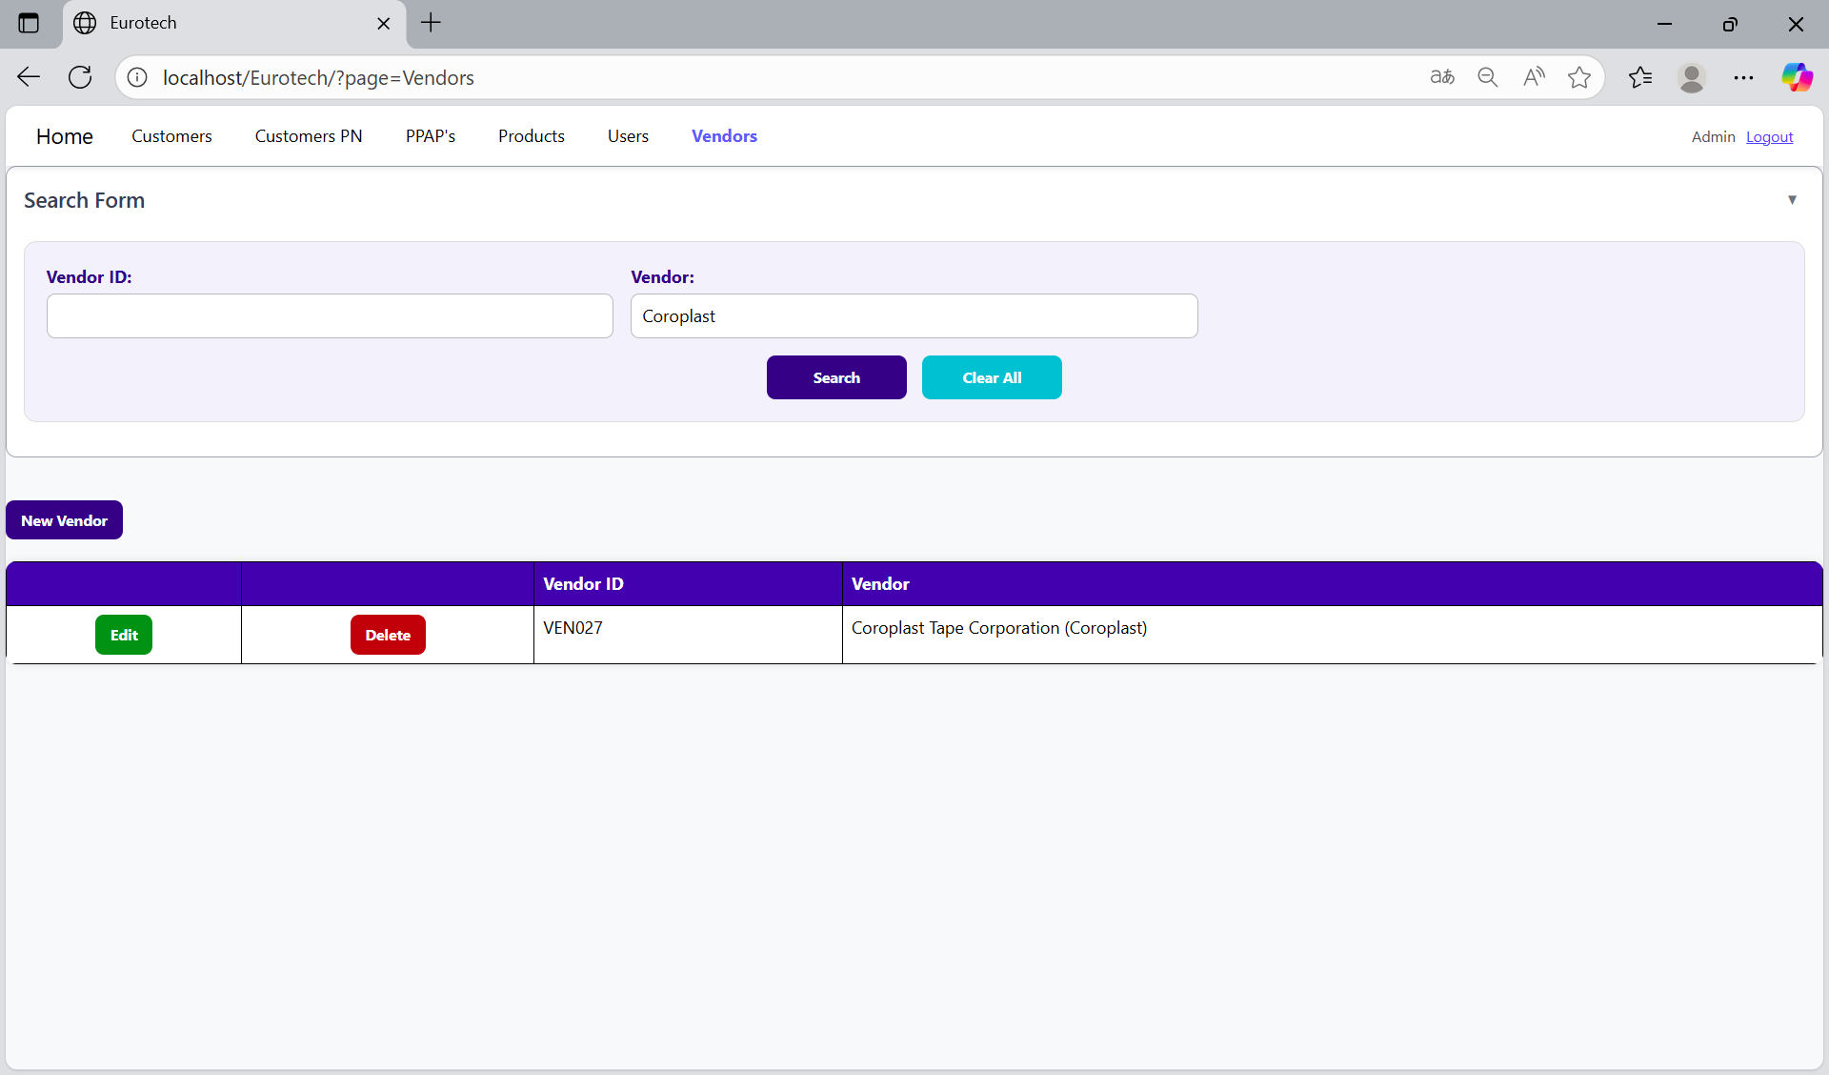

And with the “Clear All” button, you can clean the querying and see all the registers of the vendors.

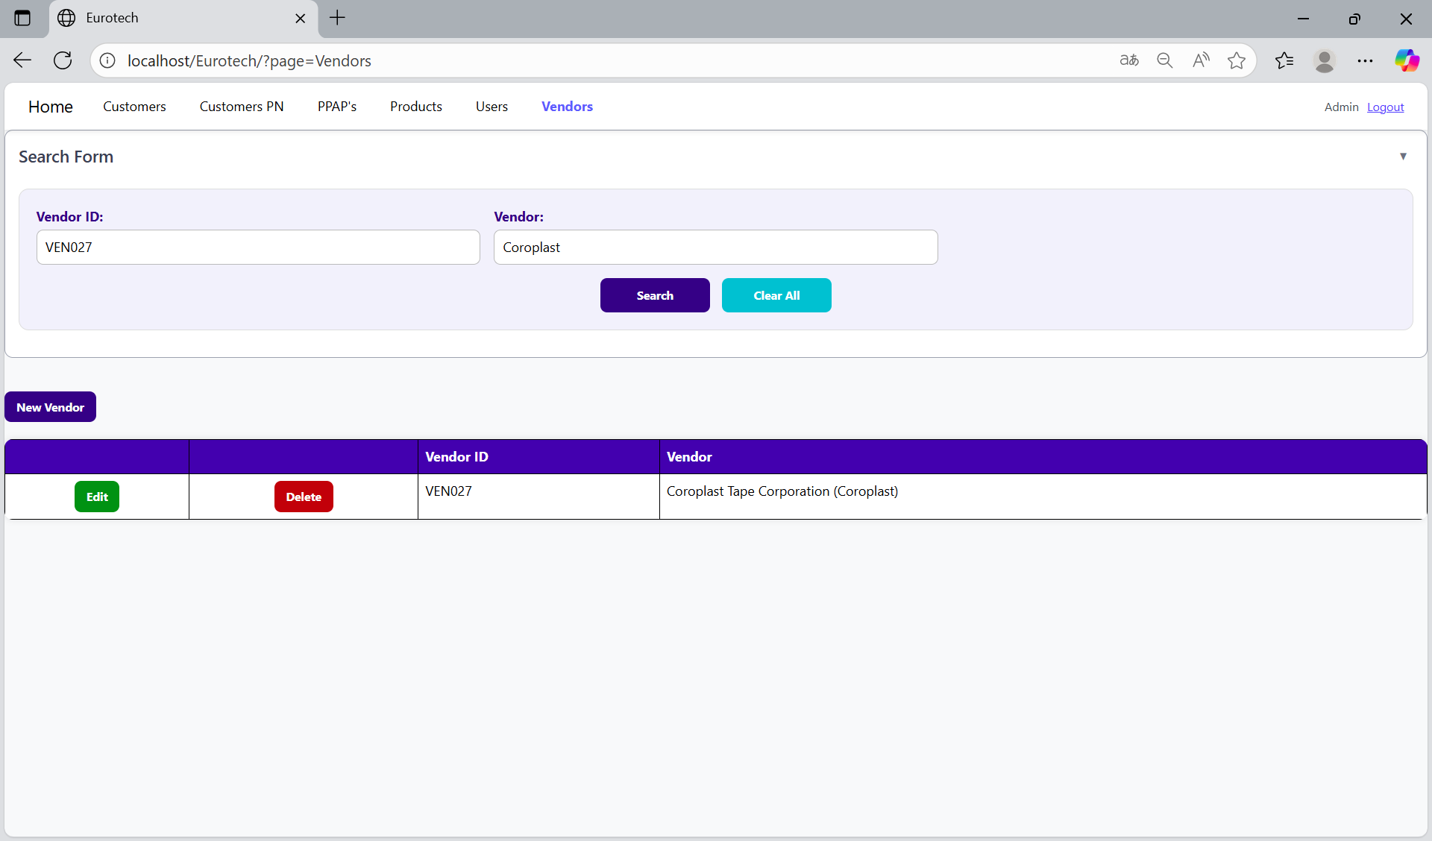

Once you click the “Clear All” button, the fields of the “Search Form” will be empty, and in the table will be shown all the vendors.

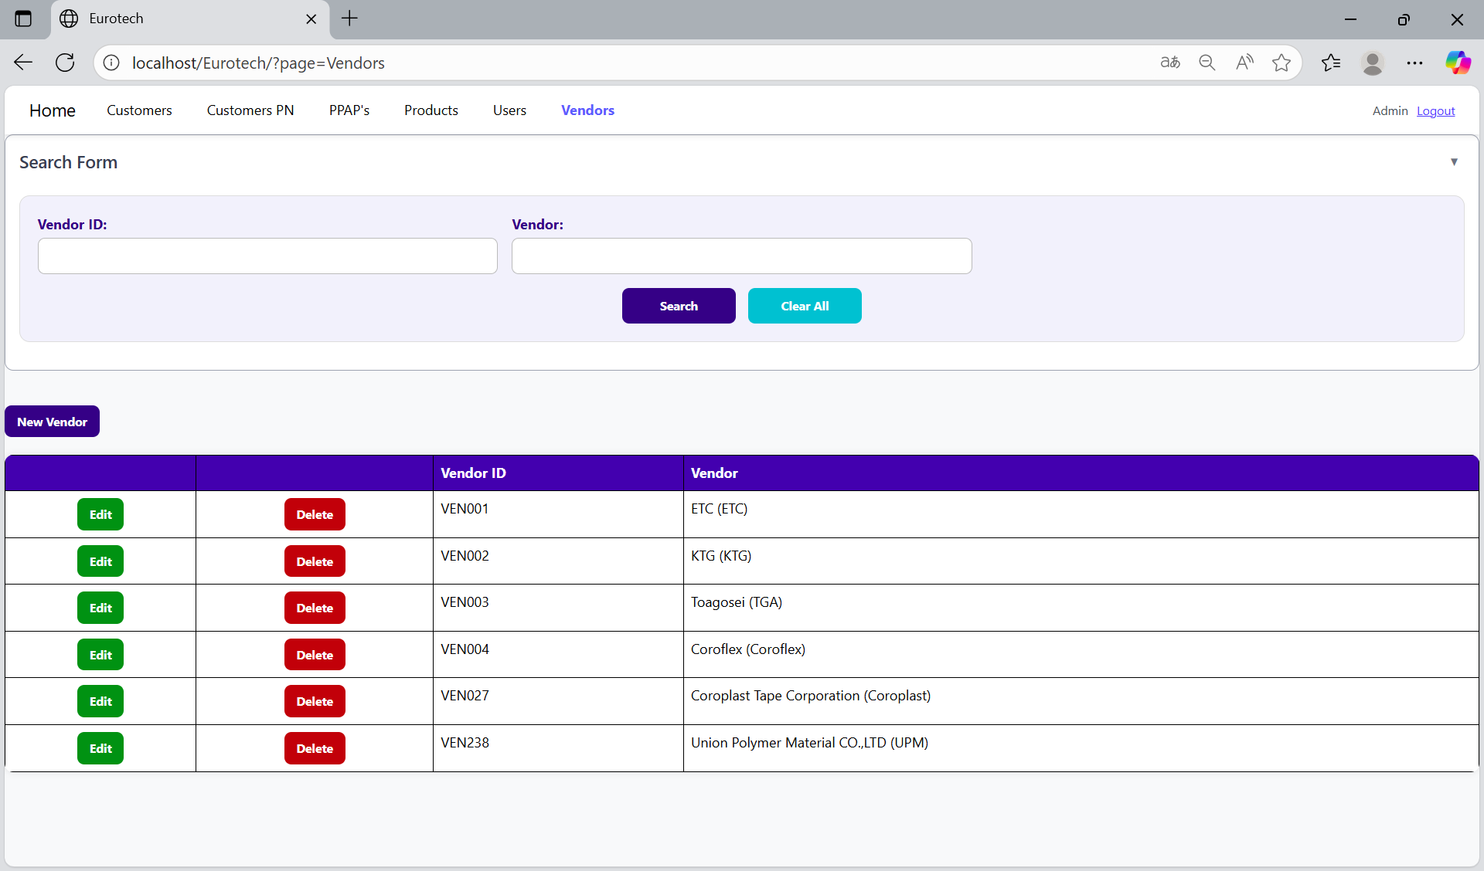

### *3.10.3 How to Add a New Vendor.*

If you want to add a new vendor, you must click the “New Vendor” button that is below the “Search Form”.



Once you click the “New Vendor” button, it will display a register form to create a new vendor.

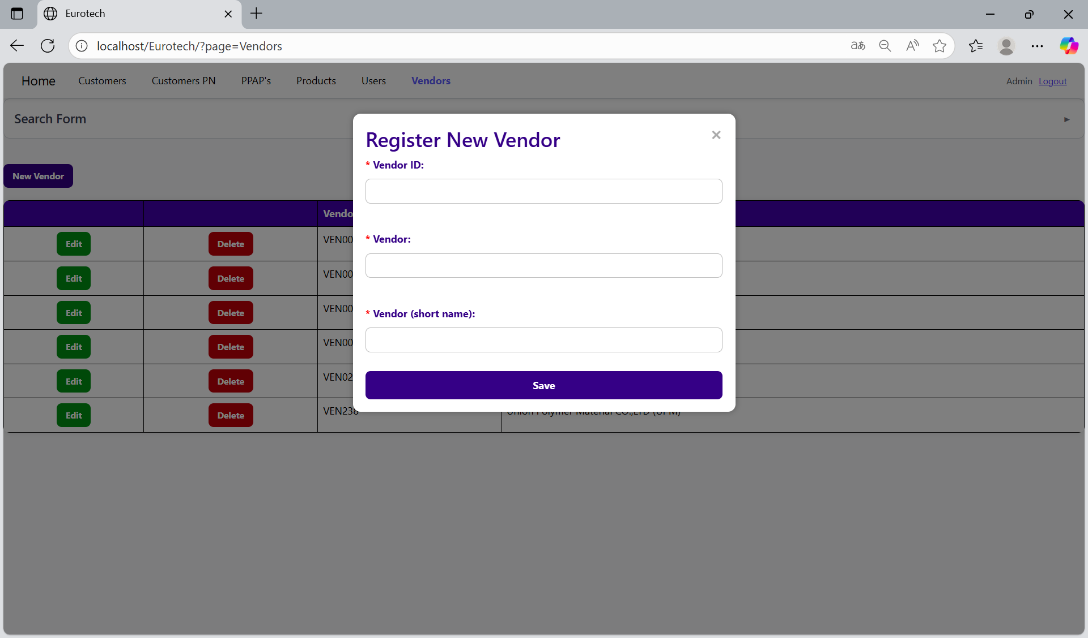

Mandatory fields

If you want to save the register of a new vendor, you must click the “Save” button.

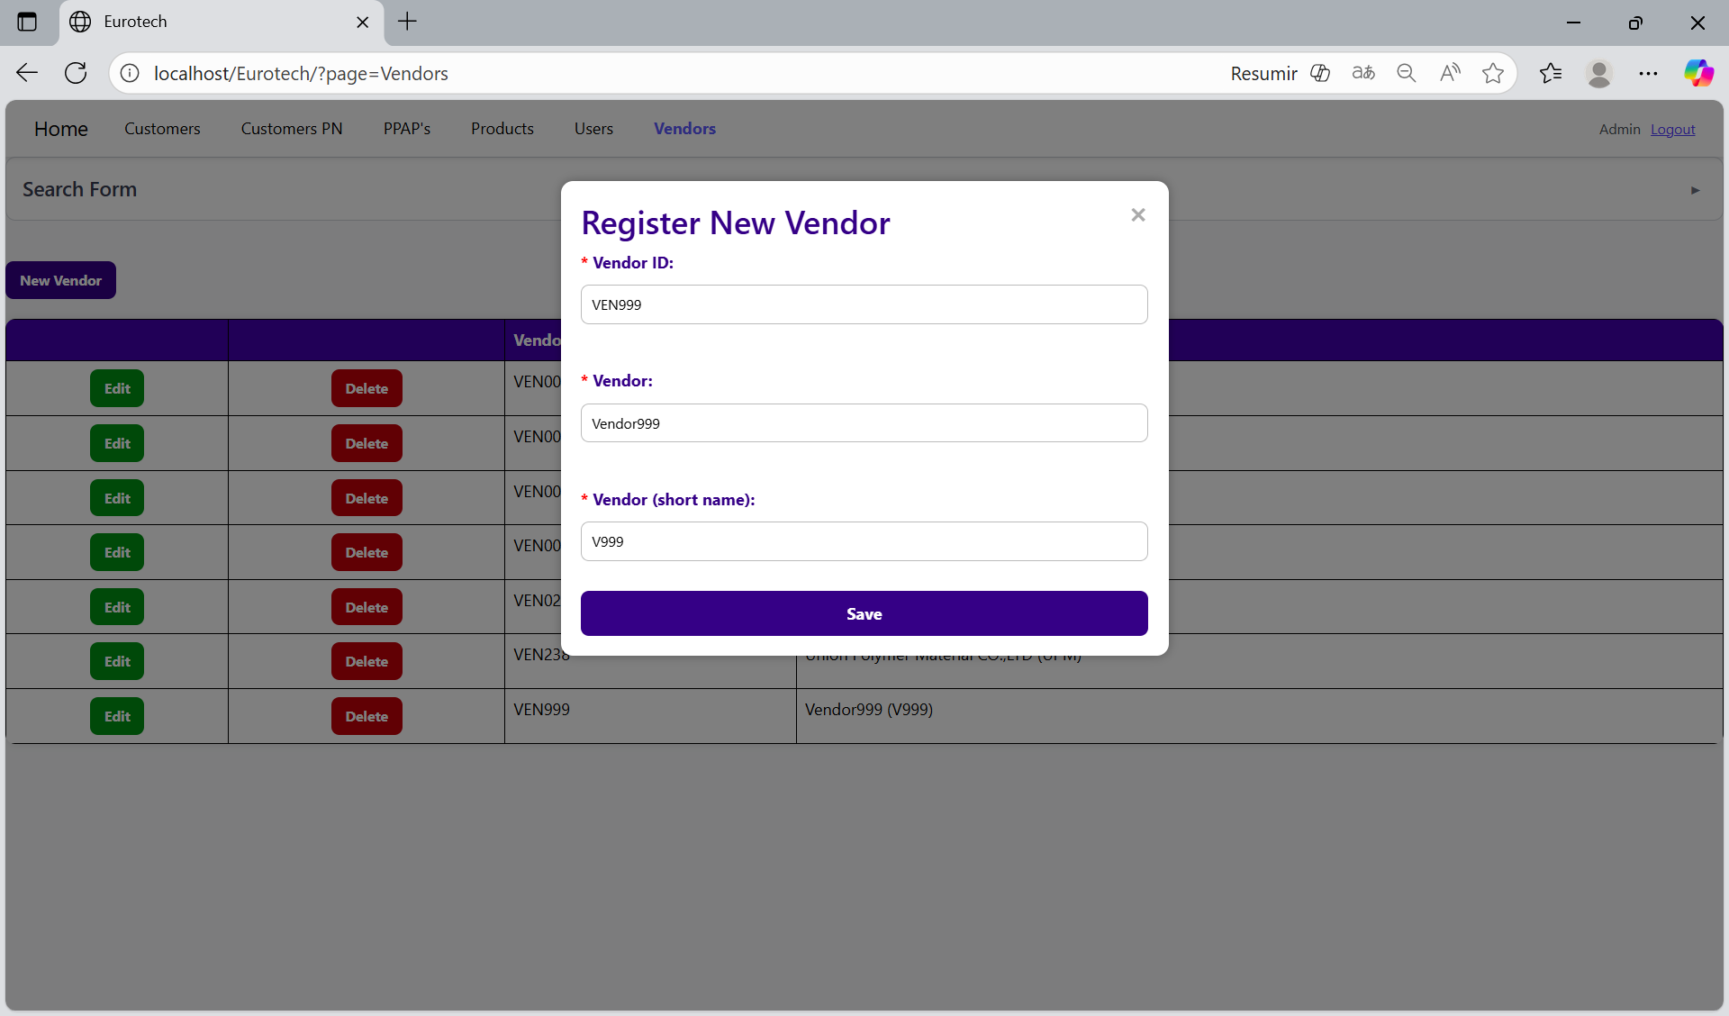

If no errors are found, the register will be added successfully.

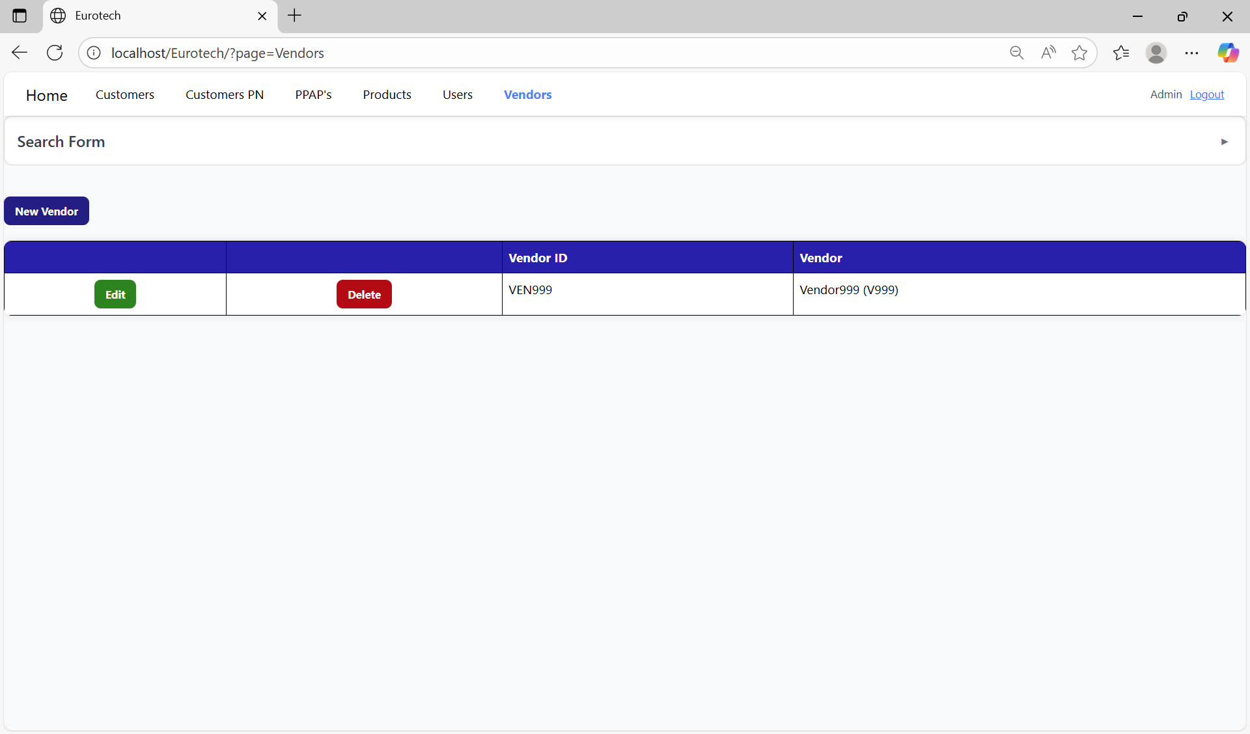

If an error is found, you can check in the Index the instruction *3.11.6.1 Register Form Errors.*

### *3.10.4 How to Edit Information of a Vendor.*

In each register from the table, it will be an “Edit” button. You must click the “Edit” button of the register you want to update.



Once you click the “Edit” button, it will display an update form to edit the information of the selected vendor.

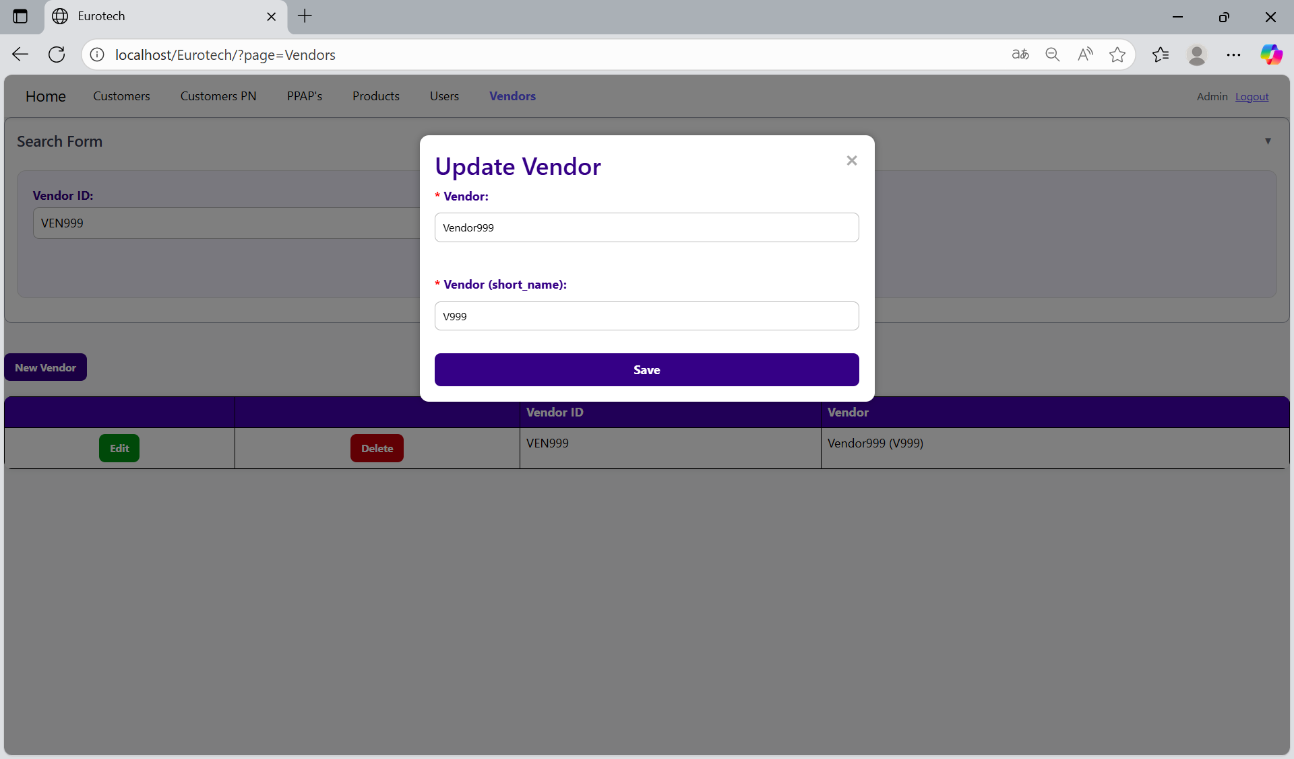

To save the changes, you must click the “Save” button.

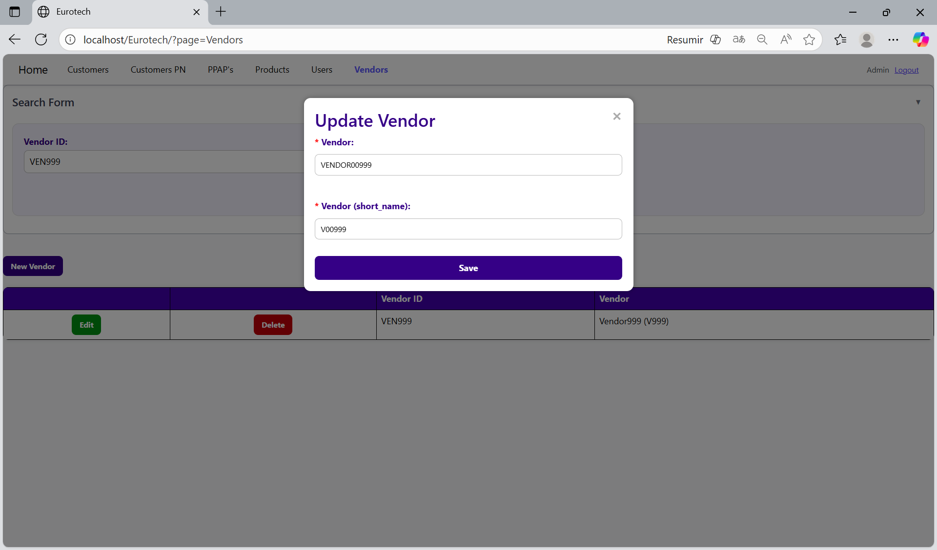

If no errors are found, the register will be updated successfully.

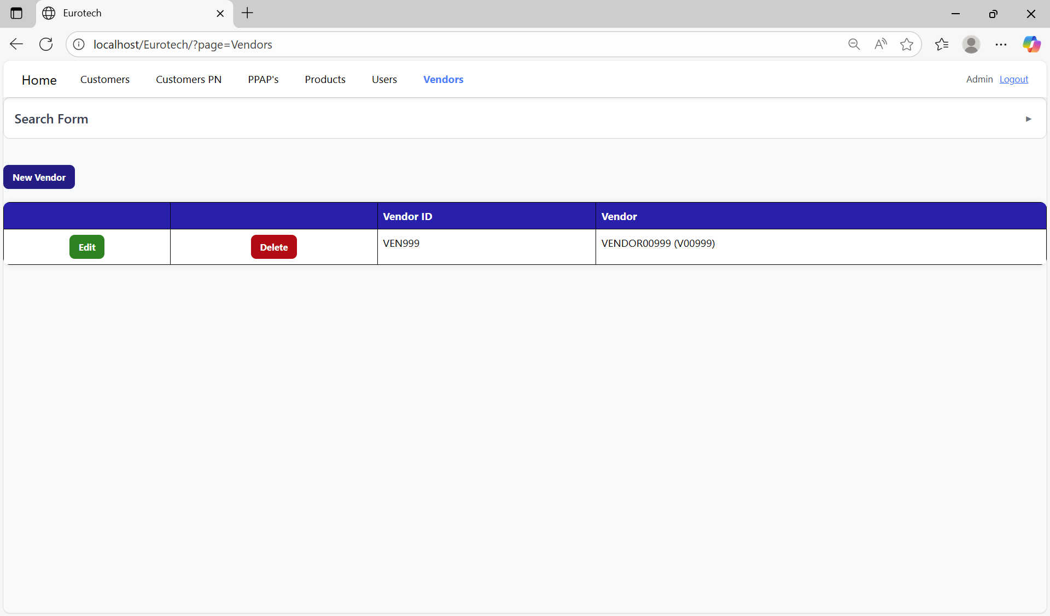

If an error is found, you can check in the Index the instruction *3.11.6.2 Edit Form Errors.*

### *3.10.5 How to Delete a Vendor.*

In each register from the table, it will be a “Delete” button. You must click the “Delete” button of the register you want to delete.



Once you click the “Delete” button, it will display the information of the selected vendor with a message to confirm the delete action. To confirm the delete of the vendor, you must click the “Confirm” button. It only deletes vendors that don’t have registers in “Products” and “PPAP’s” pages.

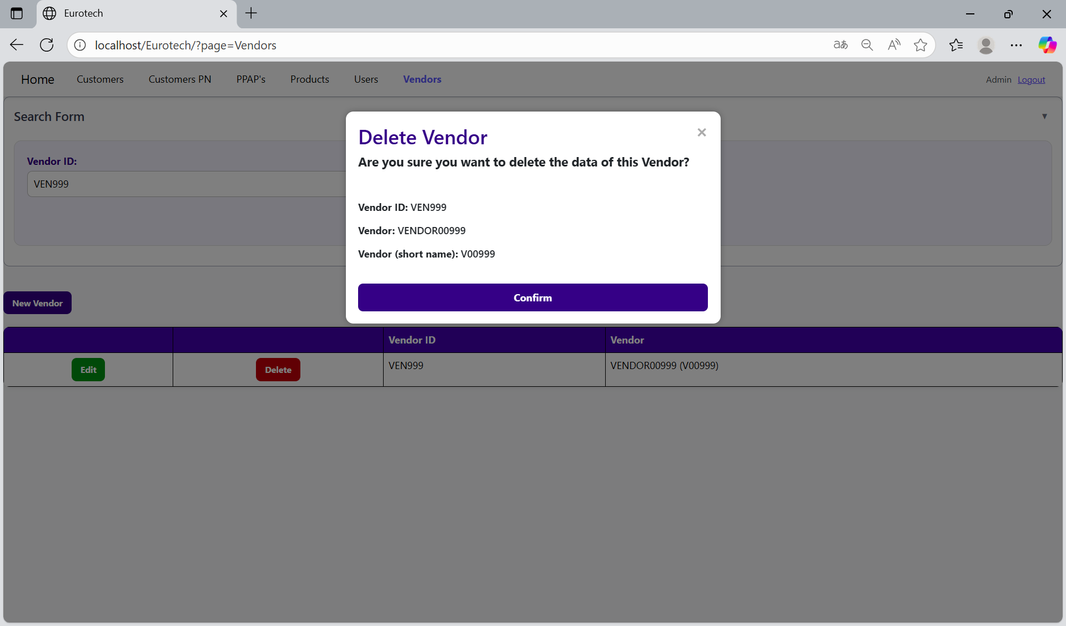

If an error is found, you can check in the Index the instruction *3.11.6.3 Delete Form Errors.*

## ***3.11 Errors.***

### *3.11.1 Customers Page Errors.*

#### 3.11.1.1 Register Form Errors.

##### 3.11.1.1.1 Customer ID must start with ‘CUS’.

If you don’t write correctly the “Customer ID” by not writing “CUS” at the beginning of the ID, it will show an error message, that says that the “Customer ID” must starts with “CUS”.

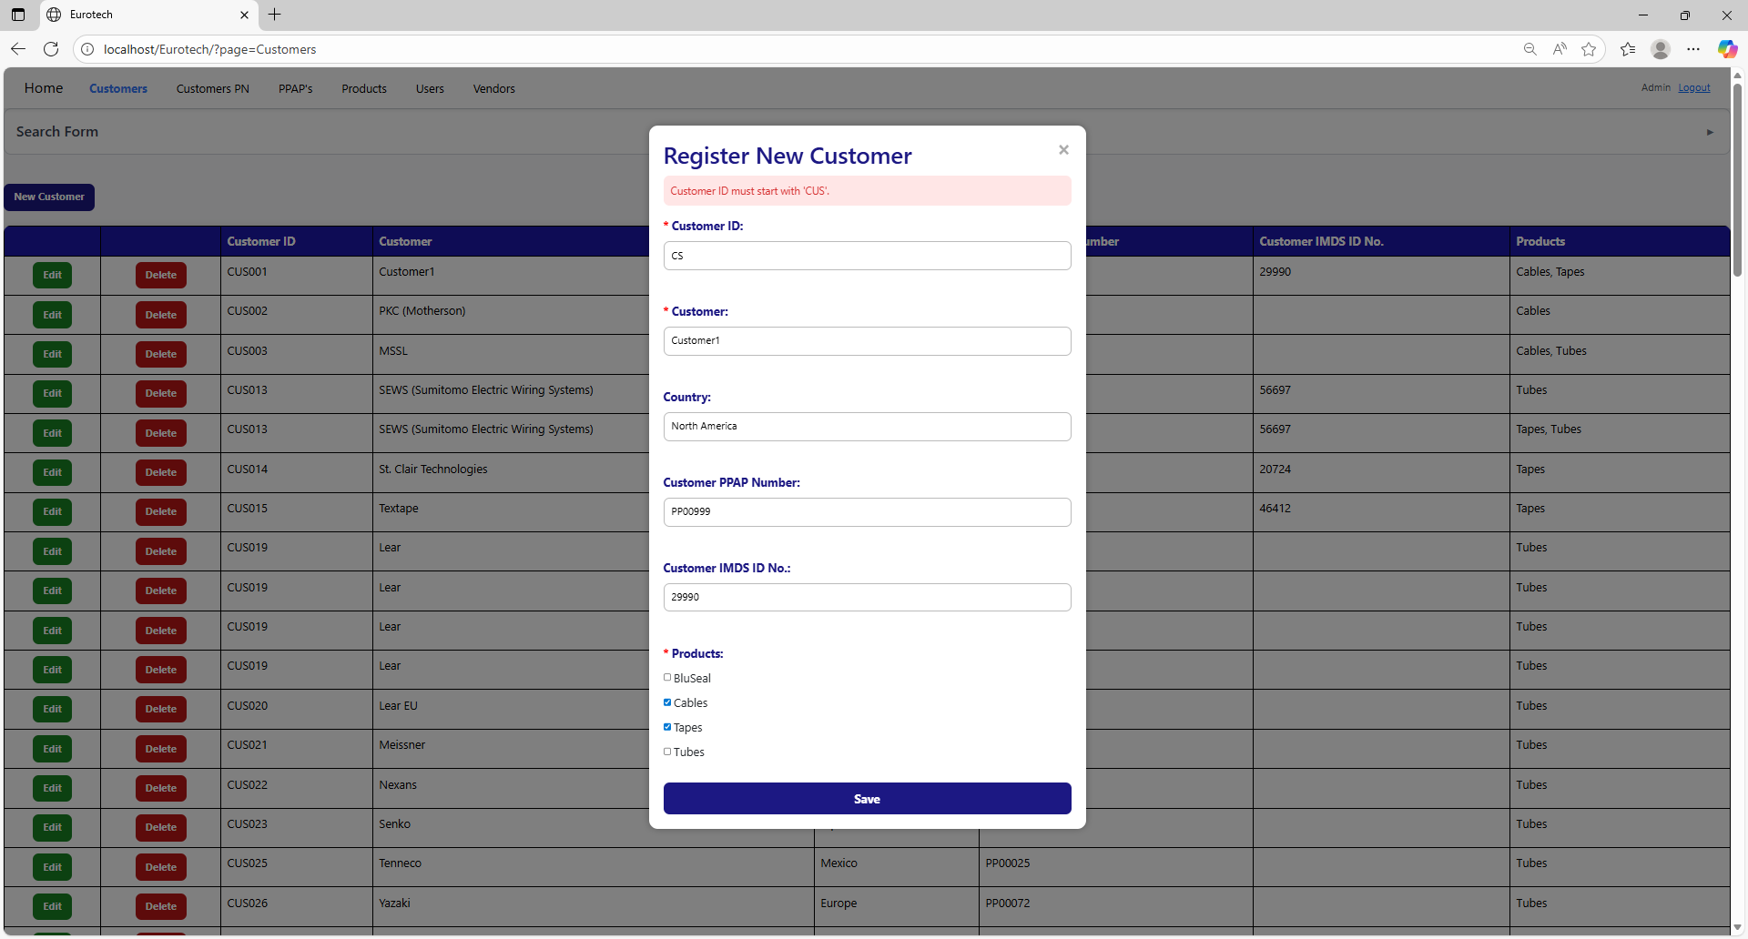

To correct this error, you must write a valid “Customer ID” following the format “CUS000” or “CUS0000”, like this example:

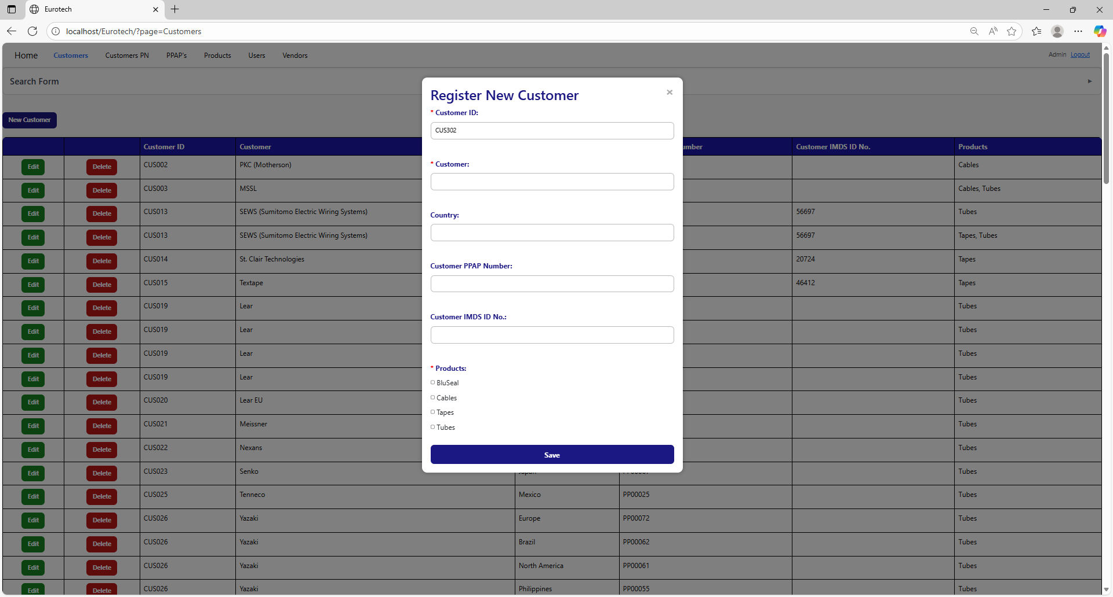

##### 3.11.1.1.2 Customer ID must contain only numbers after ‘CUS’.

If you don’t write correctly the “Customer ID” by not writing only numbers after “CUS”, it will show an error message, that says that the “Customer ID” must contain only numbers after “CUS”.

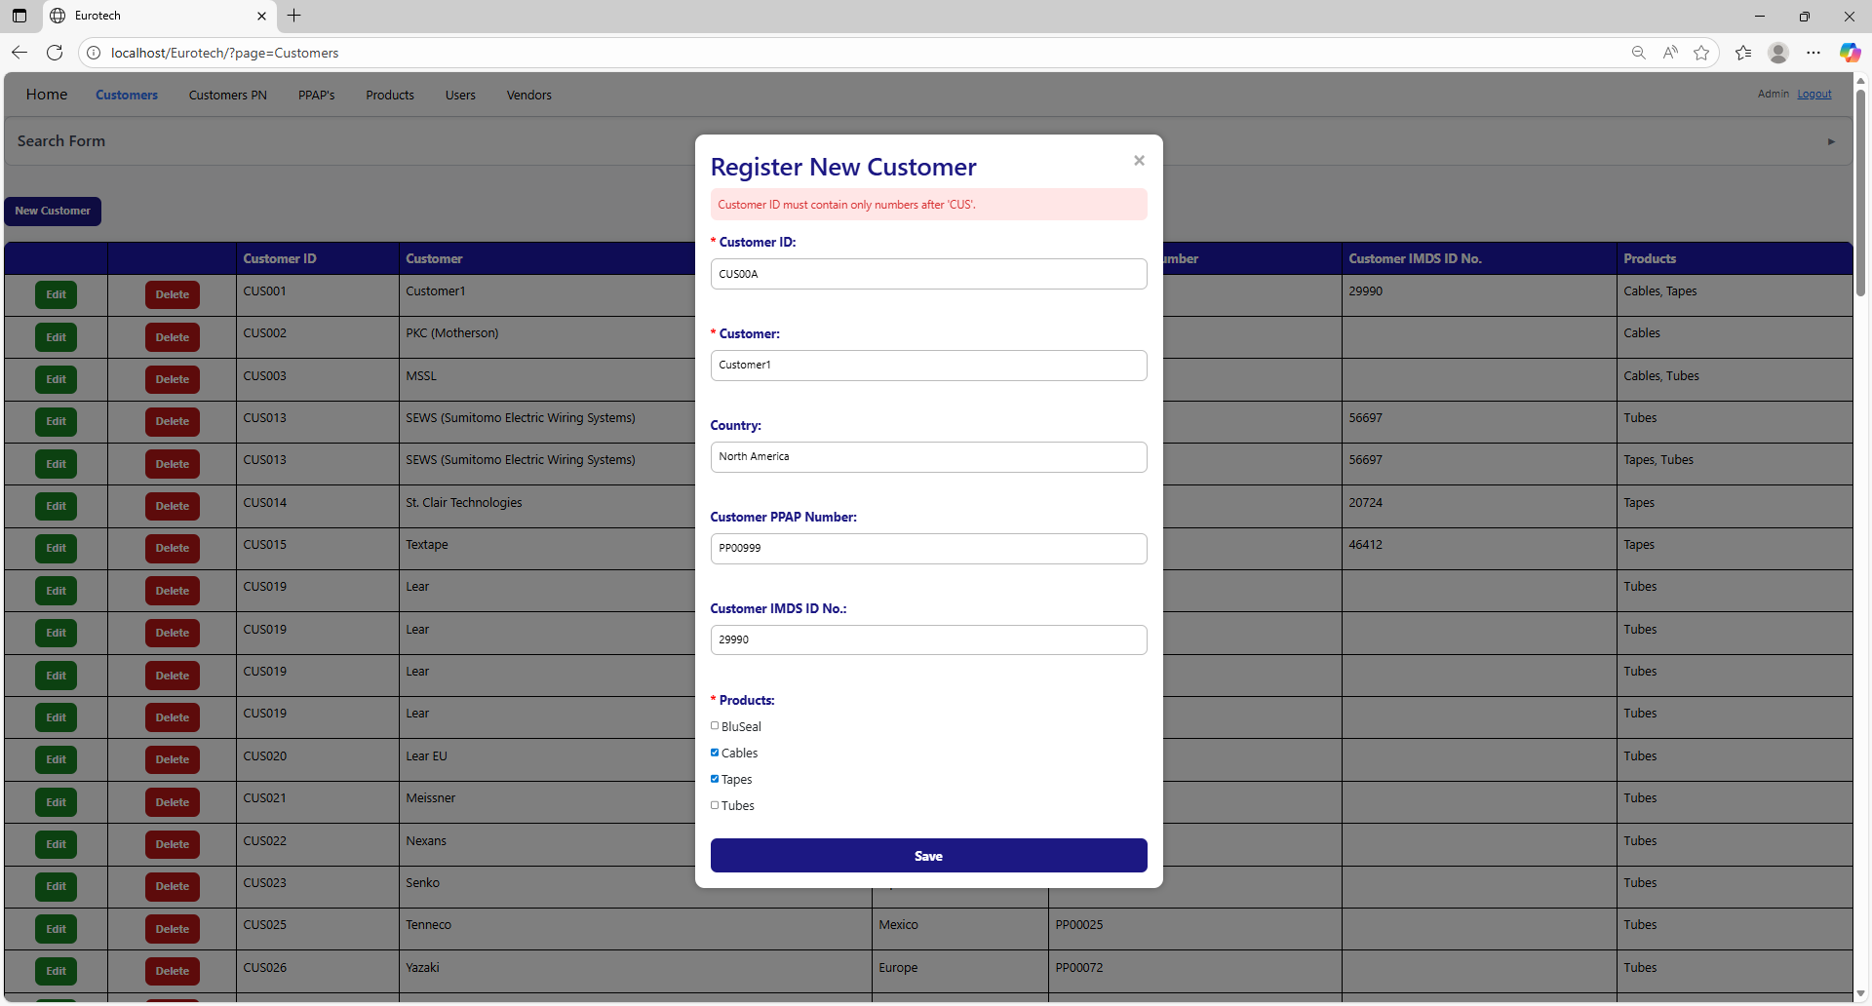

To correct this error, you must write a valid “Customer ID” following the format “CUS000” or “CUS0000”, like this example:



##### 3.11.1.1.3 The customer *customer’s name* - *country* already exists.

If you write in the fields “Customer” and “Country” the data of a customer that already exists, it will show an error message, that says that already exists a register with the customer’s name and country you are trying to register.

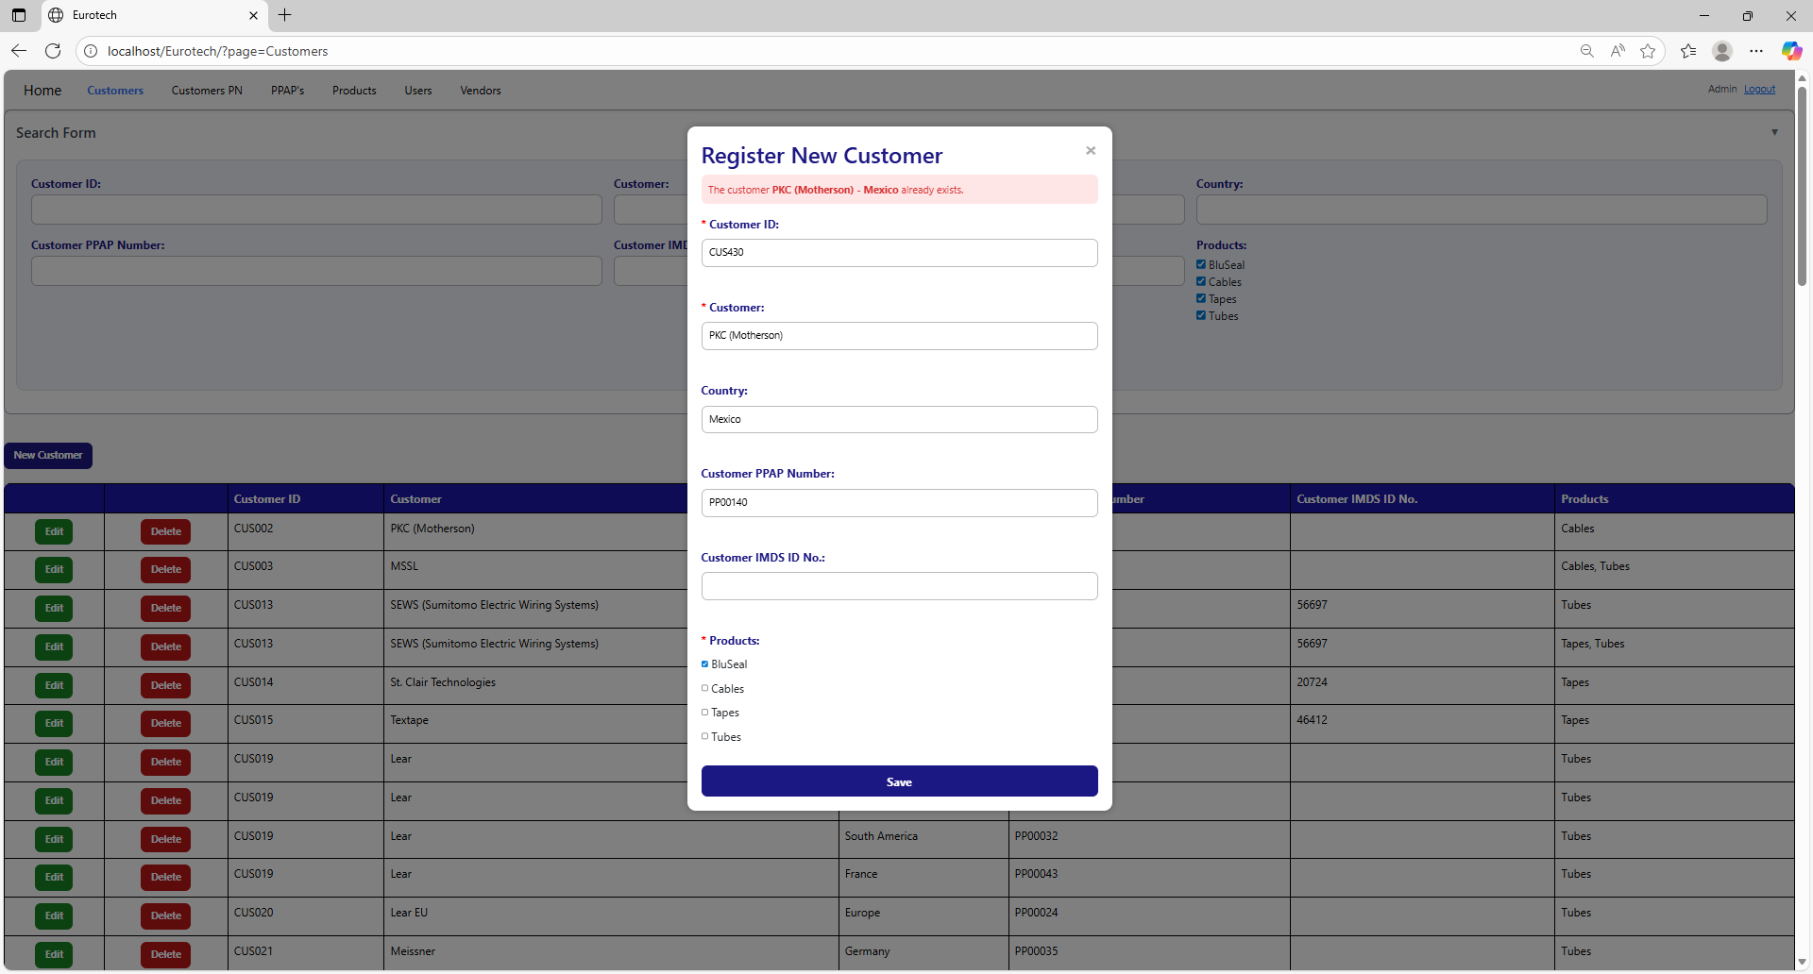

The error message prevents duplicate registers of customers.

##### 3.11.1.1.4 The customer *customer’s name* already exists.

If you write in the “Customer” field and the “Country” field is empty, and this data match with a customer that already exists, it will show an error message, that says that already exists a register with the customer’s name you are trying to register.

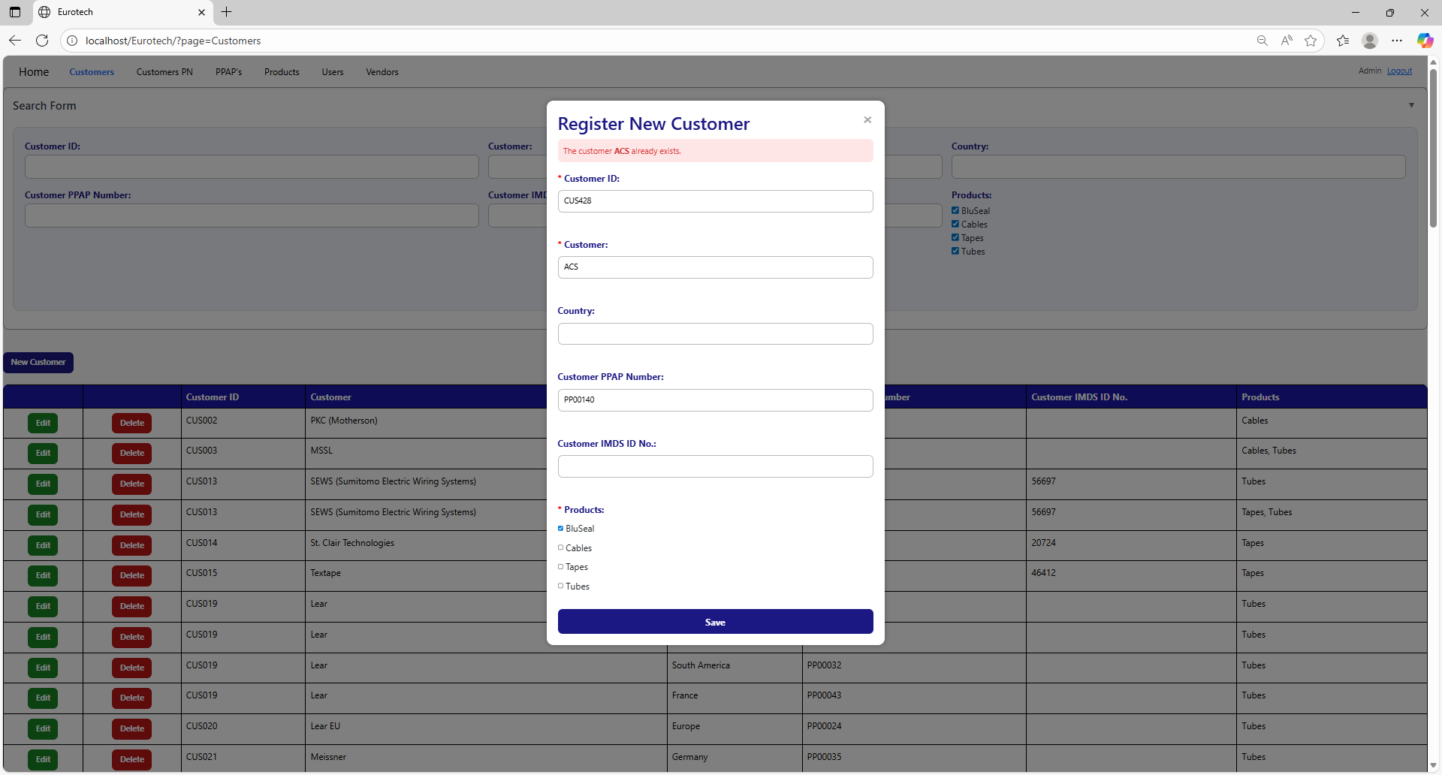

The error message prevents duplicate registers of customers.

##### 3.11.1.1.5 Customer PPAP Number must have the form 'PP00000'.

If you don’t write correctly the “Customer PPAP Number” by not writing “PP” at the beginning or by not writing a 5-digit number after “PP”, it will show an error message, that says that the “Customer PPAP Number” must have the form “PP00000”.

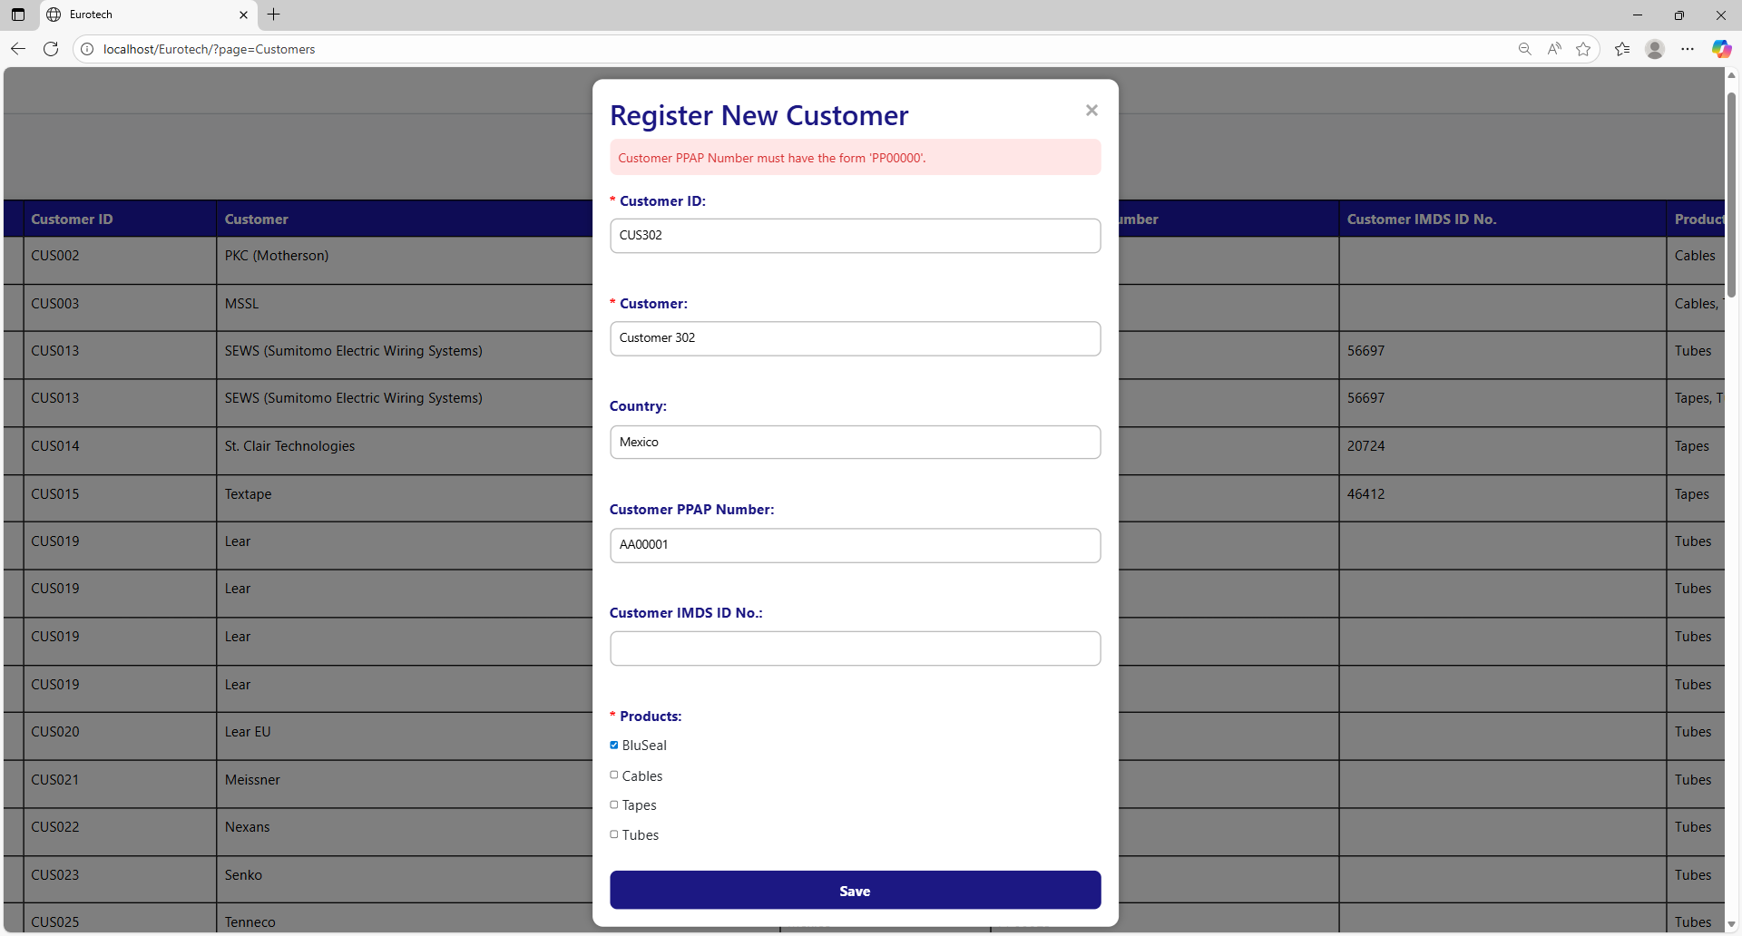

To correct this error, you must write a valid “Customer PPAP Number” following the format “PP00000”, like this example:

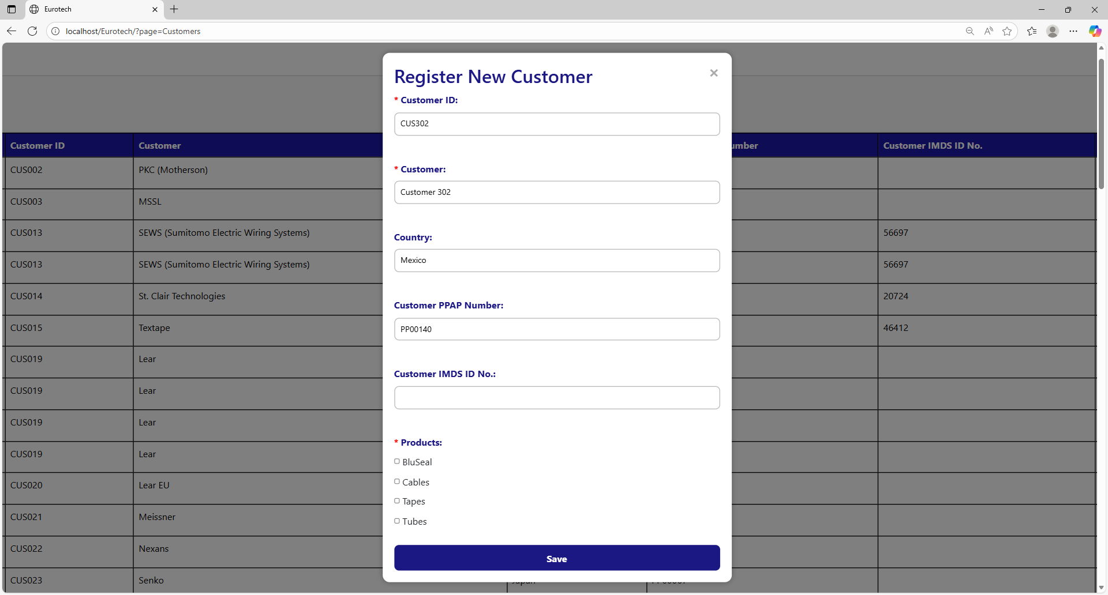

##### 3.11.1.1.6 The Customer PPAP Number *Customer PPAP Number* already exists.

If you write in the “Customer PPAP Number” field a Customer PPAP Number that already exists, it will show an error message, that says that already exists a register with the Customer PPAP Number you are trying to register.

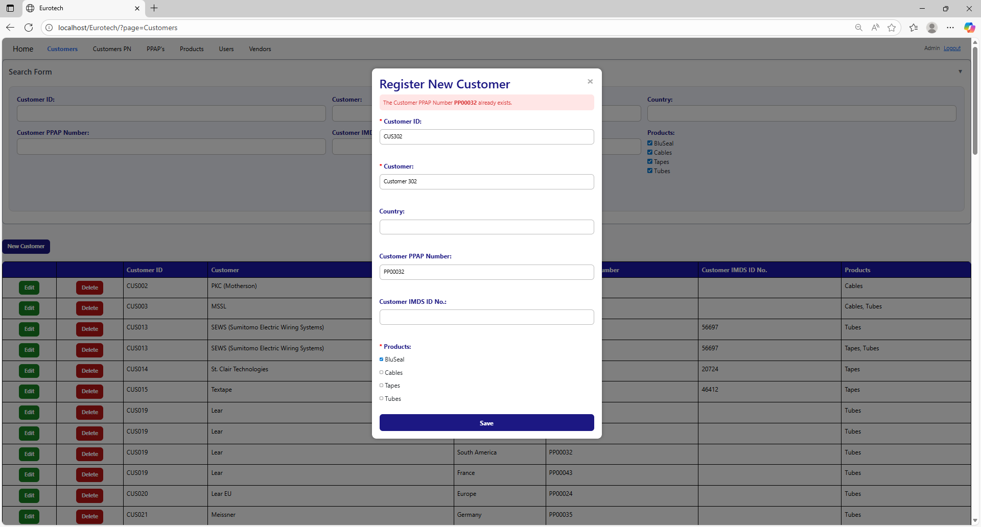

To correct this error, you must write a “Customer PPAP Number” that doesn’t exist.

##### 3.11.1.1.7 You must select at least 1 product for the customer.

If you don’t select at least 1 product in the “Product” field, it will show an error message, that says that you must select at least 1 product for the customer.

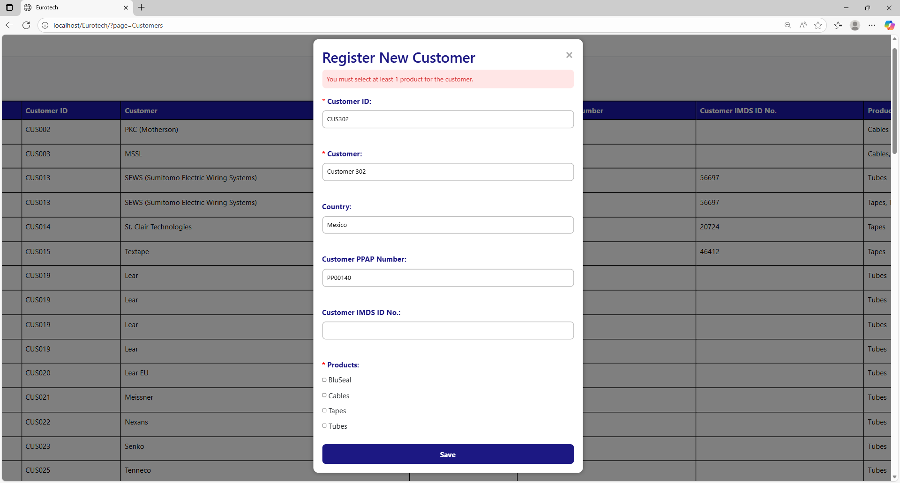

To correct this error, you must select at least 1 product for the customer, like this example:

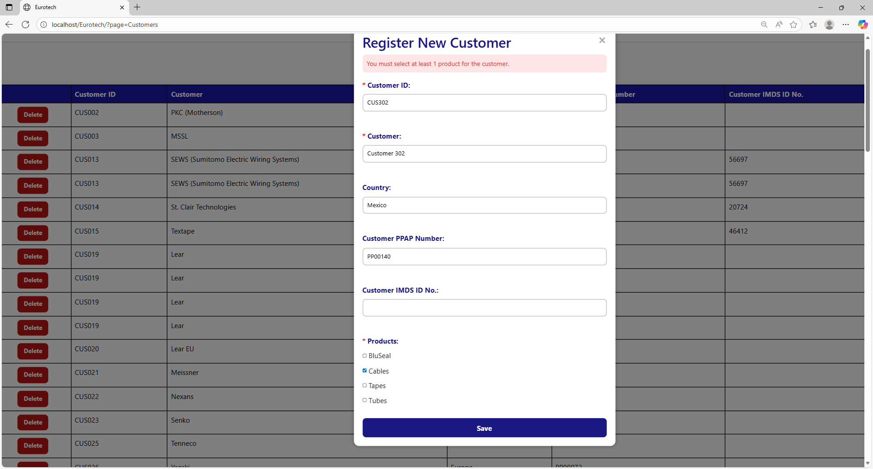

#### 3.11.1.2 Edit Form Errors.

##### 3.11.1.2.1 Customer ID must start with ‘CUS’.

If you don’t write correctly the “Customer ID” by not writing “CUS” at the beginning of the ID, it will show an error message, that says that the “Customer ID” must starts with “CUS”.

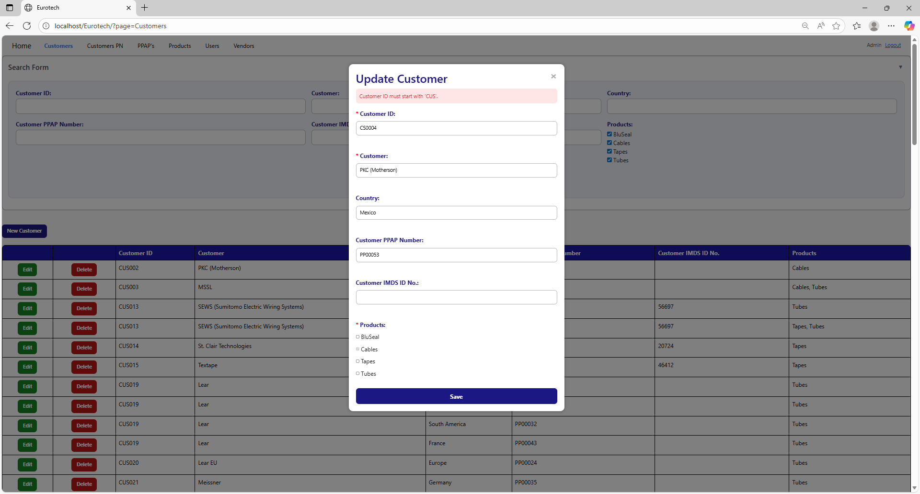

To correct this error, you must write a valid “Customer ID” following the format “CUS000” or “CUS0000”, like this example:

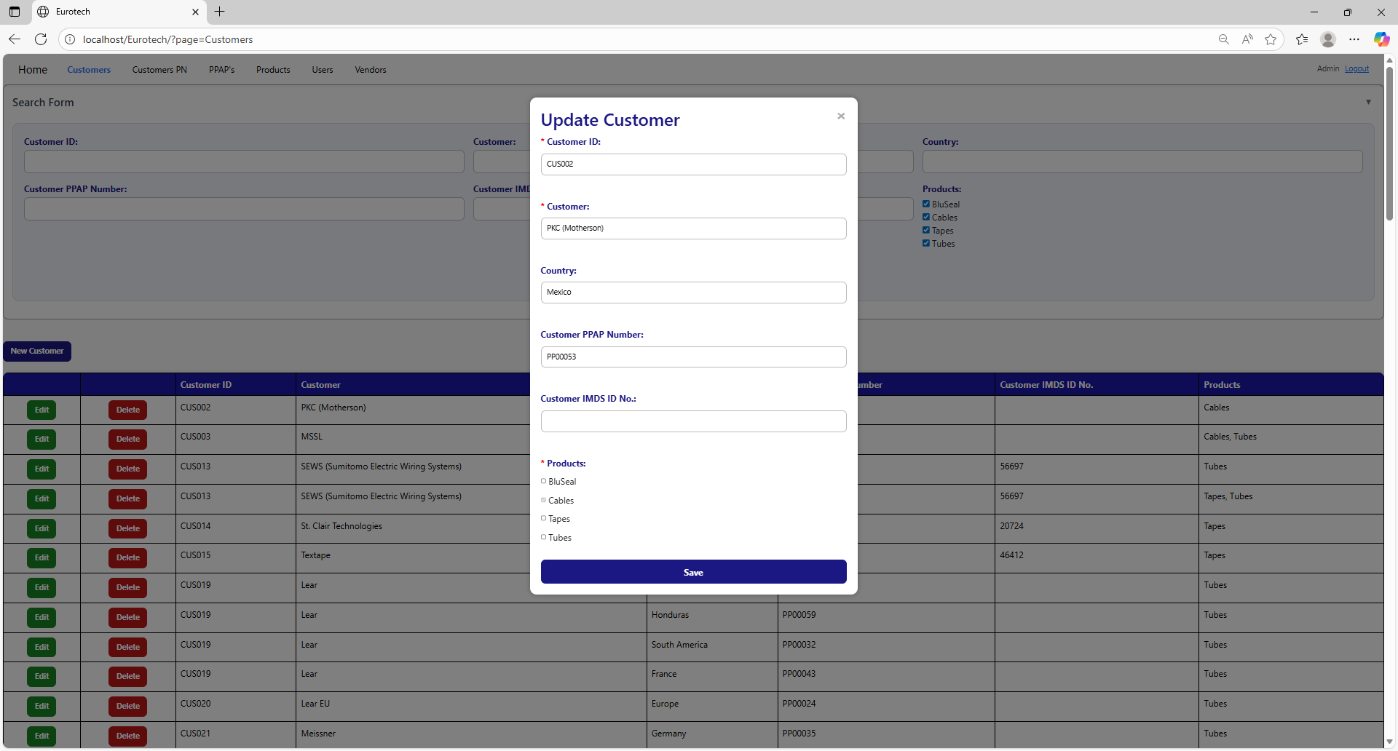

##### 3.11.1.2.2 Customer ID must contain only numbers after ‘CUS’.

If you don’t write correctly the “Customer ID” by not writing only numbers after “CUS”, it will show an error message, that says that the “Customer ID” must contain only numbers after “CUS”.

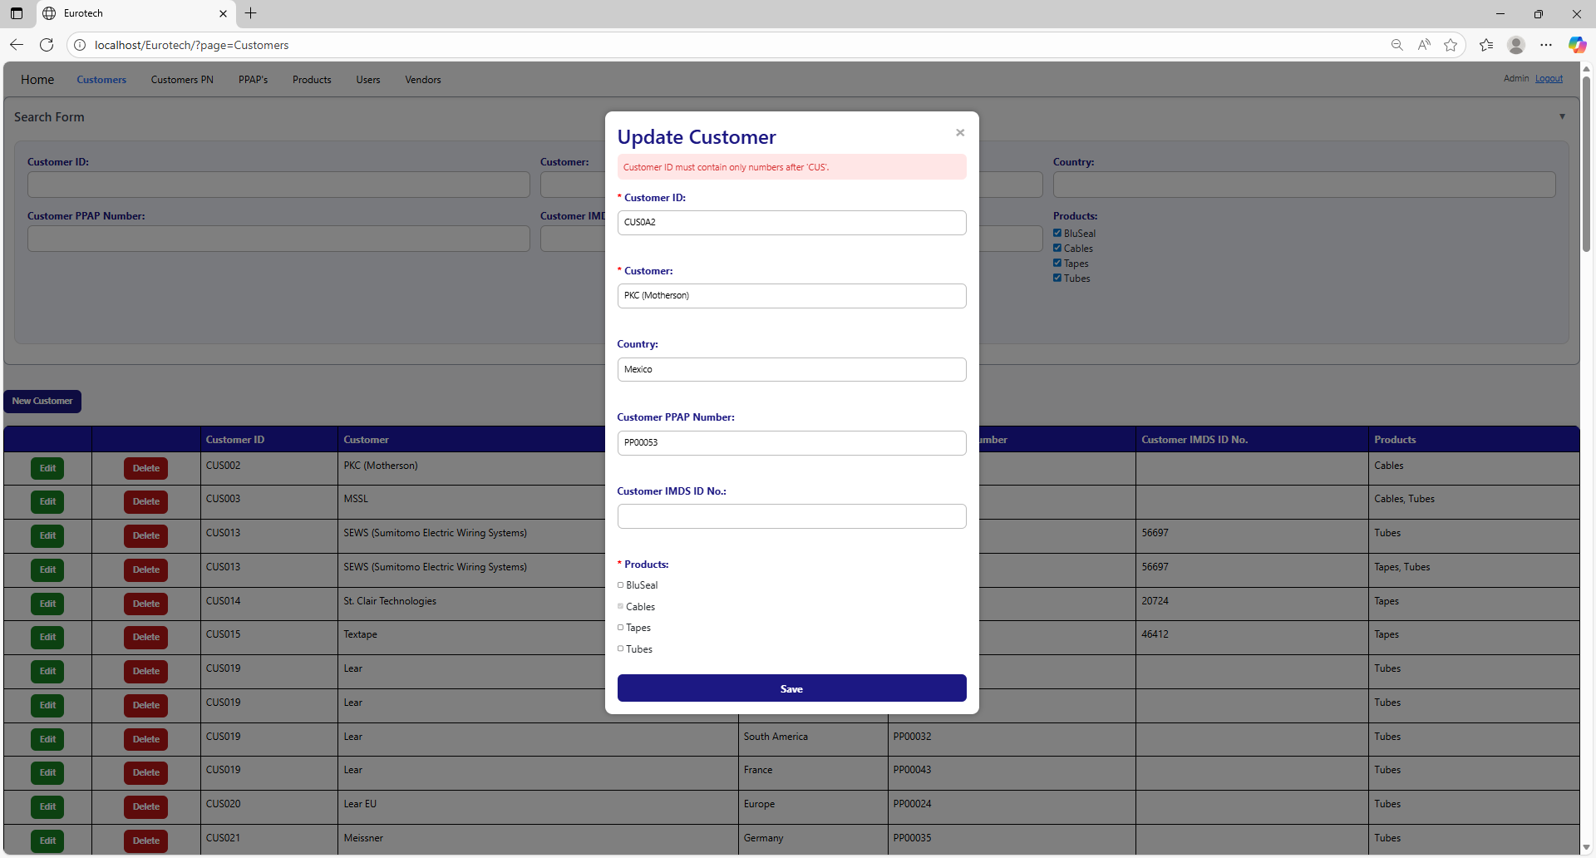

To correct this error, you must write a valid “Customer ID” following the format “CUS000” or “CUS0000”, like this example:



##### 3.11.1.2.3 The customer *customer’s name* - *country* already exists.

If you write in the fields “Customer” and “Country” the data of a customer that already exists, it will show an error message, that says that already exists a register with the customer’s name and country you are trying to register.

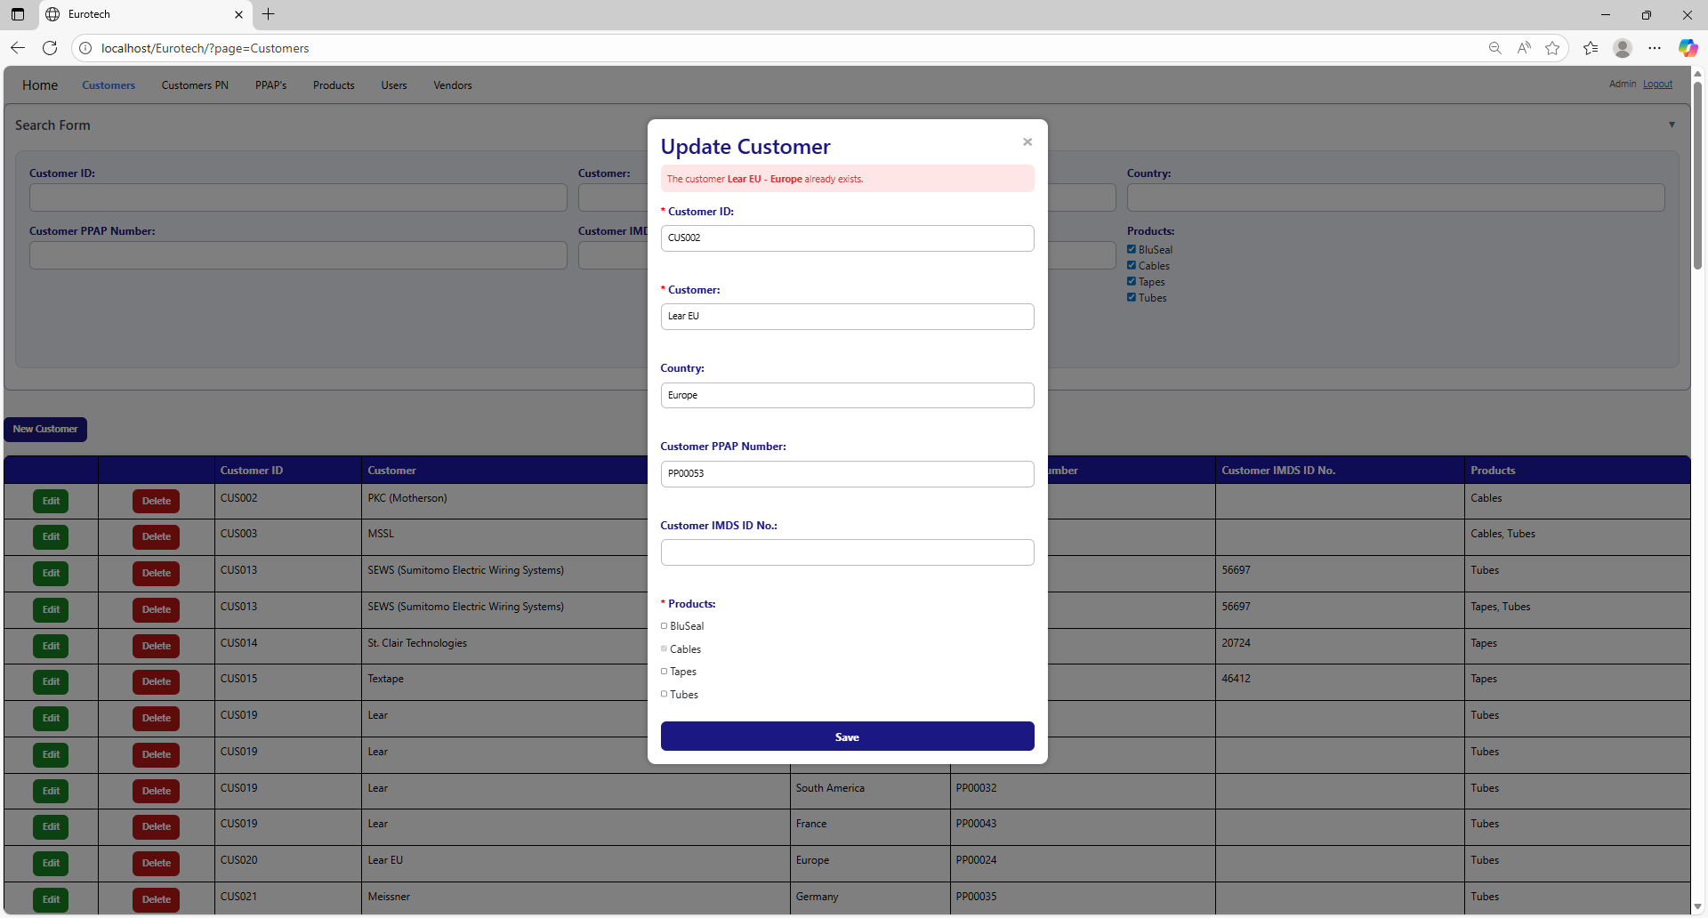

The error message prevents duplicate registers of customers.

##### 3.11.1.2.4 The customer *customer’s name* already exists.

If you write in the “Customer” field and the “Country” field is empty, and this data match with a customer that already exists, it will show an error message, that says that already exists a register with the customer’s name you are trying to register.

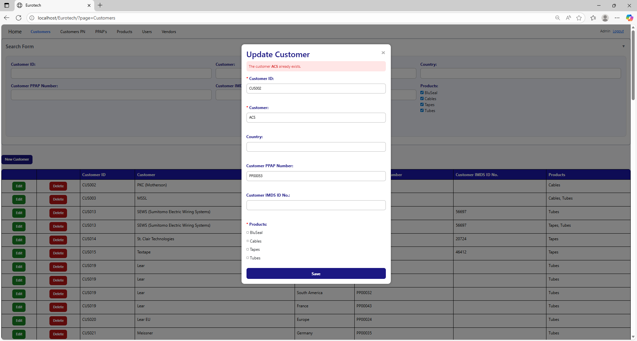

The error message prevents duplicate registers of customers.

##### 3.11.1.2.5 Customer PPAP Number must have the form 'PP00000'.

If you don’t write correctly the “Customer PPAP Number” by not writing “PP” at the beginning or by not writing a 5-digit number after “PP”, it will show an error message, that says that the “Customer PPAP Number” must have the form “PP00000”.

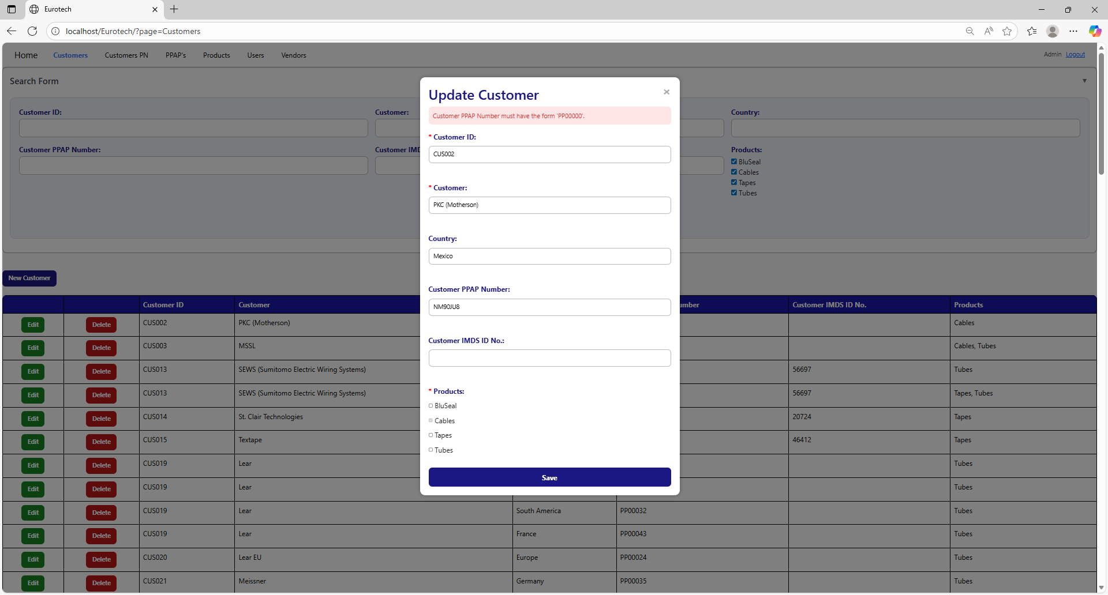

To correct this error, you must write a valid “Customer PPAP Number” following the format “PP00000”, like this example:



##### 3.11.1.2.6 The Customer PPAP Number *Customer PPAP Number* already exists.

If you write in the “Customer PPAP Number” field a Customer PPAP Number that already exists, it will show an error message, that says that already exists a register with the Customer PPAP Number you are trying to register.

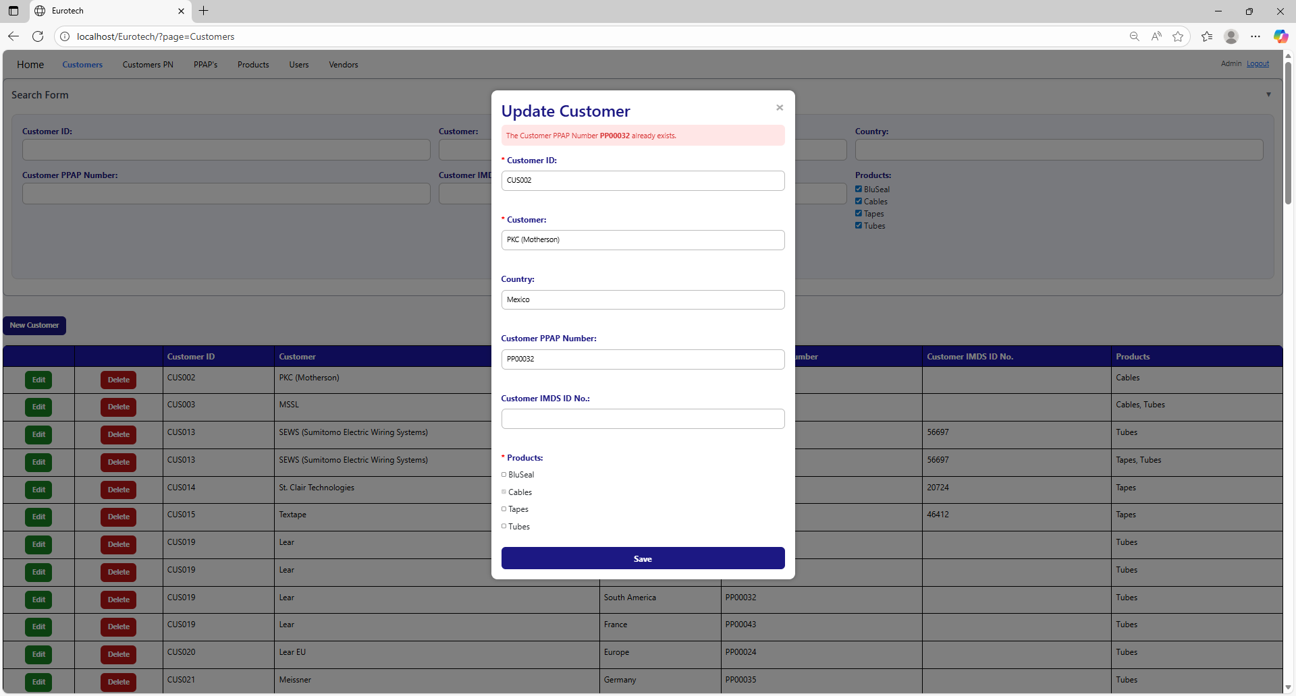

To correct this error, you must write a “Customer PPAP Number” that doesn’t exist.

#### 3.11.1.3 Delete Form Errors.

##### 3.11.1.3.1 This customer can't be deleted, because it already has registers.

If you tried to delete a customer, and it shows you an error message, that says that the customer you are trying to delete can’t be deleted, because it already has registers, this means that the customer has registers in the “Customers PN” page and probably in the “PPAP’s” page.

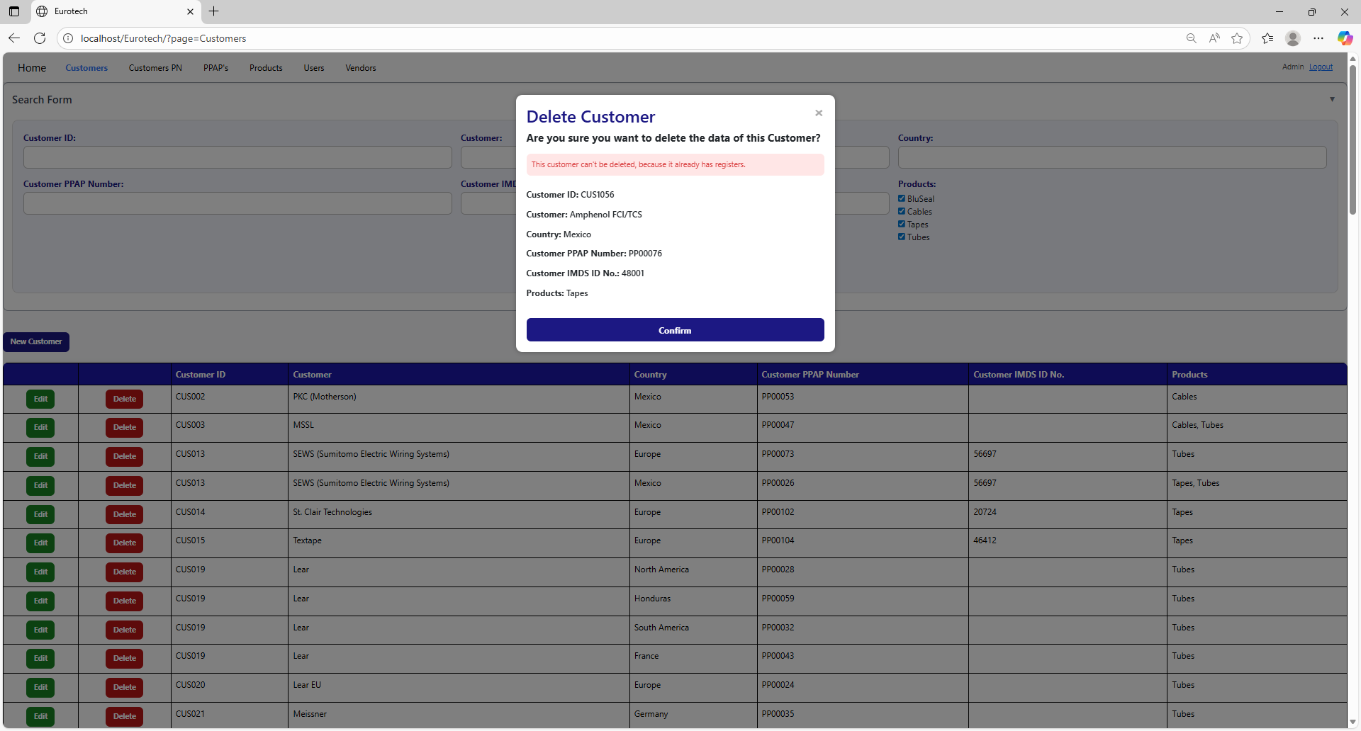

If you want to delete the customer, you must delete all the registers of this customer in the “Customers PN” and “PPAP’s” pages.

### *3.11.2 Customers PN Page Errors.*

#### 3.11.2.1 Register Form Errors.

##### 3.11.2.1.1 The customer *customer’s name* - *country* doesn’t exist.

If you write in the fields “Customer” and “Country” the data of a customer that doesn’t exist, it will show an error message, that says that doesn’t exist a register with the customer’s name and country you are trying to register.

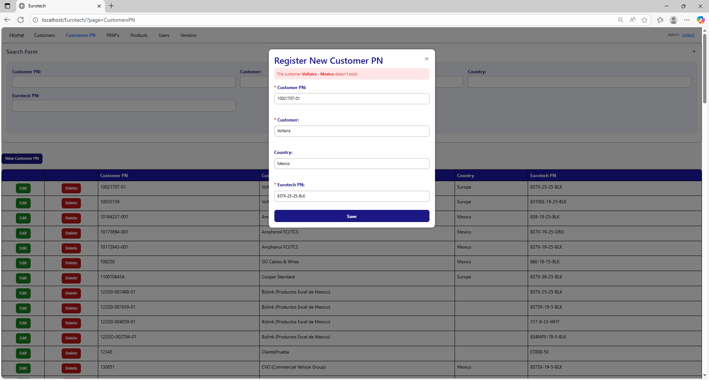

To correct this error, you must check first if the “Customer” and “Country” are written correctly. If they are written correctly but it keeps showing the same error message, then you must check in the “Customers” page if the register of the customer exists **(you can check in the Index the instruction *3.1.2 How to Search a Customer*).**

If the customer is not in the registers of the “Customers” page, then you must create a new register for that customer **(you can check in the Index the instruction *3.1.3 How to Add a new Customer*).**

Once you create the customer, you can now try to register the new Customer PN again.

##### 3.11.2.1.2 The customer *customer’s name* doesn’t exist.

If you write in the “Customer” field and the “Country” field is empty, and the data doesn’t match with a register of a customer, it will show an error message, that says that doesn’t exist a register with the customer’s name you are trying to register.

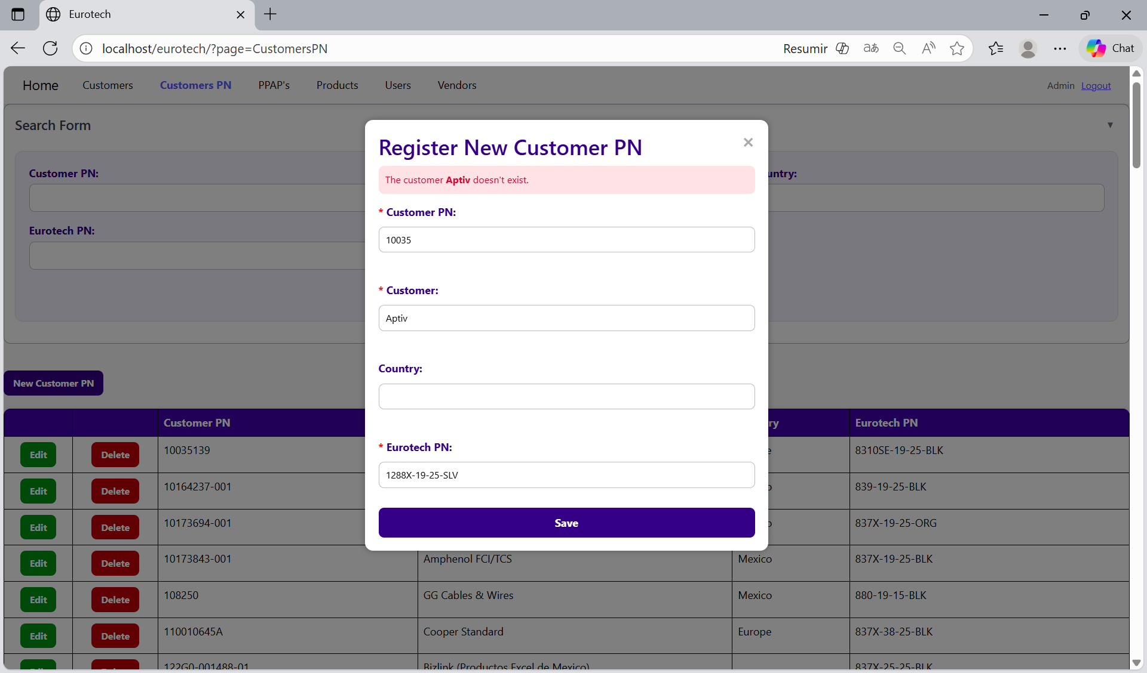

To correct this error, you must check first if the “Customer” is written correctly. If it is written correctly but it keeps showing the same error message, then you must check in the “Customers” page if the register of the customer exists **(you can check in the Index the instruction *3.1.2 How to Search a Customer*).**

If the customer is not in the registers of the “Customers” page, then you must create a new register for that customer **(you can check in the Index the instruction *3.1.3 How to Add a New Customer*).**

Once you create the customer, you can now try to register the new Customer PN again.

##### 3.11.2.1.3 The Eurotech PN *Eurotech PN* doesn't exist.

If you write in the “Eurotech PN” field and the data doesn’t match with a register of a product of Eurotech, it will show an error message, that says that doesn’t exist a register with the Eurotech PN you are trying to register.

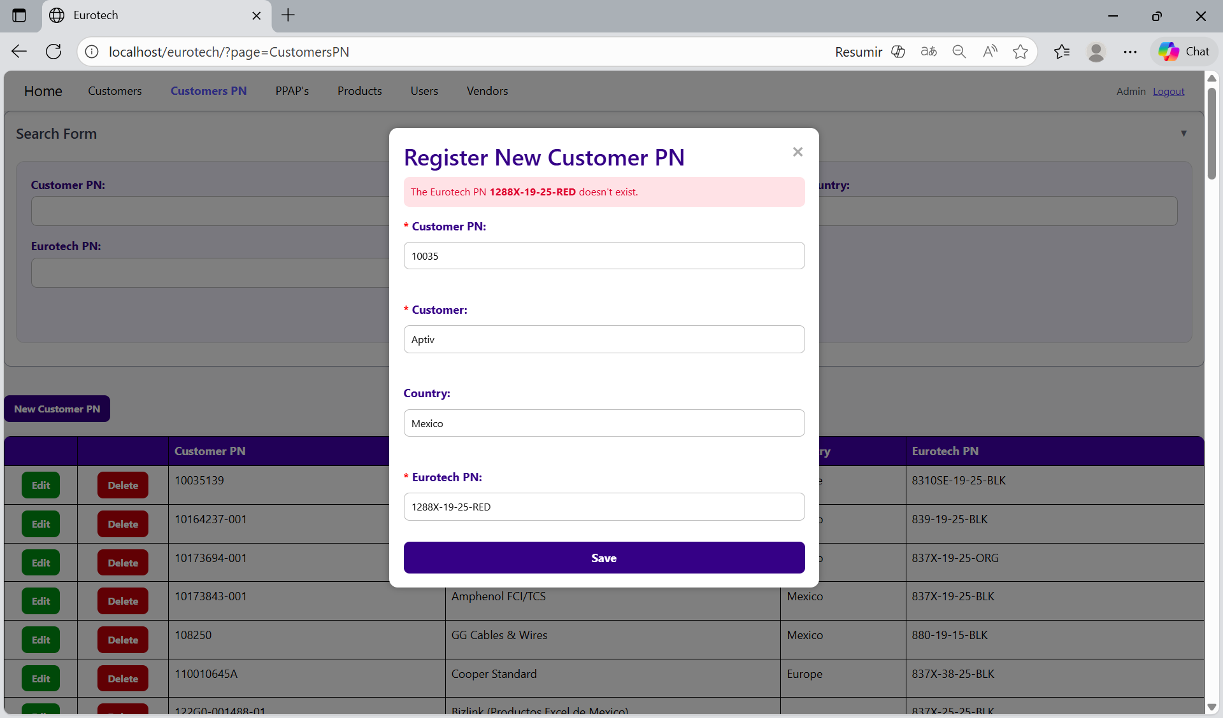

To correct this error, you must check first if the “Eurotech PN” is written correctly. If it is written correctly but it keeps showing the same error message, then you must check in the “Products” page if the register of the product exists **(you can check in the Index the instruction *3.8.2 How to Search a Product*).**

If the product is not in the registers of the “Products” page, then you must create a new register for that product **(you can check in the Index the instruction *3.8.3 How to Add a New Product*).**

Once you create the product, you can now try to register the new Customer PN again.

##### 3.11.2.1.4 A Customer PN already exists for the Eurotech PN *Eurotech PN* and the customer *customer’s name* - *country*.

If you try to duplicate a register with the same “Customer”, “Country” and “Eurotech PN”, it will show an error message, that says that a Customer PN already exists for the Eurotech PN, customer’s name and country you are trying to register.

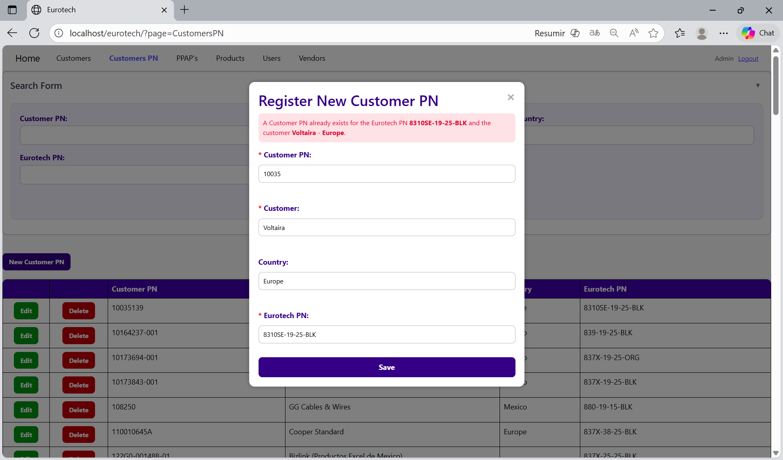

The error message prevents duplicate registers of Customers PN.

##### 3.11.2.1.5 A Customer PN already exists for the Eurotech PN *Eurotech PN* and the customer *customer’s name*.

If you try to duplicate a register with the same “Customer” and “Eurotech PN”, it will show an error message, that says that a Customer PN already exists for the Eurotech PN and customer’s name you are trying to register.

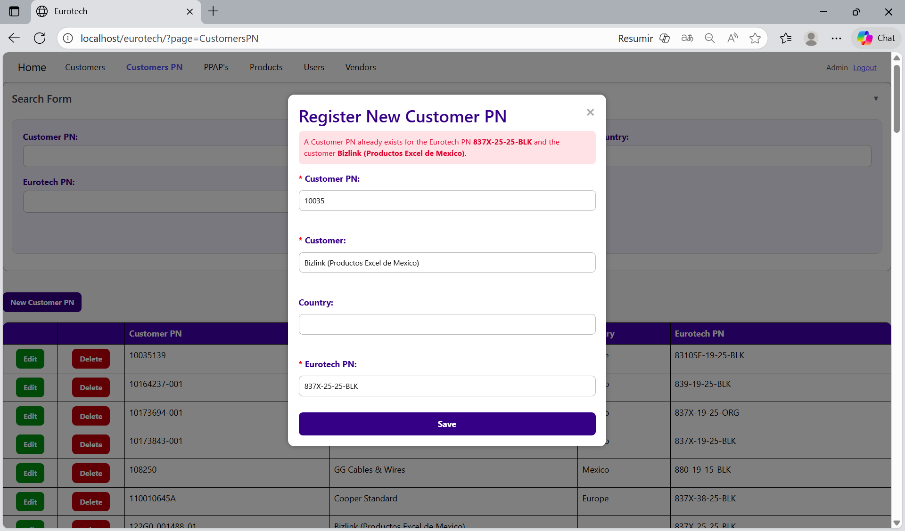

The error message prevents duplicate registers of Customers PN.

##### 3.11.2.1.6 You are duplicating the Customer PN *Customer PN* for the customer *customer’s name* - *country*.

If you try to duplicate a register with the same “Customer PN”, “Customer” and “Country”, it will show an error message, that says that a register already exists with the Customer PN, customer’s name and country you are trying to register.

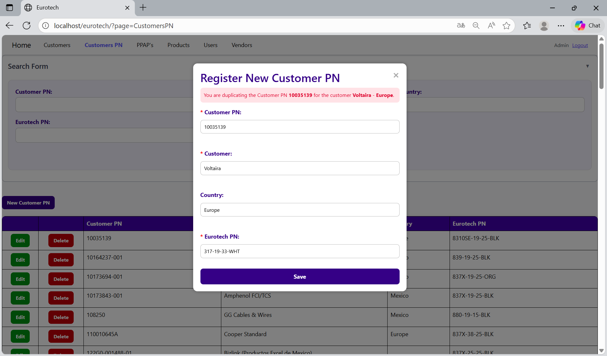

The error message prevents duplicate registers of Customers PN.

##### 3.11.2.1.7 You are duplicating the Customer PN *Customer PN* for the customer *customer’s name*.

If you try to duplicate a register with the same “Customer PN” and “Customer”, it will show an error message, that says that a register already exists with the Customer PN and customer’s name you are trying to register.

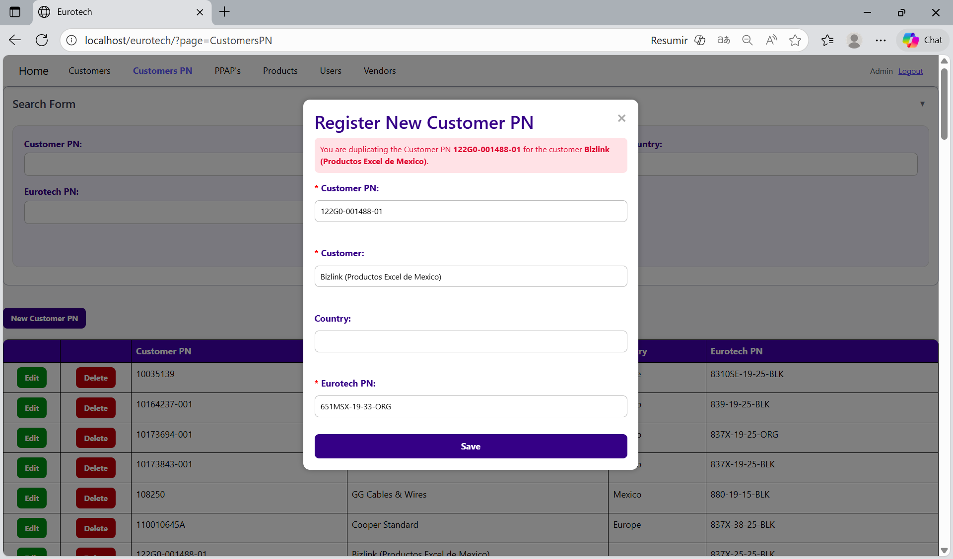

The error message prevents duplicate registers of Customers PN.

#### 3.11.2.2 Edit Form Errors.

##### 3.11.2.2.1 The customer *customer’s name* - *country* doesn’t exist.

If you write in the fields “Customer” and “Country” the data of a customer that doesn’t exist, it will show an error message, that says that doesn’t exist a register with the customer’s name and country you are trying to update.

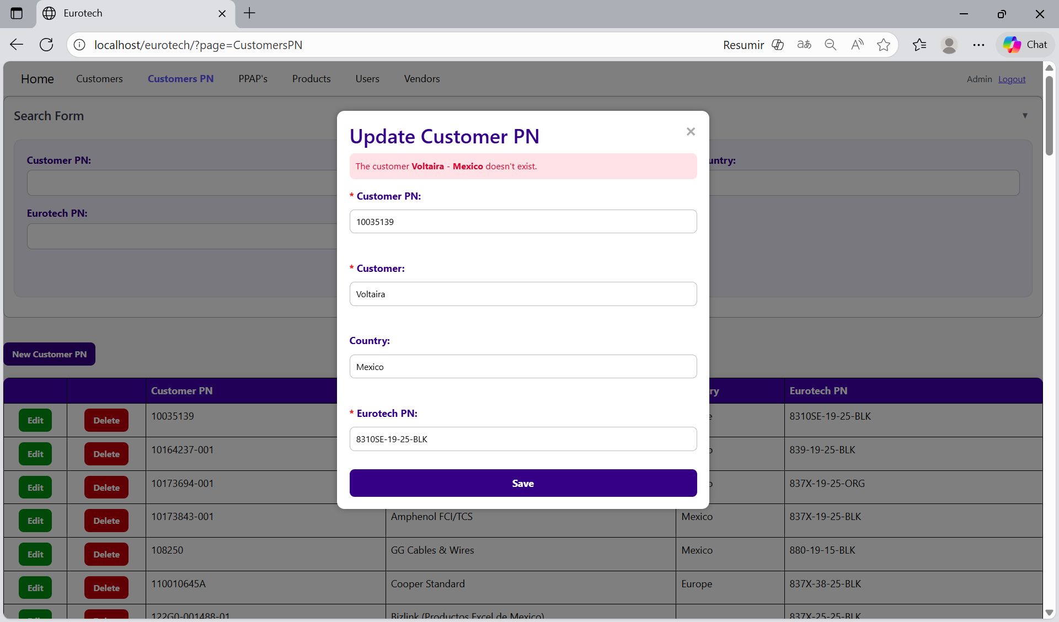

To correct this error, you must check first if the “Customer” and “Country” are written correctly. If they are written correctly but it keeps showing the same error message, then you must check in the “Customers” page if the register of the customer exists **(you can check in the Index the instruction *3.1.2 How to Search a Customer*).**

If the customer is not in the registers of the “Customers” page, then you must create a new register for that customer **(you can check in the Index the instruction *3.1.3 How to Add a New Customer*).**

Once you create the customer, you can now try to update the Customer PN again.

##### 3.11.2.2.2 The customer *customer’s name* doesn’t exist.

If you write in the “Customer” field and the “Country” field is empty, and the data doesn’t match with a register of a customer, it will show an error message, that says that doesn’t exist a register with the customer’s name you are trying to update.

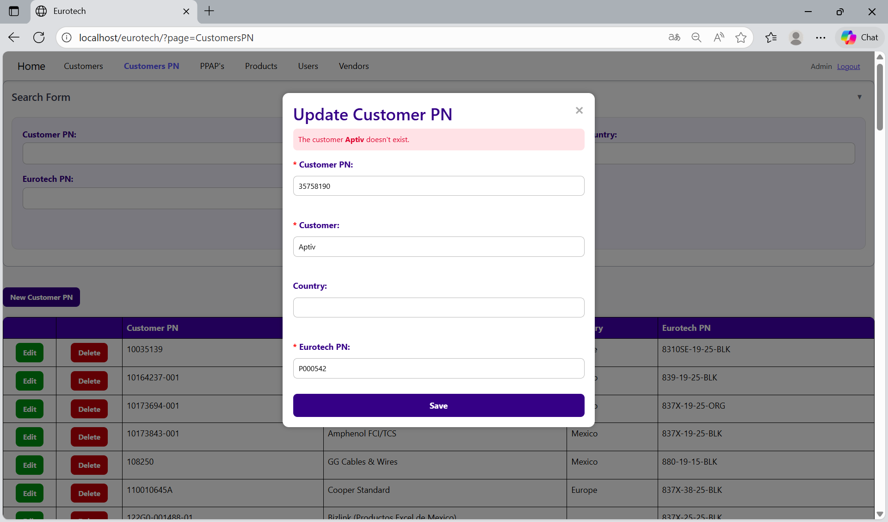

To correct this error, you must check first if the “Customer” is written correctly. If it is written correctly but it keeps showing the same error message, then you must check in the “Customers” page if the register of the customer exists **(you can check in the Index the instruction *3.1.2 How to Search a Customer*).**

If the customer is not in the registers of the “Customers” page, then you must create a new register for that customer **(you can check in the Index the instruction *3.1.3 How to Add a New Customer*).**

Once you create the customer, you can now try to update the Customer PN again.

##### 3.11.2.2.3 The Eurotech PN *Eurotech PN* doesn't exist.

If you write in the “Eurotech PN” field and the data doesn’t match with a register of a product of Eurotech, it will show an error message, that says that doesn’t exist a register with the Eurotech PN you are trying to update.

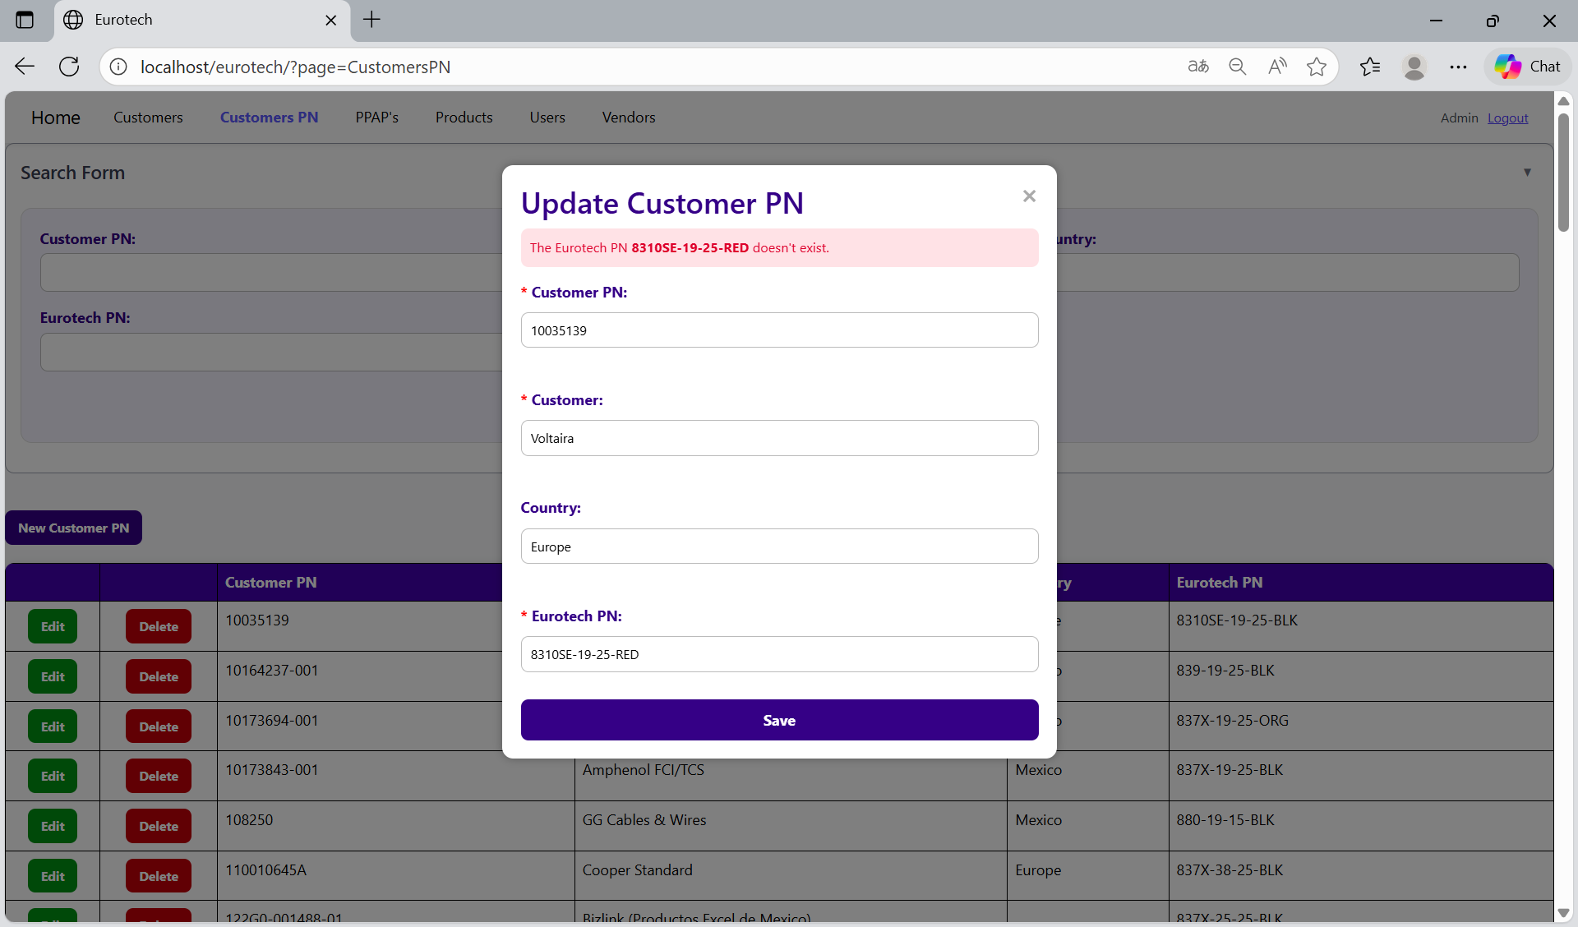

To correct this error, you must check first if the “Eurotech PN” is written correctly. If it is written correctly but it keeps showing the same error message, then you must check in the “Products” page if the register of the product exists **(you can check in the Index the instruction *3.8.2 How to Search a Product*).**

If the product is not in the registers of the “Products” page, then you must create a new register for that product **(you can check in the Index the instruction *3.8.3 How to Add a New Product*).**

Once you create the product, you can now try to update the Customer PN again.

##### 3.11.2.2.4 A Customer PN already exists for the Eurotech PN *Eurotech PN* and the customer *customer’s name* - *country*.

If you try to duplicate a register with the same “Customer”, “Country” and “Eurotech PN”, it will show an error message, that says that a Customer PN already exists for the Eurotech PN, customer’s name and country you are trying to update.

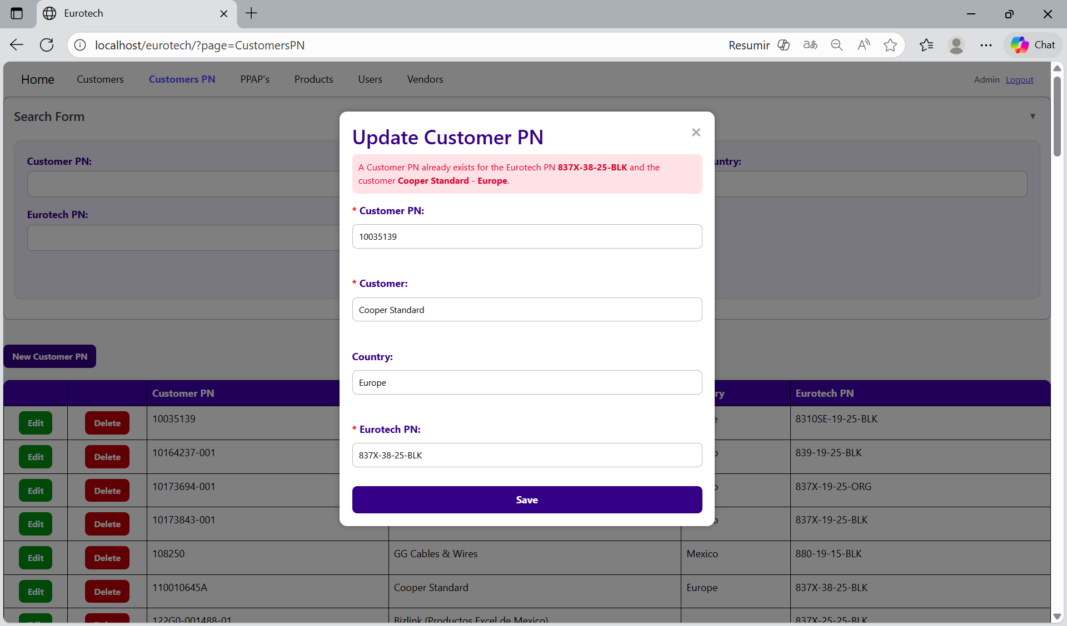

The error message prevents duplicate registers of Customers PN.

##### 3.11.2.2.5 A Customer PN already exists for the Eurotech PN *Eurotech PN* and the customer *customer’s name*.

If you try to duplicate a register with the same “Customer” and “Eurotech PN”, it will show an error message, that says that a Customer PN already exists for the Eurotech PN and customer’s name you are trying to update.

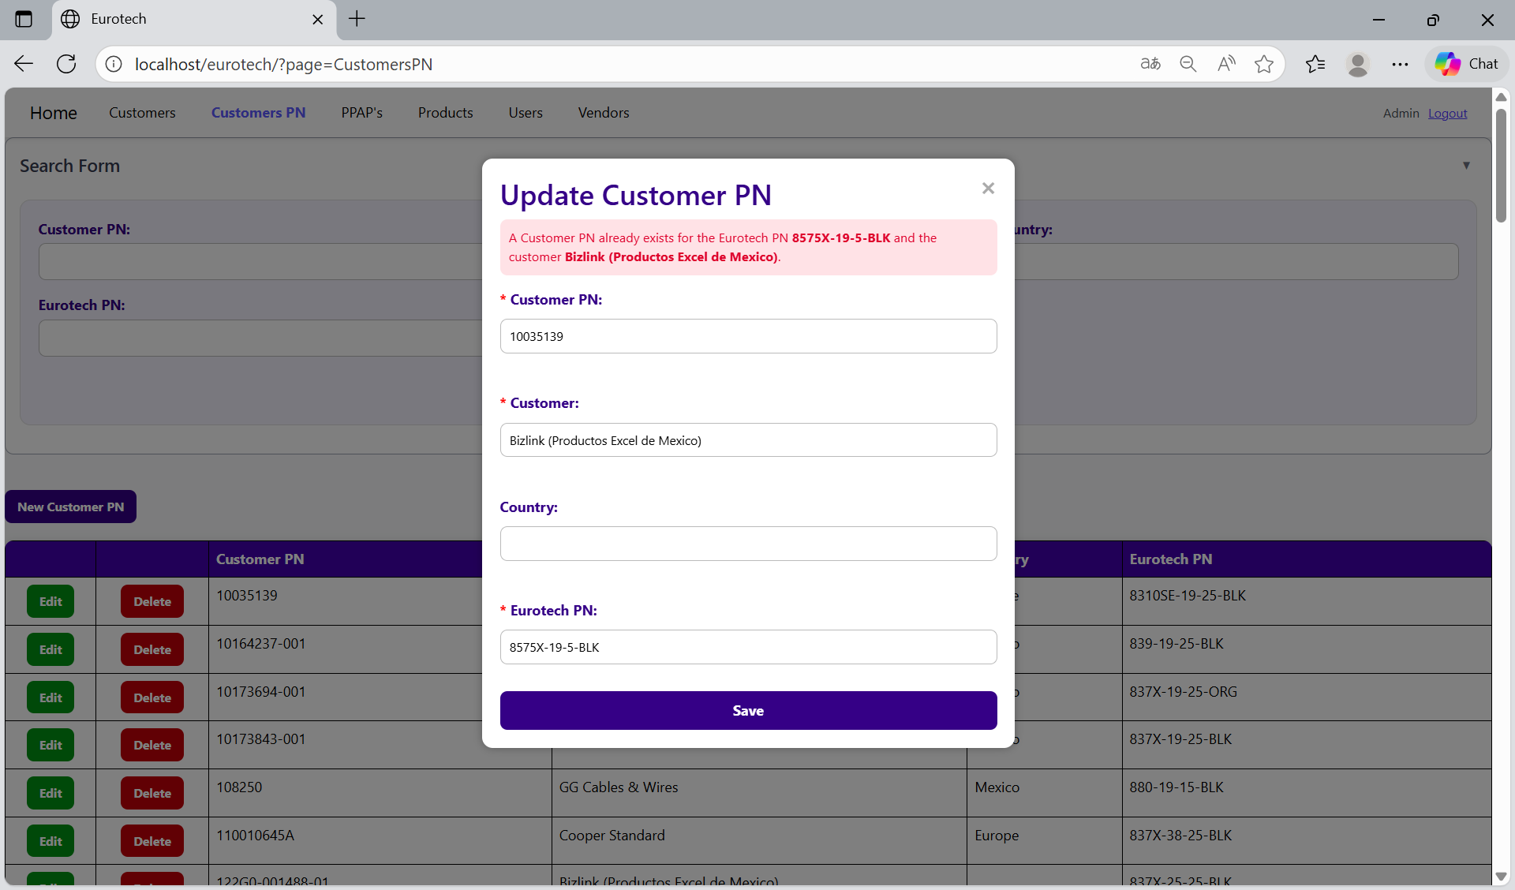

The error message prevents duplicate registers of Customers PN.

##### 3.11.2.2.6 You are duplicating the Customer PN *Customer PN* for the customer *customer’s name* - *country*.

If you try to duplicate a register with the same “Customer PN”, “Customer” and “Country”, it will show an error message, that says that a register already exists with the Customer PN, customer’s name and country you are trying to update.

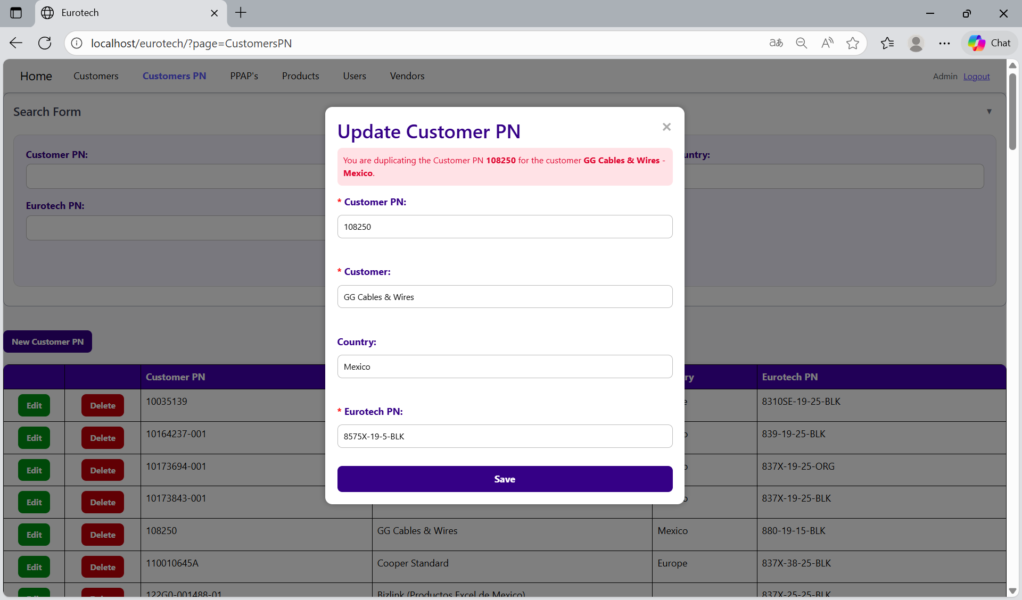

The error message prevents duplicate registers of Customers PN.

##### 3.11.2.2.7 You are duplicating the Customer PN *Customer PN* for the customer *customer’s name*.

If you try to duplicate a register with the same “Customer PN” and “Customer”, it will show an error message, that says that a register already exists with the Customer PN and customer’s name you are trying to update.

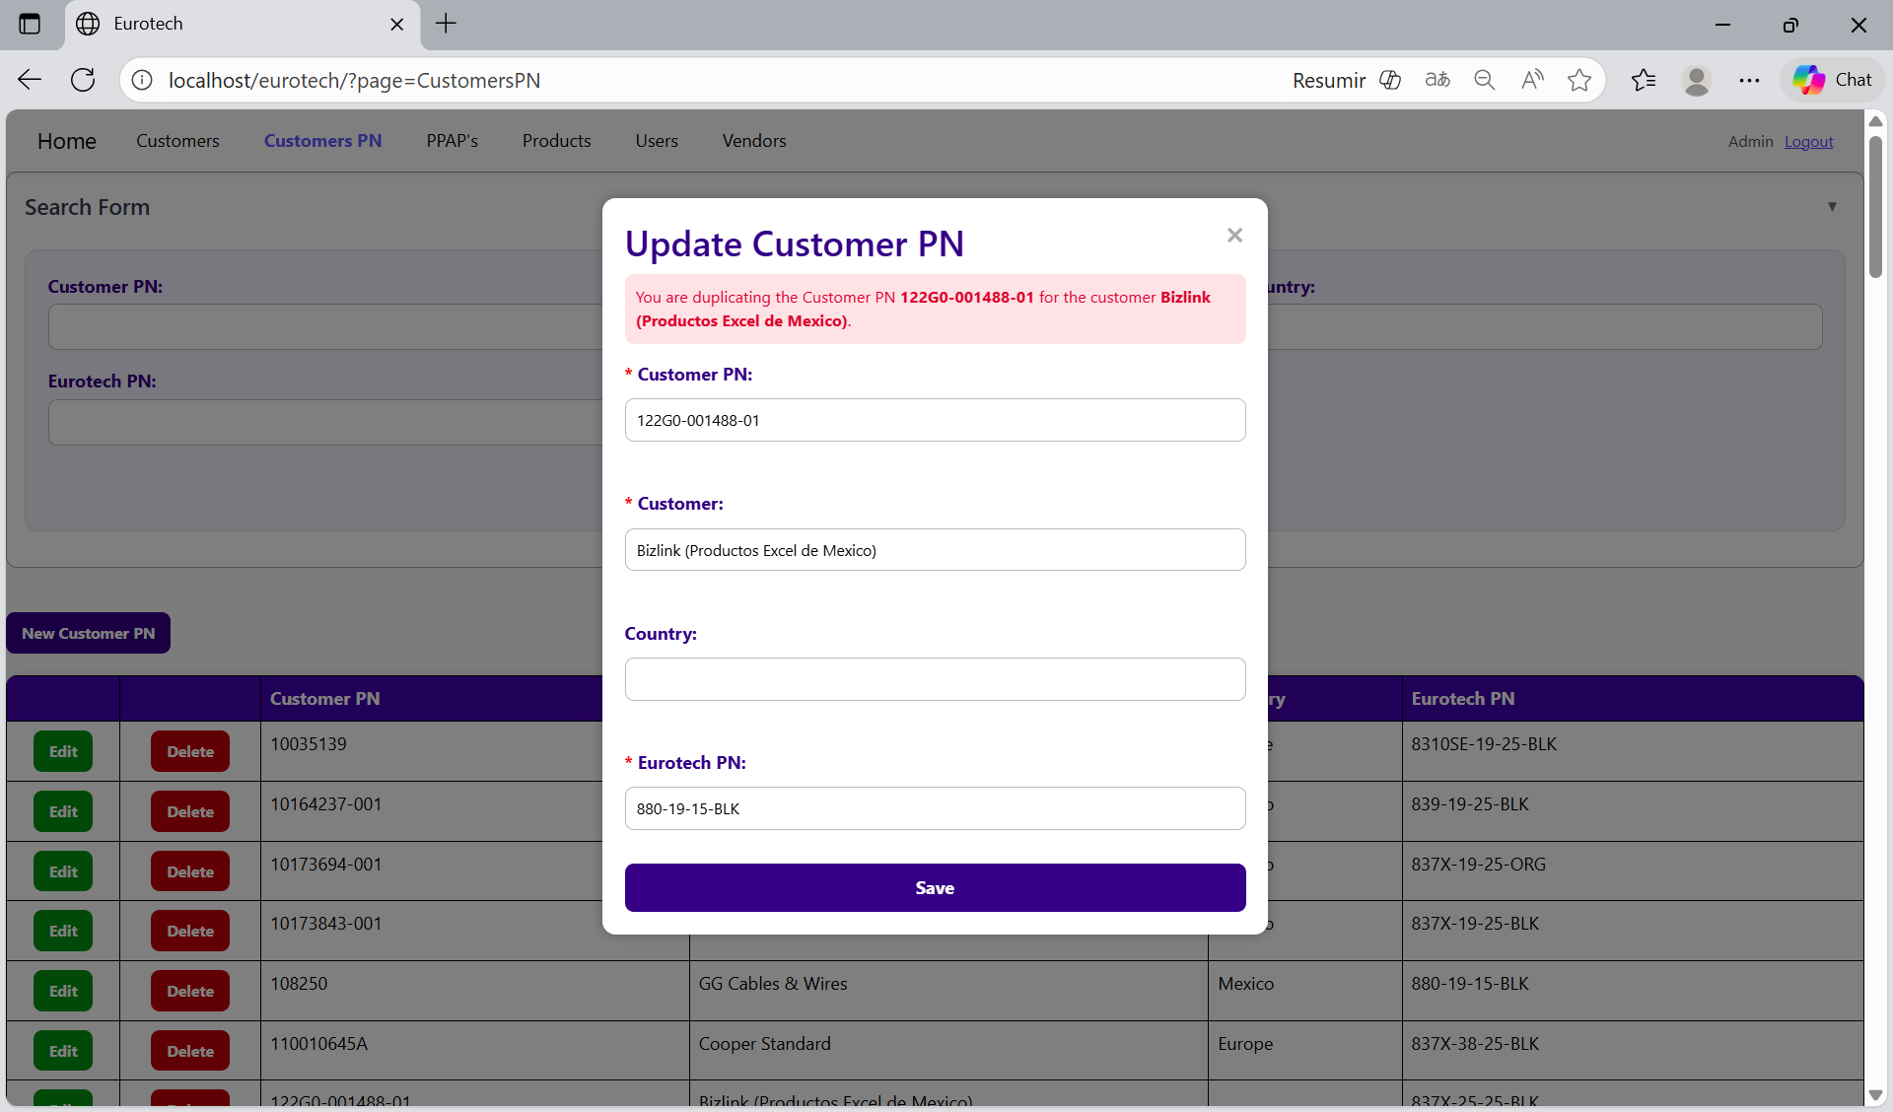

The error message prevents duplicate registers of Customers PN.

#### 3.11.2.3 Delete Form Errors.

##### 3.11.2.3.1 This customer PN can’t be deleted, because it already has registers.

If you tried to delete a Customer PN, and it shows you an error message, that says that the Customer PN you are trying to delete can’t be deleted, because it already has registers, this means that the Customer PN has registers in the “PPAP’s” page.

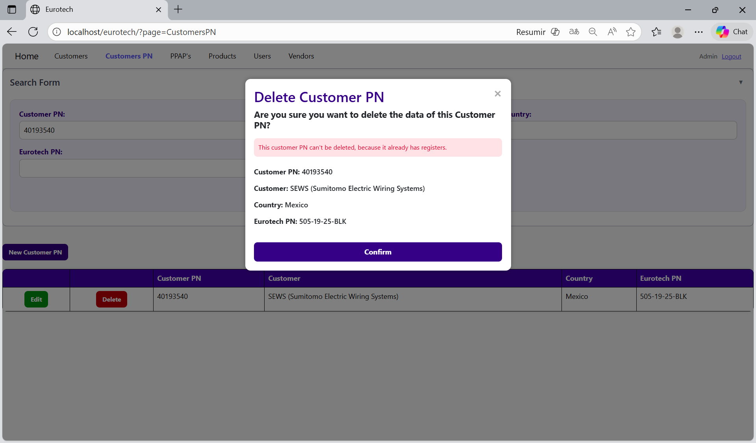

If you want to delete the Customer PN, you must delete all the registers of this Customer PN in the “PPAP’s” page.

### *3.11.3 PPAP’s, BluSeal, Cables, Tapes and Tubes Pages Errors.*

#### 3.11.3.1 Register Form Errors.

##### 3.11.3.1.1 The fields ‘Supplier PN’, ‘Customer’, ‘Country’, ‘Customer PN’, ‘Eurotech PN’ and ‘Description’ don’t match.

If you write in the fields “Supplier PN”, “Customer”, “Country”, “Customer PN”, “Eurotech PN” and “Description” the data of a product, customer or Customer PN that doesn’t exist, it will show an error message, that says that doesn’t exist a register that matches with the Supplier PN, customer’s name, country, Customer PN, Eurotech PN and description you are trying to register.

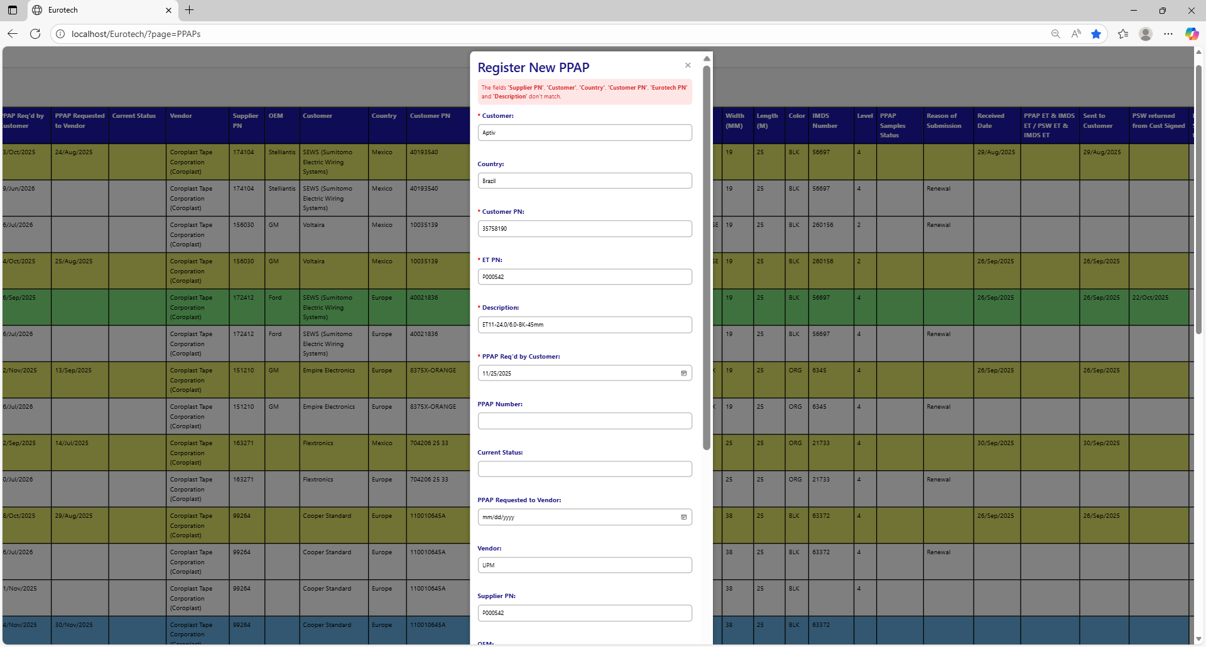

To correct this error, you must check first if the “Supplier PN”, “Customer”, “Country”, “Customer PN”, “Eurotech PN” and “Description” are written correctly. If they are written correctly but it keeps showing the same error message, then you must check:

* In the “Customers PN” page if the register of the Customer PN exists **(you can check in the Index the instruction *3.2.2 How to Search a Customer PN*).**

If the Customer PN is not in the registers of the “Customers PN” page, then you must create a new register for that Customer PN **(you can check in the Index the instruction *3.2.3 How to Add a New Customer PN*).**

Once you create the Customer PN, you can now try to register the PPAP again.

* In the “Customers” page if the register of the customer exists **(you can check in the Index the instruction *3.1.2 How to Search a Customer*).**

If the customer is not in the registers of the “Customers” page, then you must create a new register for that customer **(you can check in the Index the instruction *3.1.3 How to Add a New Customer*).**

Once you create the customer, you can now try to register the Customer PN and then try to register the PPAP again.

* In the “Products” page if the register of the product exists **(you can check in the Index the instruction *3.8.2 How to Search a Product*).**

If the product is not in the registers of the “Products” page, then you must create a new register for that product **(you can check in the Index the instruction *3.8.3 How to Add a New Product*).**

Once you create the product, you can now try to register the Customer PN and then try to register the PPAP again.

##### 3.11.3.1.2 PPAP Number must have the form 'PP00000-0000'.

If you don’t write correctly the “PPAP Number” by not following the form “PP00000-0000” it will show an error message, that says that the “PPAP Number” must have the form “PP00000-0000”.

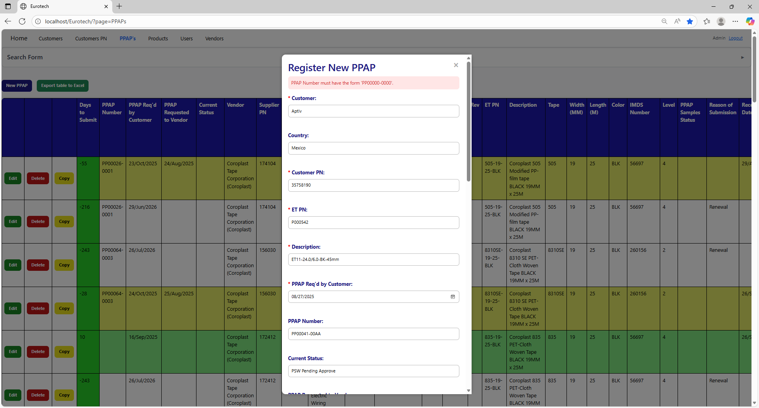

To correct this error, you must write a valid “PPAP Number” following the format “PP00000-0000”, like this example:

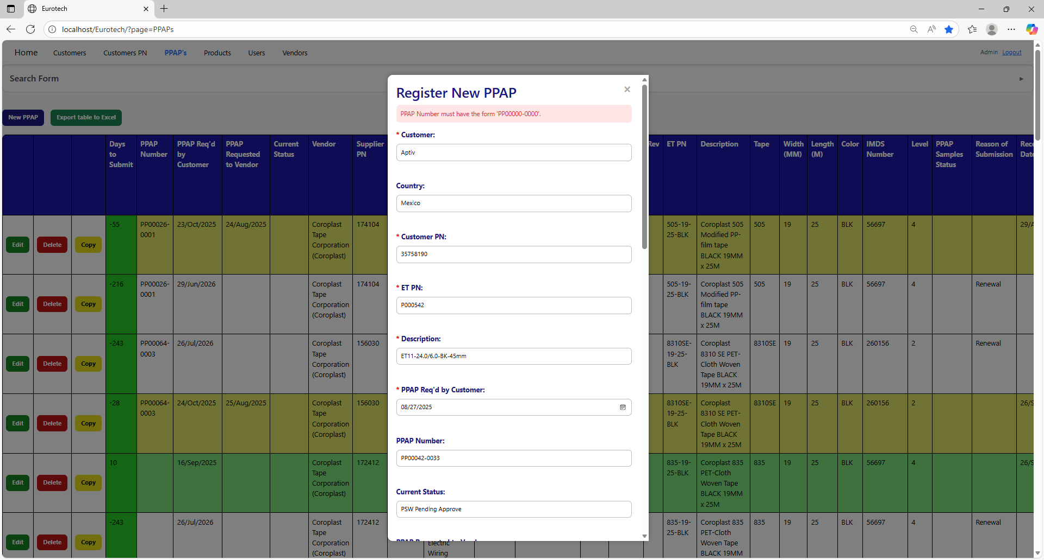

##### 3.11.3.1.3 The fields ‘PPAP Number’, ‘Customer’ and ‘Country’ don’t match.

If you write a PPAP Number that doesn’t match with the Customer PPAP Number of the customer, it will show an error message, that says that doesn’t exist a register that matches with the PPAP Number, customer’s name and country you are trying to register.

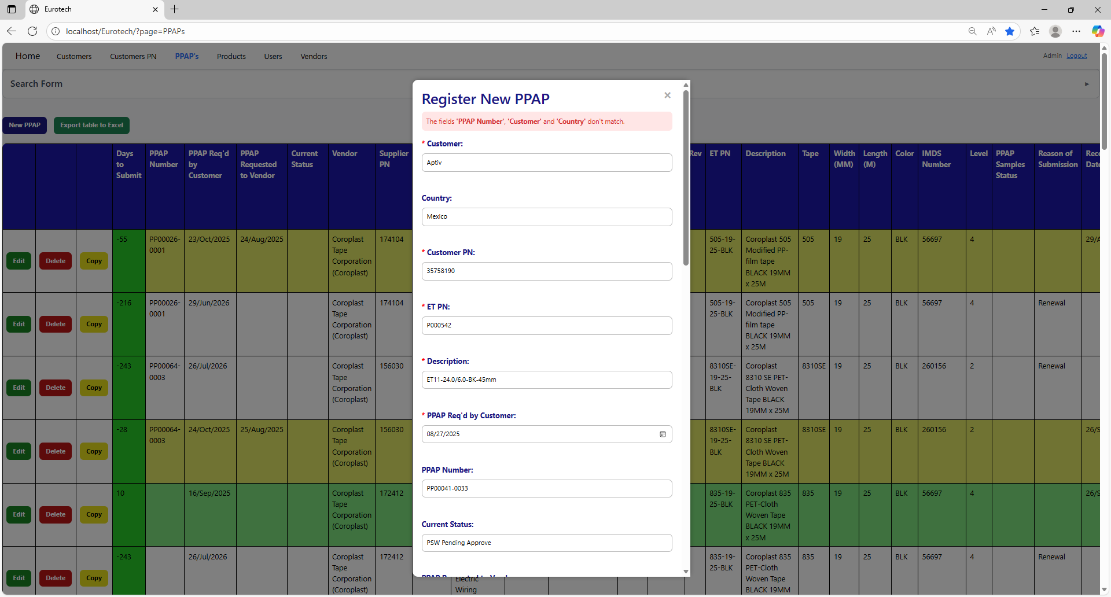

To correct this error, you must check first if the “PPAP Number” is written correctly. If it is written correctly but it keeps showing the same error message, then you must check on the “Customers” page if the PPAP Number match with the Customer PPAP Number of the customer **(you can check in the Index the instruction *3.1.2 How to Search a Customer*).**

Once you check the customer’s correct Customer PPAP Number, you can now try to register the PPAP again.

#### 3.11.3.2 Edit Form Errors.

##### 3.11.3.2.1 The fields ‘Supplier PN’, ‘Customer’, ‘Country’, ‘Customer PN’, ‘Eurotech PN’ and ‘Description’ don’t match.

If you write in the fields “Supplier PN”, “Customer”, “Country”, “Customer PN”, “Eurotech PN” and “Description” the data of a product, customer or Customer PN that doesn’t exist, it will show an error message, that says that doesn’t exist a register that matches with the Supplier PN, customer’s name, country, Customer PN, Eurotech PN and description you are trying to update.

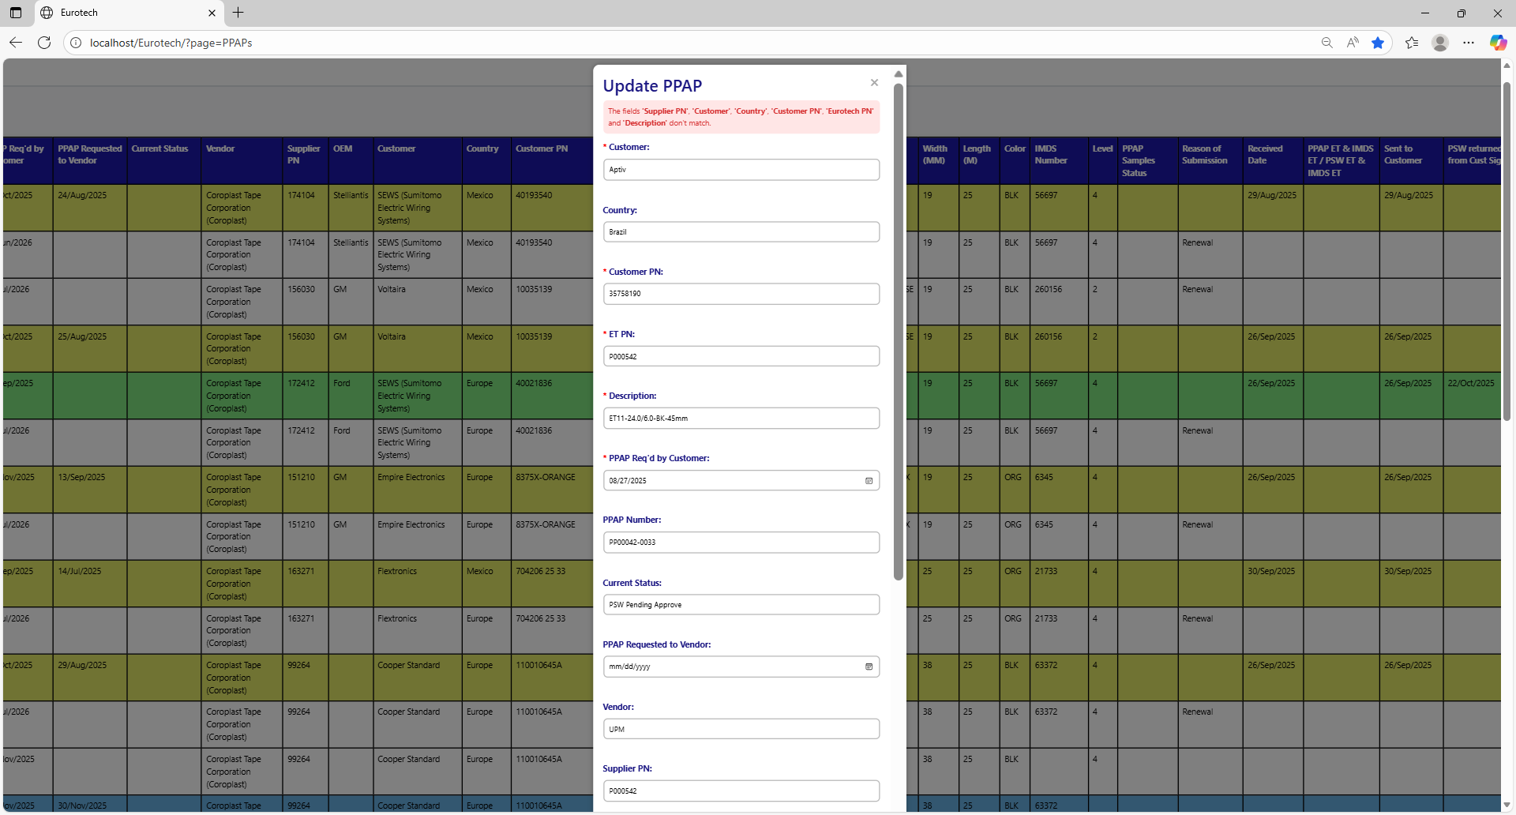

To correct this error, you must check first if the “Supplier PN”, “Customer”, “Country”, “Customer PN”, “Eurotech PN” and “Description” are written correctly. If they are written correctly but it keeps showing the same error message, then you must check:

* In the “Customers PN” page if the register of the Customer PN exists **(you can check in the Index the instruction *3.2.2 How to Search a Customer PN*).**

If the Customer PN is not in the registers of the “Customers PN” page, then you must create a new register for that Customer PN **(you can check in the Index the instruction *3.2.3 How to Add a New Customer PN*).**

Once you create the Customer PN, you can now try to update the PPAP again.

* In the “Customers” page if the register of the customer exists **(you can check in the Index the instruction *3.1.2 How to Search a Customer*).**

If the customer is not in the registers of the “Customers” page, then you must create a new register for that customer **(you can check in the Index the instruction *3.1.3 How to Add a New Customer*).**

Once you create the customer, you can now try to register the Customer PN and then try to update the PPAP again.

* In the “Products” page if the register of the product exists **(you can check in the Index the instruction *3.8.2 How to Search a Product*).**

If the product is not in the registers of the “Products” page, then you must create a new register for that product **(you can check in the Index the instruction *3.8.3 How to Add a New Product*).**

Once you create the product, you can now try to register the Customer PN and then try to update the PPAP again.

##### 3.11.3.2.2 PPAP Number must have the form 'PP00000-0000'.

If you don’t write correctly the “PPAP Number” by not following the form “PP00000-0000” it will show an error message, that says that the “PPAP Number” must have the form “PP00000-0000”.

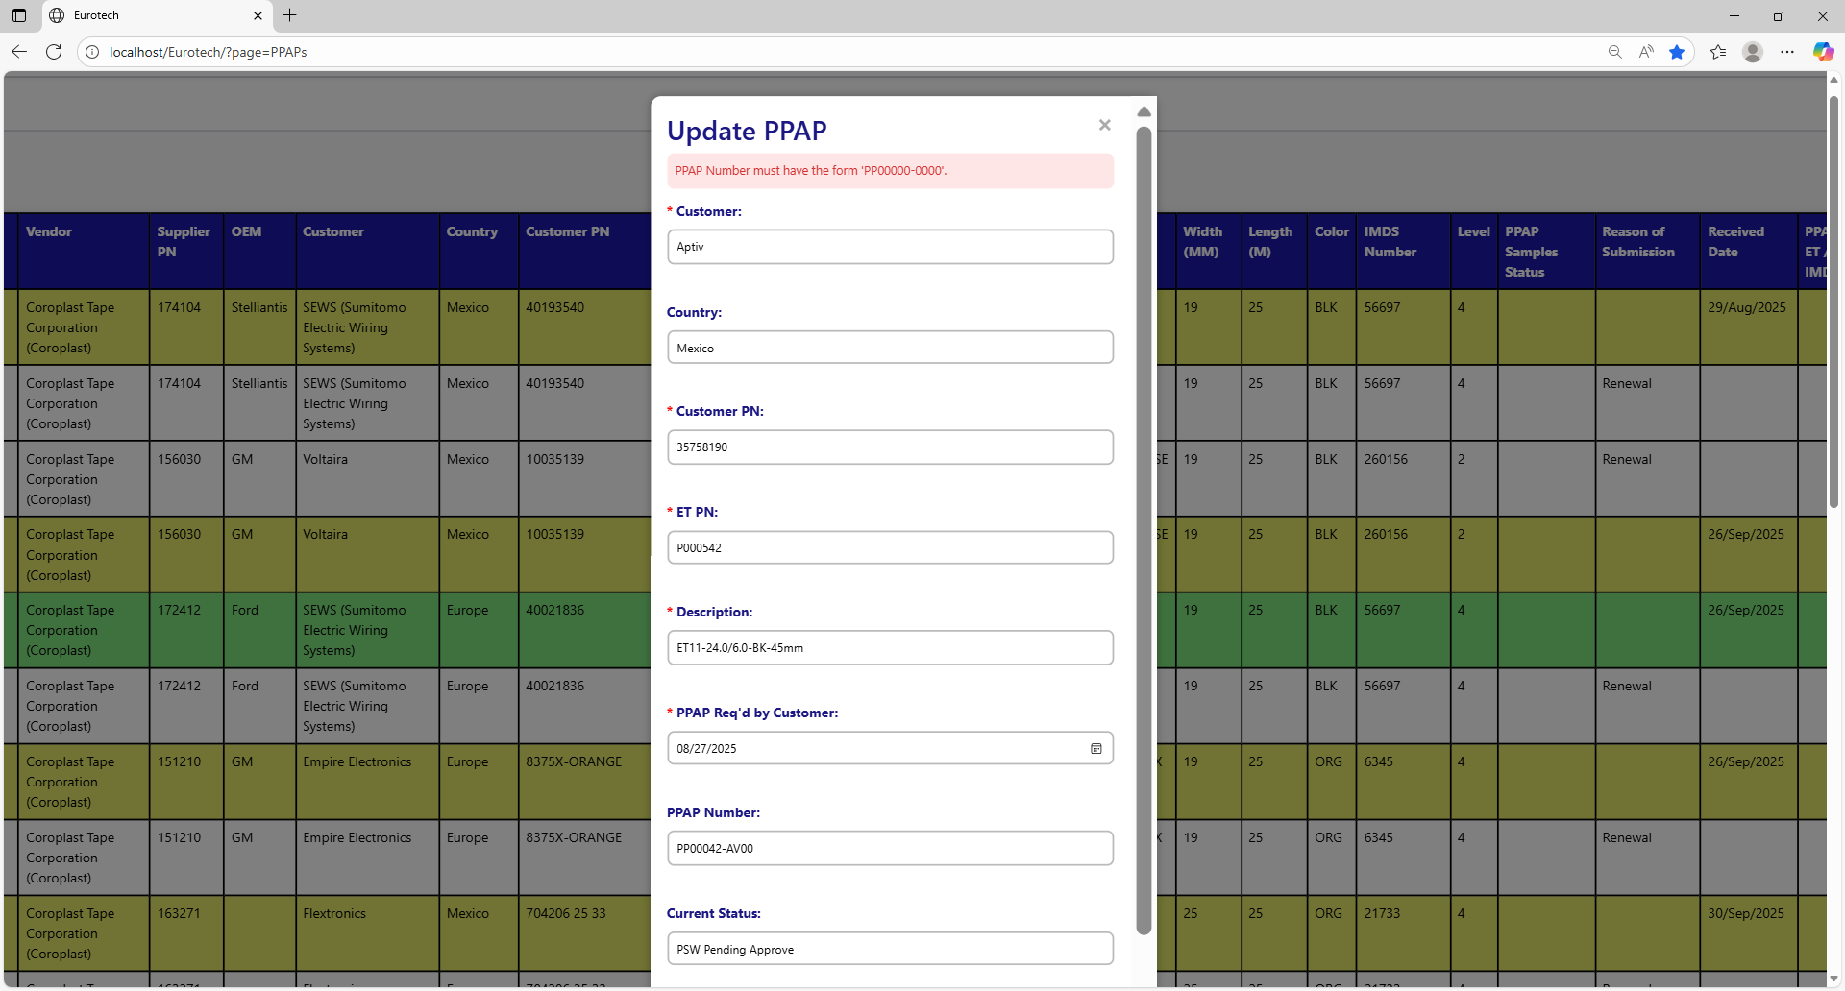

To correct this error, you must write a valid “PPAP Number” following the format “PP00000-0000”, like this example:



##### 3.11.3.2.3 The fields ‘PPAP Number’, ‘Customer’ and ‘Country’ don’t match.

If you write a PPAP Number that doesn’t match with the Customer PPAP Number of the customer, it will show an error message, that says that doesn’t exist a register that matches with the PPAP Number, customer’s name and country you are trying to update.

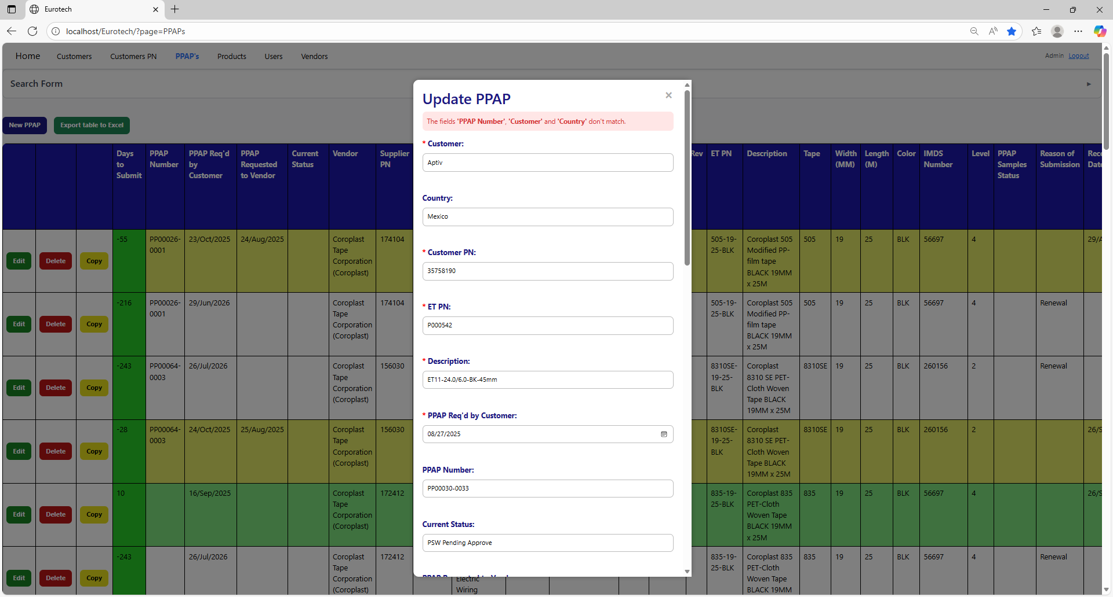

To correct this error, you must check first if the “PPAP Number” is written correctly. If it is written correctly but it keeps showing the same error message, then you must check on the “Customers” page if the PPAP Number match with the Customer PPAP Number of the customer **(you can check in the Index the instruction *3.1.2 How to Search a Customer*).**

Once you check the customer’s correct Customer PPAP Number, you can now try to update the PPAP again.

### *3.11.4 Products Page Errors.*

#### 3.11.4.1 Register Form Errors.

##### 3.11.4.1.1 The Eurotech PN *Eurotech PN* already exists.

If you write an Eurotech PN that already exists, it will show an error message, that says that exists a register with the Eurotech PN you are trying to register.

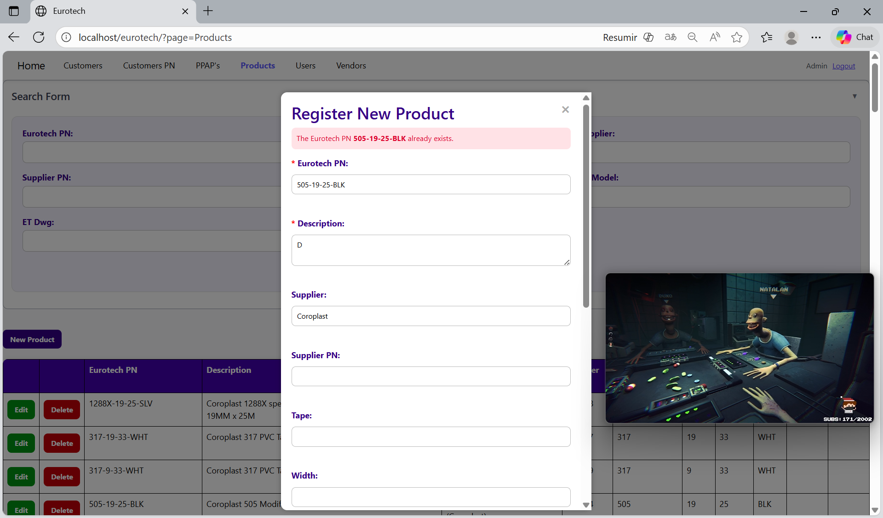

The error message prevents duplicate registers of products.

##### 3.11.4.1.2 The description *description* already exists.

If you write a description that already exists, it will show an error message, that says that exists a register with the description you are trying to register.

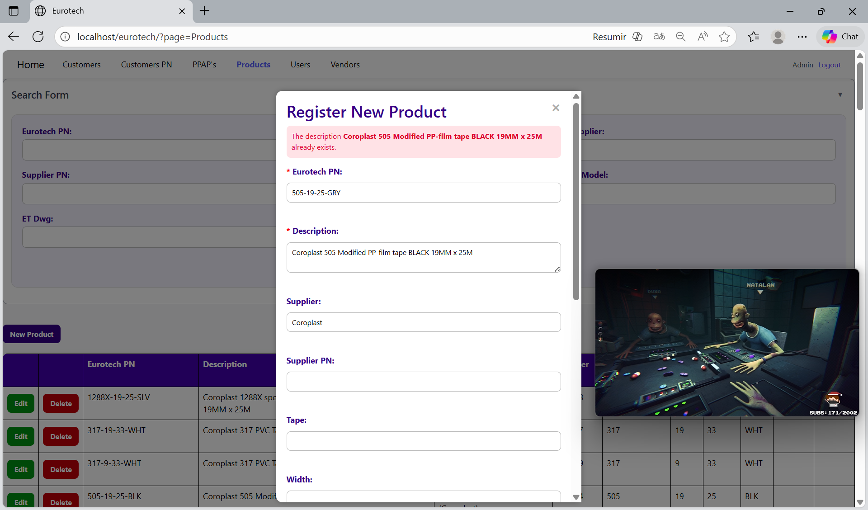

The error message prevents duplicate registers of products.

##### 3.11.4.1.3 The Supplier PN *Supplier PN* already exists.

If you write a Supplier PN that already exists, it will show an error message, that says that exists a register with the Supplier PN you are trying to register.

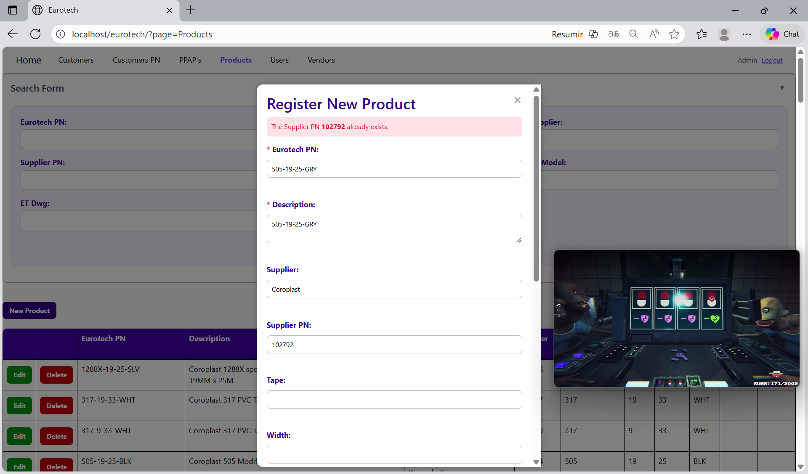

The error message prevents duplicate registers of products.

##### 3.11.4.1.4 The Eurotech PN *Eurotech PN* and the description *description* already exist.

If you write an Eurotech PN and description that already exist, it will show an error message, that says that exists a register with the Eurotech PN and description you are trying to register.

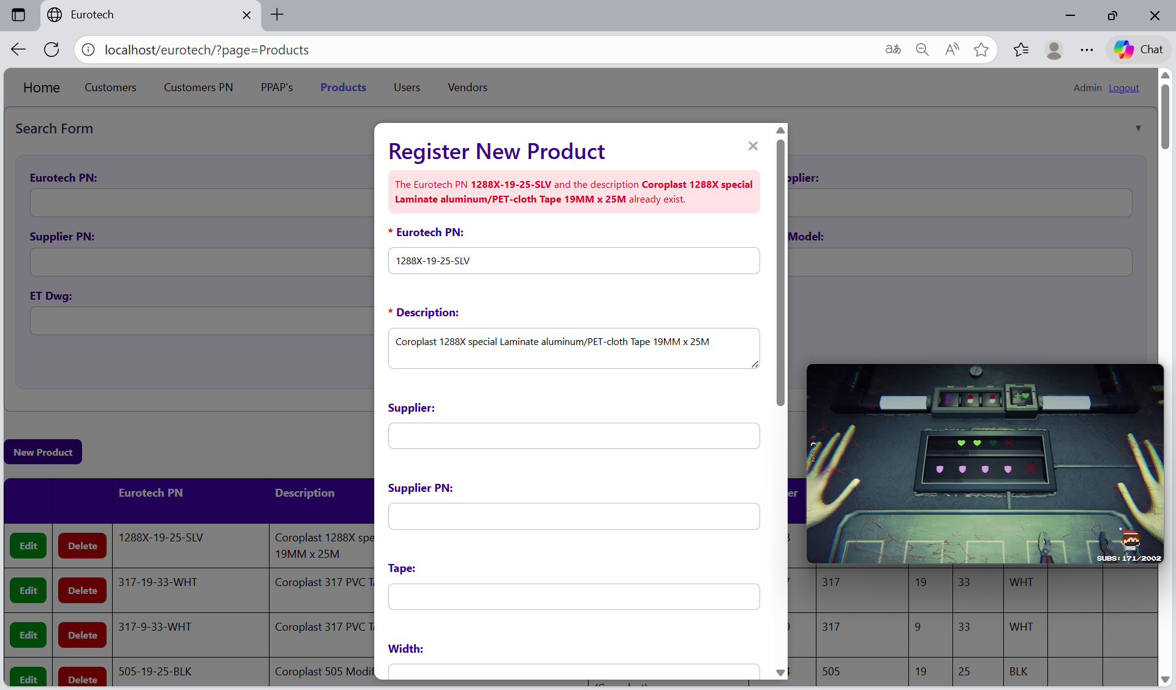

The error message prevents duplicate registers of products.

##### 3.11.4.1.5 The Eurotech PN *Eurotech PN* and the Supplier PN *Supplier PN* already exist.

If you write an Eurotech PN and Supplier PN that already exist, it will show an error message, that says that exists a register with the Eurotech PN and Supplier PN you are trying to register.

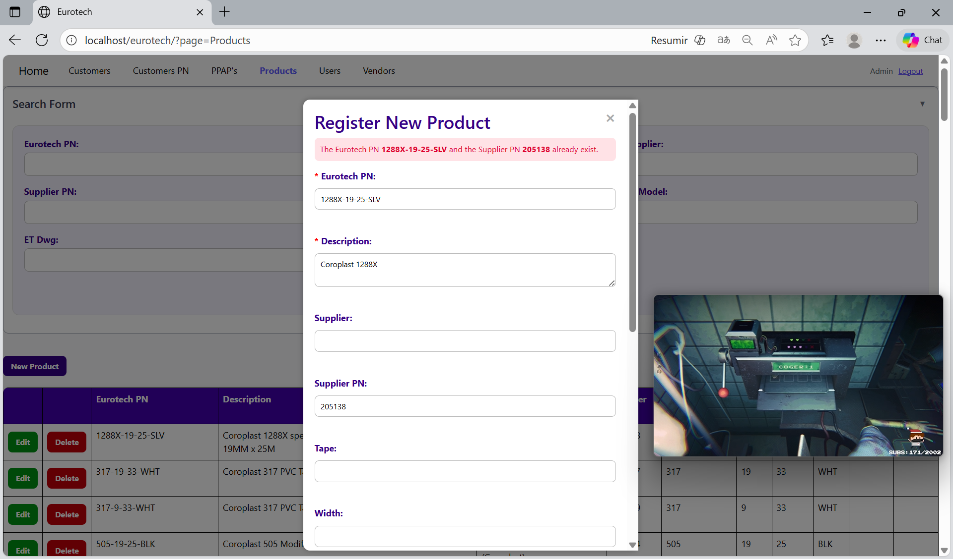

The error message prevents duplicate registers of products.

##### 3.11.4.1.6 The Supplier PN *Supplier PN* and the description *description* already exist.

If you write a Supplier PN and description that already exist, it will show an error message, that says that exists a register with the Supplier PN and description you are trying to register.

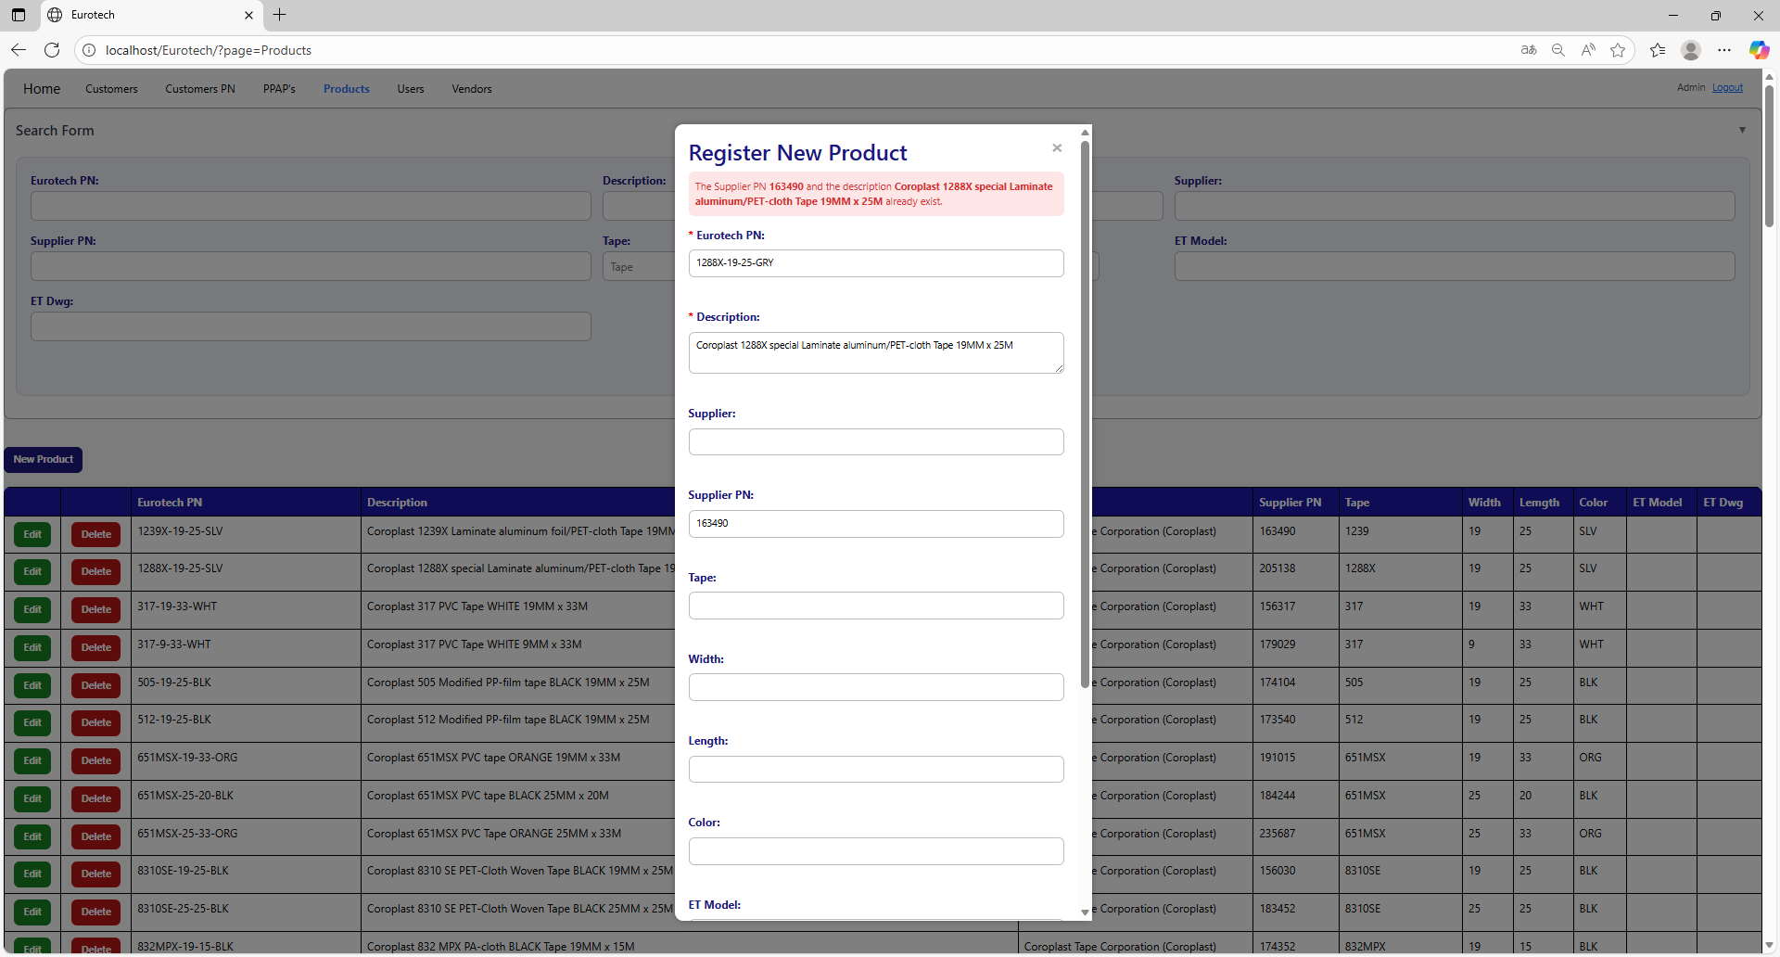

The error message prevents duplicate registers of products.

##### 3.11.4.1.7 The Eurotech PN *Eurotech PN*, the Supplier PN *Supplier PN* and the description *description* already exist.

If you write an Eurotech PN, Supplier PN and description that already exist, it will show an error message, that says that exists a register with the Eurotech PN, Supplier PN and description you are trying to register.

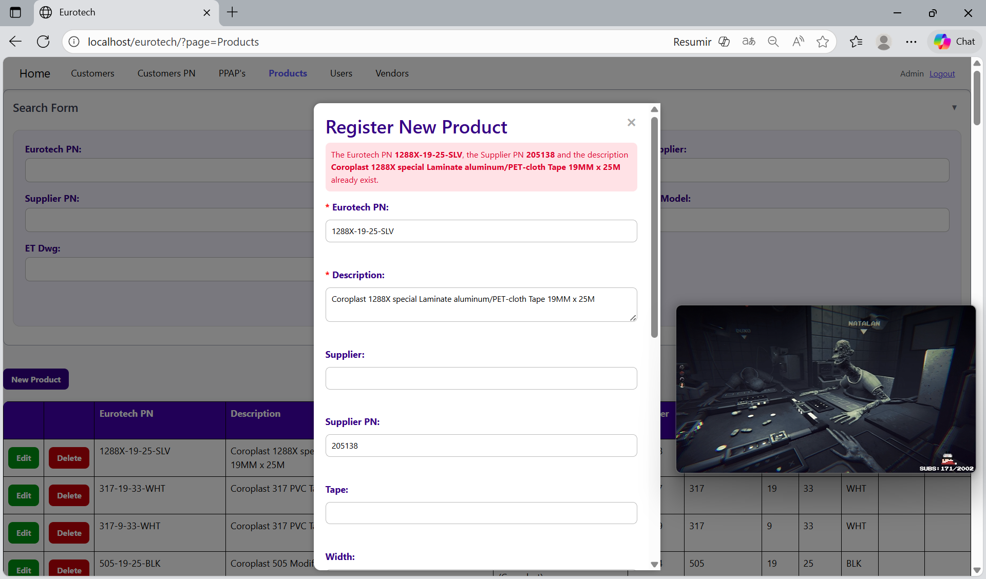

The error message prevents duplicate registers of products.

##### 3.11.4.1.8 The vendor *vendor’s name* doesn’t exist.

If you write a supplier that doesn’t exist, it will show an error message, that says that there is no register with the supplier you are trying to register.

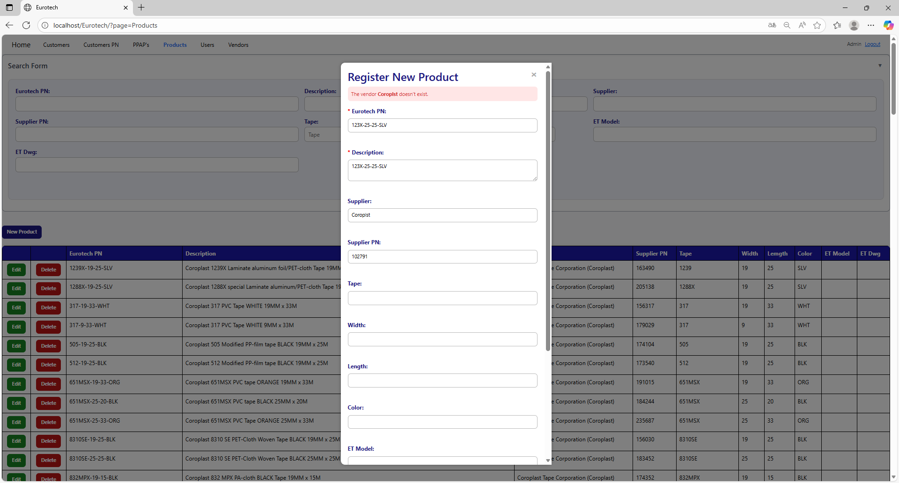

To correct this error, you must check first if the “Supplier” is written correctly. If it is written correctly but it keeps showing the same error message, then you must check in the “Vendors” page if the register of the vendor exists **(you can check in the Index the instruction *3.10.2 How to Search a Vendor*).**

If the vendor is not in the registers of the “Vendors” page, then you must create a new register for that vendor **(you can check in the Index the instruction *3.10.3 How to Add a New Vendor*).**

Once you create the vendor, you can now try to register the product again.

#### 3.11.4.2 Edit Form Errors.

##### 3.11.4.2.1 The description *description* already exists.

If you write a description that already exists, it will show an error message, that says that exists a register with the description you are trying to update.

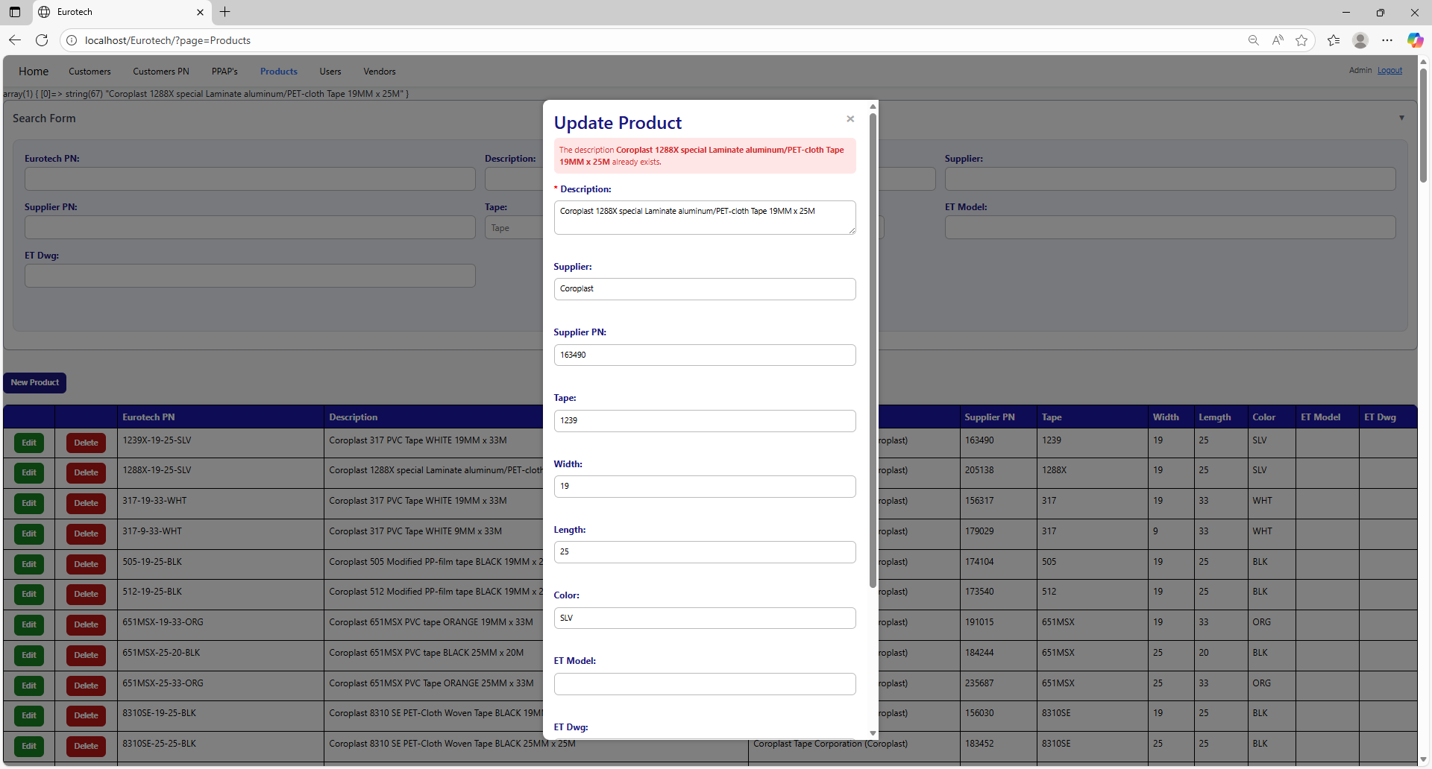

The error message prevents duplicate registers of products.

##### 3.11.4.2.2 The Supplier PN *Supplier PN* already exists.

If you write a Supplier PN that already exists, it will show an error message, that says that exists a register with the Supplier PN you are trying to update.

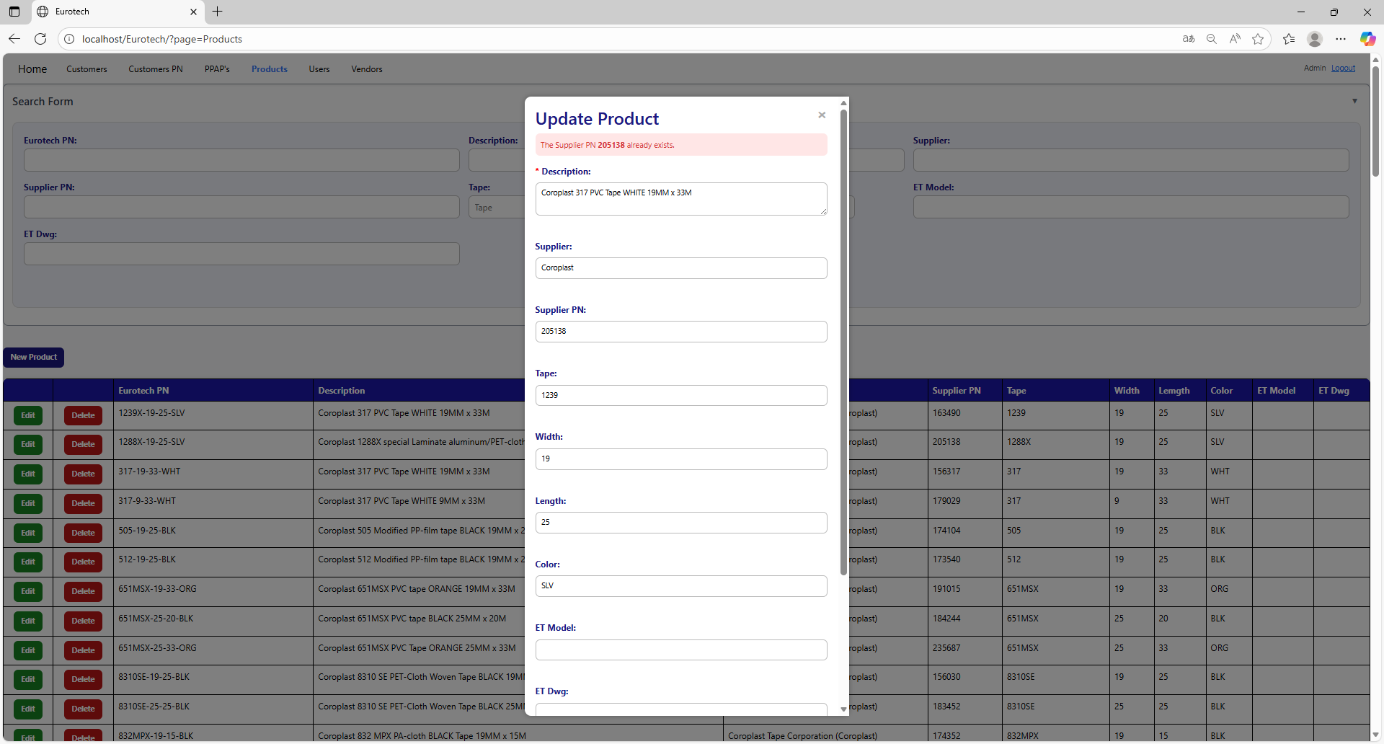

The error message prevents duplicate registers of products.

##### 3.11.4.2.3 The Supplier PN *Supplier PN* and the description *description* already exist.

If you write a Supplier PN and description that already exist, it will show an error message, that says that exists a register with the Supplier PN and description you are trying to update.

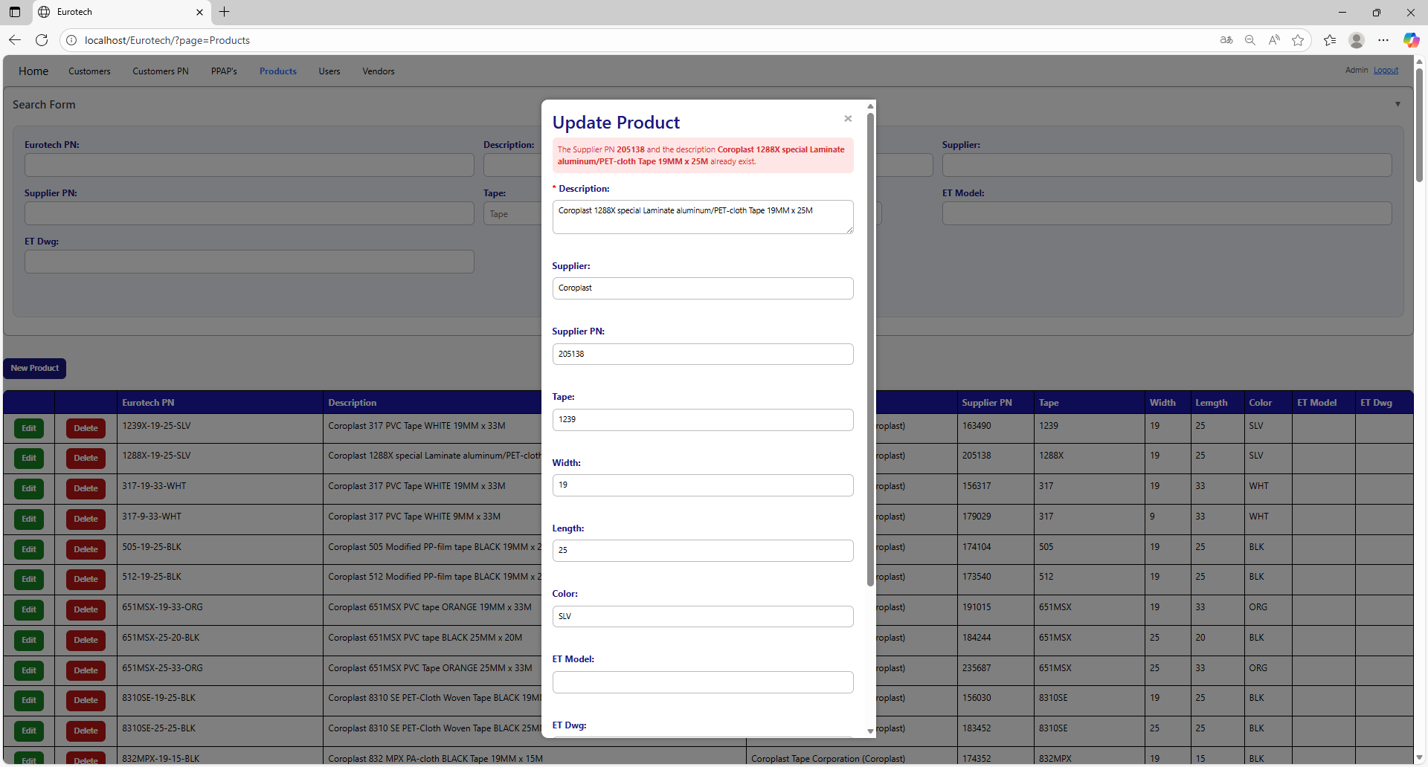

The error message prevents duplicate registers of products.

##### 3.11.4.2.4 The vendor *vendor’s name* doesn’t exist.

If you write a supplier that doesn’t exist, it will show an error message, that says that there is no register with the supplier you are trying to update.

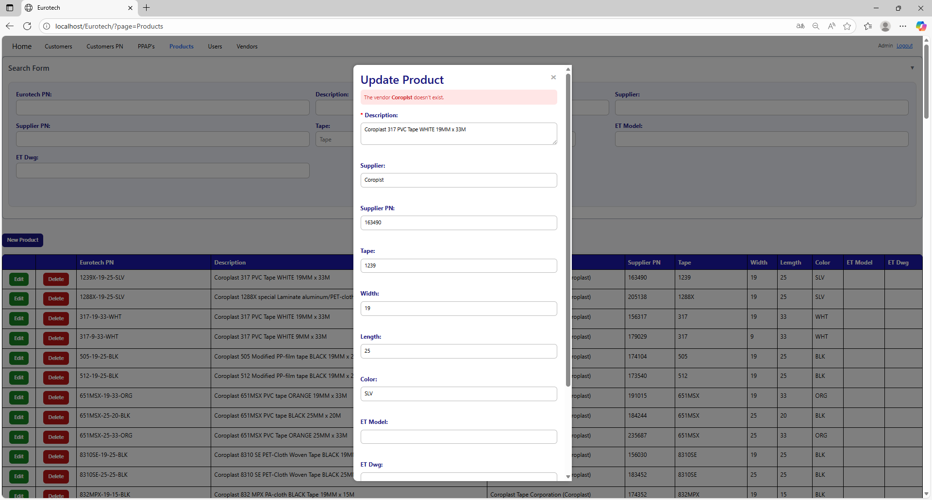

To correct this error, you must check first if the “Supplier” is written correctly. If it is written correctly but it keeps showing the same error message, then you must check in the “Vendors” page if the register of the vendor exists **(you can check in the Index the instruction *3.10.2 How to Search a Vendor*).**

If the vendor is not in the registers of the “Vendors” page, then you must create a new register for that vendor **(you can check in the Index the instruction *3.10.3 How to Add a New Vendor*).**

Once you create the vendor, you can now try to update the product again.

#### 3.11.4.3 Delete Form Errors.

##### 3.11.4.3.1 This product can’t be deleted, because it already has registers.

If you tried to delete a product, and it shows you an error message, that says that the product you are trying to delete can’t be deleted, because it already has registers, this means that the product has registers in the “Customers PN” page and probably in the “PPAP’s” page.

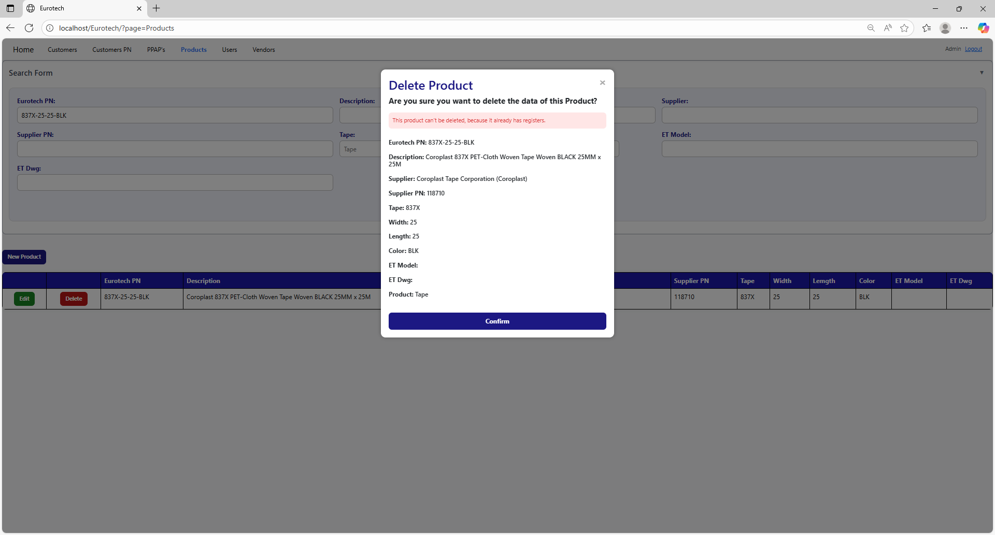

If you want to delete the customer, you must delete all the registers of this customer in the “Customers PN” and “PPAP’s” pages.

### *3.11.5 Users Page Errors.*

#### 3.11.5.1 Register Form Errors.

##### 3.11.5.1.1 Username *username* already exists.

If you write a username that already exists, it will show an error message, that says that exists a register with the username you are trying to register.

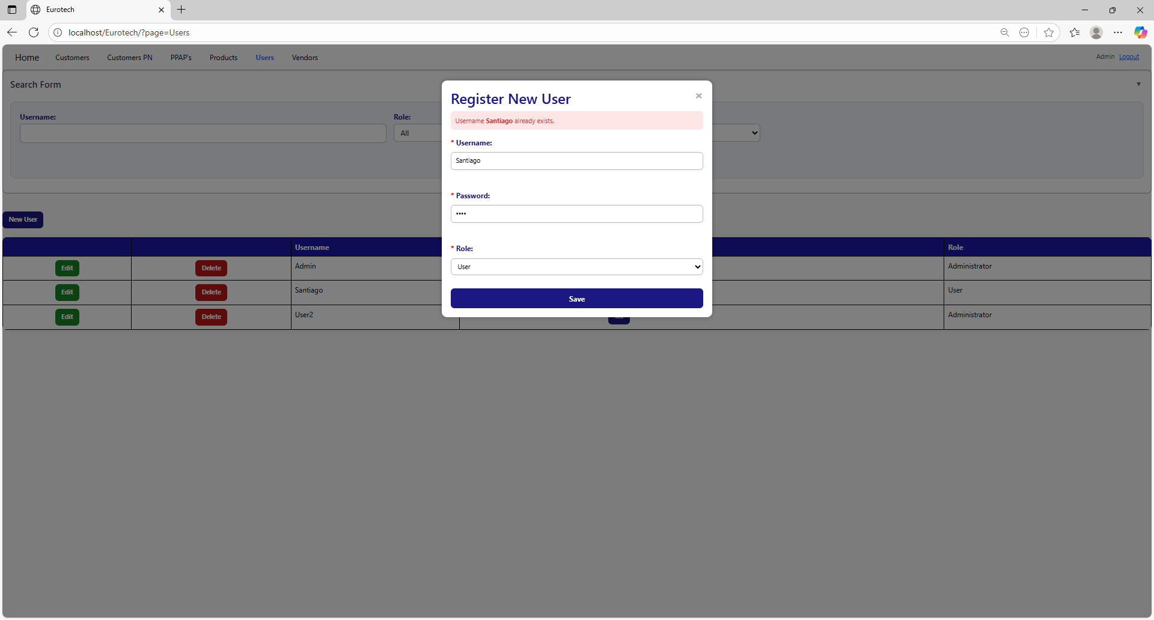

The error message prevents duplicate registers of users.

#### 3.11.5.2 Edit Form Errors.

##### 3.11.5.2.1 Username *username* already exists.

If you write a username that already exists, it will show an error message, that says that exists a register with the username you are trying to update.

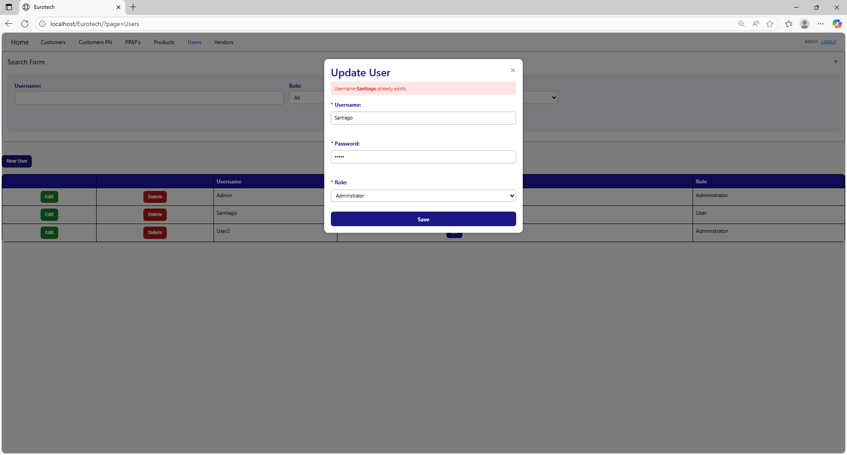

The error message prevents duplicate registers of users.